Name:
A2 Economics:
Globalisation
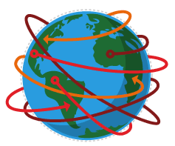

Globalisation

Starter activity: In pairs discuss and write down words that you associate with globalisation.

What do you think is meant by the term Globalisation? (Write it down and be prepared to read it out)
…………………………………………………………………………………………………………………………………………………………………………………………………………………………………………………………………………………………………………………………………………………………………………………………………………………………………………………………………………………………………………………………………………………………………………………………………………………………………………………………………………………………………………………………………………………………………………………………………………………………………………………………………………………………………………………………………………
Definition of Globalisation
………………………………………………………………………………………………………………………………………………………………………………………………………………………………………………………………………………………………………………………………………………………………………………………………………………………………………………………………………………………………………………………………………………

Activity 1: Using the images, data and text on the reverse of this sheet of paper to write a list of the key characteristics of globalisation.
Characteristics of Globalisation
Notes

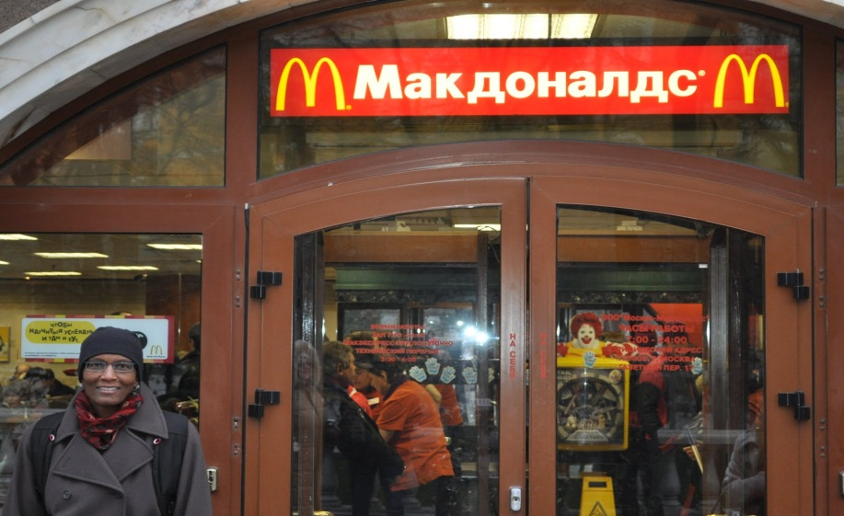
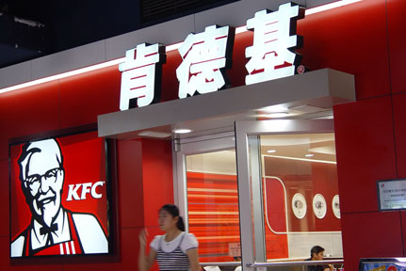
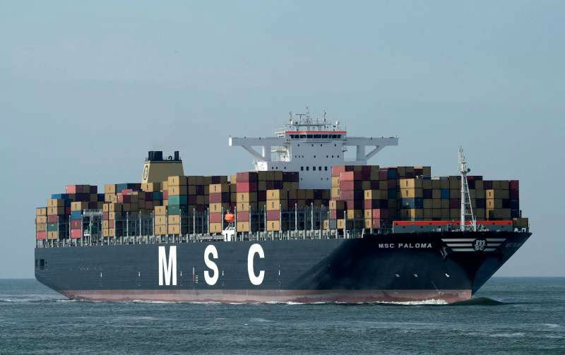
Indian Call centre

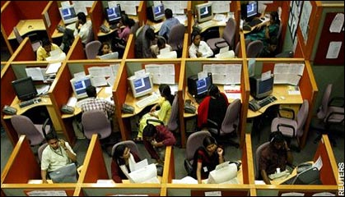
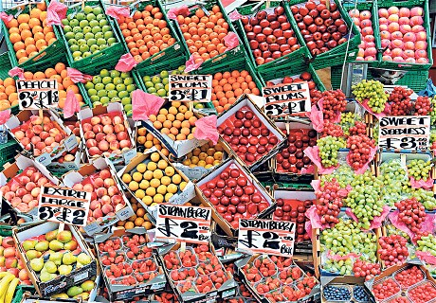
UK Fruit stall
Extract A

A man in his mid-40s, identified in reports only as "Bob", was a star programmer earning a six-figure salary at an American infrastructure company. When the company commissioned a network-security audit, they belatedly discovered that "Bob" had outsourced his own job to a Chinese software company for a fifth of his pay. Relieved of his workload, Bob would spend his entire office day on the internet, flicking from eBay to Facebook to cat videos, before writing a progress-report email for his bosses and knocking off at 5pm.
17th Jan 2013 Gurdian.

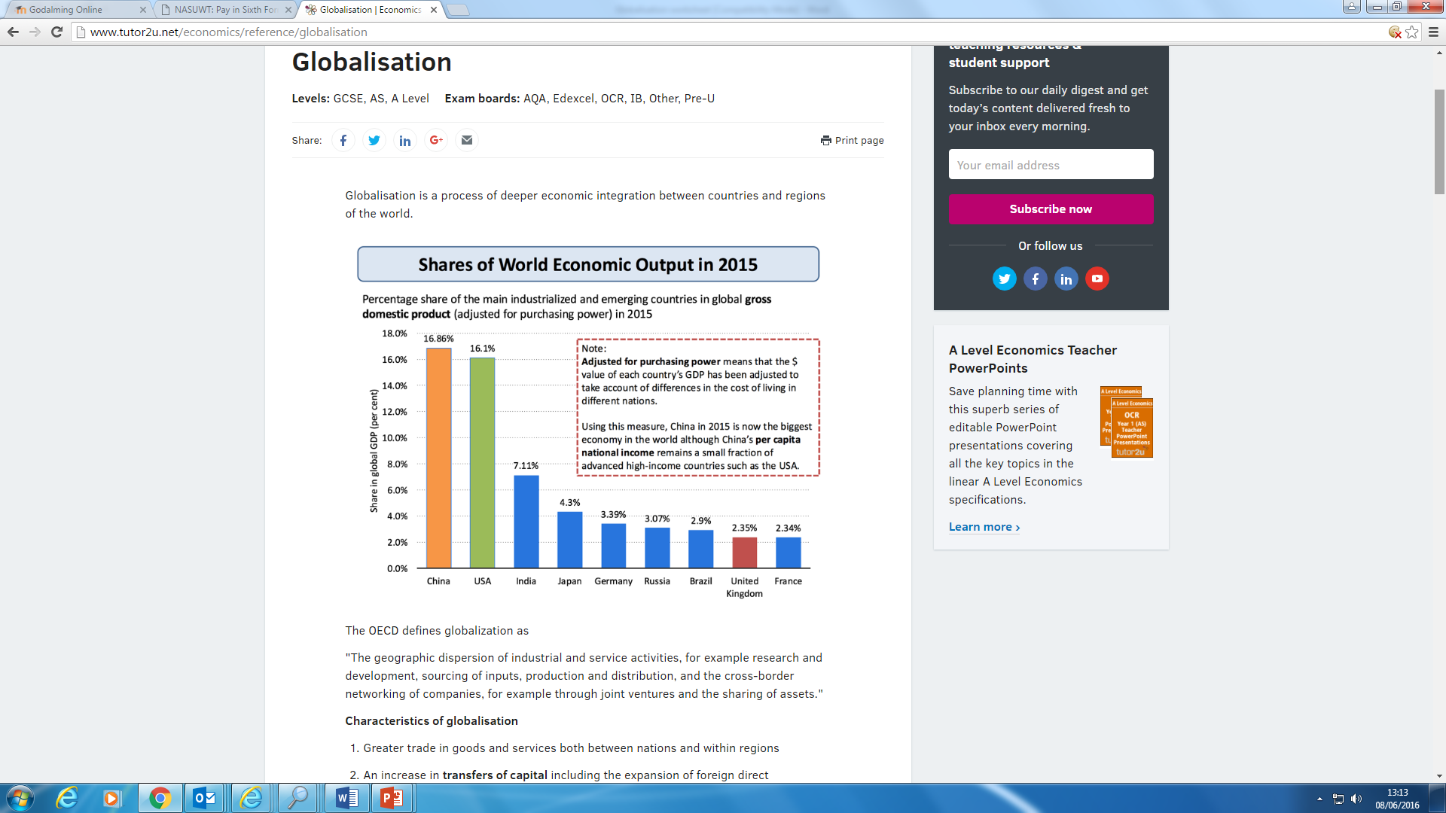
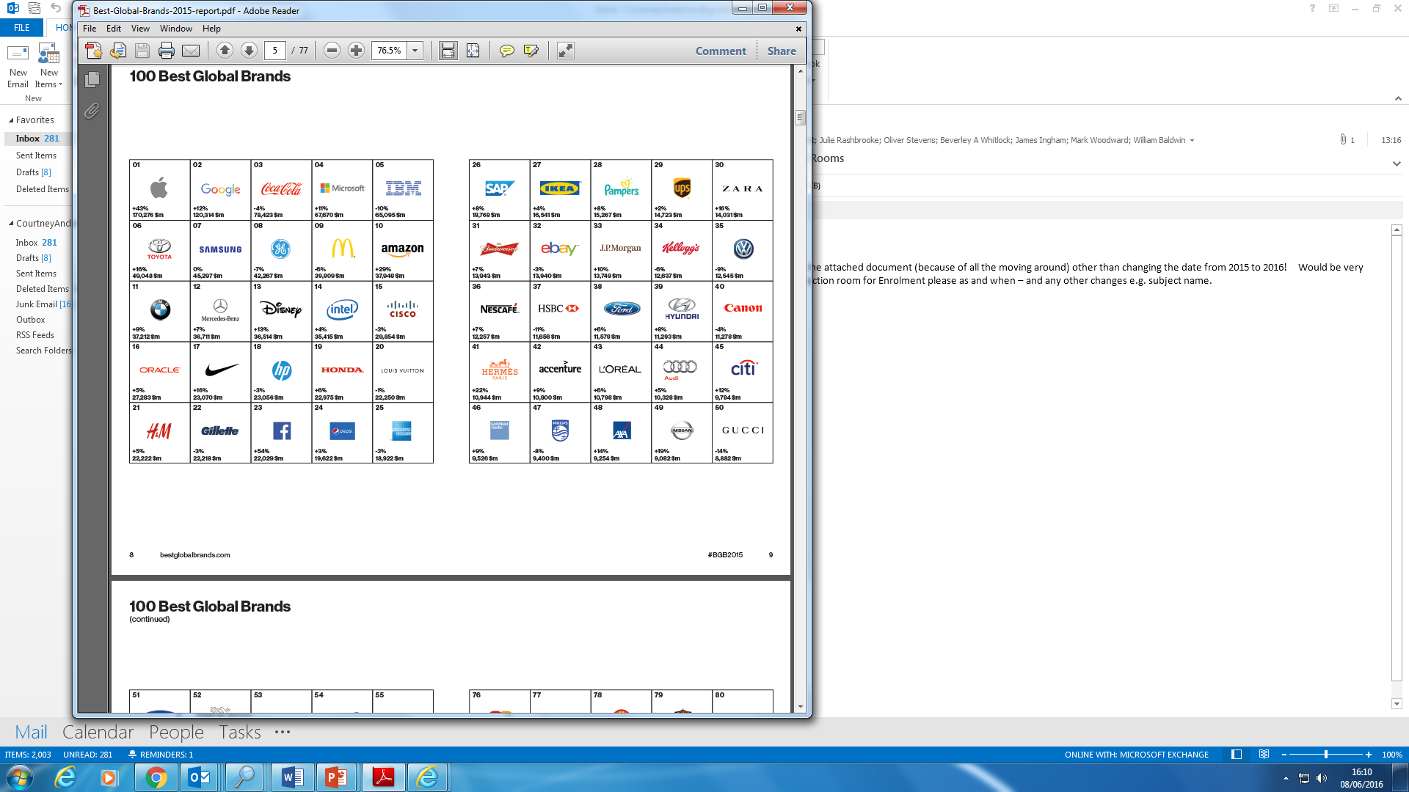
The world’s best brands
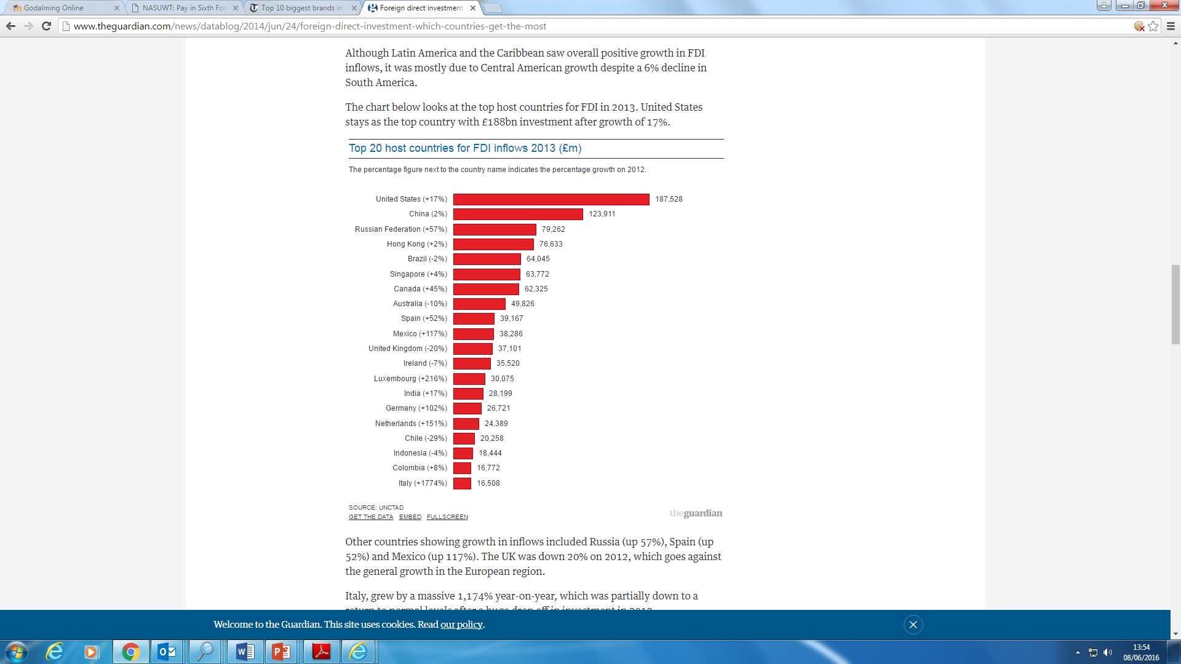
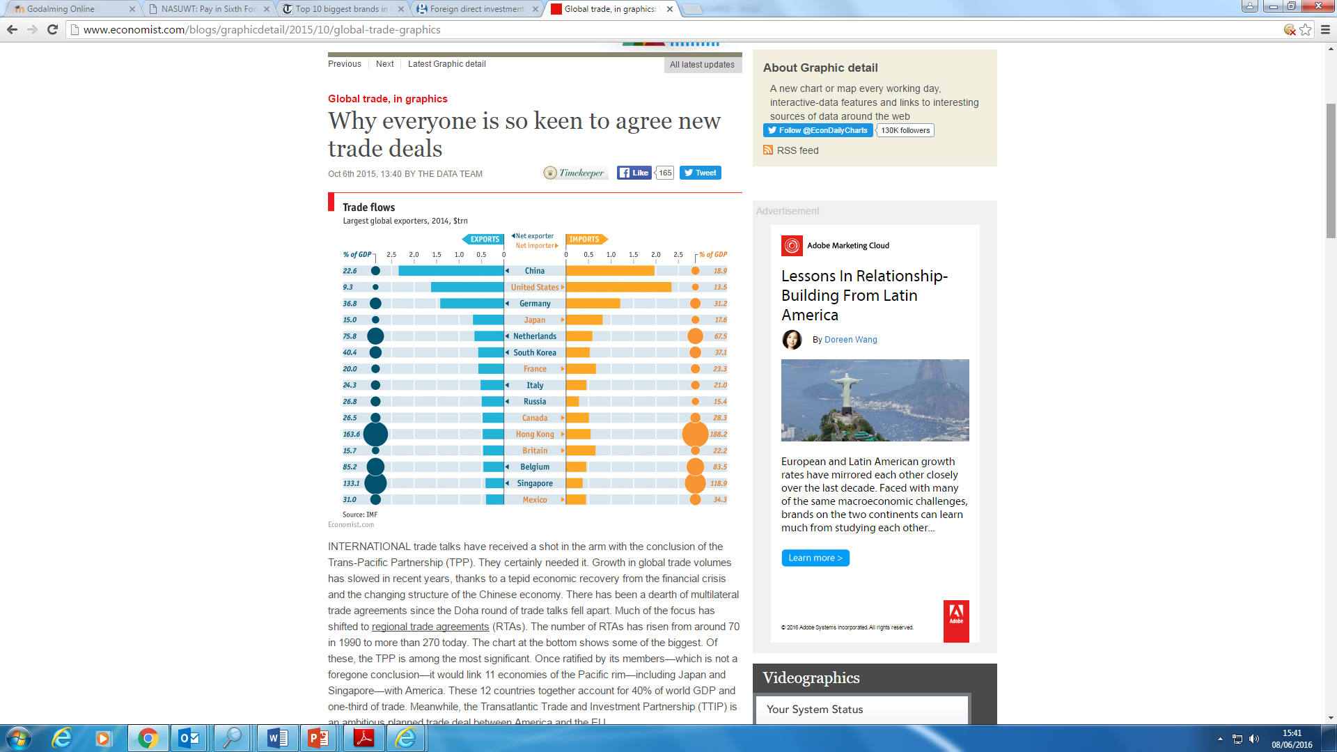

Article 1:

'Choice' is an overused word in business. The people of Totnes rightly opted for community resilience over predatory markets. Guardian Friday 2 November, 2012
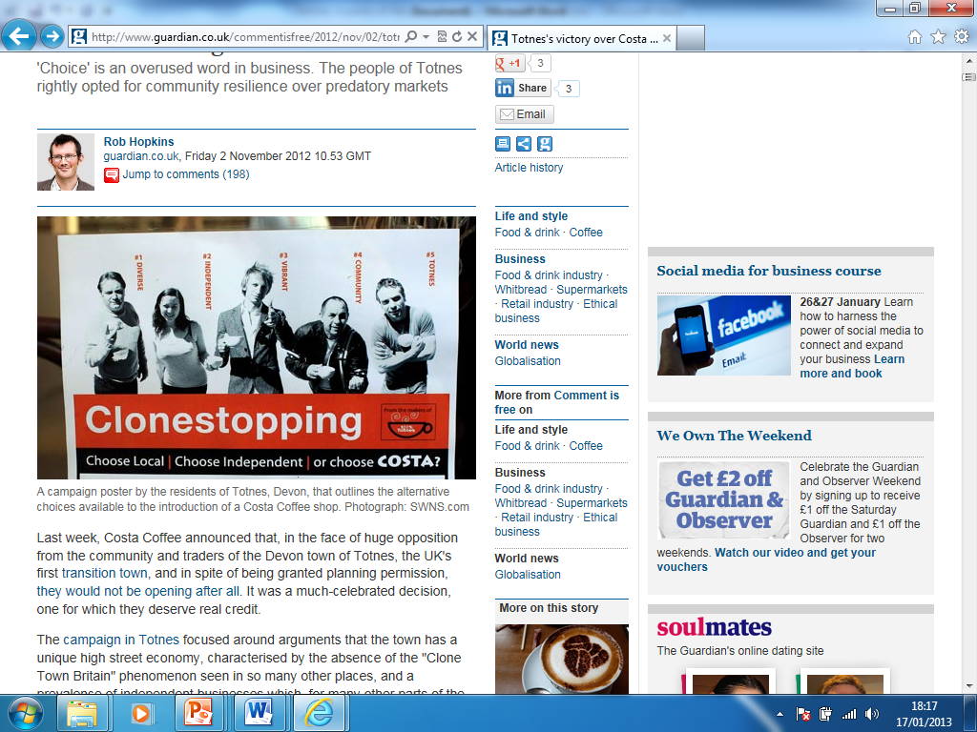
Last week, Costa Coffee announced that, in the face of huge opposition from the community and traders of the Devon town of Totnes, the UK's first transition town, and in spite of being granted planning permission, they would not be opening after all. It was a much-celebrated decision, one for which they deserve real credit.
The campaign in Totnes focused around arguments that the town has a unique high street economy, characterised by the absence of the "Clone Town Britain" phenomenon seen in so many other places, and a prevalence of independent businesses which, for many other parts of the UK, is but a distant memory. It was argued that the community's economic resilience lies in diversity and local markets, not in long supply chains and distant, remote ownership.
Costa claimed that their store would "add to the vibrancy of the town", adding to the choice already on offer.

Article 2

Call centres are blamed for a rise in loose living among India's affluent new elite

Why does it take so long to get through to an Indian call centre? Because everyone is too busy chatting up their colleagues – and more – if the Catholic Church is to be believed.

Why does it take so long to get through to an Indian call centre? Because everyone is too busy chatting up their colleagues – and
more – if the Catholic Church is to be believed.The Church is so concerned by evidence that call centres are becoming dens of iniquity that it is offering week-long retreats and counselling, in the hope of turning staff away from a life of sin.
Employees who are young, usually single, and on starting salaries much higher than those of doctors or lawyers, India's booming call centre industry has been responsible for a social revolution. "Women come to work with condoms in their handbags," said AlkeshDua, a call centre worker in Noida, just outside New Delhi. "Everyone is doing it. You're together all night in this cool, hip atmosphere and you end up getting intimate."

Article 3

PARIS— It has been three-and-a-half months since the government demanded at least 40 percent French-language programming by most private music-oriented radio stations, and so far, the worst fears of station managers and on-air personalities have yet to materialize.
The law was adopted in February 1994 to combat what Paris perceived as the growing influence of English-language songs on French radio stations — notably those, such as Fun Radio, Skyrock and NRJ, that feature a rock 'n' roll format. Such stations previously devoted "as little as 15 percent of their airtime" to French artists, said a spokesman for the ConseilSupérieur de l'Audiovisuel, the French media-watchdog agency.New York Times, 1995

What are the causes of Globalization?
Trade in goods & services

- Improved transport has made it easier to transport goods to overseas markets.
- Developing countries have a cost advantage in the production of manufactured goods.
- Technological development (Telecommunication and IT ) have increased the ability to trade services with one another. E.g India has become a world leader in software and then sells these skills to companies in more developed countries.
Containerisation – the costs of ocean shipping have come down, due to containerization, bulk shipping, and other efficiencies. The lower cost of shipping products around the global economy helps to bring prices in the country of manufacture closer to prices in the export market, and makes markets more contestable in an international sense.
Trade liberalism

- Since 1945 countries have increasing abandoned protectionist trade policies.
- Development of organisation such as the (WTO) World Trade Organisation and (GATT) General Agreement on Tariffs and trade
- Opening up of global financial markets: This has included the removal of capital controls in many countries facilitating foreign direct investment

Multinational companies ((MC) or Transnational corporations
- The growth of Multinational corporations has been a driver of globalisation.
- These companies operate across the globe and benefit from Economies of scale.

Communication and IT Development
- Developments in communication and information technology have speeded up communication between economic agents.
- For example in software production, a programmer does not need to be in close proximity to the client. The client can choose from the best firms wherever they are based.

Activity 2:Watch the clip and write down the advantages and disadvantages of globalisation.

https://www.youtube.com/watch?v=12YDLZq8rT4 (Norberg)

https://www.youtube.com/watch?v=sV7bRLtDr3E (Joseph Stiglitz on Globalisation)

What are the advantages and disadvantages of Globalisation?
Advantages | Disadvantages

Drivers of Globalisation
Among the main drivers of globalisation are the following:
- Containerisation – the costs of ocean shipping have come down, due to containerization, bulk shipping, and other efficiencies. The lower cost of shipping products around the global economy helps to bring prices in the country of manufacture closer to prices in the export market, and makes markets more contestable in an international sense.
- Technological change – reducing the cost of transmitting and communicating information – sometimes known as “the death of distance" – a key factor behind trade in knowledge products using web technology
- Economies of scale: Many economists believe that there has been an increase in the minimum efficient scale (MES) associated with particular industries. If the MES is rising, a domestic market may be regarded as too small to satisfy the selling needs of these industries.
- Opening up of global financial markets: This has included the removal of capital controls in many countries facilitating foreign direct investment.
- Differences in tax systems: The desire of corporations to benefit from lower unit labour costs and other favourable factor endowments abroad and develop and exploit fresh comparative advantages in production has encouraged countries to adjust their tax systems to attract foreign direct investment (FDI)
- Less protectionism - old forms of non-tariff protection such as import licencing and foreign exchange controls have gradually been dismantled. Borders have opened and average tariff levels have fallen – that said in the last few years there has been a rise in protectionism as countries have struggled to achieve growth after the global financial crisis.
Globalization no longer necessarily requires a business to own or have a physical presence in terms of either owning production plants or land in other countries, or even exports and imports. Many businesses use licensing and franchising to help expand their overseas operations.

Activity 3: Using the information you uncovered in activity 3, complete the table below.
Advantages of Globalisation to developed countries | Disadvantages of Globalisation to Developed countries
Advantage of Globalisation to developing nations | Disadvantages of Globalisation to developing countries

Activity 4: Evaluate the following statements (do you agree? are there any down-sides or counter points of these effects?)
a) Developed economies such as the UK should see the gains of free trade in terms of from greater competition, efficiency, lower cost of production, economic growth and jobs...

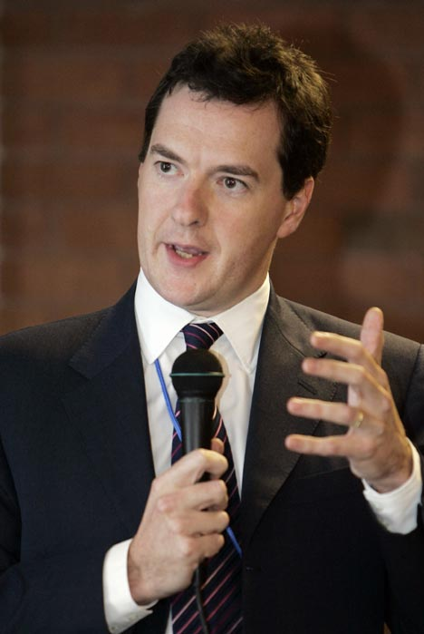

b) Global Inflation should be a lot lower as a result of country specialisation (e.g. outsourcing to China)...

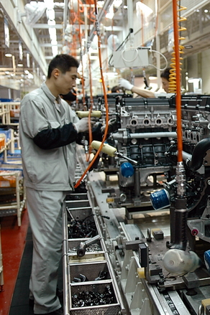

c) The UK’s Balance of payment (on the current account) should improve as a result of export-led growth...

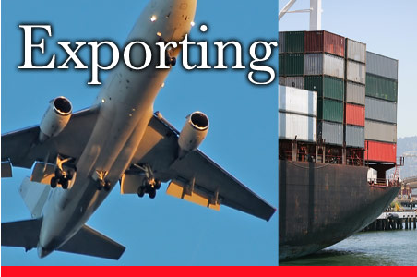

d) Multinationals will be able to thrive in the globalised economy and provide jobs, expertise and infrastructure for developing economies and greater choice for consumers in developed countries...

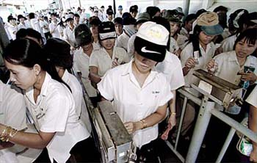

e) Producers in developing countries now have a world market to sell to and can therefore increase profits, exports and growth; as well as improving their standard of living...



World Trade Organisation

The World Trade Organization (WTO) is an international body whose purpose is to promote free trade by persuading countries to abolish import tariffs and other barriers. As such, it has become closely associated with globalisation.

The WTO is the only international agency overseeing the rules of international trade. It polices free trade agreements, settles trade disputes between governments and organises trade negotiations.
WTO decisions are absolute and every member must abide by its rulings. So, when the US and the European Union are in dispute over bananas or beef, it is the WTO which acts as judge and jury. WTO members are empowered by the organisation to enforce its decisions by imposing trade sanctions against countries that have breached the rules.

Based in Geneva, the WTO was set up in 1995, replacing another international organisation known as the General Agreement on Tariffs and Trade (Gatt). Gatt was formed in 1948 when 23 countries signed an agreement to reduce customs tariffs. The WTO has a much broader scope than Gatt. Whereas Gatt regulated trade in merchandise goods, the WTO also covers trade in services, such as telecommunications and banking, and other issues such as intellectual property rights.
China formally joined the body in December 2001 after a 15-year battle. Russia joined only after convincing the EU and US that it had reformed business practices, and after Georgia dropped its politically-motived veto in late 2011.

The highest body of the WTO is the Ministerial Conference. This meets every two years and, among other things, elects the organisation's chief executive - the director-general - and oversees the work of the General Council.

The Ministerial Conference is also the setting for negotiating global trade deals, known as "trade rounds" which are aimed at reducing barriers to free trade.
The General Council is in charge of the day-to-day running of the WTO and is made up of ambassadors from member states who also serve on various subsidiary and specialist committees.
Among these are the Dispute Settlement Panels which rule on individual country-against-country trade disputes.

Countries that join the WTO are required to achieve sustained reductions in average import tariffs. After WTO entry in July 2012 Russia’s average import tariffs will decline from 9.4% to 6.4% on industrial goods and from 15.6% to 11.3% for agricultural goods.

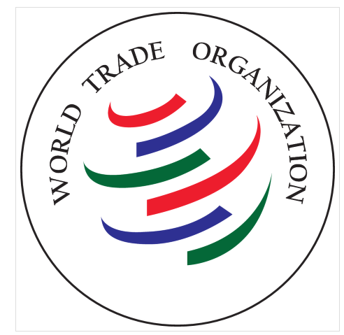

The Uruguay Round

The Uruguay Round was the 8th round of multilateral trade negotiations (MTN) conducted within the framework of the General Agreement on Tariffs and Trade (GATT), spanning from 1986 to 1994 and embracing 123 countries as "contracting parties". The Round led to the creation of the World Trade Organization, with GATT remaining as an integral part of the WTO agreements. The broad mandate of the Round had been to extend GATT trade rules to areas previously exempted as too difficult to liberalize (agriculture, textiles) and increasingly important new areas previously not included (trade in services, intellectual property, investment policy trade distortions). The Round came into effect in 1995 with deadlines ending in 2000 (2004 in the case of developing country contracting parties) under the administrative direction of the newly created World Trade Organization (WTO).

The Doha round

The WTO launched the current round of negotiations, the Doha Development Round, in Doha, Qatar on November 2001. This was to be an ambitious effort to make globalization more inclusive and help the world's poor, particularly by slashing barriers and subsidies in farming. The initial agenda comprised both further trade liberalization and new rule-making, underpinned by commitments to strengthen substantial assistance to developing countries.

Notes

Activity 5: In the space below explain the benefits and potential drawback of a new country such as North Korea joining the WTO.

Use the information in Appendix 2 to help complete the table

Benefits of joining the WTO | Drawbacks of Joining the WTO
Inflation: | Inflation:
Unemployment: | Unemployment:
Economic Growth: | Economic Growth:
Balance of Payments (current account): | Balance of trade (current account):

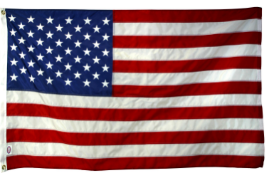

The Washington consensus

The Washington Consensus was a term first coined in 1989 in the wake of the Latin American financial crisis and over the years it has become a highly contentious canvas on which supporters and protestors of western-style globalisation have battled.
According to John Williamson, the economist who came up with the idea of the Washington Consensus it comprised a group of market-friendly policy prescriptionsfavouring the private sector including:

- Fiscal discipline - keeping control of government budget deficits and national debt
- Reallocating state spending from subsidies towards health care, education & infrastructure.
- Tax reform - widening the base of taxation and encouraging lower tax rates to boost enterprise and work incentives as a means of creating wealth
- Liberalising interest rates - allowing financial markets more freedom in setting interest rates on savings and loans and letting market interest rates allocate capital among competing uses
- Exchange rates – supports a choice of fixed or free floating exchange rates but a preference against "dirty floating" i.e. intervention to manipulate the value of a currency
- Trade liberalisation - a gradual reduction in import tariffs and other forms of protectionism – trade seen as an important engine of growth and development
- Liberalization of inward foreign direct investment - capital investment between countries
- Privatization - transferring state-owned enterprises into the private sector
- Deregulation - lowering entry and exit barriers in markets but not at the expense of necessary regulation of aspects such as working conditions and employment rights
- Property rights - protecting intellectual and other rights to encourage innovation and risk-taking

Question: Can you explain why some Economist believe that each of the above measures is likely to lead to growth and development in an economy.

Specifically discuss – a,b,c,f,g,h,i

Here are the profiles of two developing countries. You are an economic analyst trying to assess their development prospects. What would you say?

Country A: Until a decade ago, the country was highly protectionist, with an average industrial tariff rate well above 30 per cent. Despite the recent tariff reduction, important visible and invisible trade restrictions remain. The country has heavy restrictions on cross-border flows of capital, a state-owned and highly regulated banking sector, and numerous restrictions on foreign ownership of financial assets. Foreign firms producing in the country complain that they are discriminated against through differential taxes and regulations by local governments. The country has no elections and is riddled with corruption. It has opaque and complicated property rights. In particular, its protection of intellectual property rights is weak, making it the pirate capital of the world. The country has a large number of state-owned enterprises, many of which make large losses but are propped up by subsidies and government-granted monopoly rights.

Country B: The country’s trade policy has literally been the most protectionist in the world for the last few decades, with an average industrial tariff rate at 40–55 per cent. The majority of the population cannot vote, and vote-buying and electoral fraud are widespread. Corruption is rampant, with political parties selling government jobs to their financial backers. The country has never recruited a single civil servant through an open, competitive process. Its public finances are precarious, with records of government loan defaults that worry foreign investors. Despite this, it discriminates heavily against foreign investors. Especially in the banking sector, foreigners are prohibited from becoming directors while foreign shareholders cannot even exercise their voting rights unless they are resident in the country. It does not have a competition law, permitting cartels and other forms of monopoly to grow unchecked. Its protection of intellectual property rights is patchy, particularly marred by its refusal to protect foreigners’ copyrights.

Question

- How are the countries above contradicting the views of the Washington consensus?
- Can you guess the names of country A and B?

Appendix 1
Characteristics of globalisation
- Greater trade in goods and services both between nations and within regions
- An increase in transfers of capital including the expansion of foreign direct investment (FDI) by trans-national companies (TNCs) and the rising influence of sovereign wealth funds
- The development of global brands that serve markets in higher and lower income countries
- Spatial division of labour– for example out-sourcing and off shoring of production and support services as production supply-chains has become more international. As an example, the iPhone is part of a complicated global supply chain. The product was conceived and designed in Silicon Valley; the software was enhanced by software engineers working in India. Most iPhones are assembled / manufactured in China and Taiwan by TNCs such as FoxConn
- High levels of labour migration within and between countries
- New nations joining the world trading system. China and India joined the WTO in 1991, Russia joined the WTO in 2012
- A fast changing shift in the balance of economic and financial power from developed to emerging economies and markets – i.e. a change in the centre of gravity in the world economy
- Increasing spending on investment, innovation and infrastructure across large parts of the world
- Globalisation is a process of making the world economy more inter-dependent
- Many of the industrializing countries are winning a rising share of world trade and their economies are growing faster than in richer developed nations especially after the global financial crisis (GFC)

Appendix 2
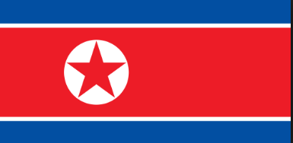

North Korea

Background information
North Korea, one of the world's most centrally directed and least open economies, faces chronic economic problems. Industrial capital stock is nearly beyond repair as a result of years of underinvestment, shortages of spare parts, and poor maintenance. Large-scale military spending draws off resources needed for investment and civilian consumption. Industrial and power outputs have stagnated for years at a fraction of pre-1990 levels. Frequent weather-related crop failures aggravated chronic food shortages caused by on-going systemic problems, including a lack of arable land, collective farming practices, poor soil quality, insufficient fertilization, and persistent shortages of tractors and fuel.
The mid 1990s were marked by severe famine and widespread starvation. Significant food aid was provided by the international community through 2009. Since that time, food assistance has declined significantly. In the last few years, domestic corn and rice production has been somewhat better, although domestic production does not fully satisfy demand. A large portion of the population continues to suffer from prolonged malnutrition and poor living conditions. Since 2002, the government has allowed informal markets to begin selling a wider range of goods. It also implemented changes in the management process of communal farms in an effort to boost agricultural output.
In December 2009, North Korea carried out a redenomination of its currency, capping the amount of North Korean won that could be exchanged for the new notes, and limiting the exchange to a one-week window. A concurrent crackdown on markets and foreign currency use yielded severe shortages and inflation, forcing Pyongyang to ease the restrictions by February 2010. In response to the sinking of the South Korean warship Cheonan and the shelling of Yeonpyeong Island in 2010, South Korea’s government cut off most aid, trade, and bilateral cooperation activities, with the exception of operations at the Kaesong Industrial Complex. North Korea continued efforts to develop special economic zones and expressed willingness to permit construction of a trilateral gas pipeline that would carry Russian natural gas to South Korea. North Korea is also working with Russia to refurbish North Korea’s dilapidated rail network and jointly rebuilt a link between a North Korean port in the Rason Special Economic Zone and the Russian rail network.

The North Korean government continues to stress its goal of improving the overall standard of living, but has taken few steps to make that goal a reality for its populace. In 2013-2014, the regime rolled out 20 new economic development zones - now totaling 25 - set up for foreign investors, although the initiative remains in its infancy. Firm political control remains the government’s overriding concern, which likely will inhibit changes to North Korea’s current economic system.

Other useful data

North Korea doesn’t publish National income data. The data provided below has been taken from the CIA factbook

Industries – Military production, machine building, electric power, chemicals, mining, metallurgy, food processing and tourism.

Imports – Petroleum, coking coal, machinery, and equipment textiles, grain.

Import partners – China 68% and South Korea 22%

Appendix 2 (continued)
Economic data | Value
GDP | $40 bn
GDP per capita | $1,800
Economic growth rate | 1%
GDP composition by sector  Agriculture  Industry  Services | 22%  47%  31%
Population | 24m
Labour force | 14m
Unemployment rate | 25%
Inflation | ?
Imports  Exports | $5.2 bn  $4.4bn

Appendix 3

Trading Blocs and Regional Trade Agreements (RTAs)
In recent years there has been a flurry of bi-lateral trade deals between countries and the emergence of regional trading blocs. For example, the European Union now has over 30 separate international trade agreements including those with countries such as Colombia and South Korea.
Some of these deals are free-trade agreements that involve a reduction in tariff and non-tariff import controls to liberalise trade in goods and services between countries.
The most sophisticated RTAs include rules on flows of investment, co-ordination of competition policies, agreements on environmental policies and the free movement of labour.
Examples of Regional Trade Agreements (RTAs):
The number of RTAs has risen from around 70 in 1990 to over 300 now – this both reflects and reinforces a switch towards greater intra-regional trade most notably between many of the world's fast-growing emerging market economies. No regional trade agreement is the same!
The WTO permits the existence of trade blocs, provided that they result in lower protection against outside countries than existed before the creation of the trade bloc
- European Union (EU) – a customs union, a single market and now with a single currency
- European Free Trade Area (EFTA)
- North American Free Trade Agreement (NAFTA) between the USA, Canada and Mexico
- Mercosur - a customs union between Brazil, Argentina, Uruguay, Paraguay and Venezuela
- Association of Southeast Asian Nations (ASEAN) Free Trade Area (AFTA)
- Common Market of Eastern and Southern Africa (COMESA)
- South Asian Free Trade Area (SAFTA) created in 2006 with countries such as India and Pakistan
- Pacific Alliance – 2013 – a regional trade agreement between Chile, Colombia, Mexico and Peru
- Trans-Pacific Partnership (TPP) - a proposed free trade agreement being negotiated during 2013 between Australia, Brunei, Chile, Canada, Malaysia, Mexico, New Zealand, Peru, Singapore, the United States, and Vietnam
General notes on regional trade blocs
Trade blocs are usually groups of countries in specific regions that manage and promote trade activities.Trade blocs lead to trade liberalisation (the freeing of trade from protectionist measures) and trade creationbetween members, since they are treated favourably in comparison to non-members. However, trade diversion away from non-members is also likely to occur, especially if protectionist measures are imposed against non-members. Trade diversion contradicts the aims of the WTO and distorts comparative advantage

