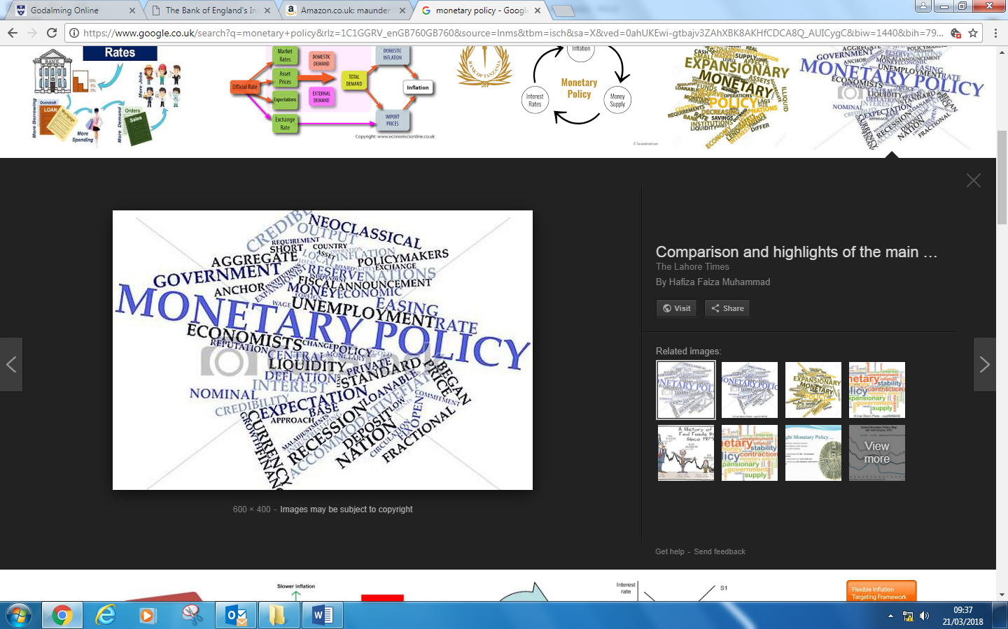

Name:

What is monetary policy?
……………………………………………………………………………………………………………………………………………………………
……………………………………………………………………………………………………………………………………………………………
……………………………………………………………………………………………………………………………………………………………
……………………………………………………………………………………………………………………………………………………………

How might an increase in interest rates affect the following Economic agents?

Type of economic agent | Effect on the economic agent
Home owners

Owners of Credit card

Firms

Monetary Policy
Over the past 20 years Monetary policy has been the principle strand of macroeconomic policy and since 1997 has been principally managed by the Monetary Policy committee of the UK’s central bank (the Bank of England).
The operational independence of the Bank of England was granted in 1997.
The MPC’s job is to use interest rates to control aggregate demand and subsequently control inflation.
In recent years the prime strand of monetary policy has been through interest rates. Through the interest rate, monetary policy affects aggregate demand.
The rate of interest and monetary policy
There is no unique rate of interest. For example, we can distinguish between savings rates and borrowing rates. However interest tend to move in the same direction. For example if the Bank of England cuts the base rate of interest we can expect to see lower borrowing mortgage rates and lower rates on savings accounts with banks and building societies.
Key definitions

Interest rates: The cost of borrowing or the reward for savings.
Real interest rates: The money rate of interest minus the rate of inflation.
Transmission mechanism: How changes in base interest rate influence the components of aggregate demand
Operational independence of the Bank of England: The bank of England is free to make decisions about Monetary Policy independent of government intervention.
Tight monetary policy is when interest rates are held high to restrict spending – for example when inflation is above target.

Loose monetary policy is when interest rates are kept low to encourage spending – for example when inflation is below target.

Activity 1: Use the space below to demonstrate (using an AD-AS diagram) how you would show the effects of an increase and a decrease in interest rates to affect inflation in an economy (Use the Keynesian AD-AS diagram).

Effects of an increase in interest rates
Effects of a decrease in interest rates

Explain how an increase in interest rates might have the effect of reducing inflation in an economy
(CREATE YOUR EXPLANATION USING CLEAR LOGICAL CHAINS)
………………………………………………………………………………………………………………………………………………………
………………………………………………………………………………………………………………………………………………………
………………………………………………………………………………………………………………………………………………………
………………………………………………………………………………………………………………………………………………………
………………………………………………………………………………………………………………………………………………………
………………………………………………………………………………………………………………………………………………………
………………………………………………………………………………………………………………………………………………………
………………………………………………………………………………………………………………………………………………………
………………………………………………………………………………………………………………………………………………………
………………………………………………………………………………………………………………………………………………………

Extension activity (evaluate the point/ you have just explained)
………………………………………………………………………………………………………………………………………………………
………………………………………………………………………………………………………………………………………………………
………………………………………………………………………………………………………………………………………………………
………………………………………………………………………………………………………………………………………………………
………………………………………………………………………………………………………………………………………………………
………………………………………………………………………………………………………………………………………………………
………………………………………………………………………………………………………………………………………………………
………………………………………………………………………………………………………………………………………………………
………………………………………………………………………………………………………………………………………………………
………………………………………………………………………………………………………………………………………………………

Transmission mechanism of monetary policy
There are several ways in which changes in interest rates influence aggregate demand. These are collectively known as the transmission mechanism of monetary policy. One of the main channels that the MPC can use to influence aggregate demand, and therefore inflation, is via, the lending and borrowing rates charged by the market.

Impacts of changes in interest rates on the aggregate demand
- Disposable incomes of mortgage payers. If interest rates increase, the disposable income of homeowners who have variable-rate mortgages will fall, leading to a decline in their purchasing power.
Possible evaluation point: However, a rise in interest rates boosts the disposable income of people who have paid off their mortgage and who have positive net savings in bank and building society accounts.
- Consumer demand for credit. Higher interest rates increase the cost of serving debt on credit cards and should lead to a slow-down in the growth of retail sales and spending on consumer durables,
Possible evaluation point, the extent of which depends on the impact of a rate change on consumer confidence.
- Consumer and business confidence. The relationship between interest rates and business and consumer confidence is complicated, depending on economic conditions. For example, when businesses and consumers are worried about the risk of a recession ,an interest rate can boost confidence, and hence aggregate demand, acting as a reassurance to the public that the Bank of England is alert to the dangers of a down turn in economic activity.
Possible evaluation points, it is possible, however, that a cut in rates could undermine confidence. For example if the Bank of England cut interest rates too quickly, sending a message to firms and consumers that the Bank is concerned about the prospect of a recession. Thus interest rate settling often calls for a finely balanced judgment.
- Business investment. Firms take the actual and expected level of interest rates into account when deciding whether or not to undertake new capital investment spending. A rise in interest rates might dampen business confidence.
Possible evaluation point. However, many other factors influence investment decisions, including consumer trends, business confidence, the price of capital, etc

Evaluate the view that an increase in interest rates will always have the effect of reducing inflation? (25 Marks)
Homework
Due:

Monetary policy is the use of Interest rates, exchange rates and controlling the money supply in order to achieve the government’s macroeconomic objectives (which are low inflation, sustainable growth, low unemployment and equilibrium on the Balance of payments). In the UK Monetary Policy is the main policy instrument for achieving for achieving the inflation target which is currently set at 2% plus or minus 1%. During this essay I will argue that there are limitations to the use of monetary policy in reducing inflation and that it must be used in conjunction with other Economic policies.
The Bank of England may decide to raise interest rates to lower inflationary pressure. By increasing its base rate other lending institutions within the economy would increase their interest rates as well. Consumers would now have an increased incentive to save money rather than spend it. As a result consumer spending in the economy would decrease (as seen in the diagram below with the movement of Aggregate Demand from AD1 – AD2). As there is less demand for goods and services, firms will begin to build up stocks of unsold inventory, in an attempt to get rid of these stock caused by excess supply in the economy firms will lower their prices – as seen by the movement in prices from P1 to P2 – as a result price levels in the economy go down and there is a reduction in inflation in the economy.

Draw appropriate diagram in the space above.

However the extent to which inflation falls is dependent on the size of the increase in interest rates, too small an increase in interest rates and the fall in consumer spending may not be enough to reduce Aggregate Demand and so therefore the resulting decrease in inflation may be too small to bring inflation with target. Alternatively a negative consequence of tight monetary policy is that too much of an increase in interest rates may lead to a severe fall in consumer spending which alongside multiplier effects associated with a decrease in spending may cause Aggregate demand too much leading to a huge fall in output in the economy which would likely lead to firms making people unemployed.
A second way in which tight monetary policy can be used to control the level of inflation is that it acts as a disincentive to firms to borrow money to invest in capital goods. When interest rates rise firms will have a disincentive to borrow because they will have to pay more money back to banks in the future. This means that firms will therefore only undertake investment projects if they believe the profits they make will be large enough to cover the increased burden of increased interest rate charges. This reduction in investment will have an impact on Aggregate Demand which will shift to the left, causing output to fall, as there is less demand for capital equipment and also a subsequent fall in the demand for the people who make them. This rise in unemployment will lead to a fall in demand for goods and services and in order to sell unsold stock firms will lower their prices therefore lowering inflation.
However ……………………………………………………………………………………………………………………………………………………………
……………………………………………………………………………………………………………………………………………………………
……………………………………………………………………………………………………………………………………………………………
……………………………………………………………………………………………………………………………………………………………
……………………………………………………………………………………………………………………………………………………………
……………………………………………………………………………………………………………………………………………………………
……………………………………………………………………………………………………………………………………………………………
……………………………………………………………………………………………………………………………………………………………
……………………………………………………………………………………………………………..................................................
..................................................................................................................................................................
..................................................................................................................................................................
..................................................................................................................................................................
..................................................................................................................................................................
..................................................................................................................................................................
..................................................................................................................................................................
..................................................................................................................................................................
..................................................................................................................................................................
……………………………………………………………………………………………………………………………………………………………
……………………………………………………………………………………………………………………………………………………………
……………………………………………………………………………………………………………………………………………………………
……………………………………………………………………………………………………………………………………………………………
……………………………………………………………………………………………………………………………………………………………
……………………………………………………………………………………………………………………………………………………………
……………………………………………………………………………………………………………………………………………………………
……………………………………………………………………………………………………………………………………………………………
……………………………………………………………………………………………………………..................................................
..................................................................................................................................................................
..................................................................................................................................................................
..................................................................................................................................................................
..................................................................................................................................................................
..................................................................................................................................................................
..................................................................................................................................................................
..................................................................................................................................................................
..................................................................................................................................................................
……………………………………………………………………………………………………………………………………………………………
……………………………………………………………………………………………………………………………………………………………
……………………………………………………………………………………………………………………………………………………………
……………………………………………………………………………………………………………………………………………………………
..................................................................................................................................................................
..................................................................................................................................................................
..................................................................................................................................................................
..................................................................................................................................................................
……………………………………………………………………………………………………………………………………………………………
……………………………………………………………………………………………………………………………………………………………
……………………………………………………………………………………………………………………………………………………………
……………………………………………………………………………………………………………………………………………………………
..................................................................................................................................................................
..................................................................................................................................................................
..................................................................................................................................................................
..................................................................................................................................................................
……………………………………………………………………………………………………………………………………………………………
…………………………………………………………………………………………………………………………………………………………
Complete all the points below for homework. You can either use several different coloured highlighter pens for question 1 & 2 or annotate the text with the abbreviations (Knowledge kn, Application Ap Analysis An and Evaluation Ev).

- Highlight where you can see the following exam skills demonstrated in the example answer above
- Highlight the telegraphed part of the 1st and 2nd point
- How many chain of reasoning were there in the first point?
- What was the evaluative word used to start the evaluative comment?
- Write two evaluative comments for the second point raised
(Hint: Are interest rates the only factor that affects firm’s decision to invest? think about the cost of capital, business confidence and government policy (e.g attitude to business taxes)
- Write a 3rd point.
- Write two evaluative comments for the third point raised
- Write a brief conclusion

Monetary policy and Exchange rates
Starter quiz
- How many members of the monetary policy committee are there?
- Monetary Policy is primarily used to control economic growth?(True/False)
- Monetary Policy is only about the use of interest rates to control the economy(True/False)
- Monetary policy affects the Aggregate Demand side of the economy (True/False)
- Interest rates are the cost of borrowing or the reward for saving (True/False)
- A decrease in interest rates guarantee an increase in business investment? (True/False)
- All things being equal, a weak pound will lead to a decrease in inflation (True/False)
- Only monetary Policy can have an impact on the inflation rate (true/False)
- The governor of the Bank of England sets the inflation target (True/False)
- Tight Monetary Policy will lead to a rightward shift in the Aggregate demand curve (True/False)

Extension

Explain how an increase in interest rates might impact on inflation in the UK.

………………………………………………………………………………………………………………………………………………………

………………………………………………………………………………………………………………………………………………………

………………………………………………………………………………………………………………………………………………………

………………………………………………………………………………………………………………………………………………………

………………………………………………………………………………………………………………………………………………………

………………………………………………………………………………………………………………………………………………………

………………………………………………………………………………………………………………………………………………………

………………………………………………………………………………………………………………………………………………………

………………………………………………………………………………………………………………………………………………………

………………………………………………………………………………………………………………………………………………………

………………………………………………………………………………………………………………………………………………………

Monetary policy – Exchange rate policy
Higher UK interest rates might lead to a strengthening of the pound because of an increased demand for the pound. Foreign holders of currency will swop their currencies for UK pounds to get a higher rate of interest -this in flow of money into the UK financial system is called ‘hot money’.
As the pound becomes stronger this will reduce the competitiveness of UK firms in overseas markets because our goods will seem more expensive (Strong Pound Imports Cheap Exports Dear).

Impact of a strong pound
- Aggregate Demand will fall and therefore suppress inflation (Demand Pull inflation is supressed)
- The cost of imported raw materials that firms use may fall which may reduce cost push inflation.

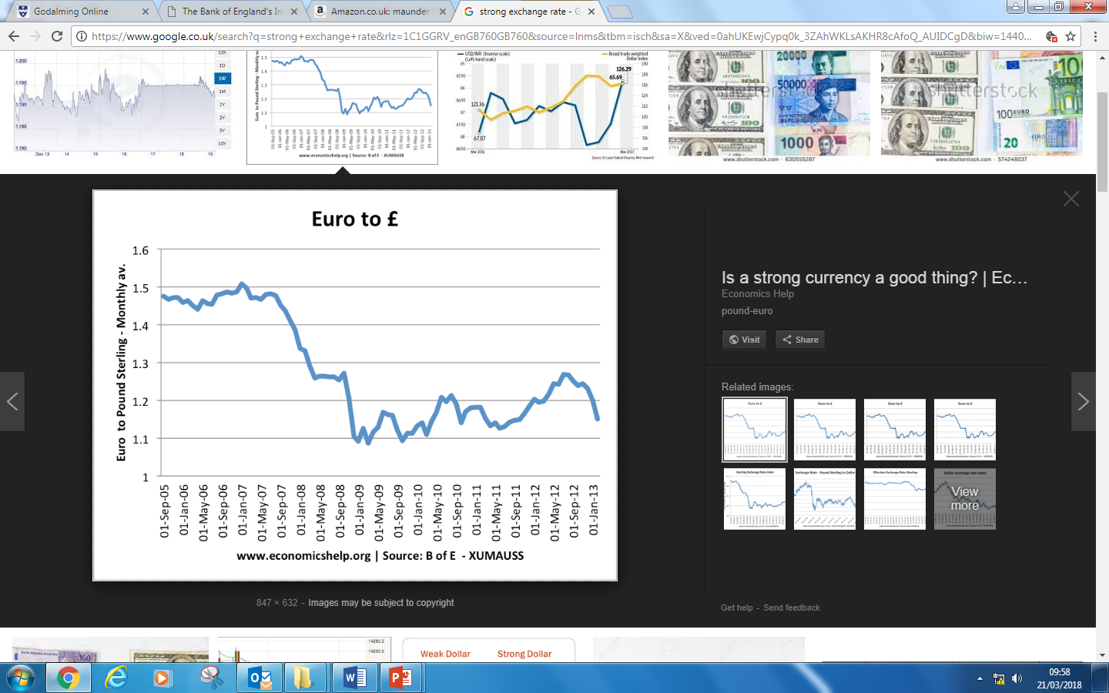

Quick question: Identify a period of time where sterling (£) was getting stronger against the Euro and a period of time when it was getting weaker against the Euro.

Activity 1
Using the information on the previous page, Explain why an increase in exchange rates might lower inflation. Use an AD AS diagram as part of your explanation and refer to it.

……………………………………………………………………………………………………………………………………………………………
……………………………………………………………………………………………………………………………………………………………
……………………………………………………………………………………………………………………………………………………………
…...............................................................................................................................................................
..................................................................................................................................................................
..................................................................................................................................................................
……………………………………………………………………………………………………………………………………………………………
……………………………………………………………………………………………………………………………………………………………
……………………………………………………………………………………………………………………………………………………………
…...............................................................................................................................................................
..................................................................................................................................................................
..................................................................................................................................................................
……………………………………………………………………………………………………………………………………………………………
……………………………………………………………………………………………………………………………………………………………
……………………………………………………………………………………………………………………………………………………………
…...............................................................................................................................................................
..................................................................................................................................................................
..................................................................................................................................................................
……………………………………………………………………………………………………………………………………………………………
……………………………………………………………………………………………………………………………………………………………
……………………………………………………………………………………………………………………………………………………………
…...............................................................................................................................................................
..................................................................................................................................................................
..................................................................................................................................................................
Extension Activity: Write two short evaluative comment suggesting why a strong exchange rates may not lead to a decrease in inflation.
Hint: How might spare capacity in the economy help reduce inflationary pressure? What other factors affect the level of exports and imports in an economy
……………………………………………………………………………………………………………………………………………………………
……………………………………………………………………………………………………………………………………………………………
……………………………………………………………………………………………………………………………………………………………
…...............................................................................................................................................................
..................................................................................................................................................................
..................................................................................................................................................................
……………………………………………………………………………………………………………………………………………………………
……………………………………………………………………………………………………………………………………………………………
……………………………………………………………………………………………………………………………………………………………
…...............................................................................................................................................................
..................................................................................................................................................................
..................................................................................................................................................................

What is the advantage of a strong pound?

- Cheaper imported goods for consumers. (Strong pound imports cheap). This will lead to a rise in consumer welfare.
- Lower production costs for firms – it’s cheaper to import raw materials, so therefore firms cost fall. This could make UK firms more competitive internationally.
- Lower inflation – A strong pound will mean that import prices are cheaper and so therefore imported raw materials are cheaper therefore inflation will fall.

What are the disadvantages of a strong pound?

What are the negative effects of a strong pound on the following groups
The Economy
(Hint: what are the effects on Economic growth, employment, the trade deficit)

Impact on business confidence

Plenary
A sustained fall in the exchange rate is most likely to decrease

A Inflation.
B international competitiveness.
C economic growth.
D unemployment.

Circle the correct answer, explain why you think it is correct and then explain why the other answers are incorrect.

A
……………………………………………………………………………………………………………………………………………………………
……………………………………………………………………………………………………………………………………………………………
……………………………………………………………………………………………………………………………………………………………
B
……………………………………………………………………………………………………………………………………………………………
……………………………………………………………………………………………………………………………………………………………
……………………………………………………………………………………………………………………………………………………………
C
……………………………………………………………………………………………………………………………………………………………
……………………………………………………………………………………………………………………………………………………………
……………………………………………………………………………………………………………………………………………………………
D
……………………………………………………………………………………………………………………………………………………………
……………………………………………………………………………………………………………………………………………………………
……………………………………………………………………………………………………………………………………………………………

Monetary policy and Money supply

- In March 2009 the Bank of England started a policy of quantitative easing (QE) for the first time
- When policy interest rates are at zero or close to zero, there is a limit to what conventional use of monetary policy can do
- The main aim of QE is to support aggregate demand and avoid a recession becoming a deflationary depression
- The Bank of England uses QE to increase the supply of money in the banking system.
- The Bank does not print new £10, £20 and £50 notes, it uses money created by the central bank to buy government bonds
- There are doubts about the effectiveness of quantitative easing – bank lending has struggled to recover since the end of the recession. At the end of 2014, the QE programme totaled £375 billion

Changes to the money supply are an important part of Monetary Policy however it will not be discussed in detail until the second year of the course.

Evaluation of monetary policy

The advantages
- Evidence shows that, in normal conditions, interest rates have a direct and powerful effect on household spending which suggests that UK consumers are highly interest rate elastic.
- The Bank of England’s Monetary Policy Committee is independent from government and can make decisions free from political interference.
- Interest rates can be adjusted on a monthly basis, which contrasts with discretionary fiscal policy which cannot be adjusted at such regular intervals.
- While the full effects of interest changes may not be experienced for up to a year, there is often an immediate effect on confidence. The time-lag on output is estimated to be around one year, and on the price level, around two years.

The disadvantages
- There are still time lags to see the full effects.
- Raising interest rates can have a negative effect on investment spending and housing market, and the exchange rate and hence the balance of payments.
- There is also the problem of the dual economy - are high rates set for the booming service sector, or low rates for the depressed manufacturing and export sector?
- The money supply is difficult to control in practice, so controlling interest rates is preferable.
- Interest rates may fall to very low levels during a deep recession, and while the demand for credit may rise, the supply may become trapped in the system, known as the liquidity trap.

TASK:Compare and Contrast.
Complete the table below by finding the similarities and differences between Fiscal Policy and Supply side policy.
Similarities | Differences

.

