

Name

Supply side policies

Starter

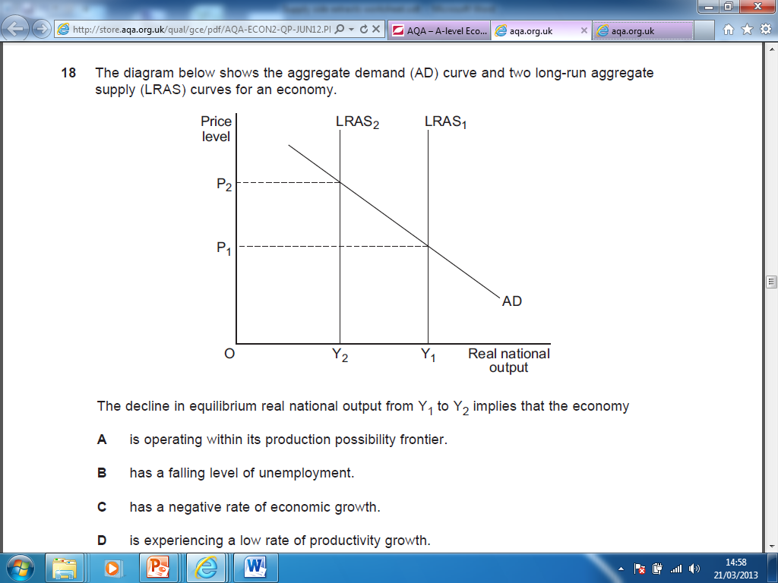

What are Supply side policies?
Supply side policies are usually defined as those policies designed to increase the economy’s productive capacity and hence shift the Long run aggregate supply curve to the right. When combined with policies to manage aggregate demand they provide an effective means for allowing governments to meet all of their macroeconomic objectives.
In reality, many of today’s improvements in the supply side of the economy arise from the private sector, rather than as a direct result of government policy.
Supply side policies are, for the most part, actually microeconomic policies, designed to improve the supply-side potential of an economy, make markets and industries operate more efficiently and thereby contribute to a faster rate of growth of real national output.

Supply side policies enable governments to achieve all the macro economic objectives at once!
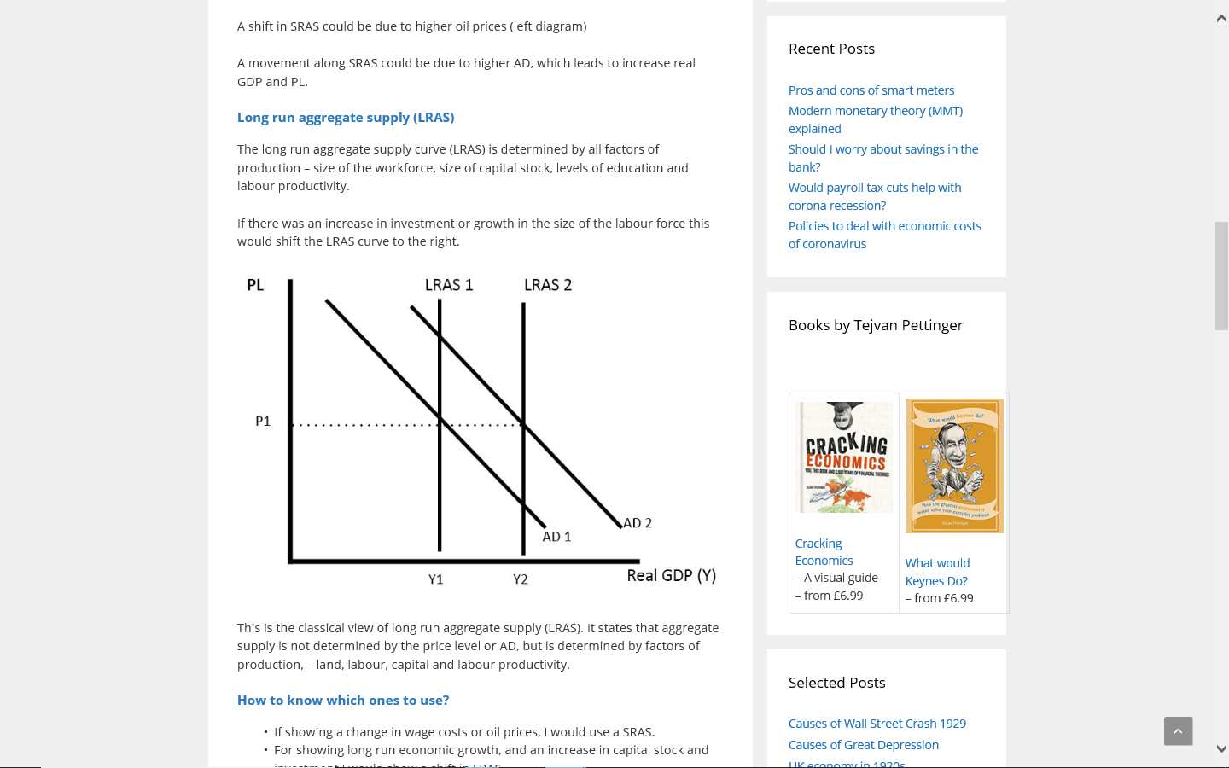

Macroeconomic objective | Effect of Supply-side policies
Low Inflation | The excess capacity caused by shifting the LRAS curve leads to falling prices. The falling prices lead to an increase in consumption in the economy, demonstrated by the extension along the AD curve
Low Unemployment | The excess capacity caused by shifting the LRAS curve leads to falling prices. The falling prices lead to an increase in consumption in the economy, demonstrated by the extension along the AD curve. As output increases more workers will be required.
Economic growth | The excess capacity caused by shifting the LRAS curve leads to falling prices. The falling prices lead to an increase in consumption in the economy, demonstrated by the extension along the AD curve. Firms increase output to match the increased demand.
Favourable current account position | The excess capacity caused by shifting the LRAS curve leads to falling prices. The falling prices lead to an improvement in the competitiveness of UK firms internationally. Exports increase as foreign buyers demand UK goods and UK consumers now prefer to buy UK goods rather than import goods. The current account moves towards surplus.
Supply side policies aim to increase the productive capacity of the economy. To do this they must increase the quantity or the quality of the factors of production with that economy.

Top tip

How to explain the effects of a Supply side policy? Sometimes students mistake an increase in aggregate supply caused by extending along a SRAS curve (for example caused by a shift right in Aggregate demand) as a supply side effect. It’s not. The explanation needs to focus on why the productive capacity of the economy has increased. Look at the explanation below:-

Explain how lowering income tax may be viewed as a supply-side policy:-
Incorrect explanation
“As income tax is lowered the amount of disposable income that workers have will increase. All things being equal this will lead to an increase in the amount of consumer spending. As consumer spending is a large proportion of Aggregate demand then an increase in consumer will increase the demand for goods and services. The increase in aggregate demand will result in a higher demand for goods and services and so therefore firms will be incentivised to increase their output. The resultant increase in Aggregate Supply means that lowering income tax is a supply side policy.


The explanation above is incorrect because it doesn’t explain the increase in productive capacity following a cut in income tax!! Instead the argument should have been made that:-
Reducing income tax: Reducing income tax will encourage more people to enter the workforce. This will increase the amount of labour in the economy. It will also increase productivity as workers will benefit more financially by working harder. Therefore reducing income tax has encouraged more people that were economically inactive (increasing the quantity of labour) into the labour market and will make those already in the labour market work harder (improving the quality of labour)



Labour market measures
Labour market measure | In the space below suggest a drawback(s) and a benefit(s)(other than the one highlighted in the adjacent box) of the Supply side policy being considered.
- Reducing income tax: Reducing income tax will encourage more people to enter the workforce. This will increase the amount of labour in the economy. It will also increase productivity as workers will benefit more financially by working harder. | (Hint: consider the effect on budget deficit, consider the effect on inflation, consider the positive and negative effects on the other macroeconomic objectives, consider the short run effect on AD)
- Cutting government spending on benefits (e.g JSA): This will encourage more people to enter the labour force thus increasing the size of the labour force. The effect will be to increase the productive potential of the economy | (Hint: Consider the impact on AD, consider the positive and negative effects on the other macroeconomic objectives, consider the short run effect on AD)
- Improving the training and of labour: offering tax concessions to firms on the money they spend on training their workforce. This will improve productivity. | (Hint: consider the impact on structural unemployment, consider the cost, consider how long it would take for this policy to work)

Labour market measures (Cont)
Labour market measure | In the space below suggest a drawback(s) and a benefit(s)(other than the one highlighted in the adjacent box) of the Supply side policy being considered.
Changing laws to reduce the power of trade unions  Removing trade unions legal protection, restricting their rights, and extending the freedom of workers not to belong to unions. This means that firms can more easily shed labour and use capital instead thereby increasing the output per worker (productivity) in the economy. | Negotiating with trade unions (ideally a single union) saves time and cost rather than dealing with all employees individually  It is also argued that trade unions protect their members by making it difficult for firms to introduce labour saving capital
Introducing short term contracts: Replacing jobs for life with short term labour contracts and introducing profit related and performance related pay will encourage labour to work harder thereby increasing productivity | (Hint: Could this policy have an effect on poverty and income equality? What effect might trade unions have on this policy)
Industrial policy measures
Industrial policy measures | In the space below suggest a drawback(s) and a benefit(s)(other than the one highlighted in the adjacent box) of the Supply side policy being considered.
Privatisation  The sale or transfer of assets such as nationalised industries from public sector to the private sector.  It is argued that firms in the private sector are much more efficient than public sector companies because they are subjected to intense competition from rivals. This forces them to lower their costs (becoming more productively efficient) and increase output. | (Hint: How might the government benefit from the sale? What might happen to employment levels in the privatised industry?)
Deregulation  The removal of previously imposed regulations in order to promote competition. Deregulation removes barriers to market entry encouraging more firms to enter the market increasing output in the industry. | (Hint: was deregulating the financial markets beneficial to the economy?)
Promoting entrepreneurship: Governments may provide subsidies or grants to entrepreneur in order to encourage business start-ups. Therefore increasing the capacity of the economy to produce goods and services
Promoting entrepreneurship: Governments may reduce the amount of taxes that start up business’ have to pay in their first few years. Therefore increasing the capacity of the economy to produce goods and services as there are more business start-ups.
Increased spending on infrastructure: This may have the effect of reducing the geographic immobility of labour and so therefore decrease structural unemployment. The additional worker in the labour force will mean there has been an increase in the country’s productive capacity. | (Hint: does this policy benefit the economy in the short run? How night this impact on the budget deficit
Although Supply-side policies ultimately increase the productive capacity of the economy some Supply-side policies can have an immediate impact on Aggregate Demand. These are known as Fiscal Supply-side policies

Task 1 – Decide which of the polices below is likely to cause a rightward shift in Aggregate demands
Supply-side Policy | Does this policy shift the AD curve to the left or right? or does it have a little effect on AD
Reducing income tax

Reducing unemployment benefits

Policies to increase the education and training of the workforce

Policies to reduce the powers of trade unions

Privatisation

Increased spending on infrastructure

Policies to promote entrepreneurial activity

Deregulation

Task 2: Without looking back at your notes can you explain how the following supply-side policies lead to an increase in the productive capacity of the economy (Remember an increase in the productive capacity of the economy is the same thing as shifting the LRAS curve to the right)
Hint: If you find yourself referring to an increase in Aggregate demand during your explanation it usually means you’re explanation is incorrect!!!
A reduction in income tax
……………………………………………………………………………………………………………………………………………………………
……………………………………………………………………………………………………………………………………………………………
……………………………………………………………………………………………………………………………………………………………
……………………………………………………………………………………………………………………………………………………………
……………………………………………………………………………………………………………………………………………………………
……………………………………………………………………………………………………………………………………………………………
Extension: Complete the rest of the explanations in Appendix 1

Plenary
1. Which one of the following is most likely to be an example of a supply-side policy?

A A reduction in the rate of interest to reduce inflation
B An increase in government expenditure on state pensions
C A reduction in company taxes to encourage greater investment
D A rise in the exchange rate to increase exports
2.
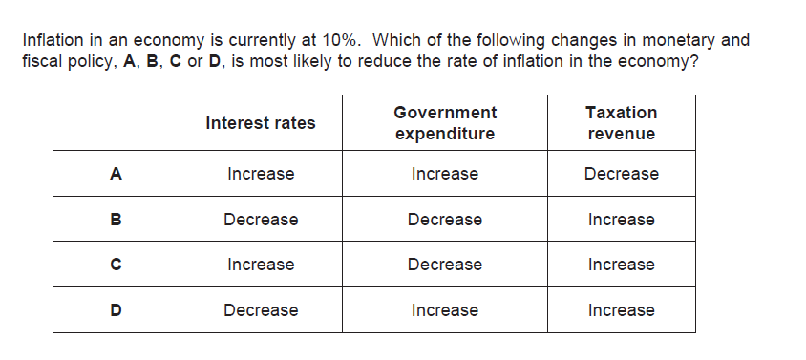

Appendix 1
Explain how the following measures might increase the productive capacity of the economy:-
Lowering unemployment benefits
……………………………………………………………………………………………………………………………………………………………
……………………………………………………………………………………………………………………………………………………………
……………………………………………………………………………………………………………………………………………………………
……………………………………………………………………………………………………………………………………………………………
……………………………………………………………………………………………………………………………………………………………
……………………………………………………………………………………………………………………………………………………………
……………………………………………………………………………………………………………………………………………………………
……………………………………………………………………………………………………………………………………………………………

Lowering Corporation Tax
……………………………………………………………………………………………………………………………………………………………
……………………………………………………………………………………………………………………………………………………………
……………………………………………………………………………………………………………………………………………………………
……………………………………………………………………………………………………………………………………………………………
……………………………………………………………………………………………………………………………………………………………
……………………………………………………………………………………………………………………………………………………………
……………………………………………………………………………………………………………………………………………………………
……………………………………………………………………………………………………………………………………………………………

Increased spending on infrastructure
……………………………………………………………………………………………………………………………………………………………
……………………………………………………………………………………………………………………………………………………………
……………………………………………………………………………………………………………………………………………………………
……………………………………………………………………………………………………………………………………………………………
……………………………………………………………………………………………………………………………………………………………
……………………………………………………………………………………………………………………………………………………………
……………………………………………………………………………………………………………………………………………………………
……………………………………………………………………………………………………………………………………………………………

Policies to improve the education and training of the workforce
……………………………………………………………………………………………………………………………………………………………
……………………………………………………………………………………………………………………………………………………………
……………………………………………………………………………………………………………………………………………………………
……………………………………………………………………………………………………………………………………………………………
……………………………………………………………………………………………………………………………………………………………
……………………………………………………………………………………………………………………………………………………………
……………………………………………………………………………………………………………………………………………………………
……………………………………………………………………………………………………………………………………………………………

Reducing trade union power
……………………………………………………………………………………………………………………………………………………………
……………………………………………………………………………………………………………………………………………………………
……………………………………………………………………………………………………………………………………………………………
……………………………………………………………………………………………………………………………………………………………
……………………………………………………………………………………………………………………………………………………………
……………………………………………………………………………………………………………………………………………………………
……………………………………………………………………………………………………………………………………………………………
……………………………………………………………………………………………………………………………………………………………

Privatisation
……………………………………………………………………………………………………………………………………………………………
……………………………………………………………………………………………………………………………………………………………
……………………………………………………………………………………………………………………………………………………………
……………………………………………………………………………………………………………………………………………………………
……………………………………………………………………………………………………………………………………………………………
……………………………………………………………………………………………………………………………………………………………
……………………………………………………………………………………………………………………………………………………………
……………………………………………………………………………………………………………………………………………………………

.

