ECONOMICS BENCHMARK 3 SUMMER TERM 2020

NAME: ………………………………..

MICRO MULTIPLE CHOICE QUESTIONS

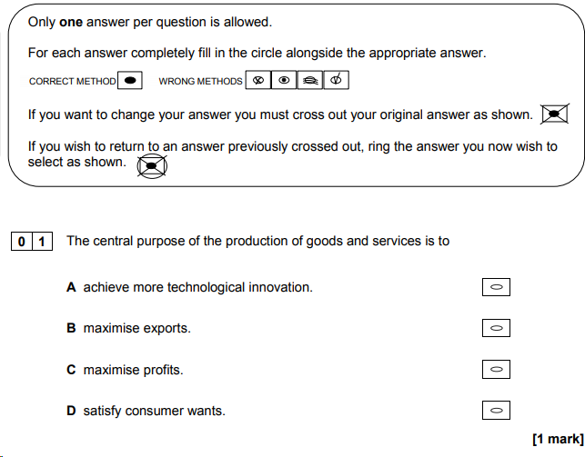
ANSWER:

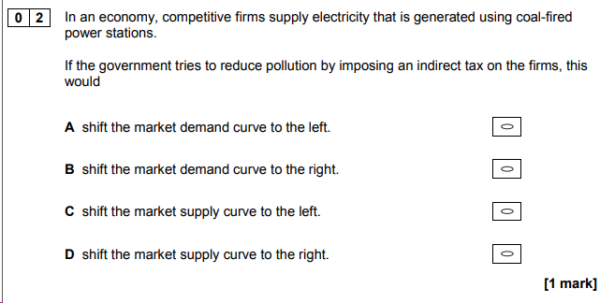
ANSWER:
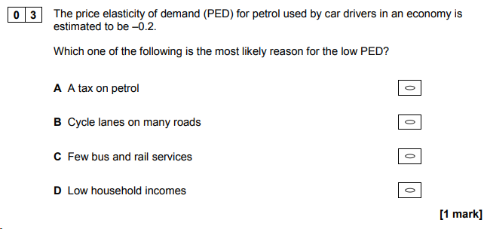
ANSWER:

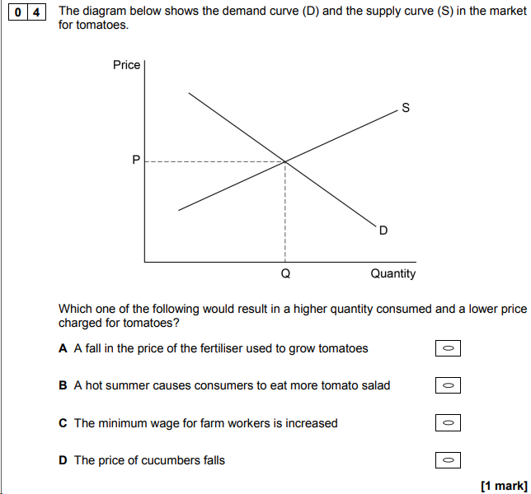
ANSWER:
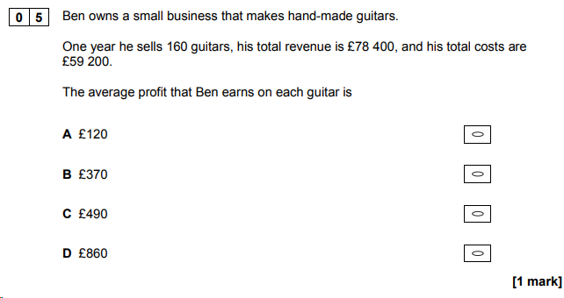
ANSWER:

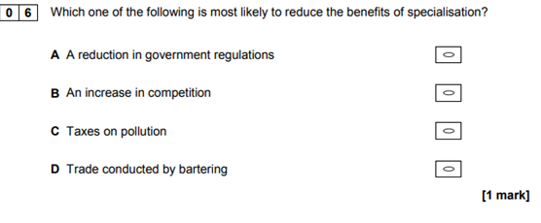
ANSWER:

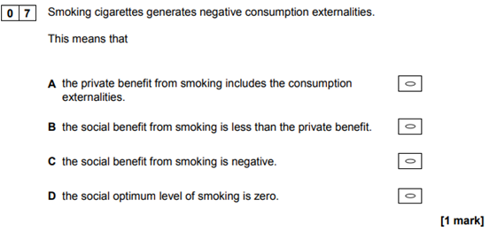
ANSWER:
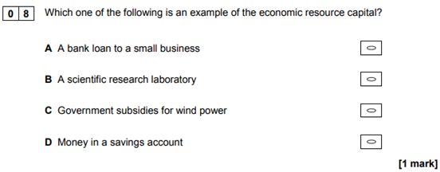
ANSWER:

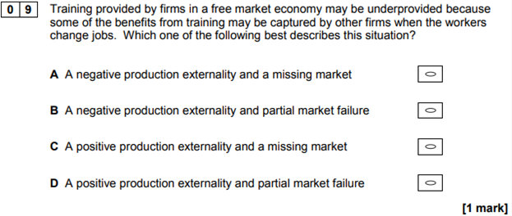
ANSWER:

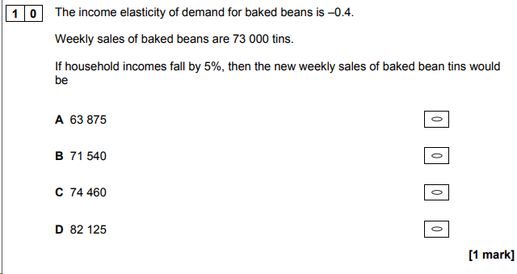

ANSWER:

MACRO MULTIPLE CHOICE QUESTIONS

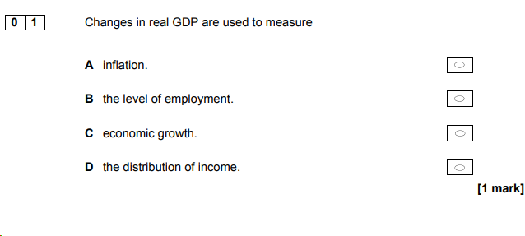
ANSWER:

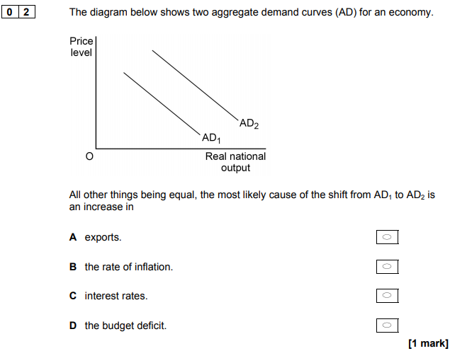
ANSWER:

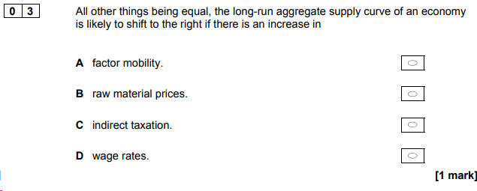
ANSWER:

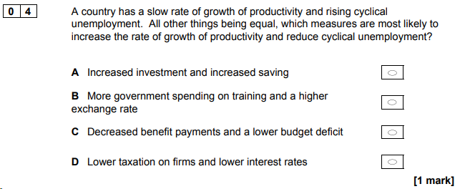
ANSWER:

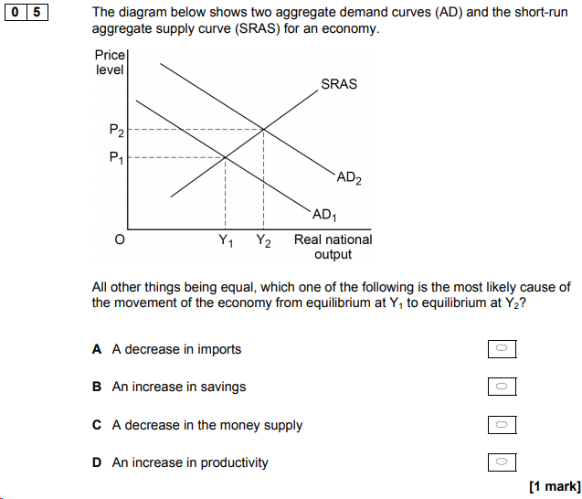

ANSWER:
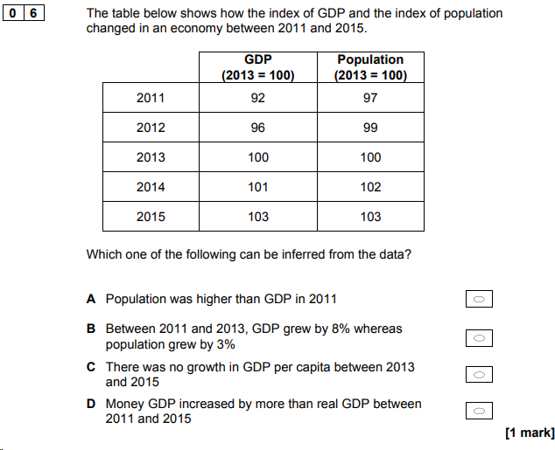
ANSWER:

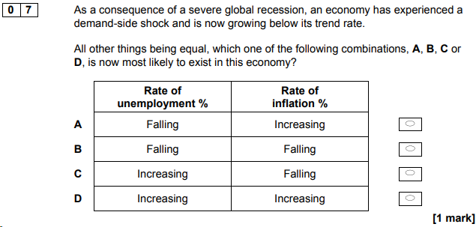
ANSWER:
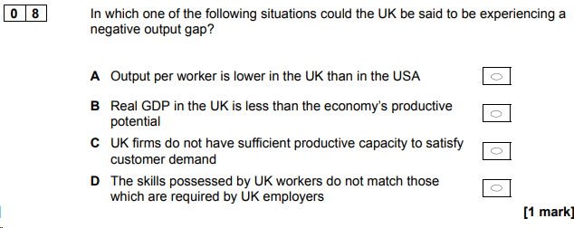
ANSWER:

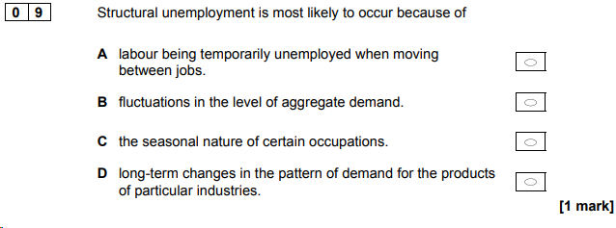
ANSWER:

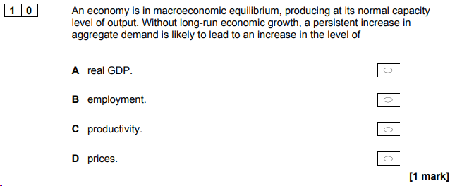
ANSWER:

Question 21:

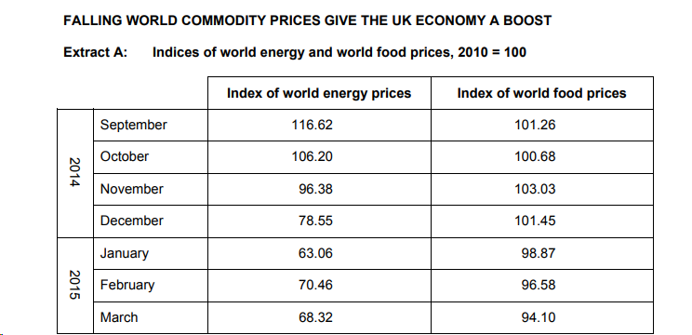

Use Extract A to calculate, to two decimal places, the percentage change in the
price of energy between September 2014 and March 2015.

Answer ……………………….
2 marks

Question 22:

Extract B: UK inflation at zero percent

The annual change in consumer prices was zero percent in March 2015. This is 1
the second month in a row that the cost of living is broadly the same as it was a
year earlier. Some economists are predicting that the CPI inflation rate will fall
further in the coming months. However, few believe that the UK is at risk of
suffering a period of sustained deflation as experienced by Japan during the 5
past 25 years. The weakness in global energy prices and food prices combined
with the recent appreciation in the pound sterling exchange rate help to explain
the recent fall in inflation in the UK. The recent price war between the
supermarkets has benefited consumers but it cannot be assumed that such
intense competition will be maintained. The price of petrol in the UK has 10
already started to increase again in response to the recent recovery in the
world market price of oil.

Extract B (lines 6 to 8) states ‘The weakness in global energy prices and food
prices combined with the recent appreciation in the pound sterling exchange rate
help to explain the recent fall in inflation in the UK.’

Explain why a rise in the pound sterling exchange rate is likely to affect the rate of inflation in the UK.

Students can use information and data from Extract A, B and C in their answer.
9 marks

Extract C: Low commodity prices are good for us… or are they?
Falling energy and food prices have benefited UK households, leading to a rise in 1
their real incomes. Average earnings growth remains low at around 2% but, with
inflation even lower, many people are now starting to feel better off. Rising real
incomes should help to boost consumer confidence, encouraging households to
spend more. Lower commodity prices have also been good for most businesses; 5
the average price that manufacturers are paying for raw materials and fuel has
fallen by 13% during the past year. However, not everyone benefits.
Firms involved in the extraction of oil and gas from the North Sea have been hit
hard by reduced revenues as a result of falling world oil and gas prices. Low or
non-existent inflation means that the Bank of England does not need to raise 10
interest rates for a while and some economists are predicting that, as long as
inflation remains below the government’s 2% target, the current expansionary
monetary policy will be maintained. This should help to sustain the growth in
business investment and in house building. Borrowers will benefit but savers
will lose out once again. Low commodity prices will affect the UK balance of 15
payments on current account which was close to a record deficit of nearly 6%
of nominal GDP in 2014. Whilst the amount spent on importing energy and
raw materials is likely to fall, the effect on the competitiveness of UK
manufacturing is less certain. The impact on the markets in which we sell
our exports is also hard to predict. 20

Answer…………

Total Marks 31

End of Benchmark

