RWS Exemplar: Capitalism, Socialism and Economics

INTRODUCTION: to the concepts
Resources: these are materials (human or physical) which are used to create or produce a product. Two broad classifications are Labour (human resources such as management, workers etc.) and Capital (physical resources which are man made or naturally occurring). | Assumptions: In microeconomics, two assumptions are made about the society we live in. Citizens in the society are assumed to have unlimited wants. They want everything now and there is no limit to how much stuff they would like. The second assumption states that resources in the world/society are limited. There is only so much wood, oil, labour etc.

Economic Problem: This causes a problem! Unlimited wants but scarce resources means that not everyone will get what they want and the problem to be solved is how do we distribute resources efficiently. In other words who gets the resources to ensure no waste and provide everybody with as much as is possible given our limited resources. It’s the best we can do as a society.  Solutions: Two possible ways of fixing this problem and distributing resources to the production of goods.  - “Capitalism”: One is through the market system where consumers and firms interact, agree on a price so that the consumer is able to afford the product and the firm can make a profit. In this way the consumer (in other words society) is voting for what it wants. The private firm distributes scarce resources.  - “Socialism”: The other method is the Government determining what needs to be produced. If they are democratically elected then arguably they are performing a function for society. The Government distributes scarce resources | 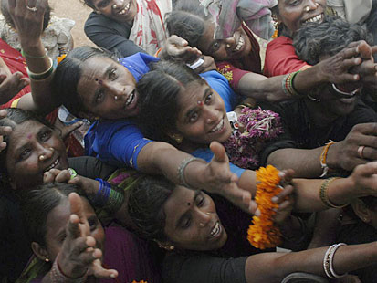

Capitalism .v. Socialism: The Cold War 1945-1990
Capitalism and Socialism are polar opposites in that Governments are heavily involved in the production process of economies with a socialist outlook as opposed to the Capitalist system of free markets etc. From 1945 until 1990, there was a clash of ideologies in the world with the two biggest superpowers, the USA and the USSR (Russia today) adopting different strategies.  In the USA you had an economic Capitalist system based upon the profit motive and the role of the entrepreneur whereas in the USSR you had an economic system of Socialism (under the guise of Communism). In the USSR, production was handled exclusively by the state in a series of 5-10 year plans whereas in the USA, production was solely in the hands of firms from healthcare to record players. | 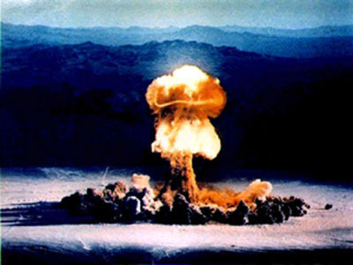 | There were socialist elements in the USA. Dam’s and schools were built by the state as the private firms would not make an immediate profit on them. The US Military is run by the Government as well for example. In the USSR, because of shortages you increasingly had black markets forming where free market trading would take place behind closed doors.  However in 1990, the Socialist economic system seemed to come to an end with the collapse of the USSR and their adoption of free market policies. Initially there were huge adverse effects with the life expectancy of the average Russian falling dramatically during the 1990’s. High inflation meant Russia lost the value of ti’s money and was unable to pay its external debts. In the late 1990’s it defaulted on all it’s debts and went through a period of decline. However this changed in 2000 and Vladmir Putin, the new President of Russia brought his country out of the hole they were in and now Russia is fast emerging as one of the BRIC countries in the world.

CAPITALISM AT WORK: The Free Market – how does it work?
The free market is free from Government intervention (or intervention is very minimal). It consists of consumers (buyers) and firms (sellers) interacting to agree a price (haggling). The price at which a product is sold will be acceptable to the consumer but will also mean the firm is making a profit. In this way there is no waste because consumers (society) are getting what they want and firms are producing it.

An example might be a powerpoint projector in a class or the shoes I am wearing right now. The reasons the projector is there is because the teacher wishes to enhance the learning of all students and therefore places a value on the powerpoint. The price they are willing to pay means a projector producing firm, might be able to make profit on such a production method. The result is the teacher wants the projector because there is value to them and the firm wishes to make the projector because there is the opportunity for profit. Profit is the big driver of the Capitalist system, as are entrepreneurs who have an incentive to tap into new markets and produce new products to meet the demands of the consumer. | 

Why is the Capitalist System not perfect?

PRODUCTION OF “BADS”  Alcohol and Obesity |  | INEQUALITY  In the USA |  | EXTERNAL COSTS TO SOCIETY  The BP Oil Spill |  | POWER OF GLOBAL BIG BUSINESS  Drugs companies and developing countries
 | Leading to too much or too little production (or maybe no production) – in other words markets can be inefficient! |  | It’s a dog eat dog world out there! If someone gets something it might be at the expense of another. Markets breed winners and losers | 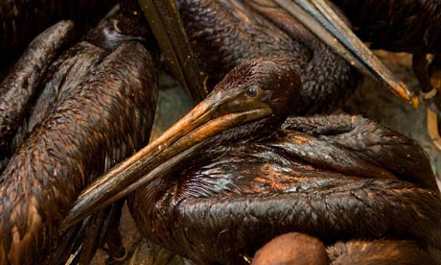 | What if the firm earns profit at whatever cost? Think about firms polluting seas etc at the expense of money | 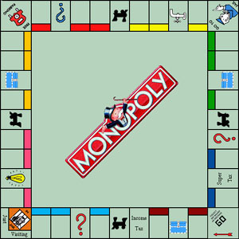 | What if the firm is king? Certain firms dominate markets and destroy all competition – where does this leave the consumer, especially if they are poor?
ALCOHOL: Alcohol is arguably overproduced by the market. People today have little information about the possible consequences of binge drinking in the future. The only information available to them is the idea that they are about to have a good time (in the short run). Therefore the consumer is overconsuming alcohol, is willing to pay a higher price and therefore a firm is able make profits  OBESITY: The production of highly saturated fatty foods which can be addictive are arguably exploited by food companies. They produce these foods because consumers want them but the wider costs to society are much greater in the long run  HOWEVER is this fair to these companies? |  | Winners and Losers  The top 1% of households own 95% of the wealth in the USA. Globally more than half the worlds population live on less than $2 a day while the richest 225 people in the world have a combined wealth of over $1 trillion; equal to the annual income of the poorest 47%. This is unprecedented inequality!  The market system means that there are winners and losers. The more the winners win, the more powerful they become and thus keep the losers in their place.  In many Western societies the promise of the “American Dream” has kep t many in their place. The poor look at the rich and think they could be up there one day and so do not make a fuss. Maybe this is changing with the Financial Crisis 2010?  Profit is where the capitalist gets more out of the workser’s labour than the wages paid to them. If this is excessive, then problems arise in our society. Is it right that someone should have 5 houses when someone else has none? |  | BP Oil Spill  In April 2010, the Deepwater Horizon oil rig exploded and has subsequently led to one of the biggest oil slicks in history and the largest ecological disaster for the US.  Effects have been a loss of jobs and industry (especially in the Tourism, Shrimp and Oyster business). Increased poverty is certain as workers’s skills are no longer needed.  Maybe demonstrates how little control we have over “Mother Nature” and Capitalism cannot tame natural forces. BP have been accused of taking shortcuts in terms of health and safety at the expense of greater profits.  Over three years the top oil companies said they had spent $39 billion to explore for new oil and gas. Yet the average investment in research and development for safety was only $20 million a year!  However are we as consumers to blame for BP’s push for riskier methods of extracting oil? Our unending thirst for oil based projects potentially drove BP to take more risks.  Also is Capitalism to the rescue with Kevin Costner and his scientific brother? A company has fulfilled a need for oil skimming by producing technology to achieve this. |  | “Big Pharma” and the Drugs Industry  The pharmaceuticals industry is a powerful economic force with the top 10 companies making a single firm called “Big Pharma”. Big Pharma’s annual sales of US$256 billion, came to more than the GNP of all the countries in sub Saharan Africa, excluding South Africa – some say this profit is too much.  Pharmaceutical companies claim that the patents and higher profits are needed to fund research and development which could not be done by smaller firms due to the risks involved. However out of those sales, an astounding 35 per cent is ploughed back into marketing, nearly twice what is spent on R+D  The African continent is not really a market for Big Pharma as people do not earn enough income to buy the drugs. Therefore Big Pharma does not supply them as they are unable to make a profit. Yet people in LEDC’s are more susceptible to disease and therefore needs are not being met by the market in order to earn greater profits.  Is the pace and extent of these profits to large? Companies should have the right to make profit but if this at the expense of peoples health and possible death, is it right?

To what extent has capitalism been a success?
Success! | Failure!
Economic development – significant economic growth in Western nations which adopt Capitalist approaches. This has led to an increase in industry and job opportunity. | Economic development? – roads, dams and large infrastructure would not be built if it was not for Government intervention. The lack of profit on these goods prevents firms from producing them even though society wants them.
Social development – Increased standard of living and reductions in poverty. Look at the likes of China with their strong Economic growth. In 1820 85% of the world’s population lived on the equivalent of less than a dollar per day. By 1950, this had fallen to 50% and today it is 20%. Poverty has fallen more in the last 50 years than it did in the previous 500! Also consumerism could be good – who is arguing that having the computer, internet and cheap flights abroad is not developing? | Social development? – inequality is a huge issue with Capitalism. Capitalism tends to lead to the greedy wanting more and becoming more powerful to prevent the poor from empowering themselves. Unequal societies tend to fall to ruin and are not examples of development. Also it leads to consumerism – this leads to unhappinesss
Sexy and fun? Capitalism suffers unjustly because it does not have the sex appeal of some of its alternatives such as socialism. Capitalism delivesr but does not inspire. Socialism inspires but does not deliver. Socialism and Environmentalism claim to be infallible. | There cannot be a coincidence that people feel there should be a more just society. Socialism and environmentalism might be popularist notions but for good reason!
Morality? Capitalism is only immoral if people get too greedy but the ability to provide what people want and give them the economic freedom to pursue their interests is surely a positive process? | Morality? Capitalism is immoral as the pursuit of profit is often at the expense of everything else around. Capitalism leads to greed and greed is immoral.
Conclusion
No socioeconomic system can guarantee people a good life. All we can reasonably hope for is that conditions will enable us to pursuer a worthwhile and happy life. We cannot be happy all the time and need to deal with the times when we are feeling down, low, worthless etc. Capitalism has provided our societies with opportunity and for this we should be grateful. The ugly side of Capitalism is the growth of unhappiness, consumerism and the pursuit of profits no matter what the cost. I think this can be exemplified by greed. A Capitalist system is a sound one as long as people do not get too greedy. Unfortunately for the Capitalist system, this is exactly the kind of people it tends to generate. An easy solution would be to have a mixture – socialism and capitalism do not have to be mutually exclusive but rather can live alongside each other to provide us with the production we need as a society to function

