**Economic and Political Ideologies of Development**

**Economic and Social** – who decides what is produced (horizontal axis) **Political** – who holds the power (vertical axis)

**The Ideology Grid**

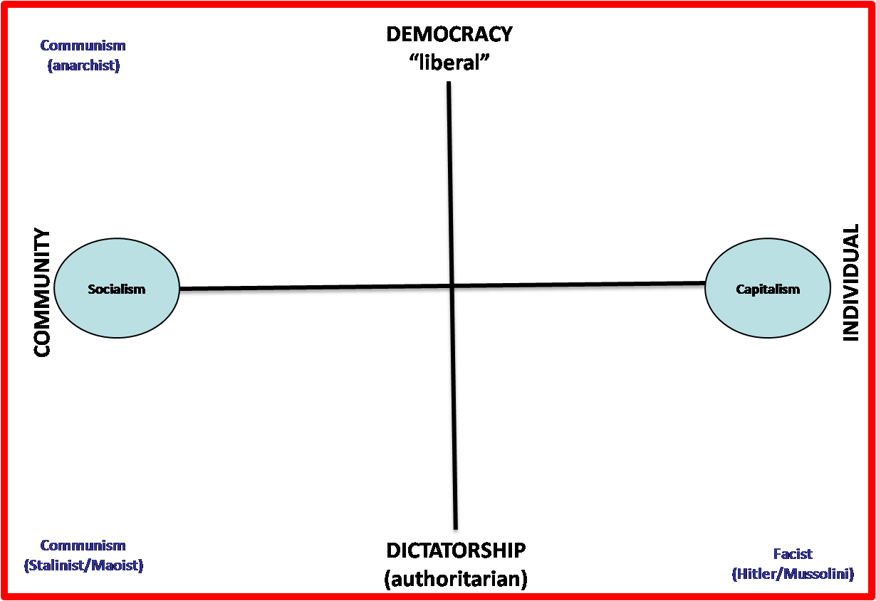

**PLEASE NOTE: This is just one interpretation of how to classify these terms. There is no black and white framework and there maybe examples outside of these parameters.**

**Capitalism** is an economic system where the means of production are privately owned and pursued because of profit. There is only a minimal role for the government in a capitalist society and it can be to establish property rights to enable private ownership. Communists and anarchists famously oppose capitalism as they say it leads to an economic inequality within a society as the rich have access to the power. Other opponents accuse capitalist systems of production of leading to greater costs to the environment etc.

**Socialism** is the opposite economic system where instead of production of goods and services being privately owned and pursued for profit, it is produced by the Government.

According to one of the original theorists, Karl Marx, **Communist theory** generally states that the only way to solve the problems existing within capitalism is for the working class, referred to alternatively as 'the proletariat', who collectively constitute the main producer of wealth in society, and who are perpetually exploited and marginalised by the capitalist class (“the bourgeoisie”), to overthrow the capitalist system in a wide-ranging (sometimes bloody) revolution.

**Communism** is an economic and political extreme where there is no Government or inequality in society. In its purest form, Communism is quite an anarchistic system where there is no state and everyone one is equal - economic production and political decisions are in the hands of the community. However over the years, many different forms of Communism have appeared and some now say the Communist ideal is to just replace the ruling class in Government with workers and to leave all power in the hands of the state (Lenin). Arguably the original philosopher associated with Communism, Karl Marx, deliberately did not specify how societies would organise themselves after “the revolution” to allow for differences in human behaviour and circumstance.

Some myths of communism:

* Communism is often used interchangeably with socialism but socialism is a transitional stage on the road to communism from the “evils and inequality” of Capitalism.
* Communism is often described as hypocritical because there is a leading party who clearly have more economic and political power than the workers – therefore unequal. This refers to the Russian leader Lenin’s take on Communism. He said that a “vanguard party” would make the decisions in the name of the workers. In other words a centralised Government where economic and political power would lie to increase equality.

**Dictatorships** are an authoritarian rule where one person claims power for themselves due to a superior military background or by inheritance. It is a form of absolute rule where the person in charge has ultimate power. **Democracy** can apply to socialist, communist and capitalist societies. Critics of democracy in capitalist societies might cite the wealthy as having the only political power and therefore maybe they are “dictatorships” of sorts?