BASIC DEMAND AND SUPPLY PRACTICE

**TASK 1: Complete the following exercises on a separate piece of paper for changes to demand curves ONLY (so just draw a demand curve)**

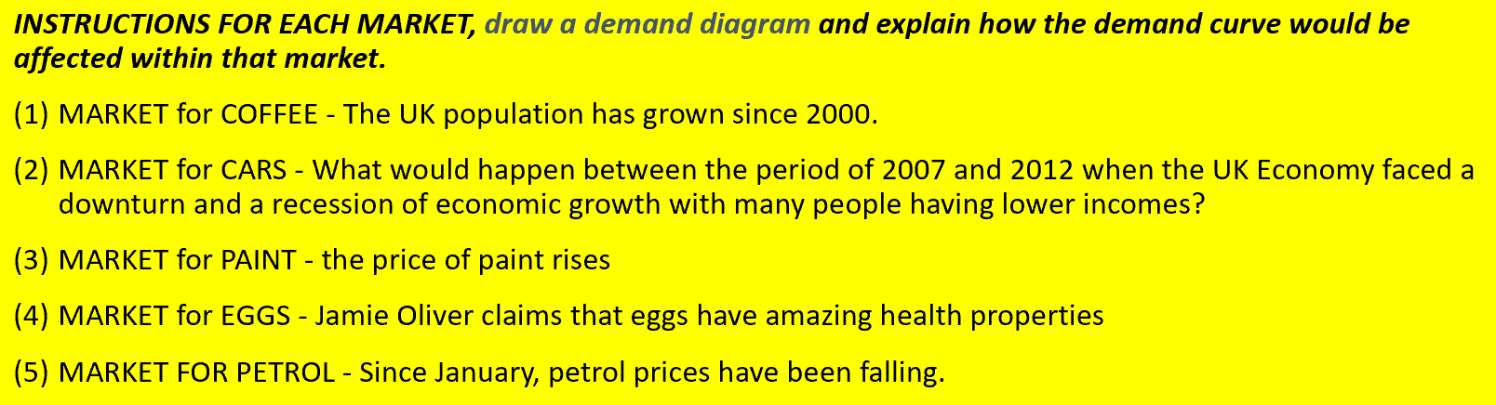

**TASK 2: Complete the following exercises on a separate piece of paper for changes to supply curves ONLY (so just draw a supply curve)**

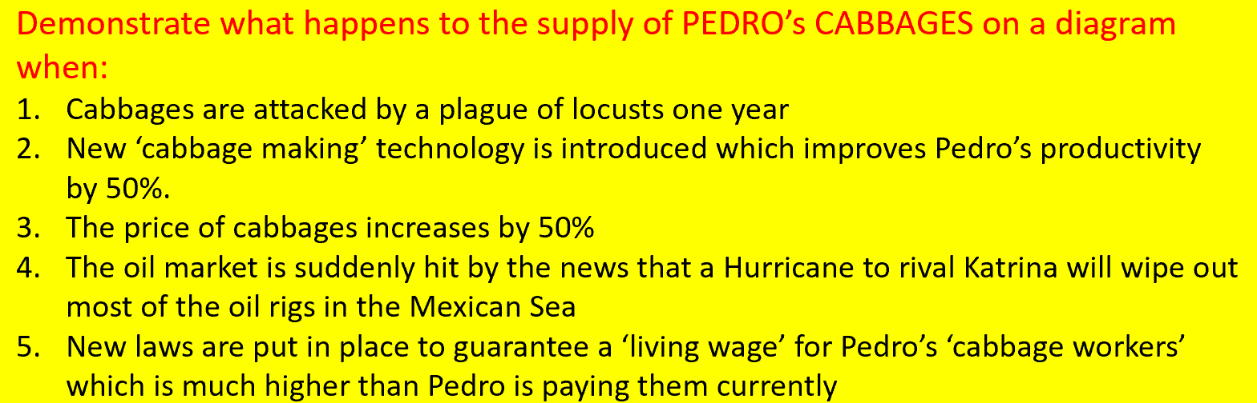

**TASK 3: Complete the following exercises on a separate piece of paper using DEMAND and SUPPLY curves TOGETHER (so ensure you have both demand and supply curve with an equilibrium in the diagram). Only attempt Task 3 when you have done your reading on Equilibrium and Disequilibrium**

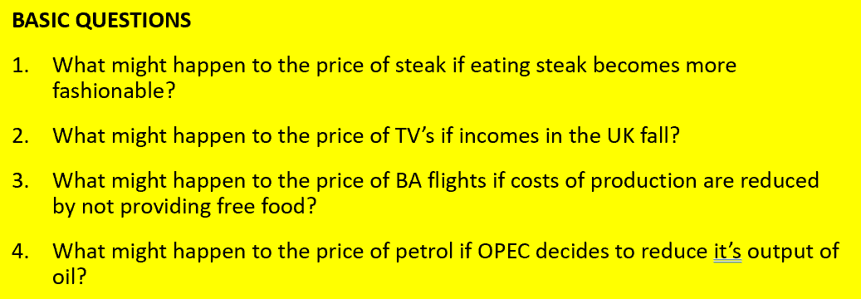

**FINAL NOTE:**

SOME OF THESE QUESTIONS ARE HARD ESPECIALLY TASK 3 AND YOU ARE TAKING A LEAP IN THE DARK WITH WHAT YOU KNOW ALREADY SO JUST HAVE A GO AND DO NOT WORRY IF YOU GET IT WRONG…WE WILL ASSESS IN CLASS HOW YOU HAVE DONE.