FOOD & AGRICULTURAL MARKET RESOURCE PACK

DATA

|  |  |  |
| --- | --- | --- |
| Source: WIKIPEDIA | | SOURCE: GUARDIAN |
|  | **BBC WEBSITE – September 2015** | |
|  |

Sectors of the Food Industry

**Primary**

Farmers! Globally (we import a lot of food from abroad) and food we make within the UK are both big issues. The CAP (Common Agricultural Policy) has a role to play in the provision of our food in the UK and is an intervention into the market from the EU (European Union) A big debate at the moment in the UK is between ‘Agribusiness’ and ‘small holdings’.

**Secondary**

Manufacturers of food tend to be very large Multi-national corporations (MNC’s) who operate and sell in many different countries…the graphic below gives you some idea of the scale of them.

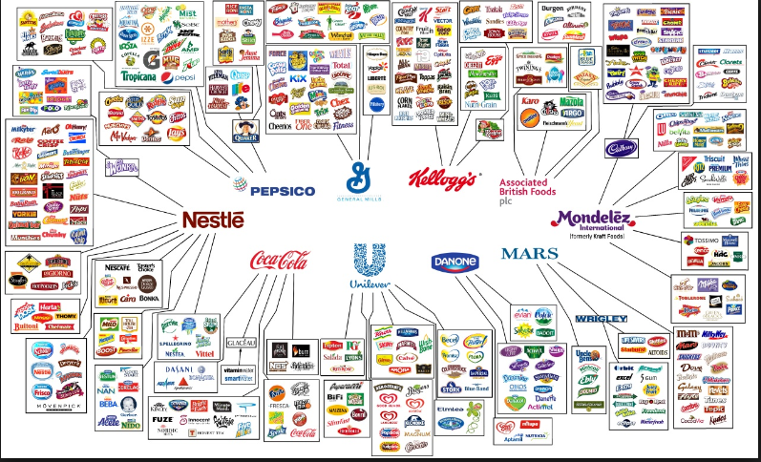

**Tertiary**

In this country, the main suppliers of food stuffs is via supermarkets…the ‘big 4’ (Sainsbury’s, Morrisons, Asda and Tesco) have recently had their dominance threatened by smaller companies (Marks and Spencer, Waitrose, Lidl and Aldi). Their stranglehold on the retail market for food as therefore been diminished and there is much greater competition in these areas.

The most notable fall has been with Tesco’s who have suffered large profit warnings and had their share price tumble in recent years.

However it was not always like this and back in 2008, the big 4 supermarkets were referred to the Competition and Markets Authority (CMA) for accusations of price fixing (i.e. colluding to push prices up) for milk. Several supermarkets were fined as a result.