HOUSING MARKET RESOURCE PACK

Data

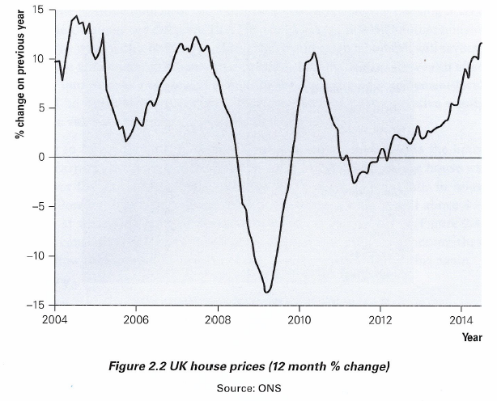
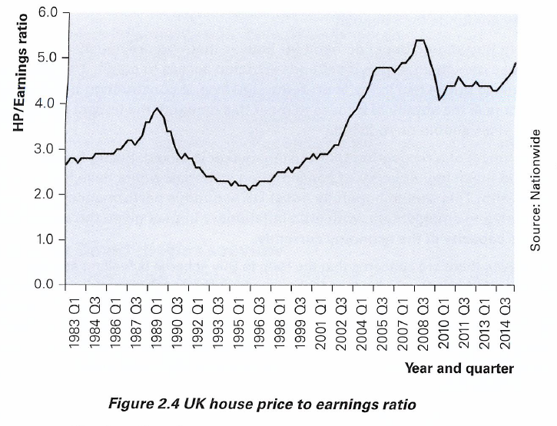
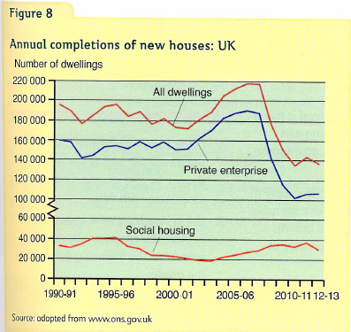 | 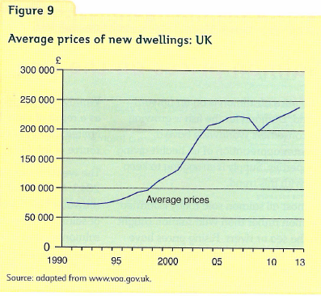 | 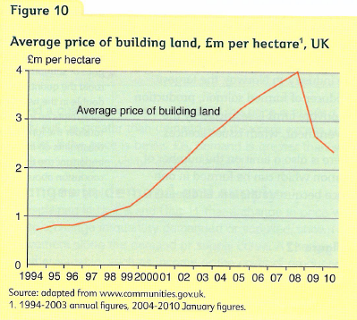

DEMAND: How do CONSUMERS GET TO live in a house/FLAT?
Several options are available to people wanting to live in a property:

RENTING

FROM PRIVATE LANDLORDS…private landlords own properties and then rent them out to individuals (tenants) on a 6 month, annual or 2 year contract. The tenant then pays monthly rent to the landlord who should make a profit on the renting of houses. Many people in the UK today ‘Buy to Let’. This means they have excess cash which they use to buy a house for the purposes of letting or renting the property. Some people make a business out of this and have over 70 properties that they rent out – it’s like a full-time job! Clearly ‘Buy to Let’ landlords are controversial as they are blamed for pushing up the price of houses for people who want to buy (especially ‘first time buyers’)

FROM COUNCIL OR HOUSING ASSOCIATION…Sometimes, this is called ‘Social Housing’. The local housing association has a group of houses which they will rent out, normally out a discount rates to people who have lower incomes. In the UK, it is argued that there are not enough of these houses and as a result long waiting lists for Council houses can occur.

BUYING
The average house price in the UK is £272,000! Most people do not have this money available to them when they first buy a property. They often need to put down a deposit (or downpayment) and then speak to a bank about taking out a loan (often called a mortgage). Many people in the UK opt to buy their own house (which is quite a different set of tastes to say Germany where the majority of people rent). This is because in the UK, ‘bricks and mortar’ is seen as a sound investment throughout your lifetime. Also owners can do anything they want to with the house unlike renting (as long as it complies with the local authority planning and building regulations!).

SECOND HAND HOUSES: The majority of houses that are bought and sold are through owners selling their existing property (making it available for market) and thus wanting to buy another property. This could be for a variety of reasons: they might be relocating for a new job, or want a bigger place or maybe they just do not like the neighbours! Buyers of second hand houses often employ ‘estate agents’ to find them a new home. Equally the ‘Estate Agent’ has an important role in selling their property too. Local authorities (Councils) also have a role in this market by having schemes to help people to buy their houses.

NEW BUILDS: These are houses that have just been built that no one has lived in before. They tend to be built by ‘Building Developers’…these tend to be large companies (like Wilmott Dixon) who build estates and groups of houses. Occasionally there maybe individuals who build houses on a plot of land.

The Importance of the Interest Rate
Every month, the Bank of England set interest rates which determine the cost of borrowing. Therefore the owners of houses tend to be very interested in this as the majority of them will have a mortgage or loan with the bank. If interest rates increase, often households will then need to pay more on their mortgages and this will mean less money is available to spend on other items which can affect the Economy.

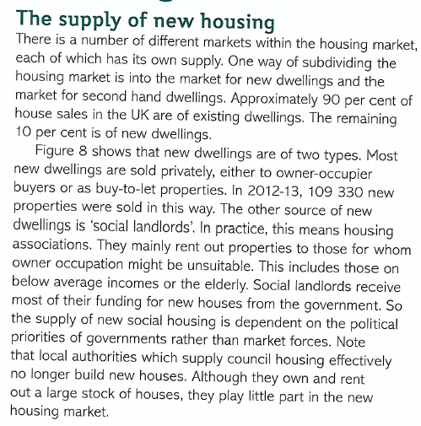  The Help to Buy Scheme from the Government  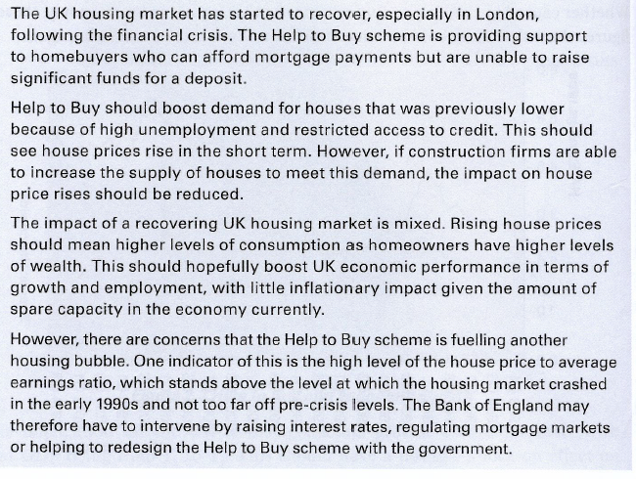 | 