**Calculating Elasticity Data WORKSHEET**

As well as being able to explain the concepts of PED, PES, YED and XED and draw diagrams to demonstrate PED and PES, you also need to be able to calculate elasticity scores and interpret them. Unfortunately, this does involve Maths but it is relatively simple.

**INTERPRETING ELASTICITY DATA**

The graphic below gives you a summary of how to interpret elasticity. Depending on the elasticity, the data can be positive or negative but not always. The number can be between 0 and infinity!

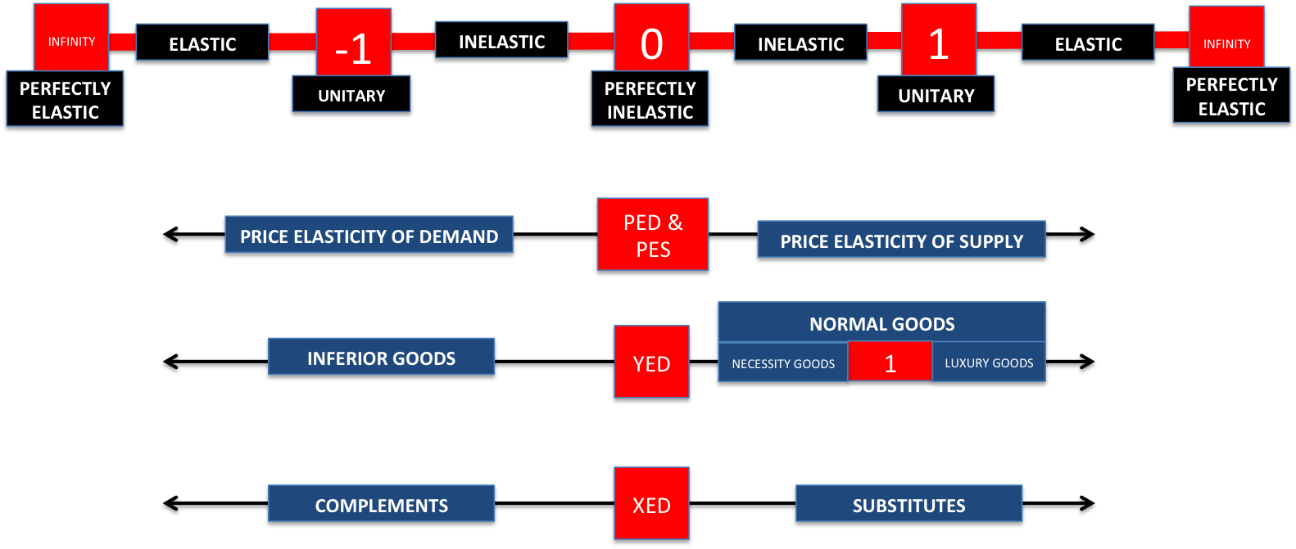

**Exercise example below:**

|  |
| --- |
| A statistician works out that the price elasticity of demand for cigarettes is -0.2 and the income elasticity for cigarettes is 0.5. This suggests that the PED of cigarettes is inelastic. This is probably because cigarettes are addictive and so even if the price rises, consumers will forego other consumption to ensure they can buy cigarettes.  Equally, the YED suggests that cigarettes are normal goods and ‘necessities’. So as incomes rise, the demand for cigarettes does increase but not by very much. If a smoker is smoking 20 cigarettes a day, just because their incomes rise, does not necessarily mean that their cigarette demand (or consumption) will increase hugely. |

**EXERCISE: Try to complete the following –**

TASK1: Why would you class Waitrose essential baked beans (as opposed to Heinz baked beans) as an inferior good and what YED data score would you give?

|  |
| --- |
|  |

TASK 2: Given that it is very hard to increase housing stock in a short space of time, what data score for price elasticity of supply would you give to the housing market? Justify your answer (bullet points are fine)

|  |
| --- |
|  |

TASK 3: Which of the following goods will have a negative cross-price elasticity of demand (XED)?

A. Pepsi and Coca-Cola B. Blu-Ray Discs and a Blu-Ray Player C. Chocolate and beef D. Cable and satellite television

TASK 4: Look at the matrix below of 2008 data on oranges and apples and comment on the PED and XED of both these goods

|  |  |
| --- | --- |
|  |  |

**CALCULATING ELASTICITY DATA**

Elasticity measures the “proportional” response of one variable (say price, income or the price of another good) on another (demand or supply). To calculate elasticity you will therefore need percentages (this is what proportionate means). When you first started studying price equilibrium changes you assumed that say a fall in price of 10% would lead to an increase in quantity by 10% say. In other words, the response was unitary or directly proportionate or proportional.

However, now, to make the price toolkit more realistic you know that because of certain conditions in the market, it could be that this relationship between two variables might be more or less responsive (or elastic) than assuming it will be proportionate. This will mean for example that a price change might have very little effect on the quantity demand for example (so very inelastic).

To calculate the elasticity data score, there is a common way to remember the calculation. A summary of each of the elasticity concepts is below:

|  |  |  |  |
| --- | --- | --- | --- |
| **Price Elasticity of Demand** | **Income Elasticity of Demand** | **Cross Price Elasticity of Demand** | **Price Elasticity of Supply** |
|  |  |  |  |

|  |  |
| --- | --- |
| TASK: Can you see any similarity between the equations above and therefore an easy way to remember them??? | **BASIC MATHS REMINDER = dividing and multiplying with negative numbers. Simple rule of thumb to remember this? If you are dividing or multiplying positive and negative numbers than the following applies:**   1. **+ and + = +** 2. **+ and - = -** 3. **- and + = -** 4. **- and - = +** |

Exercise Example Below: Good A has seen its price increase from 10p to 14p and demand has fallen from 100,000 to 20,000

|  |  |  |
| --- | --- | --- |
| STAGE 1:  Percentage change in quantity demanded is: [(20,000 – 100,000) / 100,000] x 100 = - 80% | STAGE 2:  Percentage change in price is: [(14p – 10p) / 10p] x 100 = 40% | STAGE 3:  PED therefore equals: -80% / 40% = - 2.0 |

**Complete the exercises below**

TASK 1: Using the data below compare the elasticity of these two goods and try to explain why the elasticity is the way it is

|  |  |  |  |  |
| --- | --- | --- | --- | --- |
|  | **Price (Yr 1)** | **Price (Yr 2)** | **Quantity Demanded (Yr 1)** | **Quantity Demanded (Yr 2)** |
| **Cigarettes** | £5.50 | £6.50 | 5 million | 4.5 million |
| **Chinese Takeaway** | £20 | £35 | 200,000 | 25,000 |

Working out?

TASK 2: If we assume income in the UK has **fallen by 5%** and the result for these four goods is below, complete the table

|  |  |  |  |  |
| --- | --- | --- | --- | --- |
| **Good** | **Change in QD** | **Calculate YED** | **Normal or Inferior** | **Inelastic or Elastic? Try to explain why it might be inelastic or elastic?** |
| **Foreign holidays** | **-17.5%** |  |  |  |
| **Clothes** | **-3%** |  |  |  |
| **All foodstuffs** | **-1%** |  |  |  |
| **Basic foodstuffs** | **+2.5%** |  |  |  |

TASK 3: A band sold 230,000 albums in a week for their new album. In order to increase demand they reduced their price by 20%. Given that it is known that the price elasticity of demand for their new album is -1.75, how many albums will they sell at the new lower price?

A. 80,500 B. 276,000 C. 310,500 D. 402,500

TASK 4: A sporting retailer knows that if they put the price of their tennis rackets down from £50 to £45 the weekly sales of tennis balls will increase from 125 tubes to 140 tubes.

Using this information, which of the following is the best estimate the cross-price elasticity of demand (XED) for tennis rackets and tennis balls:

A. +0.33 B. -0.33 C. -0.83 D. -1.2

TASK 5: Which of the following best describes price inelastic supply?

A. Price elasticity of supply is negative B. A 10% rise in price, would lead to a 10% increase in quantity supplied

C. The supply curve is horizontal D. Quantity supplied responds less than proportionately to a change in price