PREP2: RESEARCH PROJECTS FOR BOTH MICRO AND MACRO RWS 5

VERY IMPORTANT INSTRUCTIONS TO READ:
I have split you into groups below temporarily to work with each other in the first week back in January. Your task is to complete 1 A4 side of research notes on the area I have allocated for you for both MICRO and MACRO research examples of Government Intervention (either example 1,2,3 or 4). Your side of notes for the Micro topic and Macro topic should follow the exemplars on ‘taxation’ (MICRO) and ‘Trade Balance’ (MACRO).

For each research A4 summary for your specific Microeconomics research should be 2.25-3 hours of homework and 60 minutes of class time, equalling 3.25 to 4 hours of research and write up (max 1 side of A4) for each of your two research areas. In total therefore, homework should be 4.5 to 6 hours plus 2 hours of class time = 6.5 to 8.5 hours in total.

Therefore the 2xA4 summaries of research you produce must be of excellent quality as you have time to research fully the areas. NO MORE THAN 1 SIDE OF A4. Your efforts MUST be word processed, you should aim for font 10 to 11 and feel free to include diagrams (handdrawn or copied from internet sources).

Deadline is Monday 13th January 2019 and you need to bring enough copies of your research side of A4 for both Micro and MAcro printed out separately (not on the same piece of paper) to dish out to your group. No printing or copying is allowed on that Monday. You must have it prepared for the lesson and ready to distribute at 1445. Everyone should have a research sheet for MICRO and MACRO

Any questions, you MUST email me on ods@godalming.ac.uk to clarify anything above which does not make sense. Please be aware that this document is available electronically on GOL under PREP 2 so you are able to click on the links below.

GROUP 1 | GROUP 2 | GROUP 3 | GROUP 4
- Ollie  - Jessica  - Archie  - Seb | - Sofie  - Sam  - Ben  - Josh | - Miles  - Jon  - Ed  - Blake  - Neil | - Finn  - Miffy  - Lois  - Oscar

PLEASE DO NOT JUST COPY AND PASTE TEXT (although diagrams are OK). READ THE MATERIAL, TRY TO MAKE SENSE OF IT AND THEN WRITE IT IN YOUR OWN WORDS.

GUIDANCE FOR RESEARCH TOPICS for MICRO and MACRO

MACRO PREP WORK
Each of the key areas should be a sub-heading on your A4 summary poster

AD and AS Determinants | KEY AREAS (and SUB-HEADINGS) TO CONSIDER FOR YOUR A4 SUMMARY | KEY RESOURCES TO LOOK AT (You must read and watch the following at the very least)
ODS: Aggregate Demand (FOREIGN Trade Balance (EXEMPLAR) | - Define the ‘Trade Balance’ of Exports and Imports  - Explain how a trade deficit or trade surplus would affect Aggregate Demand (AD) in the economy.  - Explain the influence a changing exchange rate might have on AD?  - What is the ‘multiplier effect’?  - What has happened to the trade balance of the UK in recent years? | N/A – see ODS example sheet
- Aggregate Demand (HOUSEHOLDS): Consumption | - Define using examples  - Explain what ‘saving’ is using examples – how does saving relate to consumption?  - Can you find any relevant data on Consumption patterns in the UK?  - Explain why lowering unemployment might boost AD through higher consumption  - Using the concept of the ‘marginal propensity to consume’ theory, explain why lower unemployment might NOT boost AD through consumption | Use the following websites:  - ‘Economics Help’  - ‘Tutor 2U’  - ‘Econplusdal’ (videos on YouTube)  - ‘BBC Website’ for data and examples (although there will be examples in the websites above)  - ‘Guardian Website’ for data and examples (although there will be examples in the websites above)  In Google (or any other search engine) for example, you could write: “UK Consumption Economics Help” to get a good link to an article on the ‘Economics Help’ Website  The idea with the Macro PREP work is to discover your own sources which is a skill to develop in itself as you move towards University and other educational pathways.
- Aggregate Demand (FIRMS): Investment (‘Private Sector Spending’) | - Define ‘Investment’ of Firms using examples (current day examples from the News if possible?)  - Any relevant data on Investment? For example what has happened in recent years to the amount of investment in the UK from UK firms?  - Explain how Investment affects Aggregate Demand in the economy  - What is the ‘Accelerator Effect’ when we talk about ‘Investment’?  - What factors might encourage or discourage UK domestic firms from increasing Investment?
- Aggregate Demand (GOVERNMENT): Government Spending (‘Public Sector Spending’) | - Define Government Spending and Taxation using examples  - Explain the difference between a Government budget deficit and surplus  - What has happened to the Government’s bud  - Explain how an increasing budget deficit could increase AD  - How do Governments borrow and what is the ‘National debt’? Provide some details of what has been happening in the UK since 2007? Any data you can find?
- Aggregate Supply:  - Short Run Aggregate Supply:  - Long Run Aggregate Supply: Productive Capacity of the UK (Quantity and Quality of Labour and Capital) | - What is Aggregate Supply in an Economy (compared to Aggregate Demand)  - Short Run Aggregate Supply: Why is the SRAS curve upwards sloping? What shifts the SRAS curve?  - Oil Prices – find some recent data on global oil prices….why would changes in oil prices arguably ‘shift’ the SRAS curve?  - Long Run Aggregate Supply: Why is the LRAS ‘perfectly inelastic’? Why is the PPF (Production Possibility Frontier for an economy) and the LRAS essentially the same thing?  - What examples are there of what might shift the LRAS curve to the right? Try to categorise these examples under four headings: Quality of Labour, Quality of Capital, Quantity of Labour and Quantity of Capital

MICRO PREP WORK PROJECTS
Each of the key areas should be a sub-heading on your A4 summary poster

EXAMPLES OF GOVERNMENT INTERVENTION | KEY AREAS (and SUB-HEADINGS) TO CONSIDER FOR YOUR A4 SUMMARY | KEY RESOURCES TO LOOK AT (You must read and watch the following at the very least)
ODS: Taxation – Obesity (EXEMPLAR) | Looking at the ‘Food Markets’ especially those types of food that are high in sugar (and therefore calories)  - Why is the market ‘failing’ to allocate resources effectively? Think about the over consumption and production of sugary foods which are high in calories.  - The Government introduced a ‘sugar tax’ in April 2018. Provide more detail and history of this tax – what is it, how much, who is targeted at ? etc….  - Use a D+S diagram to explain how the tax would reduce consumption of high sugary foods. Explain why this tax is therefore effective.  - Why might this tax not be effective? You might find specific reasons as to what the problems are or because it’s only been in place for a few years, what could the potential problems be in the future? | N/A – See ODS example sheet
- Government Guidance Example: Tackling the obesity Issue through calorie guidance | Looking at the ‘Food Markets’ especially those types of food that are high in sugar (and therefore calories)  - Why is the market ‘failing’ to allocate resources effectively? Think about the over consumption and production of sugary foods which are high in calories….what problems is this leading to in terms of diabetes and costs to the Government?  - The Government currently have guidelines on tackling obesity to do with BMI calculations and recommended calorie guidance…what is this guidance? What about the ‘Eating Well’ Campaign?  - Use a D+S diagram to explain how this guidance would reduce consumption of high sugary foods. Explain why this intervention is therefore effective (you will not find an answer for this in the links to the right but think about it….if these interventions work then people’s tastes will start to change so on a D+S diagram, which curve will shift – can you draw the diagram and explain what is happening on the diagram in detail).  - Why might this intervention not be effective (a failure of Government)? There are some articles to read to the right but also try and think of your own ideas as to why this might not work? | - https://www.dailymail.co.uk/health/article-7677311/Number-people-obese-England-doubled-20-years.html  - https://www.economicshelp.org/blog/glossary/demerit-goods/ (ignore the diagram)  - https://www.gov.uk/government/news/behind-the-headlines-calorie-guidelines-remain-unchanged  - https://www.bbc.co.uk/bitesize/guides/z8rqw6f/revision/1  - https://www.theguardian.com/society/2016/may/22/official-advice-to-eat-low-fat-diet-is-wrong-says-health-charity  - https://www.theguardian.com/society/2018/sep/05/four-million-uk-children-too-poor-to-have-a-healthy-diet-study-finds  - https://www.tutor2u.net/economics/reference/de-merit-goods (watch the video but ignore the graphs for the moment)
- Government Provision Example: Renewal of Trident Provision | Looking very specifically at the market for providing a nuclear war deterrent by having submarines capable of launching a nuclear warhead against other countries. Currently the Government provides (and funds) for the ‘Trident Programme’  - Why would the free market (i.e. private firms) be unable to produce this service for the UK? This is pure public good theory and so you need to refer to explain why Trident is ‘non-excludable’ and ‘non-rival’ and why there might be a ‘free rider problem’ meaning that private firms are unable to provide Trident even though the majority of the UK want to be protected from nuclear attack!  - The Government are currently planning to ‘renew Trident’ as the old submarines start to need to be replaced. What is the plan here? How long will it take? How much will it cost? Etc.  - No diagram needed for this one. How can you explain why this intervention is successful (refer to tackling the issues of ‘non-excludability’ and ‘non-rivalry’ for example and the ‘free rider problem’  - Why might this intervention not be a success (failure of the Government)? Think about the opportunity cost of spending money on Trident…what else could Government money be spent on? Do we still need a nuclear deterrent in the age we live in? Find some argument as to why the renewal of trident is not a very good idea. | - https://www.economicshelp.org/micro-economic-essays/marketfailure/public-goods/  - https://www.bbc.co.uk/news/uk-politics-13442735  - https://www.theguardian.com/uk-news/2016/jul/17/trident-renewal-205bn-arguments-for-against  - https://iea.org.uk/debate-should-we-scrap-trident/  - https://www.youtube.com/watch?v=fQy9mVR3I1o
- Price Control through Minimum Prices Example: To bolster Farmers Income through the EU’s CAP | Looking very specifically at the market for agricultural crops such as wheat and barley  - Why might there have been a failure of the market (especially after World War II)? HINT: think about the livelihoods and income of farmers.  - The EU Government intervened with a ‘guaranteed price’ or ‘minimum price’ that farmers would receive for their produce. Using a supply and demand diagram, explain how this might work to solve the market failure above?  - Why and how might this Government intervention of a minimum price NOT have worked? What are the disadvantages of a minimum price? What have been the disadvantages of the CAP (Common Agricultural Policy)? | - https://www.economicshelp.org/europe/aims-cap/  - https://www.economicshelp.org/blog/69/markets/government-price-control/  - https://www.economicshelp.org/blog/621/economics/price-controls-advantages-and-disadvantages/  - https://www.economicshelp.org/europe/disadvantages-cap/  - https://www.youtube.com/watch?v=ix03LGUQC7s  - https://www.youtube.com/watch?v=krrD5dm5qDg
- Price Control through Maximum Prices Example: Rental Accommodation in London for Public Service workers (teachers, nurses etc.) | Looking very specifically at the rental market for housing in central London where there are currently no specific rental controls for public sector workers  - Why might there have been a failure of the market here especially for teachers, nurses etc. in terms of affording to live in central London near to their places of work? Think about concepts such as inequality?  - If the Government were to intervene with ‘rent controls’ and a ‘maximum price’ for rent in Central London for public sector workers, explain how this might work? Use a supply and demand diagram to explain how this would work  - Why and how might this Government Intervention of a maximum price on rent NOT work? | - https://blog.shelter.org.uk/2019/07/developing-proposals-for-london-rent-control/  - https://www.economicshelp.org/concepts/maximum-prices/  - https://www.economicshelp.org/blog/69/markets/government-price-control/  - https://www.economicshelp.org/blog/621/economics/price-controls-advantages-and-disadvantages/  - https://www.theguardian.com/politics/2019/jul/19/sadiq-khan-calls-for-new-powers-to-impose-london-rent-controls  - https://www.youtube.com/watch?v=ix03LGUQC7s  - https://www.youtube.com/watch?v=-wUum0j9TeM

EXEMPLAR MICROECONOMICS POSTER
The Sugar Tax and Obesity

Market Failure: Why is the free market ‘failing’ to allocate resources efficiently?
Looking at the ‘Food Markets’ especially those types of food that are high in sugar and fat (and therefore calories) such as fast food, energy drinks and sugary foods which I will call ‘junk food’ for the purposes of this worksheet. Consumers demand these goods because of the pleasure they provide and probably overvalue (place too high of a price) on ‘junk food’. Therefore the price is arguably very high from the average consumer and this sends a signal to firms to want to produce more ‘junk food’ over say ‘healthy food’ (which is not valued as much by the average consumer). Therefore the over consumption of junk food leads to over production by firms because of the arguably too high a price that consumers place on ‘junk food’ and although the market is in equilibrium, it is not allocatively efficient because of all the external costs associated with eating high levels of junk food such as diabetes, obesity, dental issues and heart disease.

Consumers do not want these health problems but they have ‘imperfect information’ and do not fully realise the issues or are addicted to ‘junk food’ and only think about the short-term benefits of eating a donut. Even if they know about the health problems that eating too much junk food can provide, they only look at the short-term benefits when placing a value (price) on the consumption of junk food.

Therefore the market is failing to allocated resources efficiently because consumers are over consuming junk food and therefore firms are responding and incentivised to produce too much junk food at the expense of more healthy foods.

According to NHS Digital, more than a quarter of English adults are now obese – including 2% of men and 4% of women who are classed as ‘morbidly obese’.

Government Intervention: The Sugar Tax of 2018 in the UK
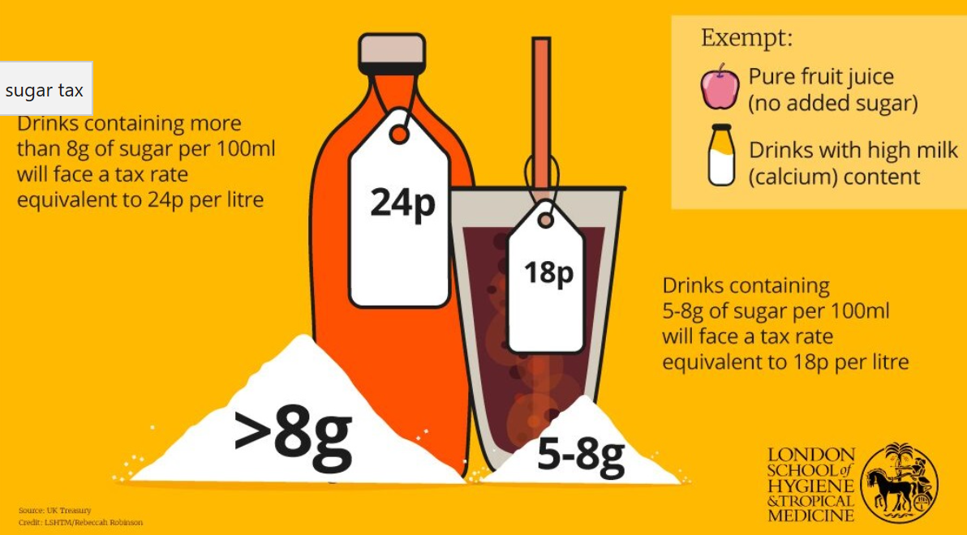 | The UK introduced a sugar tax in April 2018 and was officially called the ‘Soft Drinks Industry Levy’ or (SDIL). The tax is payable by firms directly to HMRC (the Government’s tax collectors.  Countries around the world have introduced sugar taxes on drinks in different ways – directly to increase the cost of all sodas, or indirectly by prompting manufacturers and retailers to reformulate their products, reduce portion sizes or change product lines through the introduction of healthier alternatives.

There’s no global definition of what a high-sugar drink is – an indicator is the threshold at which taxes apply. The UK has opted for 8g of sugar per 100ml, while South Africa has chosen 4g.

The first sugar tax on soft drinks was implemented in Hungary in 2011, part of a wider tax on pre-packed sweetened products, salty snacks and condiments, followed by France in 2012, charging manufacturers the equivalent of an extra 6p per litre for any beverage containing added sugar or artificial sweeteners.  How does the Sugar Tax work? In the diagram to the right, the tax on the ‘junk food’ firm has increased costs of production at each unit produced. As a result the Supply curve shifts to the left from S0 to St. The reduction in supply causes there to be excess demand at P0. So the price starts to rise to Pt. As this happens, consumers have an incentive to reduce the amount they demand from Q0 to Qt and the market will move to the new equilibrium at B. Therefore the tax has reduced consumption by making sugary foods more expensive. The tax will also raise revenue for the Government to help tackle obesity issues in the UK via the NHS. | 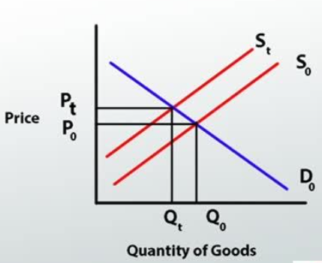

Government Failure: Why might this intervention above not work (or make the situation wise)
- ELASTICITY: If the demand curve is quite inelastic (which is quite possible given the addictive nature of foods high in sugar and fat), then the effect of the tax in reducing the quantity consumed might be limited as consumers will be willing to pay the higher price.
- AFFECTS POORER HOUSEHOLDS: The tax would disproportionately affect poorer households as they spend a larger amount of their income on sugary drinks according to some Government surveys. This therefore would potentially make them poorer and increase income inequality in the UK.
- TOO NARROW: The tax only affects sugary drinks and not other forms of food which are also causing obesity.
EXEMPLAR MACROECONOMICS
Aggregate Demand and the Trade Balance
What is the Trade Balance?
Exports (X) are goods/services which leave the UK and are sold to foreign economies (consumers, firms and Governments). Many firms in the UK rely on exports for their revenue. Imports (M) are goods/services which UK consumers/firms/Government purchase from sellers in foreign countries.

The balance of trade measures net exports of goods and services. It is the value of exports minus the value of imports. It forms the major component of the current account of the Balance of Payments. The balance of trade refers to both trade in goods (visibles) and services (Invisibles). If exports are greater than imports then the UK could be said to have a ‘trade surplus’ with more money coming into the UK than leaving it. Equally, if the UK is in a ‘trade deficit’ then the revenue gained from exports is LESS than the money leaving the UK to pay for imports.

How would a trade surplus or trade deficit affect UK Aggregate Demand (AD)?

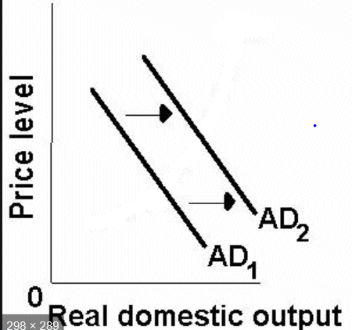 | If the UK was in a trade surplus, then more money would be coming into the UK via greater exports to UK firms. Initially, there would be a greater demand for resources to produce goods and services to export which would shift the AD curve to the right and increase overall domestic output or GDP.  If the UK was in a trade deficit then more money would be leaving the UK via increased imports than would be received through falling exports. Therefore the AD curve would shift to the left as exporting firms would reduce their demand for resources to make their goods/services. Equally, consumers would be spending their money on foreign goods rather than domestic.

Explain the influence a changing exchange rate might have on AD?

A fall in the exchange rate is known as a depreciation in the exchange rate (or devaluation in a fixed exchange rate system). It means the currency is worth less compared to other countries. When there is a depreciation, and the exchange rate goes down, Exports will be cheaper and imports will become more expensive. For example, a depreciation of the pound makes UK exports more competitive but raises the cost of importing goods into the UK. | 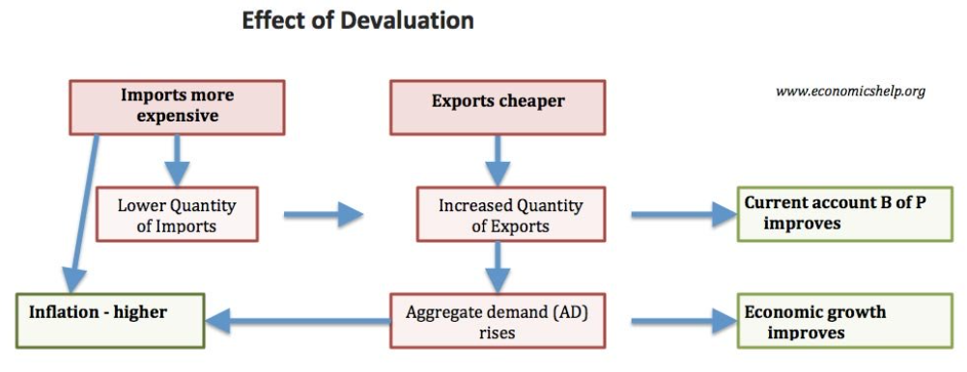
Therefore there will be an increase in exports and decrease in the quantity of imports.
Domestic firms will benefit from increased sales. This may lead to job creation and lower unemployment, especially in export industries. The increase in (X-M will) help increase Aggregate Demand (AD).

What is the ‘multiplier effect’?
If the UK exported an extra £3 billion this would cause salaries/wage of exporting firms to increase by £3 billion; therefore National Income will increase by £3 billion. However, with this extra income, workers will spend, at least part of it, in other areas of the economy. For example, if they spent 50% of the extra income there would be another £1 billion injected into the economy. e.g. shopkeepers would earn money from increased sales. This extra spending would cause an increase in output. Therefore firms would employ more workers and pay higher salaries. Therefore these workers will also increase their spending. This will lead to another injection into the economy, causing higher Real GDP In other words, if exporting firms receive higher revenues, it isn’t just the workers in those firms who benefit from higher incomes. It is also related or local industries and service industries who see some benefits.

The multiplier effect could occur from any stimulus, not just increased exports. It could be that firms invest into the UK economy or Government’s increase spending or cut taxes. Any stimulus that affects aggregate demand is likely to have a larger increase than the initial stimulus.

What has happened to the trade balance of the UK in recent years?
The UK's trade balance has been in deficit since 1998, due to deficits in trade in goods which are only partly offset by surpluses in trade in services. The total UK trade deficit widened sharply to GBP 5.19 billion in October 2019, the biggest since April, from a revised GBP 1.92 billion in the previous month. Imports jumped 6.2 percent, while exports rose at a much softer 0.8 percent, still reaching an all-time high. Balance of Trade in the United Kingdom averaged -1283.75 GBP Million from 1955 until 2019.

