**Theory of the Firm Basics: Costs, Revenue and Profit**

**PRODUCTION INTRO**

Inputs (or factors of production) are needed to create a good or service (Output). The two main factors are Labour (workers) and Capital (factories, machinery, tools etc.).

Specialisation and efficiency: in a firm, workers will be organised and divided into certain roles. This will allow them to ‘specialise’ in a particular pahse of the production process. This means workers will become skilled at their particular role in the firm and their productivity will increase (ability to produce output over a certain time period).

**Production in the Short and Long Run**

|  |  |
| --- | --- |
| * The Short-Run: “A time period when labour can be variable but capital remains fixed.” * The Long-Run: “A time period when both labour and capital can be variable” | In the long run all factor inputs are variable. The producer can increase capacity by moving into a larger factory, buying new machinery, as well as increasing labour and using more raw materials. |

|  |  |
| --- | --- |
| **Revenue and Costs: Totals and Average Mathematical Analysis**   * Revenue = income earned by firms for selling their output (goods and services). If a cabbage seller sells 10 cabbages for £0.50 then their total revenue will be £5 and the ‘average revenue’ is £0.50 (so it is just the price of the product). This makes sense because average revenue is the revenue you receive per unit which is just the price paid by the consumer! * Costs = money spent by firms for producing their products. This will be spent on inputs so labour (wages) and capital (cost of machinery, tools etc.). Total cost is the total amount the firm spends on labour and capital. Average cost is the cost of labour and capital per unit sold.   Remember, mathematically when we study costs and revenues we will always need to specify which type we are talking about:   * Total: all added together * Average (mean): divided by total quantity made | TASK: Draw an AR Curve (P and Q on axis) |

**PRODUCTION IN THE SHORT RUN**

**Explanation for the shape of the Aggregate Revenue Curve**

Downward sloping: The AR curve is simply the revenue earned per unit sold which is just the price. Therefore if a firm wants to increase it’s sales, it will have to lower it’s price to make their product more attractive to consumers. Therefore average revenue (or price) will fall as output increase. Equally demand for this output will increase as prices fall.

Elasticity of Demand Curve or AR Curve (RECAP from RWS3 on Elasticity): In a more competitive firm, the demand curve for the firm will become more elastic as there are other substitutes for the firm selling the same product. Equally, the less competition, the more inelastic the demand curve will become. As we know from this revision worksheet, a more inelastic curve will lead to firms raising prices to increase their revenue and for a firm with an elastic demand curve, they will cut their prices to raise revenue.

**Explanation for the short run average cost curve being U-shaped**

Average cost falls initially as output increases due to specialisation. As more labour is added to the fixed capital, workers organise themselves and become more productive leading to lower costs per unit. However, the firm cannot keep on adding labour to fixed capital as ‘too many cooks spoil the broth’ and diminshing marginal returns will set in so that additional labour interferes with other workers and slows them down. Ultimately this leads to inefficiency and AC will rise as more output is attempted.

**Why are there two types of Profit (Normal and Abnormal) in Economics?**

|  |  |  |
| --- | --- | --- |
| Economists class profit into two categories:   * NORMAL (similar to breaking even in business studies): This is where the AR and AC equal each other. * ABNORMAL: This is where the AR is greater than AC | **NORMAL PROFIT**    **Firms will still produce at this level because they are not losing money.** | **ABNORMAL PROFIT**    **Firms will be very happy about producing here. There objective is to maximise profit.** |

**PRODUCTION IN THE LONG RUN**

**Internal Economies and Diseconomies of Scale: AC in the Long Run (LRAC):**

Movement along the LRAC (and shifts of the SRAC curve)

|  |  |
| --- | --- |
| **Internal Economies of Scale** | “INTERNAL factors within a firm which cause **long-run** average cost to fall at the size of the firm’s output increases” |
| **Internal Diseconomies of Scale** | “Factors which cause long-run average cost to rise as a firm’s output increases” |

|  |  |
| --- | --- |
| Innocent Smoothie will be able to gain economies of scale due to being such a large firm and as they produce on such a large quantity they should see their long-run average cost (LRAC) fall (movement along the line). This is the equivalent of the short run average cost curve shifting downwards. The reason that firms are able to the scale of their operations is because both labour and capital are variable in the long run. In the short-run one factor would be fixed (e.g. factory size, capital) and so scale cannot be increased.  Diseconomies of scale occur when the firm has become too large and further increases in output lead to rising average costs. | TASK: Read the box on the left and draw a LRAC curve below (use the internet to look it up if you need to check your attempt). |

**TASK:** Read the information below and try to summarise it into the Mind Map below on page 3 . Each ‘source’ of economies and diseconomies of scale should be summarized into only a few words.

**SOURCES OF ECONOMIES OF SCALE**

Larger firms may be able to reduce LRAC as they can purchase at lower cost e.g. interest on loans, cost raw materials.

* Financial: as a firm grows in size, it is better able to access loans at low cost. Banks will be more willing to lend and at lower interest rates as there is perceived to be less risk. This reduces the cost of servicing loans.
* Purchasing: larger firms ordering supplies may be able to gain discount from suppliers as they are ordering in bulk. This reduced the cost of purchasing raw materials and supplies.

Larger firms can also spread fixed costs over more units. For example, if fixed costs were £1,000,000 but the firm was producing 1 million units then the average cost would only be £1. A small firm would not be able to gain such low long-run average cost if they only produced 100 units.

* Technical: large firms can spread the cost of machinery over more units and help reduce their long-run average cost. Furthermore, this machinery should help firms to be more productive compared to smaller firms who cannot afford the equipment, meaning the larger firm will again have lower LRAC.
* Marketing: large firms can also spread the cost of marketing over more units and more different products lowering LRAC which a small firm would not be able to do at low output. Furthermore, large firms with wide product ranges can advertise more than one product at once by promoting their brand at little extra cost reducing the need for more adverts and lowering LRAC.
* Managerial: manager’s salaries can also be spread over more units and therefore lower LRAC. Furthermore, by employing specialist managers in accounting, marketing and finance for example this should improve efficiency and lower long-run average costs.

SOURCES OF DISECONOMIES OF SCALE

|  |  |
| --- | --- |
| **Type** | **Explanation** |
| **Communication & Co-ordination** | In large firms communication and co-ordination becomes harder as there are more employees to talk to and organise. This will mean large firms may suffer from being inefficient and therefore see LRAC rise. |
| **Motivation & Labour Relations** | In larger firms workers may feel isolated and suffer from low morale as their input into the company is felt to be limited. Workers may work less productively and therefore raise LRAC or may leave, which would increase recruitment costs and again LRAC. |
| **Bureaucracy** | Large firms may also suffer from bureaucracy as there may be an increasing number of forms to fill in and administrative tasks to complete. This may mean the firm has higher costs, lower efficiency and ultimately rising LRAC. |

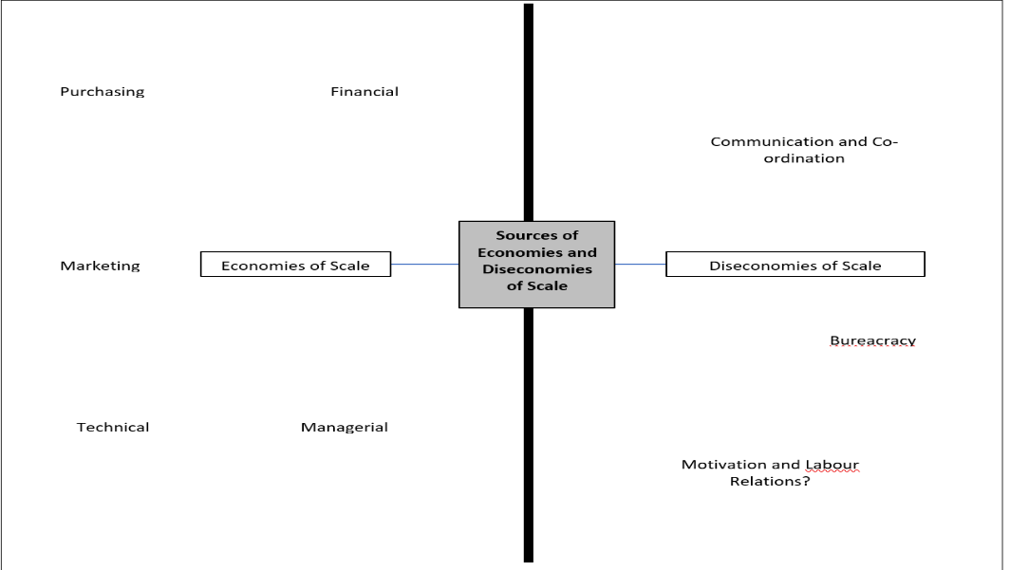

**External Economies and Diseconomies of Scale: Shifts in the LRAC Curve**

|  |  |
| --- | --- |
| **External Economies of Scale** | “Factors which cause long-run average cost to fall as a the **size of the industry** increases” |

Some economies of scale have an impact on the entire industry and lower the long-run average cost curve. When an industry is larger (and often located together) they can gain:

* **Skilled labour attracted to the area:** if firms locate in the same area (e.g. Silicon Valley) then this should attract more highly-skilled labour. This should reduce recruitment costs and LRAC.
* **Suppliers may locate nearby:** if firms cluster together it makes sense for suppliers to locate nearby. This will reduce transportation costs for raw materials and therefore reduce LRAC.
* **Better infrastructure e.g. road links, railway etc:** shared infrastructure should improve the efficiency of transportation and again reduce LRAC. It will benefit all local businesses if these are in place.
* **Share innovations & administration:** firms may also benefit from the innovations of other firms which will lower LRAC if they can share them. Furthermore, if firms share administration facilities or staff then this will reduce LRAC for the whole industry.

|  |  |
| --- | --- |
| **External Diseconomies of Scale** | “Factors which cause long-run average cost to rise as a the **size of the industry** increases” |

Some economies of scale have an impact on the entire industry not just from one firm expanding too far but from having a larger industry in general. Examples include:

* **Rising wage costs:** For example, assume there is a manufacturer in a given city. If the average wage level increases across all other markets as a result to an increased demand for labour, then to entice workers to produce, the manufacturer must pay more in wages, which will raise the total costs and LRAC.
* **Rising raw material costs:** similarly if there is a large increase in demand for raw materials as an industry grows then there will be a rise in the cost of raw materials and commodities. This will again increase LRAC due to a larger sized industry.
* **Regulation costs:** with a larger industry there may be more scrutiny by Competition authorities. This may mean that there is an increase chance of fines and time spent meeting these regulations. This increases LRAC as well.

**TASK:** Show what the effect might be of external economies of scale on a firms long run average cost curve using the info above?

|  |
| --- |
|  |

**Cost Curve Summary**

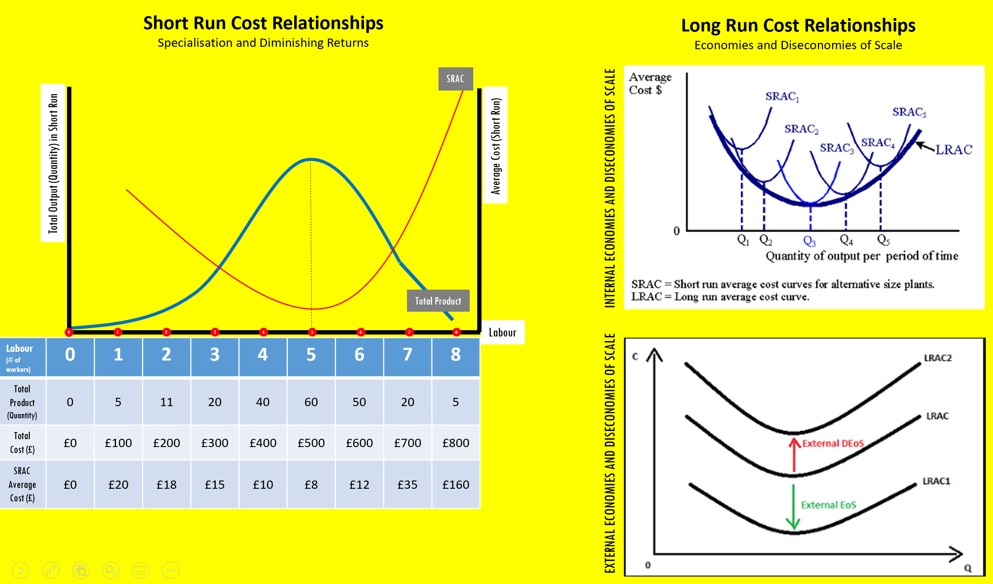

**Market Structure: The Competition Spectrum**

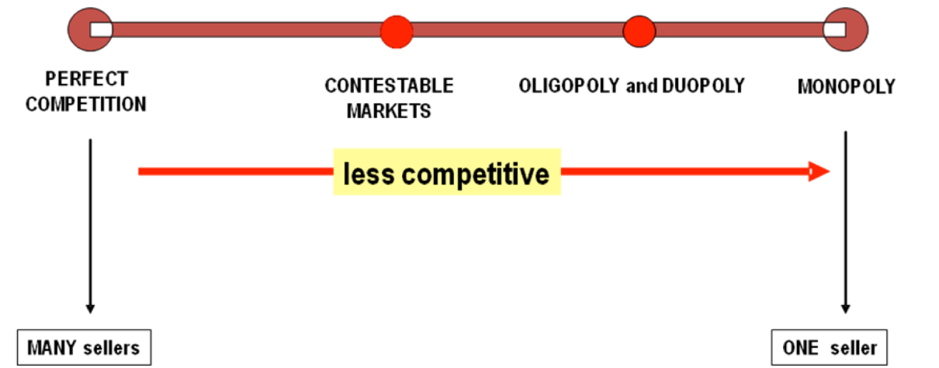

Markets structure is an indicator of how much competition there is in the market. As with all spectrum’s, there are two extremes at either end, so-called ‘perfect competition’ and ‘pure monopoly’. In reality, neither of these two extremes really exist but they are useful for framing the discussion about how much competition is in a market and whether this is a good thing or not. One way to measure competition in the market and the size and power of firms is to measure the ‘concentration ratio’ of the market.

**Measuring Market Power: ‘Concentration Ratio’s’ and the Grocery Market in the UK (or supermarkets)**

Market structures range from perfect competition which have low concentration to monopoly with high concentration. A high concentration implies that there are few firms in the market and low competition. A concentration ratio expresses the % of the market (market share) accounted for by a given number of firms in an industry e.g. a 3-firm concentration ratio is the market share of the top 3 firms in the industry.

|  |  |  |
| --- | --- | --- |
| 020%20kantar%20graph | **What is a concentration ration?** |  |
| **What is the difference between a three firm and five firm concentration ratio?** |  |
| **What is the four firm concentration ratio of the UK grocery market currently (e.g. supermarkets) See above** |  |

|  |  |
| --- | --- |
| **Why since 2007 have the ‘big four’ supermarkets lost market share to the likes of Lidl and Aldi in your view?** |  |
| **Why might you argue there is not adequate competition in the UK grocery market at present?** |  |
| **Why might you argue that competition in the grocery market is very good?** |  |

**Market Structure: Perfect Competition**

**The Four Key Assumptions**

The four characteristics of perfect competition are below.

|  |  |
| --- | --- |
| (1) | **Many buyers and sellers –** there are many consumers and firms in the market |
| (2) | **Homogenous Products –** all the products in the market are exactly the same. No brands are assumed for example. Every product is the same. |
| (3) | **Perfect Information –** consumers and firms are assumed to have ‘perfect information’ which means they know about all the products, where all the competitor are and the true value of all goods (remember that behavioural economists would probably have some issues with this!) |
| (4) | **Barriers to Entry and Exit do not exist –** firms wanting to enter the market can do so easily with minimum cost. Equally, there are zero ‘sunk costs’ (costs that cannot be recovered once they have occurred). Therefore firms can leave markets very easily. |

**Case Study: The Pig Farming Industry**

To what extent is the pig farming industry a good case study of perfect competition?

|  |  |  |
| --- | --- | --- |
| **(1) Many Buyers and Sellers** | | hey-pig-piggy-pig-pig-pig |
| Good Case Study? | Evaluation? |
| **(2) Homogenous Products** | |
| Good Case Study? | Evaluation? |
| **(3) Perfect Information** | |
| Good Case Study? | Evaluation? |
| **(4) Barriers to Entry and Exit are Limited** | |
| Good Case Study? | Evaluation? |

**Market Structure: Monopoly**

**Different Types of Monopoly**

|  |  |
| --- | --- |
| **PURE MONOPOLY** | A pure monopoly is quite a theoretical term and means there is only one firm with 100% of market share in a market. In reality there are very few pure monopolies because it is suggesting there are no alternatives.  **The best example might be a water company in a certain area? Explain why this could be considered to be a 100% monopoly?** |
| **MONOPOLY POWER** | The more realistic view of monopolies is how much market power firms have in a particular market. The closer the firm is to having 100% of the market, the more they are able to influence the market. |
| **NATURAL MONOPOLY** | In the past “utility” industries such as water, gas, electricity and the telephone industries have been regarded as natural monopolies. All four industries have to be distributed through a central network or grid into millions of businesses and homes. Competition in the distribution of these services is extremely wasteful since it requires the duplication of huge fixed assets and therefore massive costs which firms would not be able to recover, considering their market share. |
| **LOCAL MONOPOLY** | A monopoly does not necessarily have to be a big firm. At the end of the day, a monopoly is a firm offering a good or service which is in demand and other firms are not providing.  **To what extent is Godalming College Canteen a local monopoly?** |
| **LEGAL MONOPOLY** | A company that has over 25% of market share – UK Definition |

**Sources of Monopoly Power**

|  |  |  |
| --- | --- | --- |
| **(1) Available Substitutes / Potential Competitors** | **(2) Barrier to Entry: Branding (Advertising & Product Differentiation/ Branding )** | **(3) Other Barriers to Entry (Natural, Geographical, Government created)** |
| (Using Godalming College canteen as an example, explain why this condition might provide monopoly power) | (Using Costa coffee as an example, explain why this condition might provide monopoly power) | (Using the UK’s retail electricity market as an example, come up with three different examples of barriers to a potential firm wanting to set up and compete) |
|  |  |  |

**What degree of monopoly power do YOU think the Eurotunnel, Royal Mail, South West Trains and Tesco’s have got? Justify your answer using the three criteria above.**

|  |  |  |  |
| --- | --- | --- | --- |
| Eurotunnel | Royal Mail | South West Trains | Tesco’s |
|  |  |  |  |
| VERDICT: | VERDICT: | VERDICT: | VERDICT: |

