CONSUMPTION EXTERNALITIES: ‘Externality Diagrams’

TASK 1: VIDEO (45 minutes)
Watch the following videos (LINK and LINK – click on these links or they are also at the bottom of this page if you need to type them into the URL bar). The videos are on consumption externalities to reinforce the learning in the lesson. Ultimately you need to understand:
- Why each diagram demonstrates a market failure (in this case allocative inefficiency of over or under consumption)
- The logistics of the diagrams….where are the private, external and social costs and benefits
Then:
- Draw two diagrams below for positive and negative consumption externalities, highlight the ‘values’ (measured in pounds) for MSB,MPB and MEB on the y-axis (price level).
- Explain why each diagram demonstrates market failure (remember to talk about the assumptions of ‘selfishness’ to understand where the free market equilibrium-B- would be as opposed to the socially optimal equilibrium – A)

Positive Externality Diagram  Goods with unaccounted positive externalities are called ‘MERIT GOODS’. As well as healthcare, other examples of merit goods might be education etc. The consumption of these goods has benefits to the private individual BUT also to the rest of society (external benefits). However these external benefits are not taken into account by the person conducting the activity. | Negative Externality Diagram  Goods with unaccounted negative externalities are called ‘DEMERIT GOODS’. As well as fatty foods, other examples of good might be cigarettes, alcohol etc. The consumption of these goods has benefits to the private individual BUT also has costs to the rest of society (external costs). However these external costs (negative external benefits!) are not taken into account by the person conducting the activity.
DIAGRAM | DIAGRAM
EXPLANATION FOR WHY A MARKET FAILURE | EXPLANATION FOR WHY A MARKET FAILURE

LINK 1: https://www.youtube.com/watch?v=aj6FTueEICY (Negative Externalities in Consumption) – 14 minutes
LINK 2: https://www.youtube.com/watch?v=lb1fnodI3YU (Positive Externalities in Consumption) – 12 minutes
TASK 2: MULTIPLE CHOICE ASSESSMENT (45 minutes)
Complete the following multiple choice questions under timed conditions (1 minute per question for those with standard time). After the 10 minutes, access the answers on GOL and work out which ones you got wrong. Now revisit these questions and try to understand why you got the questions wrong.

QUESTION 1  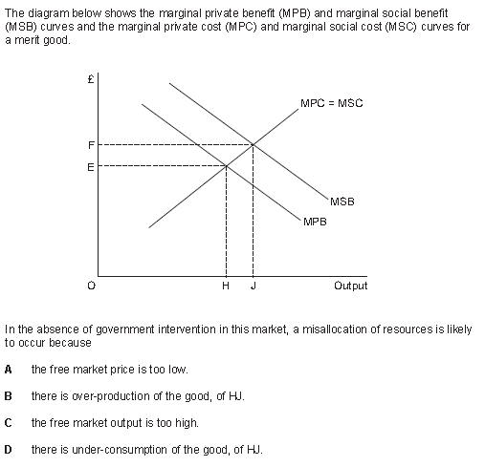  high | QUESTION 6  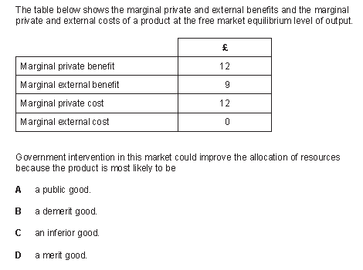  A luxury good
QUESTION 2  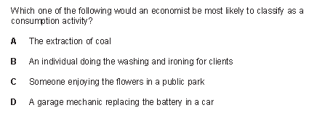 | QUESTION 7  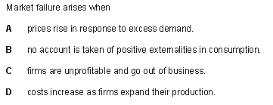
QUESTION 3  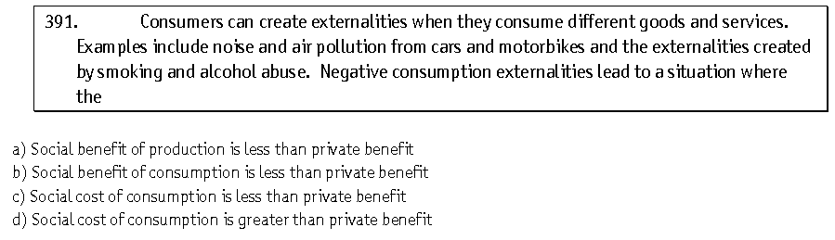 | QUESTION 8  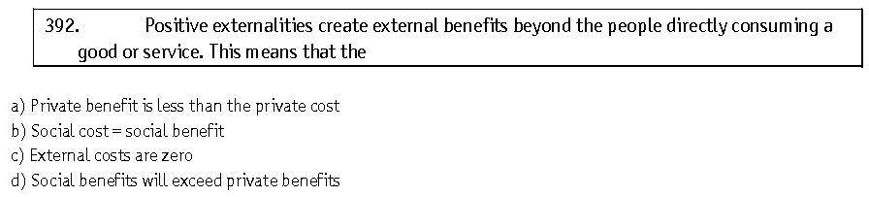
QUESTION 4  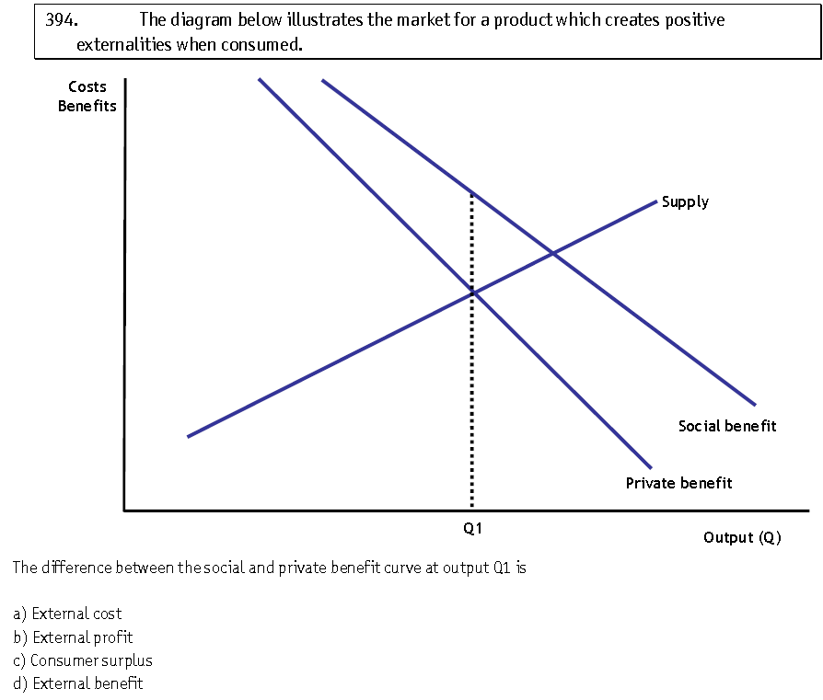 | QUESTION 9  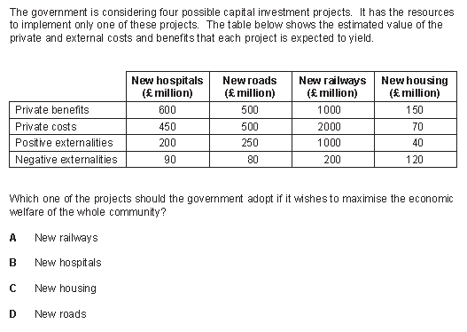
QUESTION 5  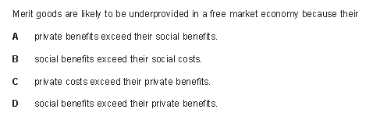 | QUESTION 10  