**END OF LINE DOCUMENTARY – How to Access**

Hi all,

To access this documentary, you will need to access ‘Planet e-stream’ which can be found on Godalming Online if you scroll down to the boxes at the bottom:

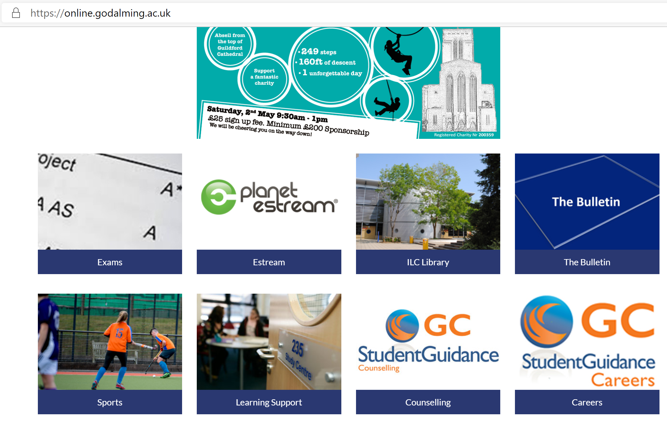

Sign in with your College login details as normal.

Type in ‘End of the Line 2009’ to the search box and VOILA you should see the link to the documentary. It is 1 hour 15 minutes to watch.

Equally you could click on this LINK: <https://estream.godalming.ac.uk:444/View.aspx?id=12374~5e~WDi2rIs4iG>