**TAXATION AND GOVERNMENT SPENDING IN THE UK**

Introduction to Taxation and Spending in the UK 2019-20 (Source: HRMC)

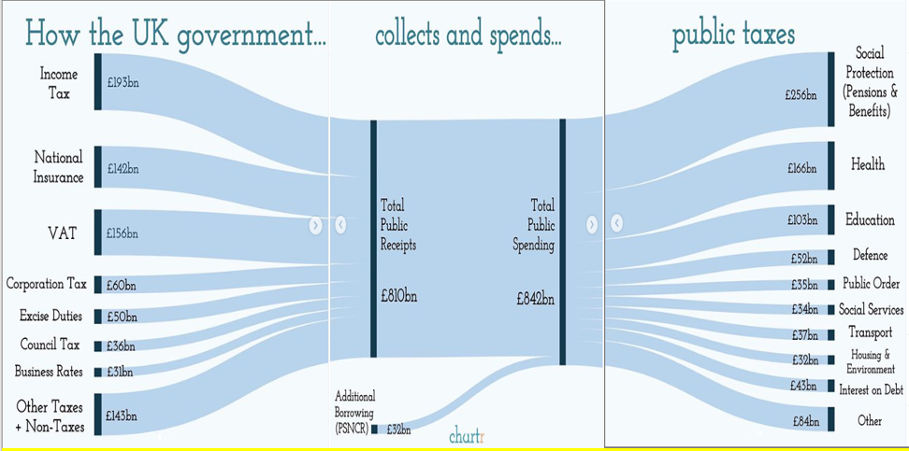

How do Direct Taxes like ‘Income’ and ‘Corporation’ Tax Work?

|  |  |
| --- | --- |
| INCOME TAX (Tax on income earned by workers in households) | CORPORATION TAX (Tax on profits earned by firms) |
|  |  |
| Comment on the table above – what is surprising, obvious and/or interesting? | Comment on the table above – what is surprising, obvious and/or interesting? |

Income tax is collected via PAYE (Pay as you Earn) system.

Complete the table below

|  |  |  |  |  |  |  |  |
| --- | --- | --- | --- | --- | --- | --- | --- |
|  |  | HOW MUCH TAX DOES EACH EMPLOYEE PAY??? | | | | |  |
| Employee | Salary | Personal Allowance?  Up to £12,500 | Basic Rate?  £12,501-£50,000 | Higher Rate  £50,001 to £150,000 | Additional Rate  Over £150,000 | Total Tax Paid | Salary Left Over to Spend |
| If Lionel Messi lived in the UK (and didn’t try to avoid paying tax) | £102,000,000 |  |  |  |  |  |  |
| Lawyer | £125,000 |  |  |  |  |  |  |
| Manager of Sainsbury’s Godalming | £75,0000 |  |  |  |  |  |  |
| Teacher at a Sixth Form College | £39,000 |  |  |  |  |  |  |
| Nurse | £27,000 |  |  |  |  |  |  |
| Worker on minimum wage | £15,600 |  |  |  |  |  |  |

How do Indirect Taxes like ‘Value Added Tax’ Work?

|  |  |
| --- | --- |
|  | Why do you think VAT is called an ‘indirect tax’? |

What is the difference between a regressive and progressive tax?

|  |  |
| --- | --- |
|  |  |

TASK: Using the information in the table above, comment on whether you think income, corporation and VAT are progressive or regressive AND WHY?

|  |  |  |
| --- | --- | --- |
| INCOME | CORPORATION | VAT |
|  |  |  |

May 2019 Conservative Party Leadership (and therefore Prime Minister) Contest

|  |  |
| --- | --- |
| What is Boris Johnson’s pledge with INCOME TAX?  What will the impact be on inequality and poverty do you think?  What are the advantages and disadvantages for the UK economy? | What is Jeremy Hunt’s pledge with CORPORATION TAX?  What will the impact be on inequality and poverty do you think?  What are the advantages and disadvantages for the UK economy? |