RWS10: Market Failure #5 – Inequality and Poverty
PREP HWK – Due for Monday 10th June 2019

Introduction to the Labour Market (45 Minutes in Total)

TASK: Answer the following two questions…
Why does Cristiano Ronaldo get paid more than a Nurse? | Is it right that Cristiano Ronaldo gets paid more than a Nurse?

TASK: Complete 2 rough mind maps for discussion in class (THIS IS AVAILABLE ON GODALMING ONLINE WITH THE RESOURCES)
- MIND MAP 1: The UK Labour Market Today (1 side of A4)
  - Read the first 3 pages of the September update from the Office of National Statistics and comment on the amount of people who are working, unemployed or ‘economically inactive’
  - What is Robert Peston’s view - summarise his thoughts in his article - LINK
  - Use the internet to research ‘The Living Wage’. What is it and how is it similar and different to the ‘Minimum Wage’?
  - Women in the labour market. Summarise the Guardian’s account of the latest UN report - LINK
- MIND MAP 2: ‘Flexible Labour Markets’ (1 side of A4)
  - What are flexible labour markets? Watch the video below and take notes on the case study
    - VID1: “The McDonalds employees struggling to live on zero hours contracts” (available on YouTube if you type in that title if the link does not work)
  - Read the articles on GOL (“Flexible Labour Market Debate”) and watch this video (VID2) draw up arguments for and against the idea of flexible labour markets in the UK. VID2 is from tutor2u – type in to Google “A* Evaluation on Flexible Labour Markets Tutor 2u”
  - What impact does Globalisation have on flexible labour markets do you think? Just some jotted down thoughts.

PLEASE TURN OVER
Defining and Measuring Poverty (1 hour)

Poverty in India/DRC etc: “Developing Countries”  VIDEO: “Dispatches: The Slumdog Children of Mumbai”  Watch the first 12 minutes (on estream via GOL) | Poverty in UK/USA: “Developed Countries”  VIDEO: “Panorama - What next for Kurt”  Watch the first 11 minutes (on estream via GOL)
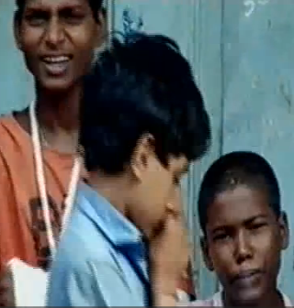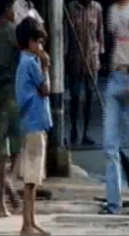 | 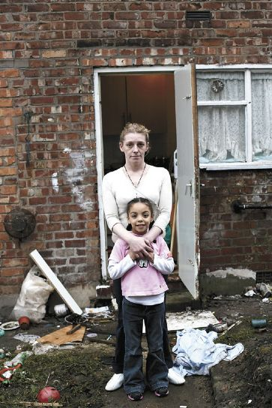
Describe the type of poverty experience by kids in India | Describe the type of poverty experienced by kids in the UK
What are the similarities between the experiences of kids in poverty in India and the UK? | What are the differences between the experiences of kids in poverty in India and the UK

Measuring Poverty in the UK: Classifications
TASK: Read this table and try to find some stats from the internet
Type of Poverty | Definition | Statistics (try to jot down the source and date of your statistic)
Absolute Poverty | - Unable to meet basic necessities to survive (water, food, shelter and clothing)  - Measured by the World Bank as living on less than $1.25 dollars per day (PPP) and so the numbers in the UK are very limited.
Relative Poverty | - People are poor in comparison to others in society. Unable to meet the needs to function in a society which may have different definitions depending on the society.  - Less than 60% of the median income
Age Group Poverty | - CHILD POVERTY: Children living in a household with an income less than 60% of the median average  - PENSIONER POVERTY: Men (over 65) and Women (over 60) [by 2020 it will be 66 for both] who are living in a household with an income of less than 60% of the median average. 20% of pensioners live in poverty?
Postcode Poverty | - You may be trapped in poverty with limited access to good schools, healthcare etc. You might also be more vulnerable to crime etc.  - No specific measure - more a concept to highlight the inequality caused by property prices and the disadvantages in terms of social mobility
Fuel Poverty | - People are in poverty because they are spending a disproportionate amount of money on energy costs  - Households who spend more than 10% of their income on fuel. Roughly 2.5 million people.

Defining and Measuring Inequality (1 hour)
- What is ‘Income’? Income is a flow concept. A flow of money generated or received over a period of time.
- What is ‘Wealth’? Wealth is a stock concept. Wealth refers to a stock of valuable assets.

Put these examples under the correct heading of either income or wealth?
(Wages, Property, salaries, Art, dividends, benefits, shares, wine, cash, Bank deposit)
Income | Wealth

Measuring Income Inequality (Lorenz Curve for Inequality and the corresponding Gini Coefficient)
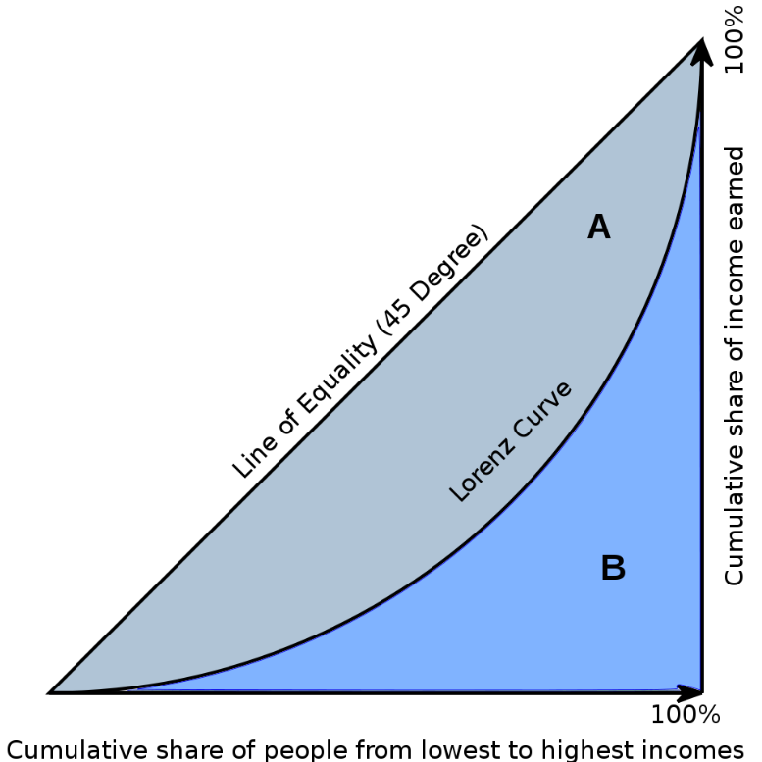  Gini Co-Efficient:  A / A+B | Country 2010  UK 0.345  Sweden 0.259  France 0.293  USA 0.378  Brazil 0.508  Figure 1 | 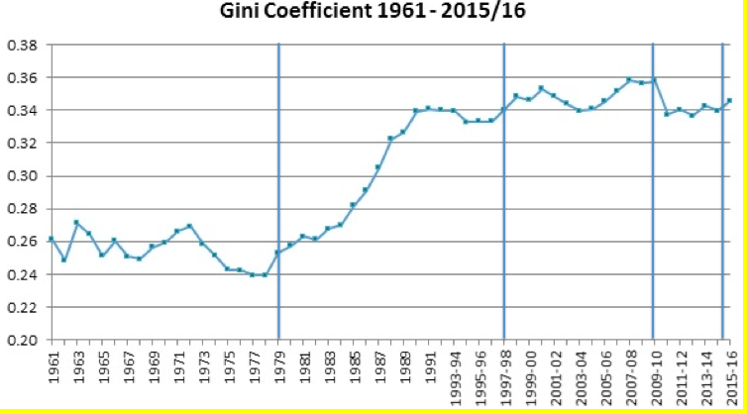  Figure 2
What is the lorenz curve and the ‘Gini’ coefficient (research on the internet)? | Identify two significant features of figure 1 and figure 2 and in one sentence each, explain what they each show.
Using the figures and information above, comment on what has happened to poverty and inequality since 1979?

Measuring Wealth Inequality (Lorenz Curve for Wealth)
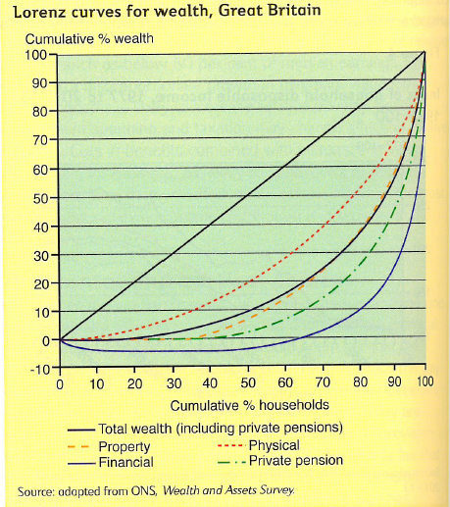 | Identify one significant features of this Lorenz Curve to do with ‘Financial’ (this is wealth such as money in the bank or investments) and then ‘Property’ (how much property is owned as wealth).

