Causes of Poverty and Inequality since 1979 – Market or Government Failure?

(A) MARKET FAILURE??

(1) Growth of ‘Neoliberalism’ since 1979
Neoliberalism is a term commonly used to describe free-market economics. Neoliberalism involves policies associated with free trade, privatisation, price deregulation, a reduced size of government and flexible labour markets. Neo-liberalism is closely associated with the Washington Consensus – the free market approach of the IMF and other institutions. It also closely overlaps with the classical economic philosophy of laissez faire.  Recently, neoliberalism has been associated with the policies of austerity and attempts to reduce budget deficits – usually by cutting government spending on social programmes. | Explain why ‘neo-liberalism might lead to poverty and inequality in the UK?
 | Evaluate your position above – why might neoliberalism not be to blame?

(2) Flexible Labour Markets
Flexible Labour Markets means that the labour markets quickly adjust to a competitive equilibrium and involve factors like:  •Easy to hire and fire workers  •Labour is occupationally and geographically mobile  •Government intervention does not distort the market  Characteristics of Flexible Markets:  - Skilled workforce which can adapt to changing requirements (less structural unemployment)  - Flexible hours and working contracts e.g. more temporary employment or working from home. (‘Zero Contract Hours’)  - Self-employment where workers and firms can be more flexible in how and when to work. (‘Gig Economy’) | Advantages of Zero Contract Hours | Disadvantages of Zero Contract Hours

(3) Globalisation and the North South Divide in the UK
The red circles represent key areas of the country where there used to be key industries before Globalisation. Using arrows from the diagram, name the regions and industries below: | 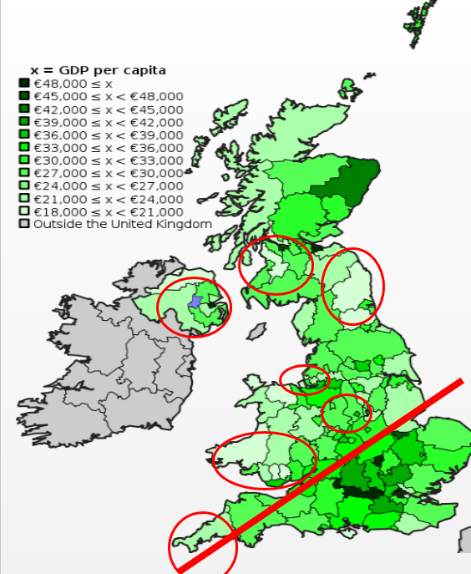 | Explain why globalisation has exacerbated the North/South divide in the UK? (think both lost industries in the North and gained industries in the South)

(B) GOVERNMENT FAILURE??

THATCHERISM  “The neo-liberal revolution has begun”  - Margaret Thatcher 1979-1990  - John Major 1990-1997 | BLAIR/BROWN-ISM  “The rich get richer but support the poor”  - Tony Blair 1997-2007  - Gordon Brown 2007-2010 | ‘AUSTERITY POLITICS’  “We’re all in it together”  - 2010-2015 Coalition Politics  - 2015-2017 Conservative Govt.
KEY POLICIES  - Reduces the power of trade unions which leads to a fall in wage increases  - Reduce the support of the welfare state and the state (including health and education)  - Cutting tax for the highest income earners  - Privatisation and deregulation of key industries | POLICIES  - No changes to Conservatives trade union reforms, tax changes and privatisation from ‘Thatcherism’. Also cut unemployment benefit further.  - Introducing minimum wage legislation, working tax credits and ‘The New Deal’ (a work programme to get the long term unemployed into work) | POLICIES  - Reducing the influence of the state through significant cuts from education to benefits  - Introduction of ‘The Work Programme’, Universal Credit scheme and ‘Living Wage’ (a higher minimum wage)  - Reduction in taxation on high income earners, corporation tax but increases in regressive taxation (VAT)
 | 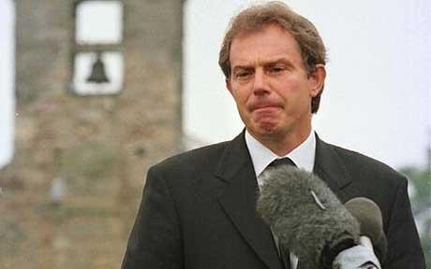   | 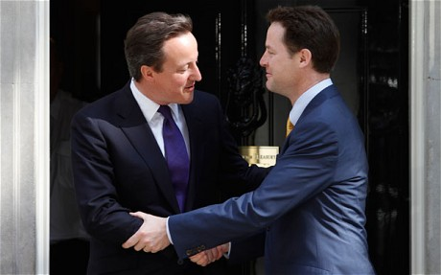  

TASK: Read the attached article ‘APPENDIX 1’ at the back of this worksheet. Then research:
The Coalition Government of Conservatives and Liberal Democrats 2010-2015 and then the Conservative Government from 2015 until today have implemented these key policies….research each of them and write brief notes in the boxes below
 | Provide some brief detail of this policy and when it occured | How might this affect inequality and poverty? Explain your answer?
Cuts to education and benefits
Introduction of the ‘Universal Credit Scheme’
Changing the Minimum Wage to the ‘Living Wage’
Reduction in taxation on high income earners and corporation tax
Increase taxation such as VAT
Market Failure or Government Failure?
Some political parties feel that people are poor or have less income and wealth than others because….
- AGENCY: It is the fault of the individual. The individual has failed to maximise their full potential by making the wrong choices (smoking, getting into debt etc.) and not grasping opportunities (too lazy etc.)
- STRUCTURAL: It is the fault of the systems in society. Perhaps some are more priviliged than others and have greater opportunities available to them. It could also be that Government interventions have failed to help those who are in poverty and it is not the fault of the individual.

SOURCES OF POVERTY EXERCISES
 | Explain why the following would lead to poverty (and hence greater inequality) | Is this source a market failure or government failure in your view? Explain your point
Unemployment and low wages
Sickness, Disability and Old Age
A Poverty Trap - limited opportunity or ‘social mobility’ for certain people

SOURCES OF INCOME INEQUALITY EXERCISES
 | Explain why these causes would lead to greater inequality in the UK? | Is this source a market failure or government failure in your view? Explain your point
Inheritance: In the UK large stocks of wealth including estates and titles (for example, dukedoms) are passed down from one generation of already wealthy families to the next. This tends to perpetuate holdings of wealth among already wealthy families.
Marriage: Wealthy people tend to marry other wealthy people, reinforcing the concentration of wealth among relatively few people.
Access to Finance: High earners are better able to save and earn interest, as well as getting access to higher interest savings accounts. Indeed, those who have a propensity to save a higher percentage of their income will build up more wealth than those who save a smaller percentage.

Evaluating the effects of inequality: To what extent is inequality a problem for society?
Read the following arguments, discuss with the person next to you and write a conclusion at the bottom.

PROBLEMS OF INEQUALITY  Arguably, inequality is a type of market failure. Market failure occurs when there is an inefficient allocation of resources in a free market. | PRO’s OF INEQUALITY  Perhaps inequality is not a market failure. We can evaluate the arguments for it being a market failure and point out the possible advantages of inequality.
Greater poverty – living standards for some will become unacceptably low and relative or absolute poverty will occur. | Equality is impossible – To have a society where everyone earns the same is impossible. Perhaps a degree of relative poverty is inevitable?
Social unrest - Arguably inequality can lead to social friction. It can be a factor in precipitating riots or higher crime levels. In this case all members of society lose out. This is more pressing if the inequality is perceived to arise out of unfair allocation of opportunities (e.g. inherited wealth, monopoly power) | Positive Incentives - If someone works harder and as a consequence receives a higher wage then this is not market failure. The promise of a higher wage is essential to encourage extra effort. By rewarding hard work, there will be a boost to productivity leading to a higher national output – so everyone can benefit. Inequality is also necessary to encourage entrepreneurs to take risks and set up new business. Without the prospect of substantial rewards, there would be little incentive to take risks and invest in new business opportunities.
Leads to wealth inequality - Inherited wealth gives people an ‘unfair’ advantage in life. It may also make give them a ‘disincentive to work’ as they can live off rent, profit and dividends. The problem never becomes solved because wealth is passed from generation to generation. It can also lead to very wealthy people interfering with democracy by the owning of media outlets etc. | Trickle Down Effect - If some people gain extra income, then this can ‘trickle down’ to other people, e.g. if an entrepreneur sets up a business he may become a millionaire, but also will create jobs and provide incomes for other workers. There may be a gap between highest and lowest earners. But, the lowest earners are still better off than without the entrepreneur. (more on trickle down effect – which is quite controversial)
Diminishing Marginal Utility of Income - Income has a diminishing marginal utility. The first £1,000 of income you earn gives substantial benefits. With this first £1,000 you can buy food to eat and contribute towards your rent and other basic necessities. Your first £1,000 has the highest utility because it is essential to maintain life and avoid absolute poverty. If you gain another £1,000 income this also increases your utility (satisfaction) because you can now buy better quality food and have improved shelter. But, the increase in utility is less than first £1,000. However, if you are a millionaire and gain an extra £1,000. The extra (marginal) utility is very limited. You can maybe buy a slightly more expensive car, you can buy a yacht that is 3ft bigger. But, the increase in utility / satisfaction is fairly limited. Therefore increasing income equality can lead to an overall net gain because the poor see a bigger increase in utility than the loss faced by high earners. | Demand and Supply - People deserve to keep higher incomes if their skills merit it. If a top footballer gets paid £100,000 a week, this is a reflection that people are willing to pay that kind of money to watch him.
CONCLUSION (remember to state a position, support it and then defend it)

APPENDIX 1: POLITICAL FACTORS – Conservatives .v. New Labour 1979 to 2010

1979 – 1997 – The Conservatives in Power: Margaret Thatcher to John Major
Since 1979, inequality has been increasing for a number of reasons. It was most stark between 1979 and 1990 when Margaret Thatcher was in power – the Gini-Coefficient for the UK went from 0.24 (a reasonably respectable figure) to 0.35. Using the table below, provide explanations as to why these different factors led to worsening income inequality. They have been split into Economic, Political and Social Factors
Reasons for increased inequality 1979-1997 | Detail (case study examples) | Arguably why was this to blame for the growing inequality? |  | EVALUATION: why was this not to blame for the growing inequality?
Economic and Political Factors: The Neoliberal Agenda  Thatcher was one of the architect’s arguably of the global revolution of neo-liberal theories in the 1980’s. You have already studied the impact of the SAP’s in Zmabia during the 1980’s and 90’s | Tax Cuts for the Wealthy  Top earners reduced tax rate from 83% to 40% |  | Rich got Richer  Tax rates for what were then the very rich (for anyone who earnt over £40000) were at 83% and Thatcher reduced this to 40% (the figure it is today). Simply top earners in the UK earned more money, leaving the rest of the UK behind and increasing income inequality | Trickle Down Effect  Top income earners are maybe more likely to spend or invest a greater degree of money, creating profits for business and job opportunities which will increase everyones incomes (trickles down), not just the rich
 | Privatisation  Privatisation literally means moving state run industries into the private sector. The Government sold off many industries to private companies in the 8o’s and 90’s. Companies such as BT, British Rail, British Gas, British Airways, BP etc. were all sold to private shareholders. |  | Higher Pay for Managers  Private sector companies pay their managers more as state run enterprises can have limits on how much managers can earn in relation to their employees. Therefore this would make the rich richer and increase inequality.  Unemployment  Although some state industries were inefficient, others were earning profit. Private companies have a goal to maximize profits and to earn more profit costs have to be reduced. This is usually at the expense of job positions. Therefore a greater degree of unemployment will lead to inequality as those without a job are left behind  Share Opportunities  Shares are issued by private companies to allow individuals to own a small part of a company. “Investing” in shares by individuals is normally the pursuit of the wealthy as they have the excess income to afford to save. Therefore if the wealthy have more opportunities to get richer, this might leave lower income citizens without these opportunities as they are unable to save. Also arguably the shares were sold off to cheaply meaning there was less money for the Government to protect the vulnearable in society arguably exacerbating the existing inequality | More Efficiency  It might be argued that greater efficiency is created in a private company compared to a state run one due to the profit motive amongst private companies. This greater efficiency could lead to greater job opportunities for all and prevent stagnant inefficient industry from being a drain on the economy. This would mean inequality would not be affected because the greater job opportunities create income and wealth for all  Share Opportunities  The privatization of state owned companies was considered by many to be a “one way bet”. In other words the share price could only increase. If everyone has the opportunity to buy shares then poorer and richer should benefit alike and therefore it should not affect inequality too much
 | Reduction in Trade Union power  Famously Margaret Thatcher “smashed” the General Coal Miners Union in the mid 80’s with running pitched battles and strikes which lasted many months. She introduced legislation to restrict the powers of the trade unions such as making certain striking action illegal |  | Loss of Jobs  The trade unions represented the working man in a lot of the manufacutring industries which were leaving the shores of the UK. Thatcher famously smashed the general mining union in the mid 80’s and implemented legislation to restrict Trade Union strikes and therefore much of their power. Resulting unemployment means already low wage workers were prevented from earning as the rest of the UK had an income; leading to growing income inequality  Demultiplier Effects  It was not just individuals in Northern areas or England who suffered from a reduction in trade union power. Local communities who relied on these industries for jobs also suffered even though people may not have been directly employed by the local industry. If a mine is closed down or workers receive less money through their wages, they will spend less. Consequently other industries in the area (cinemas, restaurants etc) start to lose business and they may have to cut jobs too. It all leads to some areas of the country declining whereas others improve thus making inequalities worse especially between deinsudtrialised areas and the rest. | More Efficiency  Arguably trade unions create inefficiencies in the market and create wages higher than the market rate, causing unemployment. Therefore there removal would mean lower wages but possibly greater employment which might reduce the scale of growing inequality?
 | Restructuring of the UK Economy: Secondary to Tertiary  A movement to the tertiary level of an economy occurred in the 80’s and 90’s |  | De-industrialisation  The North-West (textiles), the North (steel), The Midlands (pottery, automobiles, aircraft), the North-East (ship-building, coal), Glasgow (shipbuilding), Cornwall (tin), Wales (coal, steel) all lost their industries during the 1980’s and 90’s as emerging economies such as China, India and others benefitted from decreasing transport costs and much cheaper labour. The Northern areas of the UK subsequently suffered as communities were descimated by the extraction of these industries. In some ways this was due to the Government not helping these areas to re-establish themselves with new industries. However maybe this transition for the UK economy was inevitable and out of the control of the Government but rather due to global forces? It meant however that traditional manufacturing areas of the country did not benefit from the growth in the economy and excarbated the economic inequality between the North and South | Cheaper Import Prices  Some areas were revitalized in these years and cheaper imported prices for manufactured goods might have meant that standards of living did not disappear for those on low incomes. Therefore was this to blame for the growing inequality?
 |  |  | “The Big Bang”  Part of the transformation of the UK economy came through the Government’s deregulation of the financial markets. This meant that the rules and watchdogs of the financial markets (i.e. shares, insurance, currency) were removed. The result was much easier credit. People could suddenly take out lots more loans and the opportunity to make money in “the City” took off. This meant that with bonuses etc. people in these areas became the new super rich of the UK leaving behind the stricken manufacturing areas of the country | “The Big Bang”: London is the Financial Centre of the World  By 1997, London had arguably become the hub of the global financial world creating jobs for all with more widely available credit for businesses to invest and create jobs. This would lead to incomes for all and arguably is not to blame for the growing inequality.
Social Factors: A Changing Society  Thatcher famously once said “There is no such thing as society” | Consumerism  A more individualistic outlook was generated for all. |  | Greater Debt Pressure  A desire to increase one’s status through the purchase of goods became common place in the 1980’s and 90’s. Thatcher’s freedom to choose and easy credit led to many increasing their private debt. This would mean that people on lower incomes might not be able to afford the debt they were taking on (and at higher interest rates) making it more expensive to take out credit and reducing disposable income. | Fuel an Economy  Consumerism led to a growing economy in the late 1980’s and from the mid 1990’s onwards started to enjoy one of the most successful economies in Europe. This would mean that the economic “pie” would increase for everyone and not necessarily increase inequality.
1997 – 2010 - “New” Labour in Power: The Blair and Brown Partnership
Under New Labour, the Government targeted issues to do with inequality most notably, child poverty. The persistent rise in inequality, although still rising, slowed significantly and in some cases started to fall. Using the table below, provide explanations as to whether these different factors solved the problem of growing inequality or not.

POINTS |  | SUPPORTING ARGUMENT to your POINT | EVALUATIVE ARGUMENT to your POINT:
ECONOMIC FACTORS: | 1990’s – 2000’s:  Blair and Brown’s fight against Child Poverty meant that the growing inequality was at least slowed down under Blair and Brown but still did increase | Reform of the Welfare State  - Increase in benefits…through the Working Tax Credits (research these areas…..)  - Introduction of a minimum wage (research these areas…..)  - Increased spending on healthcare and education – huge amounts of spending by New Labour  Helped people on lowest incomes by raising their incomes and life chances reduced inequality (or at least slowed the growth down)  The Goldilocks Economy  - From the fairy tale of Goldilocks and the Three Bear. The “Goldilocks” Economy – in other words, the economy is ‘not too hot and not too cold but just right’?  - New Labour under the direction of Gordon Brown maintained strong GDP growth and looked to be developing very well economically especially when compared to Europe. A strong and robust economy from 1997  - Policies like the ‘New Deal’ helped to get the long term unemployed back to work  Created jobs for the unemployed and raised incomes of the very poor | How successful were these reforms?  - The minimum wage arguably was set too low and had minimal impact.  - There were lots of administrative problems with the Working Tax Credit  Did these policies really have an effect? Did they just create a ‘Dependency Culture’?  Other policies?  - Tuition fees for University?  - Further cuts in JSA (Job Seekers Allowance) for those without a job  These measures would not have helped people on the lowest income to improve their standard of living or life chances  Tony Blair’s continuation of Thatcher’s policies?  - Tony Blair was also seen to be embracing big business and holding off the Unions by not restoring their power, which Thatcher had taken from them. This was a big change in direction for the Labour party who originally were set up by the workers for the workers!  So although the poor were becoming marginally richer, the very rich were becoming enormously rich. Rise of the ‘super rich’ in the UK?  The Goldilocks Economy???  - It was an unstable economy that in 2008 had a meltdown – the Conservatives today blame New Labour for borrowing too much and being irresponsible with the Nations finances)  - Arguments to say that the ‘New Deal’ was an expensive waste of time and had minimal impact  Could the arguably poor management of the economy before 2010 be to blame for growing inequality today?

