**BRITAIN’s FLEXIBLE LABOUR MARKETS**

**In Britain's labour market 'flexibility' means letting employers off the hook**

By Heather Stewart in The Guardian – Wednesday 15th February 2015

**The idea that zero-hours contracts somehow benefit staff is undermined by the fact so many people on them wish they weren’t**

|  |
| --- |
| Working mother |

Zero-hours contracts are the ultimate expression of Britain’s “flexible” labour market. Deregulate the workforce, free up firms to hire and fire, and they will be less burdened by fixed costs, leaner and more competitive – and create more jobs. So went the post-Thatcherite consensus.

So now we have at least 697,000 workers in the economy who don’t know how many hours they’re going to be working from one week to the next, or sometimes even one day to the next. In theory, they might be footloose and fancy-free – using their spare time to launch a dotcom startup or gig with a band. Yet these workers, many of whom are juggling more than one zero-hours contract, according to the ONS (which explains why there are 1.8m of them) fit exactly the characteristics of the groups that usually do worst out of the labour market.

More than half of them are women – 55%, compared with 47% of the workforce as a whole; and more than a third of them are aged 16–24, compared with 12% of the wider workforce. If zero-hours working were a lifestyle choice, surely more of the workforce’s traditional winners would be doing it?

There’s a profound human cost here, of the kind detailed over the past decade by London Citizens’ living-wage campaign, which has been as much about the casualisation of jobs as poverty pay; but there’s also a price for the wider economy. These easy-come-easy-go workers are highly unlikely to build up the work skills they will need to take them through life; and their employers have little incentive to invest in training and equipping them.

Yet building up Britain’s “human capital” is critical to boosting our flagging productivity, and ensuring the economy can grow in the long-term, at a time when some experts fear we may be facing a period of stagnation. Our short-termist employers may need to lose a bit in efficiency, for all of us to gain in economic progress – and who knows, by offering their staff predictability and security, they may find they make gains in loyalty and productivity too.

**The Times – February 26th 2015**

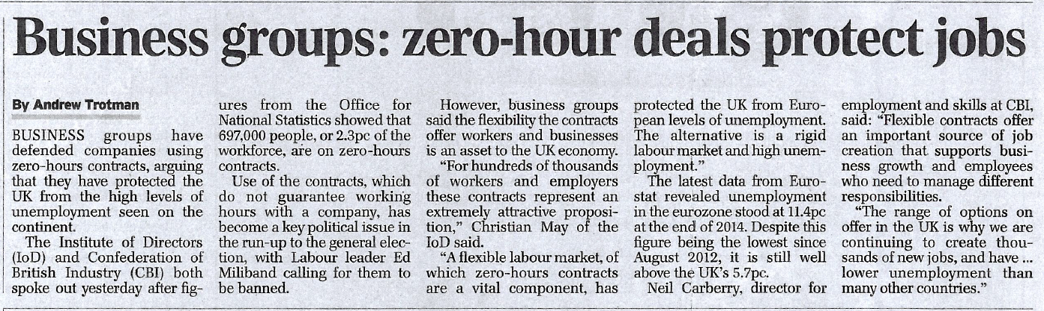

**The unemployment figures expose the philosophy behind our economic recovery**

By Alex Andreou in theguardian.com, Wednesday 13 August 2014 16.16 BST

*Many people are enjoying neither good wages nor job security – the outcome of the UK government’s neoliberal philosophy*

The recent destruction of business regulation, employment rights and unionisation has helped create a toxic environment in which most people are enjoying neither good wages nor job security.

The labour market figures released today show unemployment continuing to fall and the employment rate rising. This is good news, of course. The most striking data, however, has been on wage growth. For the first time since 2009, wages actually fell by 0.2% in the three months to June. Combined with a rising consumer price inflation index of 1.9% over the same period, it confirms a catastrophic squeeze on living standards.

The work and pensions secretary, Iain Duncan Smith, insisted all is not as bad as it seems. “You have to be in work in order to even have a chance of your wages rising,” he said. But that is to focus on the thousands of people entering the job market as somehow offsetting the problem of the many millions who were already working and have seen their wages squeezed for years now, while the cost of basic living continues to rise.

Recently, my friend J related to me her tale of self-employment over a drink. Having been made redundant from her job in a media company, she went into her local job centre to sign on. “Do you have any hobbies that involve making something?” she was asked by her adviser. “Well, I quite like to knit,” she responded. That was it. She was going to sell knitwear on eBay for a living. Despite her protestations, she was enrolled on a one-week start-up training course (this meant that she was paid the equivalent of jobseeker’s allowance but from a different fund and never showed up in unemployment statistics). On the first day of the course, she was put in a room with other “entrepreneurs” and shown episodes of the BBC’s Dragon’s Den. She was encouraged to use her savings to buy supplies for her “business”. She became anxious and unhappy. Thankfully, J found a regular job soon after and is now trying to sell the knitting supplies on eBay to recover some of her outlay costs.

This is, of course, only an anecdote – by no means an isolated one – but an anecdote that fits interestingly with the IPPR’s senior economic analyst Spencer Thompson’s view that “some [self-employed] are entrepreneurs, driven by high-growth ambitions, innovation and disruptive business models, but many are sole-traders simply looking to get by”. This is why, according to the IPPR, some in the Bank of England’s monetary policy committee see the dramatic rise in self-employment not as the success story it is being presented as, but as indicative of an underlying weakness in the recovery.

The squeeze is no temporary glitch, either. This morning the Bank halved its forecast for wage growth from 2.5% to 1.25% – below expected inflation – so the pincer movement is likely to continue. These figures represent a brittleness in the economic recovery and a significant political risk for the government. The more their vociferous insistence that things are getting better diverges from the reality of people’s lives, the bigger the chance it will be discounted as a fabrication by the electorate. Such ostrich-ism feeds directly into the perception that they are out of touch.

Duncan Smith’s thesis that people are more interested in security than wage increases may be true. But the government is uncomfortably shoehorning more and more of the workforce into self-employment, part-time work and zero-hours contracts. This combines with a sustained erosion of business regulation, employment rights and unionisation to create a toxic environment in which most people are enjoying neither good wages nor job security. It confirms critics’ assessments that the past four years have been not so much crisis-necessitated austerity as a structural change inspired by a neoliberal philosophy.

**It's not zero-hours contracts that are the problem, it's the bosses who abuse them**

By Ruth Hardy in theguardian.com, Thursday 19 December 2013 18.32 GMT

***As someone who has worked a zero-hours contract, I welcome Vince Cable's consultation – and his intention to crack down on exploitation***

Vince Cable intends to crack down on 'exclusivity clauses [in zero-hours contracts], meaning their workers are guaranteed no hours, but are prohibited from finding work with anyone else'.

Vince Cable today launched a consultation on zero-hours contracts, saying he wanted greater fairness, but would not be calling for a complete ban. Having worked a zero-hours contract for just under a year, I think he's right. For many, a flexible contract where you are not obliged to work fits in well with the demands of studying or another job. The problem is not with the contracts themselves, but with the way that employers are abusing them.

It is estimated that about 1 million Britons are on these contracts, and in recent years they have become much more widespread. For those who have a steady source of income that covers rent, food and other essentials, but occasionally need to top it up with extra work (such as students in the summer holidays, or those who have retired), zero-hours contracts can be a good fit for both employer and employee.

The problems arise when companies use zero-hours contracts for nearly all their staff, as a way to cut their own costs and limit the rights that their workers have. The distinction between "worker" and "employee" is a complicated one, but those on zero-hours contracts are usually defined as workers, meaning they have fewer rights than employees. Employees are entitled to statutory redundancy pay and the right not to be unfairly dismissed. Not all workers, however, are.

If you want a job with guaranteed hours, to be forced on to a zero-hours contract denies you the psychological security that comes with knowing how much you will earn in a given month. Insecure employment means that you are constantly worrying about money and making ends meet: you can have plenty of hours one week, and none the next. There is no safety net of a minimum number of hours. There is nothing to stop you from earning nothing.

And some companies have even been using exclusivity clauses, meaning their workers are guaranteed no hours, but are prohibited from finding work with anyone else. Vince Cable has announced that he intends to crack down on these, but it is an indication of how exploitative the current labour market is that they have so far been allowed.

Zero-hours contracts enable companies to transfer the burden of an uncertain economy on to those that they employ. They are assured of a pool of workers from whom they can draw in busy times and ignore in quieter times. At the staffing agency I worked for, we were told that some shifts were "non-cancellation", meaning that cancelling the shift (even from ill health or an emergency) would incur a fine of £10. Yet the company was not restrained by its own rules: once I took a day off my internship to make a non-cancellation shift, as I needed the hours. The day before, I was told numbers had been reduced so I would no longer be needed after all. This short-term cutting of shifts happened often, sometimes just hours before you were meant to start.

A culture in which employers are allowed to treat their workers as disposable cogs in a commercial machine is exploitative, and there needs to be more regulation to ensure that those who want a stable, set-hours contract are entitled to one, while those who need to work flexibly can continue to do so. The needs of businesses should not take precedence over the rights of those that work for them – even in an economic situation that seems to have lapped up most of our principles with it.