 | Inheritance Tax – should we increase inheritance tax to reduce poverty and inequality?
 | BACKGROUND |  |  |  |  |  |  | ARGUMENTS FOR | ARGUMENTS AGAINST
 | - 2.6% of inherited wealth is taxed in the UK (2010) and this increased to 6% in 2015 thanks to rising property rights  - 2.9bn raised per year in tax (compared to 158 billion for income tax)  - Conservatives recently (2015) cut inheritance tax that would have meant that 11.6% of estates would be paying IHT by 2017 would now be reduced to 6%  - Married couples would pay inheritance tax for any wealth over £1million  - Single person (who has not been widowed) has a threshold of £325,000  - The average house price in the South East is £338,000 and it's £510,000 in London.  - Any money above the threshold is taxed at 40% |  | 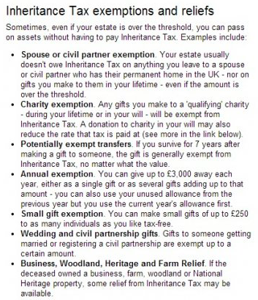 |  |  | 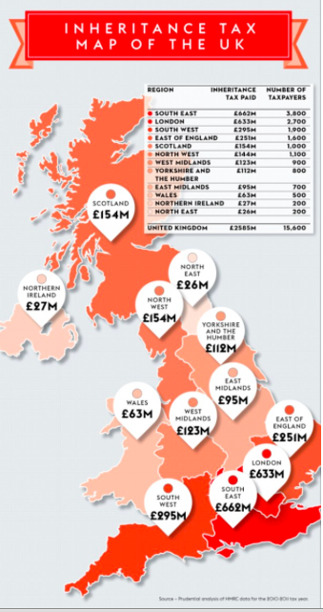 |  | - Inherited wealth provides people with an ‘unfair’ advantage in life. It creates an ‘inequality of opportunity’. It is a moral imperative that we have a tax to stop the rich getting richer and the poor getting poorer.  - Disincentive effect – richer inherited children have lower productivity?  - Forces house sales which provides more houses onto the open market and makes  - Some homeowners have not even been taxed once as they have benefitted from years of rising house prices simply because of the housing market as opposed to anything they may have done. It is right that they are taxed at their new found wealth.  - Only raises 2.9bn so far and could be much higher if loopholes for the very wealthy are removed. | - Unfair measure that taxes ‘hard working people’ twice and forces families to sell homes that my have been in their families for generations. It also prevents parents from helping their children.  - One measure which might have an impact but on it’s own would not solve the issue singlehandedly.  - Better measures available to ensure equality of opportunity; investment in education etc.  - Fall in entrepreneurial activity as family savings can be a useful form of finance to start new business especially in the light of a lack of lending from banks after the financial crisis of 2008  - Capital flight – wealthy pensioners leaving the UK means less money for investment in UK private sector  - A very unpopular tax – 2015 March YouGov poll found that 59% of voters thought it unfair. Raising it would be politically hard to do.  - So many loopholes that further increases in inheritance tax will not raise much extra revenue as the wealthy will avoid paying the tax
 |   One of the many books on Amazon to help you avoid paying inheritance tax | 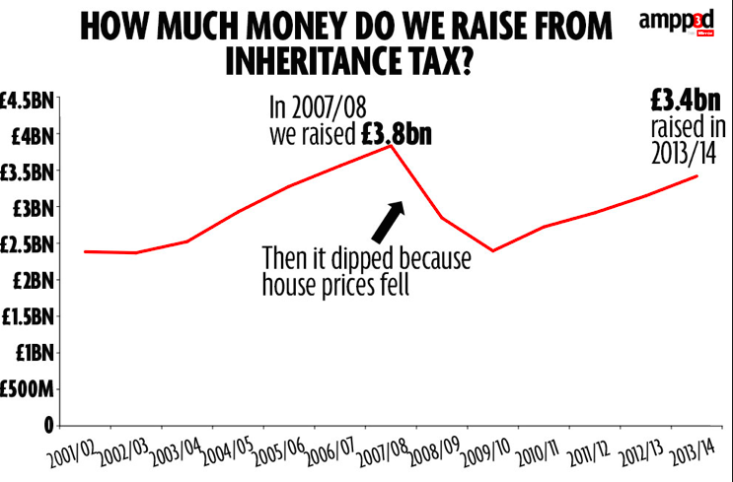
 | 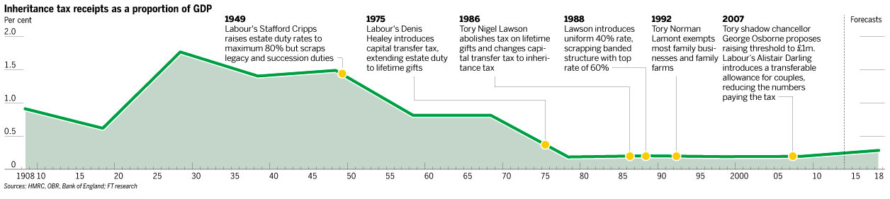
Taxation – should we increase progressive taxes (income and corporation tax) and reduce regressive taxation (VAT and excise duties) to reduce poverty and inequality
BACKGROUND |  |  |  |  |  |  | ARGUMENTS FOR |  |  | ARGUMENTS AGAINST
- VAT is currently 20% and was increased by the ‘Coalition Government’ in 2010 from 17.5%  - Income tax is measured in bands  - First £10,600 (Tax Free)  - £10600 to £31785 (20%)  - £31786-£150,000 (40%)  - £150,001 + (45%)  - Corporation tax is 20% |  |  |  | 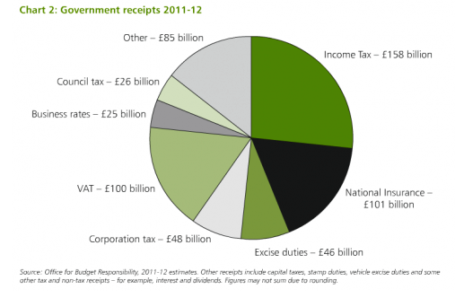 |  |  | - Income tax progressive and will hit poor least hard. VAT is a regressive tax and affects everyone and lower incomes pay a higher proportion of tax as their marginal propensity to consume is much higher. Excise duties hit the poor the hardest with high taxes on smoking for example. People on lower incomes are more likely to smoke and it takes up a much larger percentage of their total income.  - Diminishing marginal utility of income argument – Income has a diminishing marginal utility. The first £1,000 of income you earn gives substantial benefits. With this first £1,000 you can buy food to eat and contribute towards your rent and other basic necessities. Your first £1,000 has the highest utility because it is essential to maintain life and avoid absolute poverty. If you gain another £1,000 income this also increases your utility (satisfaction) because you can now buy better quality food and have improved shelter. But, the increase in utility is less than first £1,000. However, if you are a millionaire and gain an extra £1,000. The extra (marginal) utility is very limited. You can maybe buy a slightly more expensive car, you can buy a yacht that is 3ft bigger. But, the increase in utility / satisfaction is fairly limited. Therefore increasing income equality can lead to an overall net gain because the poor see a bigger increase in utility than the loss faced by high earners.  - Trickle down effect is dubious? Corporation tax is just one factor which might determine whether entrepreneurs take risks to start business  - The ‘Tax Gap’ is already there with non-doms etc. The Home Office Annual Fraud Indicator, suggests in 2011, tax evasion cost the taxpayer £15bn (Annual Fraud Indicator). This compares to benefit fraud of around £3.8bn. Therefore is increasing direct taxes going to make a difference; shouldn’t the Government be cracking down on this through legal means?  - During the 1980’s and 1990’s, Margaret Thatcher altered the tax system to put a greater burden onto poorer households which partly explains the increase in inequality since 1979 |  |  |  | - Disincentive effect – too high marginal tax rates = less likely that entrepreneurs (including foreign) will take risks to make money which might affect employment rates. Less of a trickle down effect? Also, less likely workers will supply labour if they have to pay too much tax (poverty trap?).  - VAT is not that regressive; it is aimed at luxury goods so some areas are not included – e.g. certain vegetables, raw meat, water to households, babywear, cycle helmets among other things!  - Tax Gap Arguments…Tax evasion and avoidance – wealthy individuals and corporations are more likely to be able to afford accountants who can get off shore accounts and avoid paying tax if rates are too high. Non dom status in the UK for example?  - Politics of envy – a calculated attempt by the ‘jealous’ to stop ‘hard working’ and ‘deserving’ people from making a living  - Excise duties are placed onto certain goods (e.g. smoking) to prevent negative externalities and smoking in the long run is bad for health and could lead to greater pensioner poverty?  - Wider economic effects – could lead to greater cost-push inflation if firms pass on the higher indirect taxation to consumers  - Politically unpopular to increase direct taxes…no political party iin recent times has won an election on a pledge to increase income tax for example.
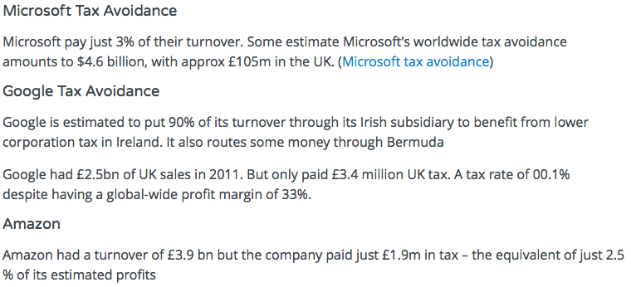  THE LAFFER CURVE  In economics, the Laffer curve is one possible representation of the relationship between rates of taxation and the hypothetical resulting levels of government revenue.  If the tax rate is increased, at first more revenue is collected but eventually taxpayers will look for ways to avoid paying the tax by either not working, not starting a business, not buying a particular good etc. |  |  |  |  | Exemptions from VAT  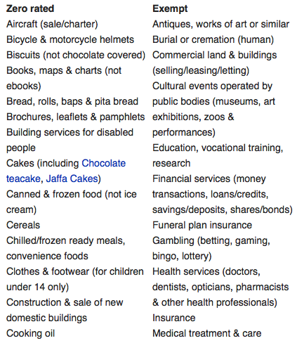  Other goods such as ‘Tampons’, take aways and alcohol are all subject to VAT.

