The Theory of the Firm: What is a Firm?
Introduction to types of firm, the role of shareholders and objectives of firms
TASK: Read the information below and complete the boxes using the internet, textbooks and your own knowledge

What is a Firm?
A firm is a business enterprise that either produces or deals in and exchanges goods or services. Unlike non-business organisations (e.g. a central government department), firms are commercial, earning revenue to cover the costs they incur in the hope of breaking even (earning “normal” profit) or earning more than their costs (earning “abnormal” or “supernormal” profit). There are different classifications of firms in the UK today.

Unincorporated Enterprises  - Sole Traders and Partnerships  Incorporated Enterprises  - Private Companies (Ltd)  - Public Companies (PLC) |  | Explain the difference between an ‘unincorporated’ firm and an ‘incorporated firm’
Example of a sole trader or partnership? | Example of a private company (Ltd) |  | Example of a public company (PLC) | 

The Structure of a Firm - The Main Players
 | Description and Example – Find out! | 
Entrepreneur
Owner/Shareholder
Manger/Director/CEO
Worker/Employee

The Divorce between Ownership and Management
Private companies tend to be smaller companies than public companies. As a result, the ownership and management of the company tend to be the same – there is no ‘divorce’ between the two. However, in larger public companies there maybe thousands of “owners” or “shareholders” (who have bought their shares on the stockmarket). These shareholders will appoint a CEO (Chief Executive Officer) or Manager to run the company for them. If this happens, it is called a ‘divorce between ownership and management – the person running the company does not own it….what do you think might be the positives and negatives of such a move? Use the internet to help with your evaluation.

What might be the positive effects of having this divorce? | What might be the negative effects of this divorce?

The Control of Companies – The Role of Shareholders
A shareholder is a person/organisation with a “holding” in the company. In other words, they own a part of the company. The shareholder can also have a say in the decision making process of the company. Shares can be a useful way of funding the business and raising money.

Private Companies and Shareholders - In a private company, the owner will hold a majority share with maybe several other shareholders. To buy shares in a private company, the investor would have to approach the owner of the company and persuade them to sell part of their business. Or the private firm might approach potential investors to persuade them to invest in their business: the basis of the BBC programme “Dragon’s Den”. Private firms tend to be smaller as a result, although the shareholders (the owners) tend to have more control over their business. They are also more likely to be the managers of the business as well as the owners.

Public Companies and Shareholders - Public companies can raise money by issuing shares on the stockmarket, which fundholders/individuals will buy up as an ‘investment’. The buying and selling of shares and the raising of finance becomes much easier and public companies (although fewer than private companies) tend to be much bigger. Often the ‘owners’ of these companies will employ specialist managers to run the company. However there is a “trade-off” with shareholder control at a public company level. Individual shareholders have much less power in a public company. Every year there is a report produced for the shareholder and an annual meeting (AGM) where shareholders can have their say and hold their managers to account.

TASK: Answer these questions using the information above and ‘research’ you have found from the internet and textbooks
Explain why the power of shareholders in large public companies might be limited compared to a private company?
Some people think that recently the power of shareholders in large companies has had a revival because of the ‘Shareholder Spring’. What does this mean?
In the UK, firms are often accused of being ‘short-termist’. What does this mean and why is it considered to be a problem and an advantage?
What has happened to share prices of Tesco’s in the past 10 years (up or down) and why might this be the case? Would you buy Tesco’s shares? Explain your answer.

Objectives of Firms
What motivates a firm in its actions? A question like this may only be answered if there is a clear understanding of who controls the decision making process: the owners (shareholders?), directors or managers, workers or the state? Traditional economic theory suggests that the firm’s main goal is to maximise profit and this is a central assumption in the work we will be doing on the subject.
TASK: Complete the mind map below by writing notes to describe the differing objectives below. Look up the terms using the internet and textbook to complete the mind map.

Behavioural Theories
(of ‘individuals’ in the Firm)

Maximise short run profit
Managerial Theories (Profit Satisficing)

Objectives of Firms

Ethical Reasons
Maximising Sales

QUESTION: Which do you think is the most influential objective of firms? Justify your answer

Market Structure: The Competition Spectrum

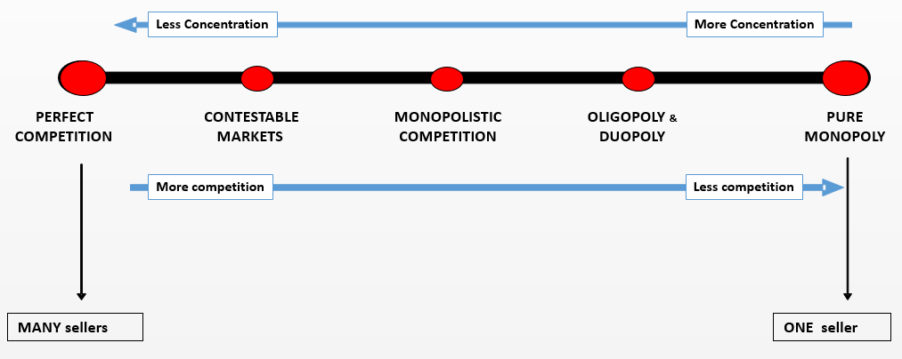 | Markets structure is an indicator of how much competition there is in the market. As with all spectrum’s, there are two extremes at either end, so-called ‘perfect competition’ and ‘pure monopoly’. In reality, neither of these two extremes really exist but they are useful for framing the discussion about how much competition is in a market and whether this is a good thing or not. One way to measure competition in the market and the size and power of firms is to measure the ‘concentration ratio’ of the market.

Measuring Market Power: ‘Concentration Ratio’s’ and the Grocery Market in the UK (or supermarkets)
TASK: complete the worksheet below using the internet and text book
What is a concentration ration?
What is the difference between a three firm and five firm concentration ratio?
What is the four firm concentration ratio of the UK grocery market currently (e.g. supermarkets)
Why since 2007 have the ‘big four’ supermarkets lost market share to the likes of Lidl and Aldi in your view?
How could you argue that there is adequate competition in the UK grocery market at present?
How could you argue that competition in the grocery market is not very good?
Why is competition very important in a market and what are the problems with monopoly power in a market?

Perfect Competition to Monopoly: The Growth of Firms

Why do Firms want to Grow?
The main objective for firms is to “make money” or “profit”. In a perfectly competitive market firms will only earn normal profit in the long run. Therefore they have an incentive to get bigger, dominate the market and benefit from economies of scale to enable them to start to make abnormal profit in the long run with a degree of market power.

Internal and External Growth
Internal growth is sometimes called “organic” growth. It is the idea that firms grow by investing in their productive capacity maybe via a new factory, office or the development of a brand. By its very nature, internal growth, although more stable, is likely to take a long time. External growth is a quicker method of growth and can make companies become very big in a short space of time. However this is at great immediate cost that might stretch the resources of a company and is considered to be more unstable.

Internal Growth: Investment and Branding
TASK: Using the company ‘Apple’ as an example, explain how they have expanded using internal growth….has it been a complete success? Research on the internet.

External Growth: Mergers and Takeovers
- A Takeover occurs when one firms (acquiring) buys another firm (target). Takeovers can be classed as friendly or hostile. A successful takeover will lead to an effective merger and the new firm having a greater market share.
- A merger occurs when two firms join together to form one. The new firm will have an increased market share, which may reduce competition but could also benefit from economies of scale.
- A merger is often associated with two firms in the same sector of the economy (e.g. a pub merges with another pub or a manufacturing company takes over another company. This traditional type of merger is called ‘horizontal integration’. However it could also be with another firm up or down the ‘supply chain’ thus making it an example of ‘vertical integration’. Or it could be between firms that have very little in common in terms of what they sell and this is called a ‘conglomerate merger’. For example if Google decided to merge with McDonalds!
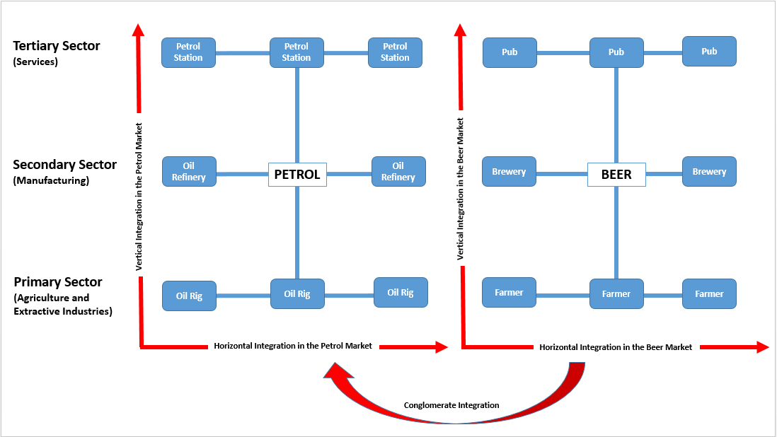
  Is the following takeover/merger an example of horizontal, vertical or conglomerate integration?
  WM Morrison (supermarket chain) with Safeway (supermarket chain) – 2004
  Greene King (a brewer and pub operator with Laurel (a pub operator) – 2004
  Kwik-Fit (a mechanics) with Ford (a car manufacturer) – 1999
  British American Tobacco (a tobacco company) with Farmers Group (a US insurance group) – 1988
  Pete and Johnny (a manufacturer of smoothies, a crushed fruit drink) with Pepsi (the drinks and snack group) - 2005
TASK: Using the internet to research, explain why Microsoft took over Nokia in 2013 using the concepts of vertical, horizontal and conglomerate integration, as appropriate? (i.e. you do not need to use every term; perhaps just one which explains the takeover)

