Shareholder spring: where are we now?
Jamie Dunkley Wednesday 22 April 2015 in the ‘Independent Newspaper’

Boardroom heads rolled when investors rose up and staged a series of pay revolts in the 2012 AGM season. Jamie Dunkley examines whether the events that rocked the City of London were game-changing or have been consigned to history

A wave of revolutionary demonstrations spread across Tunisia in December 2010 after a 26-year-old street vendor called Mohamed Bouazizi set himself on fire in protest at his treatment by police. Within weeks, the turmoil spread to other Middle East countries and months later, rulers in countries including Egypt and Libya had been overthrown.  To link this so-called “Arab Spring” to the City of London may sound ludicrous, but this is what happened a year later when a series of pay revolts by investors took place during the 2012 annual general meeting (AGM) season. Britain’s “shareholder spring” contributed to the downfall of AstraZeneca’s chief executive, David Brennan, as well as Sly Bailey of Trinity Mirror and Andrew Moss at Aviva. Others including WPP’s Sir Martin Sorrell survived but were left bloody nosed by confrontations with angry investors. | 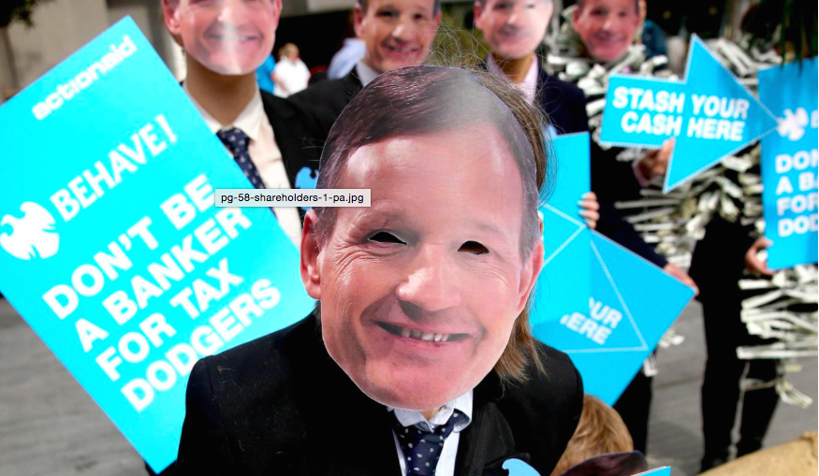

Since then, other companies, including RSA Insurance and National Express, have been hit by pay revolts. Just how game-changing were the events in 2012?

Statistical evidence in 2015 suggests not a lot, with the total remuneration packages of the largest 350 companies on the London Stock Exchange rising 12 per cent last year. Finance directors saw their pay increase by 9 per cent and other directors 12 per cent. Therefore the executives and directors are still paying themselves large amounts of money.

However other research suggests that executive pay is now more closely aligned to pay awards handed out to general employees. This follows changes to the law, which mean companies are now required to disclose broad based employee pay increases, alongside executive pay to make everything more transparent.

“Shareholder activism is no longer the sole province of the US,” said Alex Tamlyn, a partner at law firm DLA Piper. “It is a movement that is becoming global. Boards must ensure that their business behaviour is clearly aligned with their company’s declared values.”

“Some companies are certainly more sensitive to public opinion than others but I think they are now generally more proactive,” said Ashley Hamilton-Claxton, corporate governance manager at Royal London Asset Management. “We’re seeing more companies consult us on pay and it’s happening earlier in the year than before, sometimes before they’ve even decided how much to pay executives. However, that doesn’t always mean they change things if we disagree.”

In 2015, shareholders seem to be baring their teeth, with RSA Insurance‘s chief executive, Stephen Hester, reportedly facing a backlash from leading investors over the company’s decision to hand him a long-term share award worth three times his £950,000 salary. Rival insurer Aviva was also forced to water down benefit packages handed to two of its senior executives following talks with the influential shareholder voting agency Institutional Shareholder Services. The company said that both chief executive Mark Wilson and finance director Tom Stoddard had agreed not to accept the Long Term Incentive Plans (L-Tips) handed to them earlier this year, worth a maximum £3.43m and £1.03m respectively in the light of a feared backlash from public shareholders.

Executive pay rebellions loom in ‘shareholder spring’
Adapted from 2017 article in the Financial Times

Rise of populist politics, Trump and BREXIT has added to a broad dissatisfaction over remuneration of directors and executives

WPP plc (WPP) is a holding company (similar to Virgin) engaged in providing communications and marketing services. The Company comprises companies in a range of disciplines, which include advertising, media & data investment management; public relations and public affairs; branding and identity; healthcare communications; direct, digital, promotion and relationship marketing, and specialist communications. Last year, WPP went to great lengths to ensure that its annual general meeting (AGM) was a cheerful affair with a colourful stage decked out to resemble a Cuban street scene.  But shareholders were in no mood to be jollied as WPP executives prepared to defend the £70m payout for chief executive Martin Sorrell, the highest award given to any boss in the UK last year. | 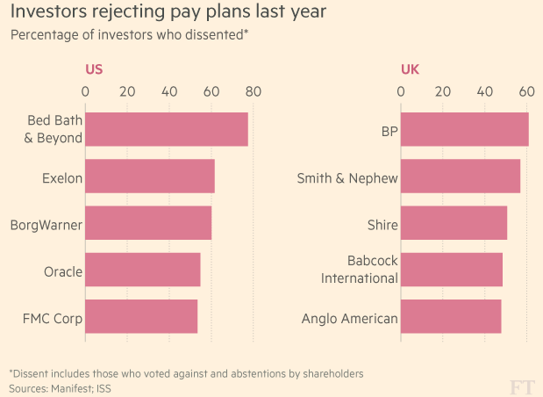

The shareholder rebellion that followed, which saw more than a third of investors reject pay plans, was just one flashpoint in the wave of shareholder unrest about escalating executive wages around the world in 2016. Some analysts are clear that these events will be the start, rather than the end, of the so-called “shareholder spring” as companies face ever more pressure to curb pay plans in the US and UK, in particular.

Investors predict a second stormy AGM season, with corporate governance experts highlighting “serial misbehavers” such as Liberty Media and Oracle in the US, and WPP, Sports Direct and BP in the UK, as companies expected to come under renewed attacks this year.

“Boards, aided by remuneration consultants, have managed to get away with giving excessive amounts of pay. There is a sense [among the public] that big businesses are fat cats who are in it for themselves,” says Richard Buxton, chief executive of Old Mutual Global Investors. “[Executive pay] has got out of hand.”

Investors put this shift down to growing public dissatisfaction with wealth inequality in the US and Europe and the criticism asset managers have received for routinely supporting management on pay.

Asset managers’ focus on the political climate marks a distinct shift for a community that usually stages a rebellion when there is a mismatch between a company’s pay plans and its performance.

Luke Hildyard, policy officer at the PLSA, an organisation that represents 1,300 UK pension funds with combined assets of £1tn, says the political climate has made it untenable for investors to turn a blind eye.

“The sense of two Americas — the economy only working for an elite at the top — was a big driver in Trump’s success. Unless stronger action is taken to address that perception, some quite economically disadvantageous policies will be advanced,” he says.

