‘Quarterly capitalism’ is short-term, myopic, greedy and dysfunctional
By Will Hutton 7 May 2016

Shareholders must stop sucking companies dry at the expense of innovation, investment and the wellbeing of the workforce

It has been obvious for years that British capitalism is profoundly dysfunctional. In 1970, £10 of every £100 of profit was distributed to shareholders: today, under intense pressure from short-term owners, companies pay out £70. Investment, innovation and productivity have slumped. Few new companies grow to any significant size before they are taken over by larger firms.

Exports from British firms has stagnated. The purpose of companies now is not to do great things, solve great problems or scale up great solutions –why capitalism is potentially the best economic system – it is to become incentives for their disengaged owners in the next big deal or takeover. Not only the British economy suffers – this process has become the major driver of rising inequality, low pay and insecurity in the workplace as management teams are forced to treat workers as costly commodities rather than allies in building the business.

There is absolutely nothing wrong at all with the British private sector, runs the Conservative argument: to the extent the British economy does have problems, they are rooted entirely in taxation, regulation from government and the trade unions NOT business. But in a week when the Financial Times – a great British asset and embodiment of the best of our journalism – has been sold to Nikkei for no better reason than to support Pearson’s short-term share price, powerful and public criticism of the way British capitalism operates has come from an unexpected quarter.

Last year, the governor of the Bank of England, Mark Carney, called on firms to have a greater “sense of their responsibilities for the system”, in particular the social contract on which market capitalism’s long-term dynamism depends. The explanation was simple: British (and indeed American) company law “puts the shareholder at the forefront of everything. It puts the short-term interest of shareholders in a position of primacy when it comes to running the firm. He thought company law that placed shareholders on a more equal footing with other stakeholders – workers, customers, clients – would work better. Dare I say it – stakeholder capitalism?

He damned the way the public limited company has developed. “The public limited company model has served the world well from a growth perspective. But you can always have too much of a good thing. The nature of shareholding today is fundamentally different than what it was a generation ago. The average share was held by the average shareholder, just after the war, for around six years. Today, that average share is held by the average shareholder for less than six months. Of course, many shareholders these days are holding shares for less than a second. No one cares about the businesses anymore apart from what profit they can glean from it.”

Hillary Clinton was also speaking from the same script, attacking what she called “quarterly capitalism”. “American business needs to break free from the tyranny of having to report profits EVERY yearly quarter, so they can do what they do best: innovate, invest and build tomorrow’s prosperity,” the Democratic presidential front runner declared. “It’s time to start measuring value in terms of years – or the next decade – not just the next quarter.”

It is long overdue and the argument is beginning to get traction in the US. Free-market apologists insist that the more cash is handed back to shareholders, then the more they have to invest in innovation. The stock market is doing its job: promoting efficiency. The trouble is that the market is hopelessly inefficient, greedy and myopic. When Larry Page and Sergey Brin floated Google, they took care to insulate the company from “quarterly capitalism”: they accorded their shares as Google’s founders 10 times the voting rights in order to protect their capacity to innovate from the stock market – what they considered Google’s real business purpose.

From robots to self-driving cars, from virtual reality glasses to investigating artificial intelligence, Google is now one of the most innovative firms on Earth. Meanwhile the typical US Plc, like its counterpart in Britain, is hunkering down, investing and innovating ever less and distributing more cash to shareholders. Far from market efficiency, the whole system is undermining the legitimacy of capitalism.

Is short-termism wrecking the economy?
By Duncan Weldon - Newsnight economics correspondent for the BBC. 30 July 2015

Last Friday on Newsnight the Bank of England's chief economist Andy Haldane sought to kick-start a debate on how companies run themselves. He told me that companies risk "eating themselves" as shareholders and management were gripped by a form of short-termism.

Instead of investing in their futures firms are choosing to pay out too much of their cash to shareholders in the form of dividends or by buying back their own shares. So, what's going on here? As I said on Newsnight last Friday, it's now everyday that the Bank of England appears to question the workings of the core institution of contemporary capitalism - the public company accountable to its shareholders.

Leaving aside the point about financial stability and whether the current model of governance encouraged excessive risk taking (which it might have), it's certainly worth considering whether "short-termism" may have serious economic consequences. As Haldane has argued corporate investment has been weak for years. It's not just an important reason why the current global recovery has been weaker than hoped, but a longer-running problem. And it may be that it requires a "structural fix". The conventional levers of fiscal and monetary policy aren't getting the response one might expect.

On the fiscal side, UK corporation tax has been slashed by the current government from 28% to a lowest in the G7, 20%. And on the monetary side interest rates have been at a record low 0.5% for six years. If lower taxes and low borrowing costs aren't spurring investment, then maybe it's worth trying something else?

This is the territory Hillary Clinton is on when she berates "quarterly capitalism”. One issue is whether such short-termism can really be bad for the whole economy rather than just individual companies? If one short-termist company forgoes a profitable long-term investment, surely another (maybe privately-owned) will step in to make it?

Maybe. But I worry that makes some heroic assumptions about market structures. In any industry with high barriers to entry, dominated by large listed firms, it may be that in the short run the necessary investment can only come from the reluctant short-termists.

Of course, serial followers of the UK corporate governance scene may be left a little confused by this as in recent years much of the debate hasn't been focussed on over-mighty shareholders being too short-termist but on disinterested shareholders who don't take their ownership responsibilities seriously enough and have devolved too much control to company management.

However it still might be perfectly possible that shareholders might be too powerful and too disinterested. The issue could be that management is too focussed on short-term shareholder returns and so prioritises returning cash to them and increasing the share price in the short term, even if that isn't in the company's long-term interest.

To understand how this situation might have arisen over the last few decades, one only needs to look at two trends. There are fewer and fewer investors willing to take a long-term view. And secondly the trend has been to increasingly tie top management payment to share price performance. In other words, whatever the long-term benefits of investment in machinery, research or training five or six years down the line, we may have a system in which the rational thing to do is to focus on the next six months, not the next six years.

The possible fixes to this situation are many and varied - from embracing a Germanic system of stakeholder capitalism (in which the workforce as well as the owners have a role in decision making), to looking again at executive compensation or maybe to an intermediate situation - perhaps ordering directors to act in the interest of a theoretical "perpetual shareholder", rather than existing (often short-term) investors. None of those options are a quick fix, all involve reform of the Companies Act, which is a mammoth bit of legislation.

And it's worth remembering that that act was supposed to allow a greater role for other stakeholders alongside shareholders but, in effect, it has increased shareholder primacy.

This is a big agenda and a big debate. On one level it could even be described as an attempt to save capitalism from capitalists, an argument that the ultimate owners of capital have stopped working in their own long-term interest.

But, perhaps in those terms, it sounds too radical. On a more micro level this is a debate about economic incentives.It may simply be that the incentive structure in Anglo-Saxon capitalism has become skewed towards rewarding short-term behaviour. If that is the case, then it's harmful to the economic growth but also very fixable.

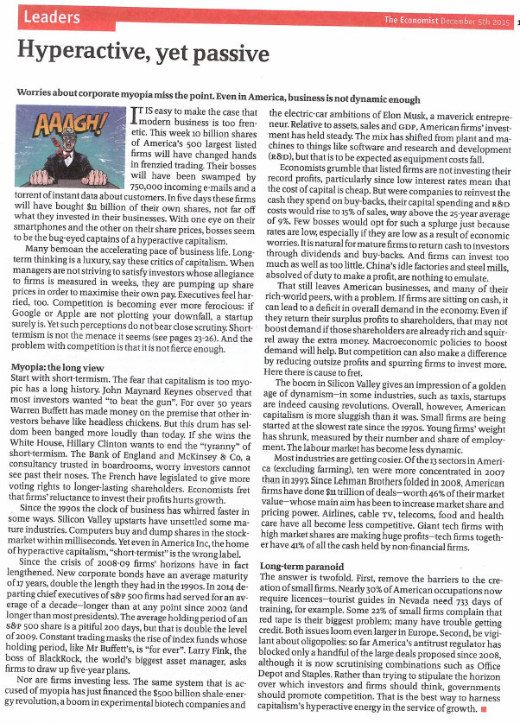
THE ECONOMIST 2016

