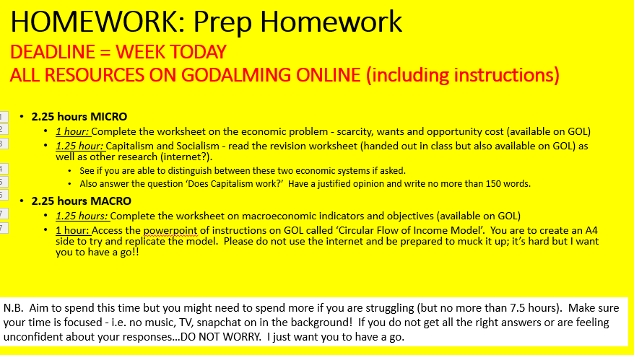

REMEMBER MY EMAIL ADDRESS IS [ods@godalming.ac.uk](mailto:ods@godalming.ac.uk) if you have any questions or queries….no question is a stupid question remember! Make sure you clarify your understanding.