The UK Economic Cycle and Unemployment

**The UK Economic Cycle 1966 to 2019**

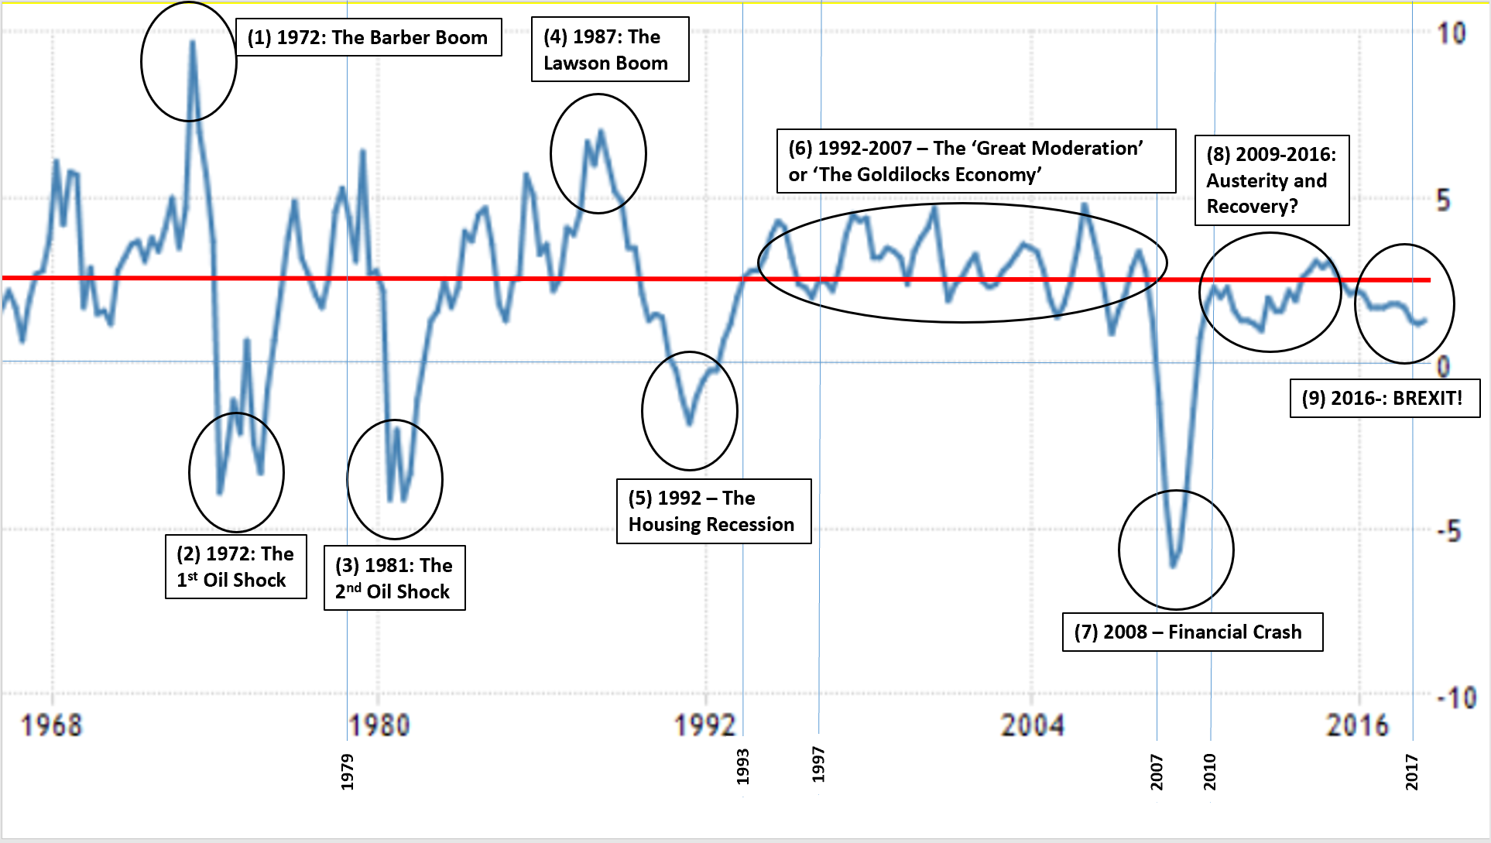

The red line represents the ‘trend growth’ rate and the blue line represents the ‘actual growth’ of the UK economy.

TASK: From the graph, identify the following:

|  |  |
| --- | --- |
| Identify the four times that the UK economy went into recession.  What do you think happened to the unemployment rate in these four periods and WHY? |  |
| At the bottom are a series of dates: 1979, 1993, 1997, 2007, 2010, 2015 and 2017. What do you think they refer to? |  |
| Section 7, refers to the 2008 Financial Crash. Using the internet, research this episode of history. What was the financial crash and why did it lead to a recession? WARNING: Do not need to go into great detail here; just a broad overview… |  |

**The Unemployment Record of the UK**

TASK: Read the article ‘Measuring Unemployment’ on GOL and then answer the questions below, using that information and the graph:

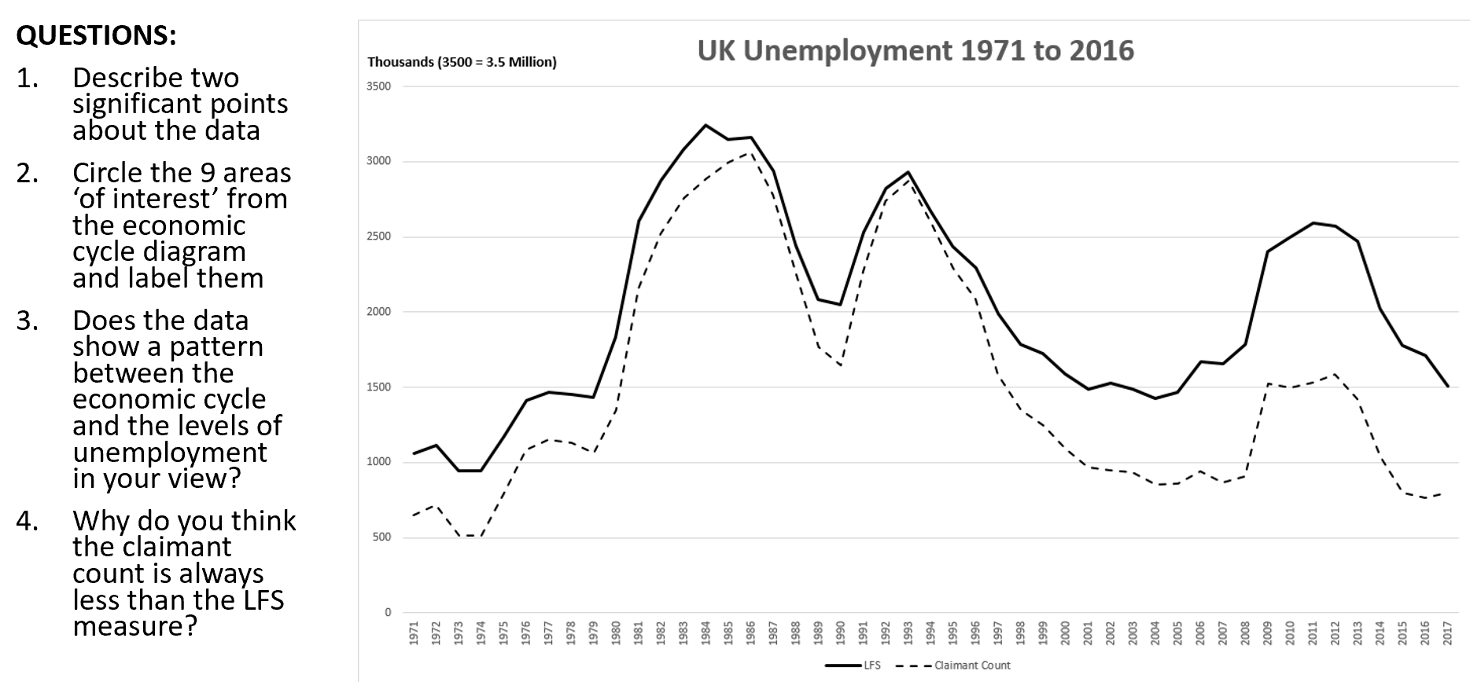

ANSWERS BELOW