UK’s current account deficit is worrying – and Osborne has no strategy to fix it
By Larry Elliott in The Guardian, Tuesday 23 December 2014 13.21 GMT

The chancellor has pledged to cut the budget deficit, but lacks a plan for dealing with Britain’s other deficit now at 6% of GDP

The deficit. For the past five years George Osborne has talked about little else. Reducing the deficit has been at the heart of what the chancellor likes to call his long-term economic plan. The plan, we are assured by the Treasury, is working.  Well, here’s the latest news. Growth is not quite so robust as the government previously thought it was. The expansion relies heavily on consumers spending money they haven’t got. And Britain has not one deficit but two: a record current account deficit to go alongside a still stubbornly high budget deficit.  The size of the current account deficit is worrying. Britain has a history of being in the red on its external accounts, because of the tendency to consume more than we produce and to import more than we export. But usually big current account deficits come at the end of raging booms, as was the case in 1973 and 1988. Today’s current account deficit is running at 6% of GDP, higher than in the early 1970s or the late 1980s, and it comes when the recovery is only 18 months old. | 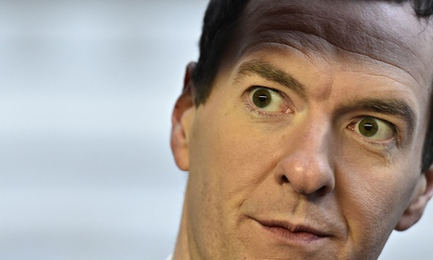  The chancellor, George Osborne. Why more people are not worried by the hidden half of Britain’s twin-deficit problem is a mystery. Photograph: Toby Melville/Reuters

What’s happened is this. Ever since the de-industrialisation of the early 1980s, Britain has run a hefty and growing deficit on its trade in goods, which stood at £32bn in the third quarter of 2014. Fortunately, this dismal performance was offset by the efforts of the UK’s service sector, which racked up a surplus of £23bn. That left a trade deficit of £9bn for the third quarter.

But the current account is more than just trade. It also takes account of how well Britain’s overseas investments are doing: not just foreign direct investment (FDI) but punts made on overseas markets. Here, there have been two recent trends. Firstly, the UK has been doing less well on its portfolio investments than in the boom days before the financial crash. More recently, overseas investors have been making more money on their FDI in the UK than UK investors have been making on their FDI abroad. The primary income account added £12.6bn to the current account deficit in the third quarter.

On top of this there is the secondary income account. This is mainly the money Britain pays for the running of international organisations such as the European Union, the United Nations and the World Bank. This added up to just over £5bn in the third quarter.

There was a time when a current account deficit of much less than 6% of GDP would have seriously troubled the financial markets. Why they are not more worried by the hidden half of Britain’s twin-deficit problem is something of a mystery, because it is clear that the country can no longer rely on North Sea oil and the racier activities of the City of London to mask the chronic deficit on visible trade.

When the markets do start to focus on the current account, this is what they will find. Firstly, export performance has been disappointing despite a 30% drop in the value of the pound between 2007 and 2009. Secondly, the recovery from the recession has been of the bog standard variety: based around rising consumer spending that will suck in imports. Thirdly, there is a real difference in the way the government approaches the twin deficit. Osborne has a plan for the budget deficit, even if it is flawed. For the current account deficit, there is no plan at all.

