**MACROECONOMCIS PREP HOMEWORK INSTRUCTIONS**

DUE FOR Monday 26th November (1.5 to 2.25 Hours Work)

**INTERNET RESEARCH, READING ARTICLES AND CREATING MIND MAPS ON Deflation in Japan and the UK**

***TASK 1 (1-1.5 hours): Japanese Deflation and ‘The Lost Decade’***

1. Draw a mind map ***(handwritten)*** and research the ‘lost decade’ by writing notes underneath each of these headings
2. What happened? ‘The Lost Decade’ of Japan
3. Causes of deflation in Japan
4. Effects of deflation for Japan
5. Solutions put forward by the Japanese to combat the deflation they experienced
6. What is ‘Abenomics’ and has it worked?

***TASK 2 (0.5 hours to 1 hour): Deflation in the UK***

**%**

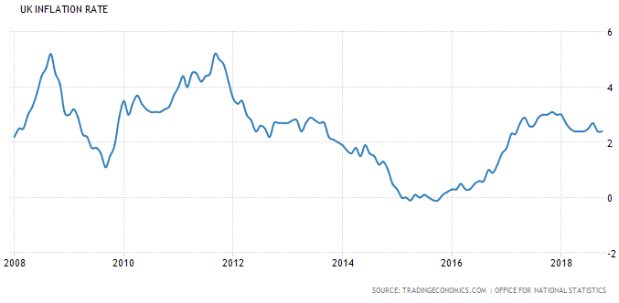

After the financial crash, there were several times in 2015 when there were significant worries that the UK would ‘do a Japan’ and suffer from deflation which could lead to a ‘deflationary spiral’. Since then inflation has picked up.

Therefore, I would like you to investigate (researching) the following two questions:

1. Why you think the inflation rate has started to increase from 2016 onwards…(hint: BREXIT but why!?).
2. To what extent do you think the UK will suffer from deflation in the next 5 years? Have at least ONE argument to say it will suffer from deflation and have at least ONE argument to say it will not.

PLEASE NOTE: This is an introductory exercise to an area you have not studied yet. I am not expecting you to understand everything you read and in some ways I am hoping this exercise raises more questions for you to bring up in class next week. Also, there is no right or wrong answer here. It is opinion based upon as much research you can do in the allotted time.

Remember it is not about the right answer with these homeworks, it is about you having a go at research and understanding these concepts on your own first to give you context in the lesson.