26.9% Yes, that's what the inflation rate was back in August 1975
Evening Standard - Jan 17, 2007

HAD YOU stopped any passer by on the street 32 years ago and asked what he thought of the prospect of three per cent inflation, he would have laughed in your stupid face. For in the summer of 1975, when Britain stared into the abyss of hyperinflation and economic meltdown, our current rate of inflation would have sounded like the stuff of fantasy.  It is a cliche that the past is a foreign country. Yet if we were transported back to London in 1975, it really would feel like a different world. Pictured through the rose-tinted glasses of nostalgia, Britain in the mid-Seventies often looks like a gaudy, dizzying disco world of glitter balls and chopper bikes, but that is certainly not how it felt at the time. In 1975, Britain was the "Sick Man of Europe", a country on the brink, economically and politically.  That August, inflation reached the dizzying level of 26.9 per cent, the worst in British history. It had begun in the late Sixties, thanks to rising commodity prices, the new ambitions of the consumer society, the stubbornness of the unions and politicians' refusal to stand up to them. |  |   Steven Speilberg released the famous “JAWS” film  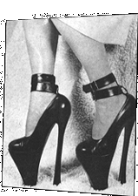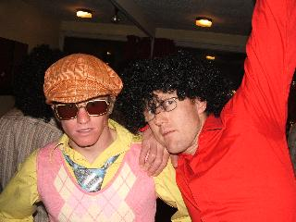  Platform shoes were Gaudy tank tops and afro’s were in!  the order of the day!
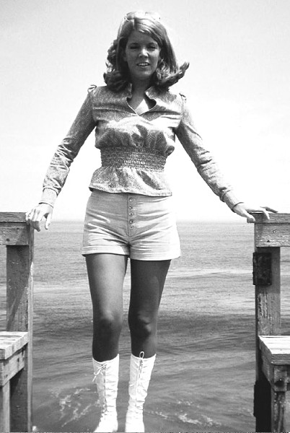  “Hot pants” were invented! | By 1970 inflation was running at more than six per cent; the 1973 oil shock made matters even worse; by the end of 1974 it was soaring towards 20 per cent.  When the capital's housewives went out to buy their sliced white loaves, Vesta curries and cans of spam, they could never be sure how much money they would need. The cost of living was soaring so rapidly that almost every morning London's greengrocers had to scribble down new prices for their fruit and veg.  That winter many offices turned off their central heating to cut costs, while most shopkeepers, accustomed to power cuts, kept a supply of candles. And with inflation eating  London had seen a roaring house price boom since the early Seventies, and many middleclass families were terrified that they would be priced out of the market. But rampant inflation was only the most pressing of Britain's problems in the summer of 1975.
To modern eyes, London would look remarkably shabby and miserable, the West End choked with diesel fumes, the pavements dusty and cluttered, the shop windows grey and lifeless.

As inflation, propelled by lavish pay claims and high oil prices, headed over 20 per cent, some turned to radical alternatives. The National Front was picking up support in London's grim new concrete estates, where many people blamed recent Asian immigrants for Britain's economic woes.

Only a few months earlier, National Front marchers had bloodily clashed with Marxist demonstrators in Holborn, and one man had been killed.

In 1975, Britain's infrastructure was astonishingly decrepit, its economy ravaged by inflation and unemployment, its international standing a joke.

To the Londoners of 1975, the idea that one day, 4.4 per cent on the Retail Price Index - the price measure which includes property costs - would be seen as a national calamity would have seemed simply unbelievable.

And that, more than anything else, should remind us how far we have come.
HOW WE LIVED THEN

 | John Stephen, Chinawhite nightclub owner: "I was selling silk dresses.  Prices were going up and no one had any money. I went bust.  Inflation is a terrible thing, but under Gordon Brown there is one tax after another and everything is more expensive."
Tim Martin - Wetherspoon pubs founder: "I was a student in Nottingham. It was the beginning of the end of an unsustainable era. There was a belief you could print money and get yourself out of economic problems.  I didn't open my first pub until 1979 but people my age (51) have seen interest rates go sky high so are more cautious than people nowadays." | 
 | Glenda Jackson MP. "I was a 39-year-old actress living in London. In the Seventies you could not bury your dead and the rubbish was not being collected. But the terrible social destruction of the Thatcher years was worse. Today is not comparable with the crisis in the Seventies."
Philip Green - retailer: "In 1975, I started importing clothes from the Far East. There were few factories, now there are hundreds and clothing and electricals are cheaper now in real terms. Inflation today is driven by oil and property. The minimum wage is up 27 per cent in four years, local rates are up, taxes are up - but show me a product that isn't cheaper." | 