UK inflation measures
Adapted from the BBC News Website: (Last Updated: Tuesday, 20 January 2009) and the ONS (2006)

Recent inflation history
Consumer price inflation dropped sharply in December to an annual rate of 3.1% from November's figure of 4.1%. The biggest factor was the cut in VAT from 17.5% to 15%, announced in the pre-Budget report on 24 November, the Office for National Statistics said. But high food, gas and electricity prices prevented the rate from falling as fast as economists had predicted. The headline Retail Prices Index (RPI) measure fell to 0.9% from November's 3% rate, the biggest fall in 28 years. | 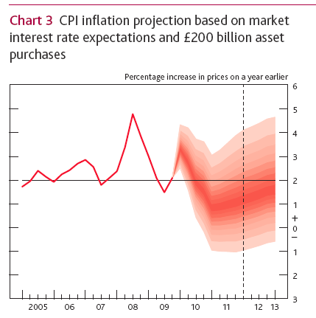
Why is there more than one inflation measure?
The inflation measures can have a major influence on the economy, affecting matters such as interest rate decisions, pensions and wage settlements. Basically because there are many different ways of measuring the way that prices change. Both the CPI and RPI are attempts to estimate inflation in the UK, but they come up with different values because there are slight differences in what goods and services they cover, and how they are calculated. The RPI measure is arguably the better known in the UK. Sometimes referred to as the "headline" rate of inflation, it is the rate often cited by unions as a benchmark for agreeing pay settlements. The CPI measure is the rate the government's inflation target is based on. It is an internationally comparable measure of inflation - CPI inflation measures are analysed by the European Central Bank when setting interest rates in the eurozone. It has been around informally since the 1988, but was properly launched in January 1997.

How are they calculated?
Both the CPI and RPI are an attempt to measure the changes in the cost of buying a representative basket of UK goods and services. The methods used to calculate both indexes are similar. Each month thousands of prices for a selection of goods and services are analysed to check on any increases. Some of the goods and services will carry a higher weighting, reflecting the fact that we spend more on some items than others.

Each year, the make-up of the "basket" of good and services, and the weightings assigned to them, are revised to take into account changes in spending patterns. For example, in recent years people have tended to spend more of their money on electrical goods, travel and leisure, while the proportion they have spent on basic items such as food has fallen.

So why do the CPI and RPI values differ?
Not all the items covered by the RPI are included in the CPI measure. For example, the CPI does not include Council Tax, mortgage interest payments and some other housing costs. The CPI measure also includes some items - such as charges for financial services - which are not in the RPI. Another difference is that the CPI measure covers a broader sample of the population in its calculations than RPI. There is also a difference in the mathematical methods used to calculate the price changes which, the Office for National Statistics says, means that in practice the CPI always shows a lower inflation rate than the RPI rate for given price data.

Why does the government target the CPI rate?
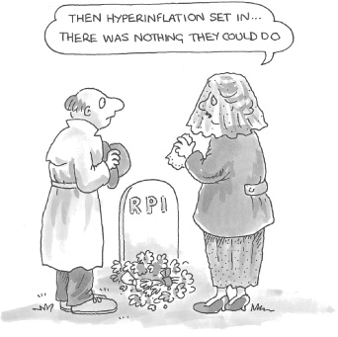 | Until 2003, the government targeted RPI. In his pre-Budget speech in December 2003, Chancellor Gordon Brown said the inflation target would be switched to the CPI measure with immediate effect. The government cited three reasons why CPI was a better measure for the purposes of setting monetary policy:  - it gives a more realistic characterisation of consumer behaviour  - it gives a better picture of spending patterns in the UK  - it is a more comparable measure of inflation internationally and represents international best practice  The government's current target for CPI is 2%, which the Bank of England is tasked with hitting. If the rate moves by more than one percentage point either way - that is, it breaks out of the range 1-3% - the governor of the Bank of England must write to the chancellor to explain why.
How the data is collected and processed
The Consumer Prices Index (CPI) and the Retail Prices Index (RPI) are published each month by the UK Office for National Statistics. These are the main measures used in the UK to record changes in the level of the prices most people pay for the goods and services they buy. The RPI is intended to reflect the average spending pattern of the great majority of private households. Only two classes of private households are excluded, on the grounds that their spending patterns differ greatly from those of the others: pensioner households and high-income households. The CPI, however, has a wider remit—it is intended to reflect the spending of all UK residents, and also covers some costs incurred by foreign visitors to the UK.

The CPI and RPI are calculated once a month and are based on a very large ‘basket’ of goods. The contents of the basket and the weights assigned to the items in the basket are updated annually to reflect changes in spending patterns. However, once decided on at the beginning of the year, they remain fixed throughout the year.

Each month, for the RPI, the price ratio for the basket is calculated relative to the previous January. The CPI works in much the same way, except that price ratios are calculated relative to the previous December. In practice, data on most prices are collected on a particular day near the middle of the month; the values of the RPI and CPI calculated using these data are referred to simply as the values of the RPI and CPI for the month. For example, the RPI took the value 183.1 in January 2004. This value measures the ratio of the overall level of prices in that month to the overall level of prices on a date at which the index was fixed at its starting value of 100. This date is called a base date, which was 15 January 1987 (in 2005). Thus the general level of prices in January 2004, as measured by the RPI were 83.1% higher than in January 1987. The base date has no significance other than to act as a reference point.
RPI Weighting  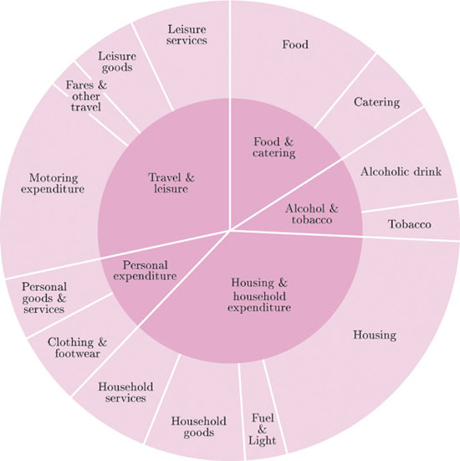 | The weighted indexes  The RPI and CPI are each based on a very large ‘basket’ of goods. (The two baskets are similar, but not exactly the same.) Each contains some six hundred and fifty items including most of the usual things people buy—food, clothes, fuel, household goods, housing, transport, services, and so on. Each basket is an ‘average’ basket for a broad range of households.  The items in the baskets are often grouped into broader categories. For the RPI (see graph to the left), the five fundamental groups are ‘Food and catering’, ‘Alcohol and tobacco’, ‘Housing and household expenditure’, ‘Personal expenditure’ and ‘Travel and leisure’. These groups are divided into fourteen more detailed subgroups (which are further divided into sections).  The inner circle shows the five groups, and the outer ring shows the fourteen subgroups. Notice that in the inner circle the sector labelled ‘Food and catering’ has been drawn almost twice as large (as measured by area) as that labelled ‘Alcohol and tobacco’. This reflects the fact that the typical household spends nearly twice as much on food and catering as on alcohol and tobacco. The weight of an item or group reflects how much money is spent on it. So the weight of the ‘Food and catering’ group is almost twice that of ‘Alcohol and tobacco’.  The outer ring represents the same total expenditure as the inner circle, but in more detail. For example, in the outer ring the area labelled ‘Food’ is more than twice as large as that labelled ‘Catering’ (which includes meals in restaurants and canteens, and take-away meals and snacks), reflecting the fact that the typical household spends more than twice as much on food as on catering; the weight of the subgroup ‘Food’ is more than double the weight of the subgroup ‘Catering’. The chart gives a good indication of average spending patterns in the UK in the early 21st century.  The items in the CPI basket are divided into twelve broad groupings called divisions which are further subdivided, rather than just 5 like the RPI
CPI Weighting

