Macroeconomic Equilibrium and Economic Growth

Economic growth is the increase in output (or income) in an economy and is measured through ‘Real GDP’. Essentially if the economy produces more ‘stuff’ then we can say it has grown. More stuff in our economy means higher standards of living etc.

You can model economic growth in several ways using the AD/AS model and I have a few examples below to demonstrate:

Short Run Demand Side Growth (and inflationary pressures)
This is where the AD curve shifts to the right and increases the output in the economy from Y1 to Y2.  Supply in the economy therefore increases along the curve from A to B.  It is considered short run as if it goes beyond the LRAS, then it will not result in more growth but rather just more inflation (wage spiral theory we looked at in class).  Also, the AD curve moving might be for short run factors such as consumption increasing or firms and Governments starting to spend money on new projects (I and G). This will immediately inject money into the economy and could lead to a further multiplier effect.  However if we are behind the LRAS, this suggests there is a negative output gap (unused capacity in the economy). The AD will therefore increase output, provide jobs etc. and be useful.  Therefore AD growth tends to just be in the short run to reduce negative output gaps. | 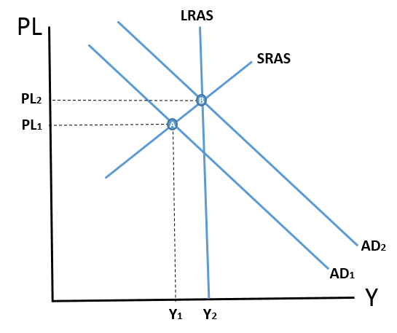

Long Run Supply Side Growth (and deflationary pressures)
Long run growth tends to occur on the supply side of the economy and involves the LRAS curve shifting to the right.  In the example to the right, the LRAS has shifted to the right as the capacity of the economy has increased (there is more capital/labour or the productivity of these two inputs has increased because of education of workforce and new technologies).  This has caused the price level to fall (deflationary pressures). The lower price level has encouraged more aggregate demand in the economy (firms can afford more raw materials, consumers can afford more goods and services etc.)  Therefore long run growth has led to the movement of the LRAS and productive capacity of the economy and perhaps dampened down inflationary pressures in the economy from PL1 to PL2. Of course it could mean (like in Japan) that the LRAS has led to too much deflation and the economy is facing a deflationary spiral! This would mean the AD curve would move left from the equilibrium of B causing further deflation and a negative output gap (if the SRAS was there)! | 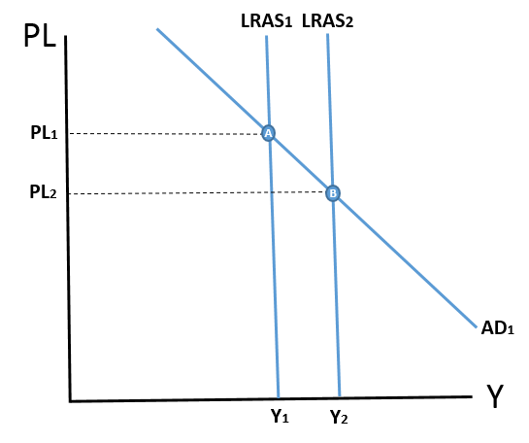

Long Run Economic Growth and Stable Price Levels

If the LRAS shifts to the right due to increases in productivity (i.e. more educated workforce or better technology), then the following will happen:  - STAGE 1: LRAS shifts from Y1 to Y2 (the SRAS moves with it as the two curves are connected  - STAGE 2: If we place an AD curve in now, you will see that the equilibrium has moved from A (at full employment) to Z (where there is now a negative output gap from Yz to Y2).  - STAGE 3: The aggregate demand curve however will move automatically (at the same time) to equilibrium B because higher productivity means that the factor inputs (labour and capital) are now more valuable. This means for example that labour will be receiving higher wages. This will result in higher consumption and AD moving perfectly to the right to remain at C.  Ta daaa…there you have it – long run economic growth and stable prices. This could happen naturally without any Government intervention. However more left-wing economists would argue that for economic growth to move faster you need both ‘supply side policies’ and ‘demand side policies’ to hasten things along faster….this is the topic of our next two revision worksheets. | STAGE 1:  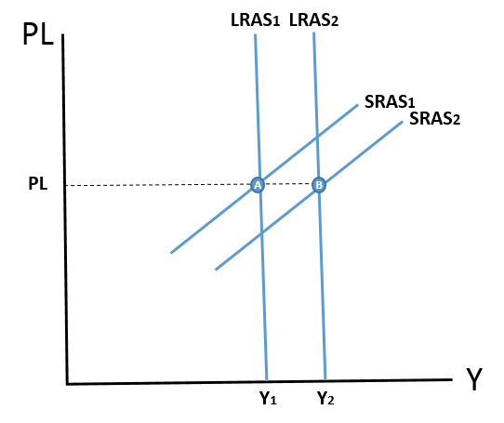 | STAGE 2:  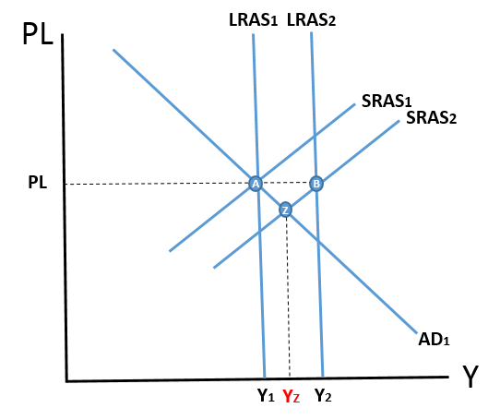
 | STAGE 3:  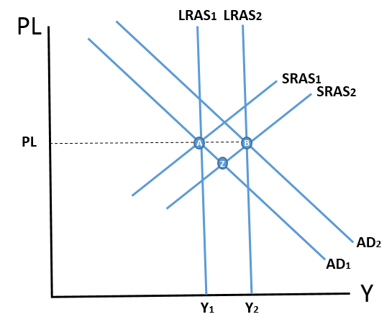 | NOTES AREA TO WRITE DOWN ANY QUESTIONS IN CLASS:

