FACTSHEET DEBATE 2: Fiscal Policy – Is the UK’s National Debt Sustainable? Should the Government make it a priority to reduce the national debt?

Background to the Debate
In general, the ‘great recession’ in the UK which represents the downturn from 2008-2013 in the UK as a direct result of the financial crisis led to lower tax receipts and higher spending on unemployment benefits. The recession particularly hit stamp duty (falling house prices) income tax and lower corporation tax. Cyclical factors have also exposed an underlying structural deficit. (deficit caused by spending greater than tax, ignoring cyclical factors). What follows is a quick potted history of Government borrowing since 1997.  1997-2010: New Labour (Tony Blair and Gordon Brown)  After a period of financial restraint, from mid 1990s, public sector debt as a % of GDP fell to 29% of GDP by 2002. From 2002 – 2007, national debt increased to 37% of GDP. This increase in debt levels occurred despite the long period of economic expansion; it was primarily due to the government’s decision to increase spending on health and education.  In 2008, public sector debt rose from 37% of GDP to 80% of GDP as a result of the financial bailout of Northern Rock, RBS, Lloyds and other banks. | 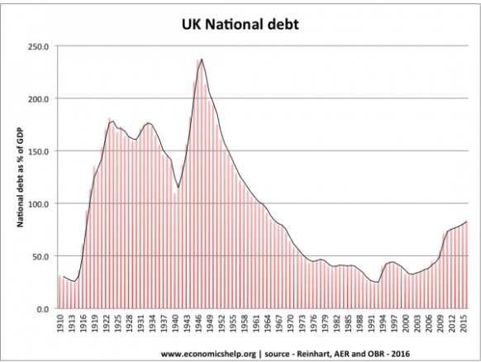

2010-2015: Conservative/Liberal Democrat Coalition Government (David Cameron, Nick Clegg and George Osbourne)
Public sector debt has increased sharply because of:
From 2011-2015, the pace of increase in the public sector debt has slowed due to the government attempts to reduce the budget deficit. The government has announced strict spending limits called ‘Austerity’.

2015-Today: Conservative Government (David Cameron and George Osbourne led to Theresa May and Phillip Hammond)
George Osbourne continued with reduced Austerity targets after not meeting his fiscal goals of the previous parliament. Philip Hammond in his Autumn statement of November 2016, abandoned any attempts to bring the Government finances into surplus by 2020 leading to a more flexible approach.

Comparison with other countries
Although 80% of GDP is high by recent UK standards, it is worth bearing in mind that other countries have a much bigger problem. Japan for example has a National debt of 225%, Italy is over 120%. The US national debt is close to 80% of GDP. Also the UK has had much higher national debt in the past, e.g. in the late 1940s, UK debt was over 200% of GDP.

Sources to Access
Articles to read
- Guardian - https://www.theguardian.com/business/2016/aug/25/how-worried-should-we-be-about-national-debt-uk-us-fiscal-austerity
- Spectator - http://blogs.spectator.co.uk/2014/10/how-to-defuse-britains-1-45-trillion-public-debt-time-bomb-or-not/
- Telegraph - http://www.telegraph.co.uk/business/2016/02/19/how-large-is-the-uks-national-debt-and-why-does-it-matter/

Evaluating this Debate
The Government should make it a priority because our current debt levels are unsustainable | The Government should not make it a priority because our current debt levels ARE sustainable.
CONCLUSION?

