**THE FINANCIAL CRASH 2008 and DEMAND SIDE POLICIES**

|  |  |  |  |  |  |
| --- | --- | --- | --- | --- | --- |
| **MACRECONOMIC INDICATORS** | 1=  1 | 2 | | 3 | 6  4 |
| **FISCAL POLICY INFO AND DATA** | 5 | **FISCAL HISTORY in the UK**   1. **1997-2010 New Labour (Tony Blair and Gordon Brown) – Spending on Education, Healthcare and….bailing out the banks:** Tony Blair and Gordon Brown increased Government spending on education and healthcare in their time in power. From 2007 and with the financial crisis, Gordon Brown bailed out the banks and further increased the budget deficit with a Keynesian style injection of stimulus to avert the effects of a recession. By 2010, the economy was starting to recover. 2. **2010-2015 Coalition Government (David Cameron, George Osborne and Nick Clegg) – a policy of Austerity:** George Osborne inherited an economy coming out of recession with arguably high levels of debt. He quickly decided to follow a policy of ‘Austerity’ by trying to decrease the budget deficit and create a surplus within three years. He was worried that lenders would perceive the UK as being a credit risk and this would mean it was more costly for the Government to service their debt. Critics argued that a policy of austerity should also include tax increases but Osborne in fact cut taxes leading to accusations that through Austerity he was just trying to shrink the size of the state to fit with his free market ideology (‘neo-liberalism’). Other economists argued that ‘austerity’ when emerging from a recession might lead to a ‘double dip’ recession and make matters worse. George Osborne just about avoided a double dip recession but evidence suggests he did delay a recovery with this policy. 3. **2015-16 (June): Conservative Government (David Cameron and George Osborne) – Austerity take 2:** George Osborne had not met his fiscal rule of reducing the budget deficit into surplus as promised in 2010. So he set a new rule that the UK would ‘balance the books’ within the time of this parliament (by 2020) through further ‘Austerity’ cuts in some areas. 4. **2016 (June) – TODAY – more flexible fiscal rules:** Conservative Government Post-Brexit Referendum (Theresa May and Phillip Hammond): Philip Hammond quickly abandoned the previous fiscal rules of trying to balance the budget by 2020 to a more flexible model. | | |  |
| **MONETARY POLICY INFO DATA** | 7 | **MONETARY POLICY HISTORY IN THE UK**   1. 1997 Independence of the Bank of England: Before 1997, Chancellor of the Exchequer’s had a reputation for artificially stimulating the economy by cutting interest rates with the Bank of England Governor before an election. New Labour made the Bank of England’s decision making about interest rates separate from Government interference in 1997 by making the BofE independent. However the Governor still has to write a letter of explanation if they do not meet the agreed inflation targets 2. **2009 Interest Rates:** Cut to 0.5% from around 5% in one year – a very sharp drop in response to the recession caused by the financial crash. It then stayed at this level until 2016 when, ‘post-Brexit’ referendum, it was further reduced by 0.25% to 0.25%. 3. 2009 - QE1: £200 billion injected into the economy by the Bank of England buying up Government debt from banks with newly created money 4. 2011 - QE2: £125 billion injected 5. 2012 - QE3 - £50 billion injected 6. 2016 - QE Extension: £60 billion injected   TOTAL OF £375 billion plus £60 billion of QE injected into the economy via private banks. | 8 | | 9  QE = Quantitative Easing  BoJ = Bank of Japan (Japanese Central Bank)  Fed = Federal Reserve (US Central Bank)  ECB = European Central Bank (Eurozone Countries)  BoE = Bank of England (UK Central Bank) |

**EXTRA GRAPHS TO LOOK AT**

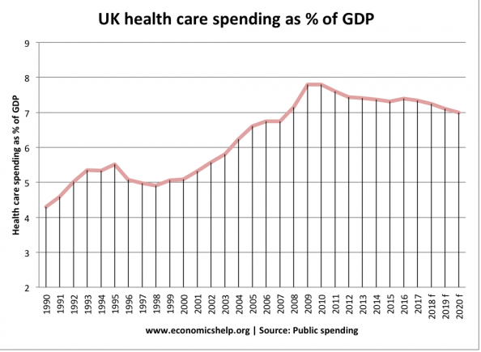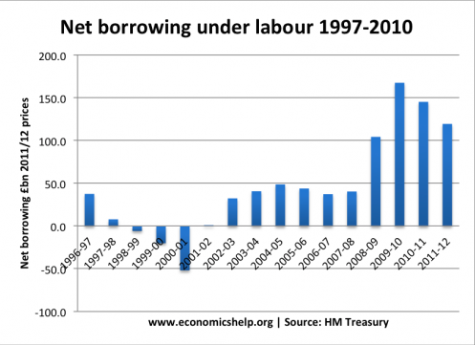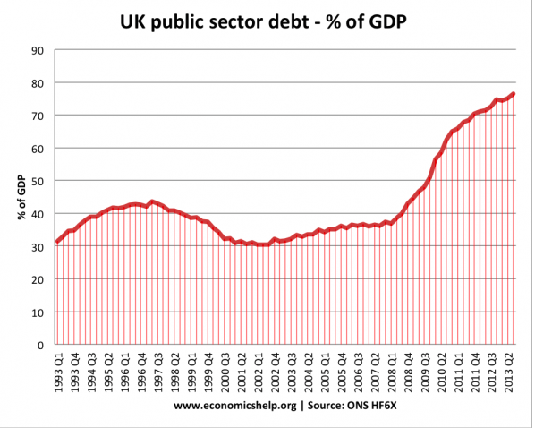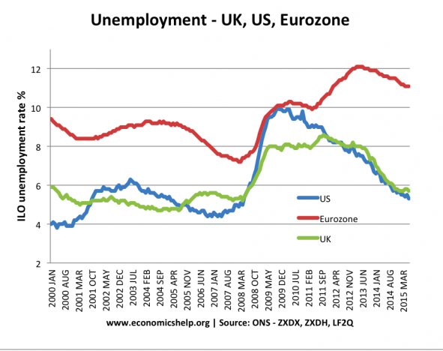

13

12

11

10

**QUESTIONS TO ANSWER: Write answers to the questions, using the 13 graphs and other information to back up your points. Remember, you only have to make 1 or 2 points and they could be just your opinion but I would hope you can use the information to reach a conclusion.**

|  |  |  |
| --- | --- | --- |
| What do the graphs 1-4 tell us about the effects of the financial crash on the UK economy? | Has the Bank of England’s monetary policy from 2009 worked in your opinion? | Looking at graphs 9 and 13, why might the ECB have been criticized from coming to Quantitative Easing too late? |
| Should we blame New Labour (97-10) for the national debt problem we find ourselves in? | George Osborne’s policy of ‘Austerity’ to reduce the budget deficit and move towards a surplus from 2010 to 2016: was it successful? | Should we be worried about our National debt levels compared to the historic levels? |