How Competitive is the UK? - UK Productivity

GDP per worker per hour

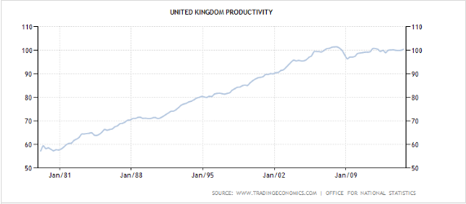

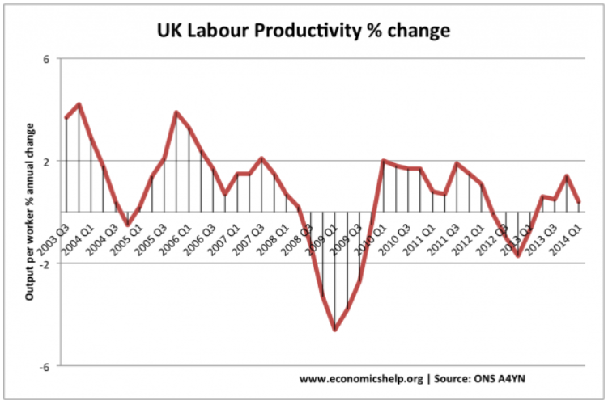
Productivity suffers as UK’s workaholics admit to timewasting
Gareth Vorster, from personaltoday.com 24 April 2008

A culture of 'presenteeism' among UK employees is having a negative affect on productivity, new research has revealed.

A survey of 2,347 people, commissioned by employee wellbeing specialist Right Corecare, found that four in 10 respondents work extra hours in the office, with 21% pointing to their bosses' expectations as the main reason to do so.

A quarter of respondents admit to checking Facebook or surfing the net on company time, often after they have finished work, with 16% admitting they work late to be seen as hard working.

The survey found that a fifth of employees aged under 45 think longer-hours workers are seen as harder workers, while the figure drops to one in 10 for the over 45s.

Adrienne Heeley, director of work-life services at Right Corecare said many people believe the only way to get ahead is to be visibly seen as hard working by bosses and colleagues.

As the economy slows down and employees become concerned about their positions within an organisation, this problem could worsen, with staff seeking to secure their jobs by being the first in and the last to leave.

"But this 'jacket-on-the-back-of-the-chair' approach is counter-productive," said Heeley. "It has a detrimental effect on the employee's wellbeing, the productivity of the business and the UK's economy as a whole."

