**PREP 2: Introduction to Exchange Rate Systems**

**Introduction to Exchange Rate Systems**

Exchange rate systems are ways in which Government’s manage their currency on the world stage. There are essentially two categories of system:

1. **Floating Exchange Rate –** is one where there is NO Government intervention and currencies are allowed to be determined by the forces of supply and demand on the FOREX (foreign exchange markets). Therefore currency values are determined by speculation by currency traders in the short run, to trade and investment requirements in the longer turn and (arguably) by inflation levels in different countries in the very long run.
2. **Fixed Exchange Rate –** is one where a currency has a fixed value against another currency (or commodity).
   1. **Fully fixed -** The best example is the ‘Gold Standard’ (see below) where countries made their currency fixed to a certain amount of gold.
   2. **Managed Exchange Rate (‘Semi Fixed’) –** are where Government’s allow the currency to float on the FOREX markets but will intervene perhaps to keep it in a narrow band in an ‘adjustable peg’ system (see Bretton Woods below) or in a ‘dirty float’ system where the Government might intervene intermittently into the FOREX markets to smooth day to day volatility. Sometimes, managed exchange rate systems are still considered ‘fixed’; for example, the ‘adjustable peg’ system is fixed within a threshold rather than to a specific weight of gold (like the gold standard example).

**Introduction to the Pound Sterling**

The pound sterling or often called the pound is the official currency of the United Kingdom. At various points it has been ‘commodity money’, so money backed by commodities such as gold or silver. Today, the pound sterling is considered to be ‘fiat money’, that is backed by the legal tender laws of the UK and is backed purely by trust in the currency and the issuer of the currency, the Bank of England.

The pound sterling is the oldest currency in the world. The origins of sterling lie in the reign of King Offa of Mercia, (757–796) who introduced the silver penny. The English currency was almost exclusively silver until 1344 when the gold noble was successfully introduced into circulation. However, silver remained the legal basis for sterling until 1816 although in 1694 with the founding of the Bank of England as the main issuer of currency, paper money started to emerge.

For most of this history of the ‘Sterling’ currency, amounts were stated in pounds, shillings, and pence, with various widely understood notations. The same amount was denoted by 32s 6d, 32/6, £1 12s 6d, £1/12/6. Towards the end of the Second World War, various attempts to decimalise the pound sterling in the United Kingdom were made, until in 1966 the British government decided to include in the Queen's Speech a plan to convert the pound into a decimal currency. As a result of this, on 15 February 1971, the UK decimalised the pound sterling, replacing the shilling and penny with a single subdivision, the new penny. For example, a price tag of £1 12s 6d became  £1.62. The word "new" was omitted from coins minted after 1981.

Today, sterling is the fifth most traded currency in the foreign exchange markets after the US dollar, the Euro, the Japanese Yen and the Chinese REnmibi (Yuan). These four currencies (plus the Chinese Renmibi or Yuan) are placed into an official basket of currencies by the IMF (International Monetary Fund – a multilateral organization created designed to stabilize the global economy).

There is a small amount of notes and coins in circulation of pound sterling, issued by the Bank of England (about 3% of the total money supply). The other supplies of sterling are held in bank deposits around the world. Recently a new £5, £10 and £20 note were issued and most recently the pound coin changed shape (February 2017).

**UK History of Exchange Rate Systems**

1. **1816 - 1914: ‘Gold Standard’ (fully fixed)**: Sterling was worth a fixed amount compared to other currencies and gold itself. In order to ensure that Sterling maintained its value, the BoE was obliged to exchange gold for pounds at the specified rate.
2. **1914-1944: Years of War:** The Gold Standard was abandoned at the start of the First World War in 1914 but a new standard was attempted in 1925 when the pound was fixed at the pre-war value. However this approach was abandoned in 1931 due to the Great Depression and sterling suffered a 25% devaluation as a result.
3. **1944 - 1971: ‘Bretton Woods System’ (semi-fixed)**: A system of currencies, pegged to the Dollar (which itself was fixed to the price of gold at $35 an ounce). This was an arrangement post WW2 to ensure stable global capital flows.
4. **1971 - 1990: Floating exchange rate:** Richard Nixon, the US President abandoned Bretton Woods in 1971 and stopped intervening to bolster the dollar but instead let it float freely in the global currency markets.
5. **1990 - 1992: ‘Exchange Rate Mechanism’ (ERM) – (semi fixed):** A semi-fixed exchange rate where Sterling was semi-fixed to the German Deutsch Mark. Margaret Thatcher had resisted joining the ERM but the new PM John Major joined and then crashed out spectacularly helping to trigger a large recession in the UK.
6. **1992 – Present: Floating exchange rate:** After the brief experiment with the European ‘semi-fixed’ exchange rate system, the pound sterling has been allowed to float freely on the global currency markets

**TASK 1:** Read the extract on the other page a few times and try to summarise the key points in the box below

|  |
| --- |
|  |

**Floating Exchange Rates**

FOREX markets or ‘Foreign Exchange Markets’ are where currency is traded with one of the biggest trading floors being in London.

Another important aspect to note about trading is when a UK consumer buys a product from a foreign country, say France (so a UK import or a foreign country export) then the UK consumer must convert their currency (pound sterling) into Euro’s (if France) as the French company selling the good to the UK consumer will not accept pounds directly. Therefore the consumer has to goto the FOREX markets to sell their pounds and buy up Euro’s for the transaction to take place. Now in reality, if you are buying something on Amazon that is imported from France, all of this goes on behind the scenes and you as the consumer does not realize that this mechanism is taking place but it is. People make a lot of money by being the ‘middle men’ for companies and trading in currencies; one day that person might be you!

Basic Demand and Supply Analysis: Movements along the Curve

TASK2: Read the following and answer the questions below

To understand how Currency Traders operate, we need to wheel out the Microeconomic supply and demand curve toolkit to help predict what will happen.

|  |  |
| --- | --- |
| FIG.1  **PRICE of £: Value of £ compared to another currency**  **Q of £**  **S**  **D**  **£1 to $1.30**  **Q\*** | The graph to the left shows how supply and demand forces can determine the exchange rate. This consists of:   * The *Demand Curve* is derived from the demand for a country’s exports (e.g. foreigners). Therefore if the currency is falling, more pounds are demanded by foreign buyers as exports are relatively cheaper hence the demand curve is downward sloping. * The *Supply Curve* is determined by the domestic (UK) demand for imports from foreign sellers (or the willingness of holders of the pound to supply their currency in the market to buy other currencies to buy imports). So if the exchange rate appreciates, then imports are cheaper, providing incentives for UK consumers to supply their pounds (sell them in the market) and buy up other foreign currencies to buy imports from foreign countries. |

|  |  |  |  |
| --- | --- | --- | --- |
| **Q1** The UK’s currency recently rose with the extension until October 31st of Article 50 to avoid a ‘No-Deal BREXIT’. Explain what would happen to the demand for UK currency, using a diagram (demand curve only) and why. | | Q2 Since the BREXIT referendum of 2016, the pound has depreciated by 5% on average over the next three years. Explain what would happen to the supply of UK currency using a diagram (supply curve only) and why. | |
| DIAGRAM | EXPLANATION | DIAGRAM | EXPLANATION |

Basic Supply and Demand Analysis: Shifts in the Curves

The graph in Fig.1 represents the equilibrium exchange rate value of the pound to the dollar. You will not be surprised to hear that the curves can shift as well. If foreigners are the ones that demand our currency and domestic UK citizens (although others might own UK currency as well) are the one that supply our currency to the FOREX markets, then what would cause the curves to shift?

**TASK3:** Below are two summary graphics to help explain what might shift both the demand curve and the supply curve, what affect this would have on the price (or the exchange rate) and how this would subsequently affect the other variable (either supply if demand or demand if supply). Read the graphic overview and then answer the questions at the bottom using this information.

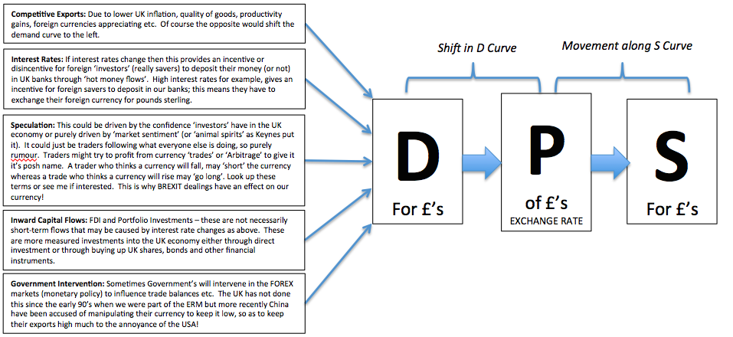

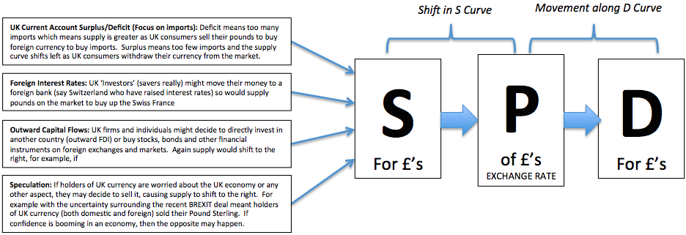

**QUESTION 1 of 4:** It is November 1st 2021 and the UK crashed out of the EU in a ‘no-deal’ scenario on October 31st 2019. Contrary to popular belief however, a ‘no-deal’ BREXIT has led to an Economic boom in the UK and the Bank of England are worried about inflation increasing beyond the 1-3% level. Therefore the Bank of England decide to increase interest rates by 2%. Explain what might happen to Pound Sterling as a result, using a diagram AND then try to evaluate this in one or two sentences (i.e. why might the change you initially state not happen or why might the effect you explain be less)

|  |  |
| --- | --- |
| DIAGRAM | EXPLANATION AND EVALUATION |

**QUESTION 2 of 4:** Since the 1990’s and because of increased Globalisation, the number of UK imports has increased dramatically, causing a persistent trade deficit. Explain the effect this might have been since then on the pound sterling, using a diagram. Also add a few sentences of evaluation to your initial explanation.

|  |  |
| --- | --- |
| DIAGRAM | EXPLANATION AND EVALUATION |

**QUESTION 3 of 4:** The exchange rate is currently £1 = $1.50. You expect that in the future, the value of the pound will depreciate (go down in value) as a ‘no-deal’ BREXIT looms. You are a currency trader holding £500,000 (in pounds)

1. At the current exchange rate, how many US $ will your £500,000 buy?
2. If the exchange rate falls to £1 = $1.20, what is the value of your US $ if you wanted to convert them back into pounds?
3. Illustrate this on a demand and supply diagram (to show the exchange rate)

|  |
| --- |
|  |

**QUESTION 4 of 4:** The ‘floating exchange rate’ system is chosen by Governments all over the world. It means they do not intervene directly in the FOREX markets to influence their own currency. You are an Economist working for Papua New Guinea (PNG), a country which has a GDP per capita of $4000 (compared to the UK’s $43,200) and currently manages their currency by fixing it to the. Should you advise the finance minister to adopt a floating exchange rate system? State ONE KEY advantage and ONE KEY disadvantage of the PNG Government adopting this system for their Macro-economy.

|  |  |
| --- | --- |
| ONE KEY ADVANTAGE OF SUCH A MOVE | ONE KEY DISADVANTAGE OF SUCH A MOVE |
|  |  |
| CONCLUSION (RECOMMENDATION TO THE FINANCE MINISTER | |