ZAMBIA (1964-2017)

INTRODUCTION
At the time of independence in 1964 Zambia was a middle income country and appeared set to develop into a prosperous nation. However, the combination of a tumultuous world economy and bad mismanagement by the Government led to rapid economic decline (fall in GDP), which continued into the 1980s and 1990s. Average economic growth from 1990–1999 was the lowest in the region, and unemployment and inflation soared resulting in per capita GDP of 50% less in 1999 than they had been 25 years earlier.  - Zambia is now considered to be of ‘medium human development’, ranked 139 out of 182 countries on the UN’s human development index (Human Development Report 2016).  - 59% of Zambians were estimated to live below the poverty line in 2016, down from 68% in 1996 however there is a higher percentage of poverty in rural areas  - The majority of these people live in rural areas in households headed by women and half the children under five in the country suffer from chronic malnutrition or stunting, a figure that has worsened rather than improved over the last thirty years.  - HIV prevalence in Zambia is amongst the highest in the world – estimated at 14.3% in 2007 although it was almost an epidemic in the 80’s and 90’s..  - Healthcare remains under-resourced, and ill health is compounded by the lack of access to clean water and sanitation.  - Access to primary education by contrast has markedly improved, but the quality of the education received is far below what is needed for widespread poverty reduction and girls in particular do not perform well beyond primary school. | 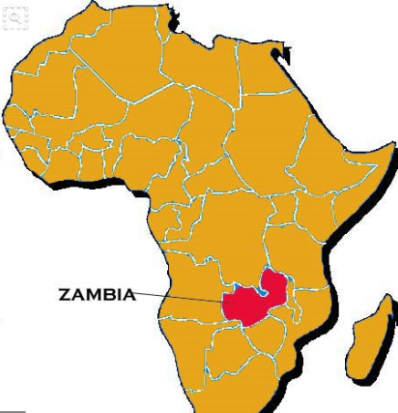  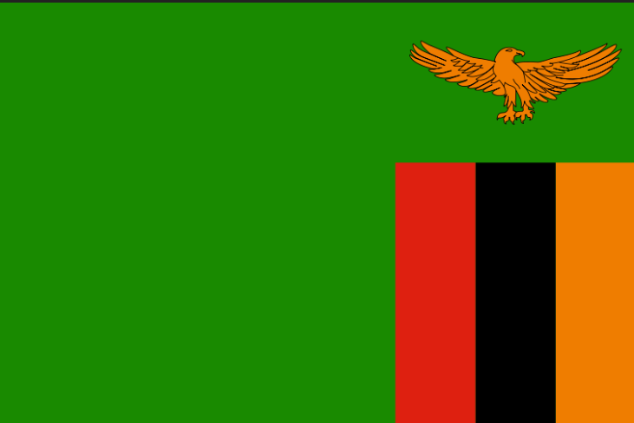

HISTORY OF ZAMBIA
Currently a land locked country in sub-Saharan Africa with a population of 13 million, Zambia is still relatively a young country. Zambia was made independent in 1964 from Britain and was led by the “freedom fighter” Kenneth Kaunda until 1991. Zambia was heralded as one of the success stories of Africa in the mid-60’s and there were high hopes for this newly formed country. Kaunda, a socialist began with socialist and protectionist policies to protect infant industry, diversify the economy to reduce reliance on Copper but at the same time exploit the copper exports of his country. From 1964-1984, Zambia was very independent with Government’s conducting 5 year plans and being accountable to this. By the 1980’s as a result of both Government policy and external factors (oil crisis), Zambia was in large amounts of debt which led to the IMF intervening and Zambia for the next 25 years had to adopt policies of Economic liberalisation from these institutions. From 1991 to 2003, Zambia was led by Fredierick Chiluba who has more recently been charged with corruption within the state. So by 2005 after a growing debt burden for 32 years, liberalised economic policies imposed by foreign powers for 22 years, a growing population and corruption within the Government ranks over the previous 15 years, Zambia’s GDP per capita had fallen, life expectancy and poverty rates had increased (especially in rural areas) and the number of people who had contracted HIV/AIDS had increased substantially (14% of the population) compared to 1964. On top of this drastic cut backs in education and healthcare damaged an already scarred workforce and population. For the past 35 years, Zambia has experienced the worst economic decline in Sub-Saharan Africa (Appolinario, 2009).

Since 2003, Zambia’s prospects had started to improve with the increase in worldwide copper prices attracting foreign investment, especially from the Chinese. Levy Mwanawasa was also elected to power in 2003 on an anti-corruption charge imprisoning and putting on trial previous ministers within the Government. As of 2005, Zambia met it’s HIPC commitments and finally qualified for full debt relief at the G8 Gleneagles summit, reducing debt from $7 billion to $500 million. Zambia’s recent growth rate in 2011 has been 7%, one of the highest in the world. Also in 2011, a new president Michael Sata was elected in a very peaceful election. Zambia has also always (on the whole) been a peaceful nation since 1964 and its model of democracy is heralded as a beacon for other countries in the region. All this points to an improving situation for Zambia demonstrated by it recently (2011) being granted lower middle income status. Further foreign investment has followed from the Chinese and other nations.

However challenges still remain. Zambia is still very reliant on the copper industry for income from abroad. The mining employment only employs 50000 people and only contributes 3% of GDP in taxation (DFID, 2011). Accusations of foreign companies investing in mines (like Glencore) and then not paying taxes to the Zambian Government are rife. HIV/AIDS is still a serious problem with 14% of the population affected and the burden on extended families still remains. The difference between rural and urban areas is still stark (OECD, 2011) therefore the rural population of Zambia are the poorest with three quarters living on less than $1 a day through subsistence farming and petty trade (DFID, 2011). Zambia, according to the Ministry of Finance has 28 donors providing ODA to Zambia – EU (14.3%), USA (10.7%), UK (9.0%), UN (8.9%), World Bank (8.7%) (OECD, 2011). It receives about $1 billion per year in foreign aid (McEwan, 2009). This is the equivalent to almost a third (29%) of Zambia’s Governmental budget (CIAFactfile, 2012) and so Zambia is still dependent on external assistance.

Zambians reliance on copper can have bad effects on the economy and this occurred in the aftermath of the Global Financial Crisis when countries stopped buying as many copper exports from Zambia and the price dropped. Zambia’s copper accounts for 70% to 80% of its exports, and due to this fall in copper prices, exports halved in 2009. The most immediate social impact was the loss of some 8,500 out of a total of some 30,000 mining jobs. A lack of income to the economy has meant less economic growth and falling output, leading to potentially greater poverty.

More recently, there has been unsettling political turmoil with the current opposition leader in jail for refusing to move aside for the current presidential incumbent! Locking up your opposition leader is a signal that Zambia’s peaceful, democratic political system may be under strain in 2017.

Strengths  - Large copper deposits – opportunities to sell copper  - Floating exchange rates and open capital markets have given discipline to the Government  - Democratic elections since 1964 when independence occurred; quite rare for this to happen in sub-saharan Africa. Often considered one of the most stable democracies in Africa. | Weaknesses  - Large copper deposits – economy too reliant on the copper price and possible resource curse? Primary specialization.  - Lack of other industries to provide jobs and growth: For example, Salaula which are imports of donated clothing from Western countries has caused the demise of the textiles industry in the UK. Salaula is the Zambian word for this second hand clothing.  - Large numbers of rural poverty  - Landlocked country – harder to trade as no sea ports = barriers to trade  - HIV/Aids Problem means there has been an issue with ‘human capital’  - Low educational achievement  - Large GINI Co-efficient  - High inflation rate (20% in 2016)
Opportunities  - Development of mobile phone technology for banking – allows poorer individuals to save and buy  - Fast growing population – larger workforce for the future? | Threats  - Alternative technologies may replace the need for Copper in the future  - Reports of ‘MP’s being suspended’ and worries about the democratic future of Zambia. Opposition leader arrested and held for a month for not giving way to a Presidential motorcade.  - Fast growing population – strain on resources  - Copper prices falling because of lack of demand from China

