**PRACTICE MICRO Data Response Questions**

**QUESTION 1**

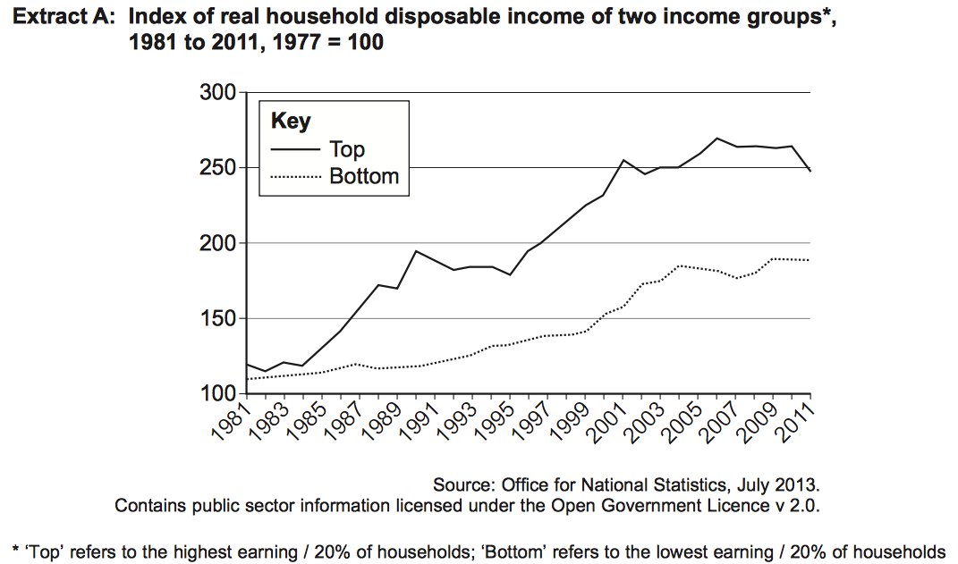

(1) Calculate the percentage increase of the top household income groups from 1981 (110) to 2011 (250) to one decimal place (2 marks)

(2) Explain how the data in extract A shows inequality has increased (4 marks)

(3) With the help of a diagram, explain how the market for luxury cars might have been affected (9 marks)

**QUESTION 2**

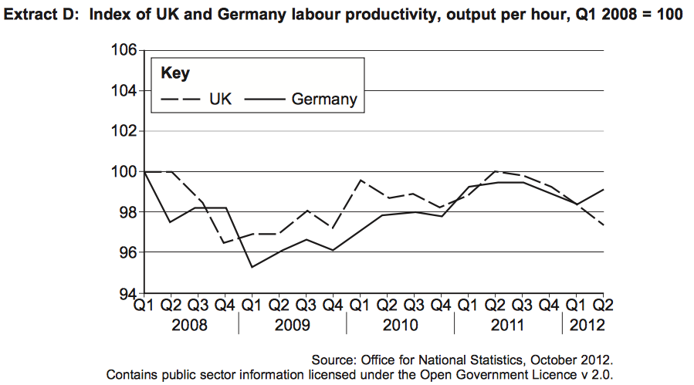

(1) Calculate the percentage change of UK productivity from Q1 2008 of the UK compared to Q2 2012 (97) to two decimal places (2 marks)

(2) Explain how the data in extract D shows how the financial crisis has affected labour productivity in Germany and the UK (4 marks)

(3) With the help of a diagram, explain how the UK market for parsnips might be affected in the year 2008 (9 marks)

**QUESTION 3**

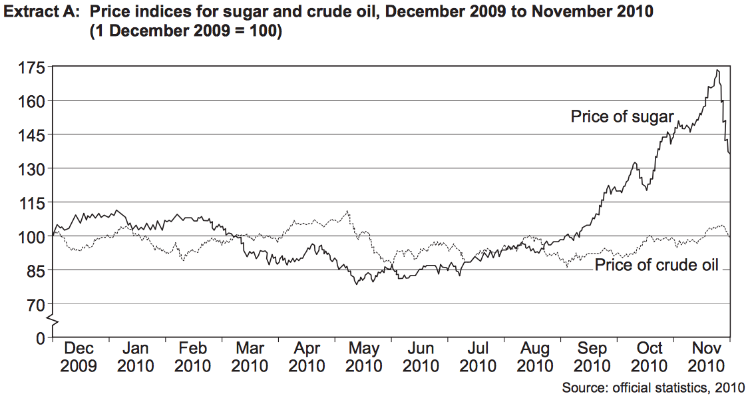

(1) Calculate the percentage increase of the price of sugar from December 2009 to November 2010 (137) to one decimal place (2 marks)

(2) Explain how the data in Extract D demonstrates the volatility between two commodities (4 marks)

(3) With the help of a diagram explain why the price of sugar may have increased from August 2010 to November 2010 (9 marks)

**QUESTION 4**

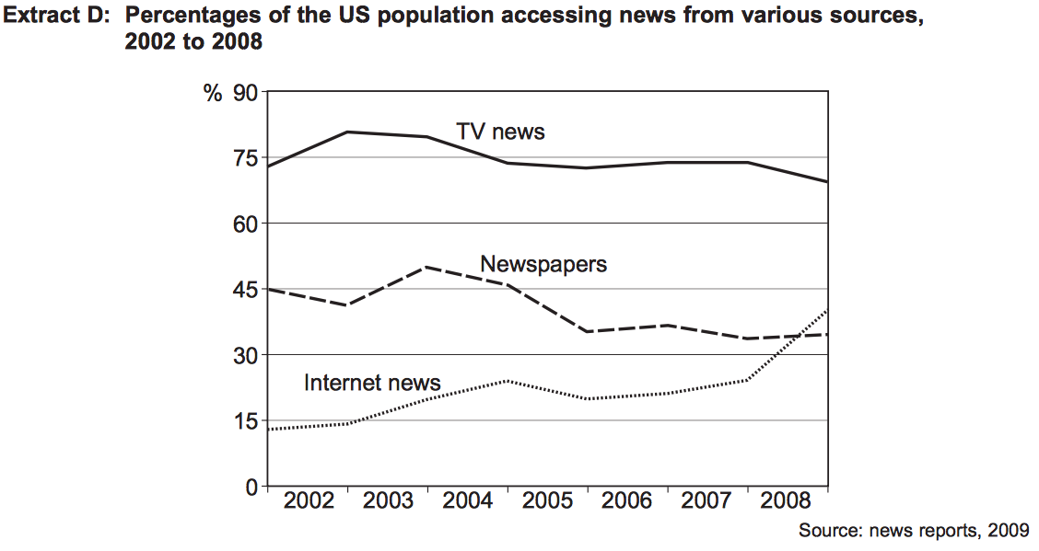

(1) Calculate the percentage increase of internet news from 2002 (14) to the end of 2008 (40) to 3 decimal points (2 marks)

(2) Explain how the data in Extract D demonstrates how the market for Media news is changing (4 marks)

(3) “Newspaper printing trade unions secured large wage increases from 2002 to 2008” according to various news sources in 2008.

With the help of a diagram, explain how this factor may have affected the price of internet news (9 marks)

EXTRA 9 MARK QUESTIONS TO TEST YOURSELF

With the help of a diagram, explain one demand and one supply reason as to why oil prices are rising.

Hurriccane Matthew has meant the price of food has increased in Haiti. With the help of a diagram, explain two reasons as to why the price may have increased.