An Intro to Financial Markets

Financial Markets
Before we start looking at financial markets undertake some background reading and research. Useful sources of information can be found in your textbook, Economics Sixth Edition by Alain Anderton, the tutor2u website and on the Bank of England website

Alongside the sources above you might want to watch the videos below
Financial Markets overview : https://www.youtube.com/watch?v=b9H6WO4yNvY&list=PLWeicFreBUYCU4IjUPrKMzP5XIt-5idCu
Types of Financial Markets: https://www.youtube.com/watch?v=xQs6Ug4MGls&list=PLWeicFreBUYCU4IjUPrKMzP5XIt-5idCu&index=2
Commercial Banks and Investment Banks: https://www.youtube.com/watch?v=myzhSwkXPkg&list=PLWeicFreBUYCU4IjUPrKMzP5XIt-5idCu&index=9
The role of a Central Bank: https://www.youtube.com/watch?v=K6VxrO_c69Q&list=PLWeicFreBUYCU4IjUPrKMzP5XIt-5idCu&index=14
Regulation of the Financial Markets: https://www.youtube.com/watch?v=bGo5OOTnmvw&list=PLWeicFreBUYCU4IjUPrKMzP5XIt-5idCu&index=17
Bank of England: (https://www.bankofengland.co.uk/knowledgebank/what-are-financial-markets-and-why-are-they-important)
Tutor2U.net

What is the purpose of a financial market?

Outline the difference between the following

The money market

The capital market

The foreign exchange market

What is the difference between a commercial and an investment bank?

What other institutions operate in financial markets?

What is the difference between debt and equity?

What is the role of the central bank?

How is the financial system in the UK regulated?

Bank of England
Financial Policy Committee | Prudential Regulation Authority | Financial Conduct Authority
Define:
Macroprudential Regulation
Microprudential Regulation
Indicate who has responsibility for the above

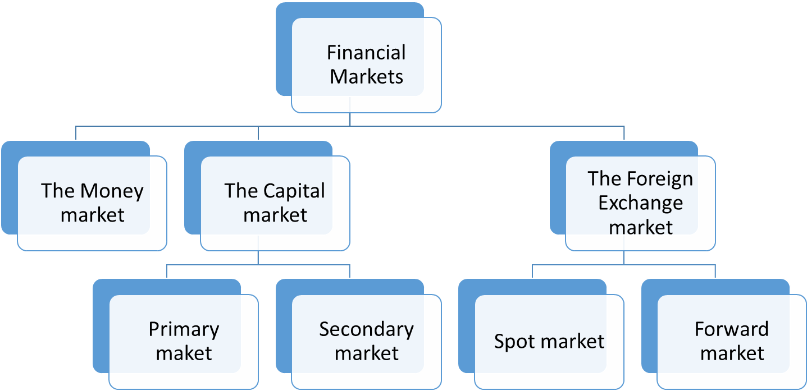Key Terms Monetary Policy and Financial Markets
Annotate the diagram below with key points about each of the financial markets to give you a one page summary of financial markets

Term | Definition
Medium of exchange
Store of value
Deferred payment
Narrow money
Broad money
Bank base rate
Financial market
Money markets
Capital markets
Foreign exchange markets
Debt
Equity
Government bond
Liquidity
Commercial bank
Investment bank
Retail bank
Central bank
Monetary policy
Bank base rate (include current rate and length of time at this rate)
Quantitative Easing
Moral Hazard
Systemic risk
Bonds
Shares
Corporate bonds
Government bonds
Coupon
Credit
Assets
Liabilities
Security
Monetary policy instruments
Transmission mechanism of interest rate policy
Forward guidance
Funding for Lending Scheme
Financial policy committee
Prudential Regulation Authority
Financial Conduct Authority
Liquidity ratio
Capital ratio

