**EnGlish**

Beginning

‘Frankenstein’

# **How does Shelley explore ‘Science and Society’?**

You are being asked to explore how Mary Shelley’s novel explores ‘Science and Society’. You will want to pay particular attention to the **methods** used in the creation of characters, settings, themes, form or language which seem directly relevant to the ideas of this theme. You will need to research the **context** of Shelley’s time to understand the impact of her ideas on contemporary readers and also to consider how our current environment might affect our own interpretation of the novel we might today. As always, the most successful responses are those which are detailed, supported with specific, relevant evidence and explored or evaluated in a thorough and systematic manner. In the exams at the end of both years you will be asked to write an essay exploring the **links** between these ideas and methods and those which you find in Kazuo Ishiguro’s ‘Never Let Me Go’.

Name: ……………………………..

Beginning ‘Frankenstein’

**Index**

Plot Summary: fill the gaps 3

The Form of the novel 4

The Settings of the novel 6

Characterisation in ‘Frankenstein’ 8

Victor: villain or Gothic hero? 9

The Creation of the Creature 10

Is the Creature a person? 11

Society in ‘Frankenstein’ 12

The women in Frankenstein 13

Mary Shelley: her life 14

Understanding ideas and their origins in ‘Frankenstein’ 15

Further exploration of context and ideas 16

Feminism in ‘Frankenstein’: some ideas 17

Science in the early 19th century 19

The Dark Side of Human Nature: Jung and psychology 22

Different readings of the novel: some starters 24

Chapters and Quotes 26

Storyboard: key events 28

Test Yourself: 10 quick questions 29

Test Yourself: Preparing for a closed book exam 30

Test Yourself: Complete the quote 31

[](http://www.google.co.uk/url?url=http://coloringpageshub.com/frankenstein-coloring-pages-free-printable-download/&rct=j&sa=U&ei=VVSYUoOiA4uV7QaP2oH4CA&ved=0CEoQ9QEwDw&sig2=NdV8NpFFg8A-WOX-kti7gQ&q=Frankenstein&usg=AFQjCNFeqyBSf3KZp3G2LWsZkXRI_-smUw)Plot Summary – Part One

Robert Walton, the captain of a ship bound for the ___________________, writes a letter to his sister, Margaret Saville, in which he says that his crew members recently discovered a man adrift at sea. The man, Victor Frankenstein, offered to tell Walton his story.

Frankenstein has a perfect childhood in _____________, with a loving family that even adopted orphans in need, including the beautiful ______________, who soon becomes Victor’s closest friend and __________. Victor also has a caring and wonderful best friend, Henry Clerval. Just before Victor turns ___________ and goes to study at the University at Ingoldstadt, his mother dies of _________. At Ingolstadt, Victor dives into “natural philosophy” with a passion, studying the secrets of ________ with such enthusiasm that he even loses touch with his family. He soon rises to the top of his field, and suddenly, one night, discovers the secret of life.

With visions of creating a new and noble _________, Victor puts his knowledge to work. But when he ____________ his first creature, its appearance is so ____________ he abandons it.

Victor hopes the monster has disappeared forever, but some months later he receives word that his youngest brother, __________, has been murdered. Though Victor sees __________________ hanging around at the site of the murder and is sure it did the deed, he fears no one will believe him and keeps _________. Justine Moritz, another adoptee in his family, has been falsely accused based of the crime. She is ________________________. Victor is consumed by _________.

**the monster convicted and executed North Pole seventeen animates Elizabeth scarlet fever horrifying**

**love life William Switzerland race silent guilt**

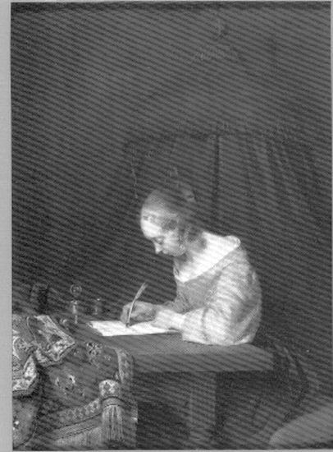The form of ‘Frankenstein’

# **An epistolary novel with a central heart?**

Define the term ‘epistolary’:

Skim the novel and focus on the letters you can find:

|  |  |  |
| --- | --- | --- |
| Identification | To/from | Date/topic |
| Letter I | Mrs Saville/Walton | Dec, scenery/aim of mission |
| Letter II |  |  |
| Letter III |  |  |
| Letter IV |  |  |
| Chapter VI |  |  |
| Chapter VII |  |  |
| Chapter XXII |  |  |
| Chapter XXIV |  |  |
| Chapter XXIV |  |  |

What are the advantages of using letters as a way to convey narrative? What is significant about where they are placed within the novel? What patterns can you see in the writers of these letters, their topics and responses?

The form of ‘Frankenstein’

# **An epistolary novel with a central heart?**

We can also think about the form of the novel as a target or heart. Think about the changes in narrative voice at different stages in the novel. Label the arrow below by identifying who tells the story and in what order they are presented to the reader.



Why has Shelley organised her tale like this? What is the effect on the reader? Whose story do you hear first? How does this prejudice you to respond to subsequent voices, information or ideas in the text? What is the power of the first/last word – or the voice at the heart of the text? How does each voice speak? Can you find a pattern or development in their words or ideas? How does your own sympathy change as a result of these methods?

The settings of ‘Frankenstein’

# **Gothic Castle Old PhotoA base for society and a base for science?**

Begin by thinking about ‘norms’:

Which setting/s provide a good base for describing a fair, well-structured society? Which setting/s would you choose as a backdrop for a flawed/corrupt society? Where do you expect ‘science’ to take place?

Once you have established some expectations, look again at Shelley’s choices and think about why she might have decided to adhere or deviate from your initial expectations? What do you think her meaning or implication might be?

Now list the settings in ‘Frankenstein’ from the early part of the novel:

|  |  |  |
| --- | --- | --- |
| *Letter* | *Setting* | *Key quote* |
| Walton’s letters |  |  |
| Victor’s childhood |  |  |
| Where does he collect the parts for the creature (p54?) |  |  |
| Where does he work? |  |  |
| What is the weather/time of creation? |  |  |
| Where do Victor and the creature meet? |  |  |

What patterns do you notice?

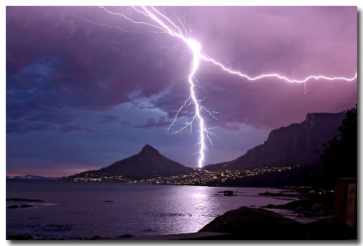Define “the sublime” and identify who is credited with this concept at this time:

What possible meanings are generated by Shelley’s use of ‘sublime’ settings? How can you link to an interpretation or comment on her society?

Shelley is also associated with the Romanticists. Think about your studies of Coleridge’s ‘The Rime of the Ancient Mariner’ last year and consider how her natural settings may have more in common with Romanticism than Gothic here? Why? How do these settings frame her message/show her priorities or values?

Select ONE setting from your completed table and write a paragraph exploring the effect of Shelley’s choice of setting at this point in the novel. Make sure you discuss in detail the importance of the chronology of the events (why does this happen NOW at THIS place?) Evaluate what this choice might reveal about Shelley’s attitudes towards Science OR Society (depending on the setting you select).

Characterisation in ‘Frankenstein’

It is really important that you always think (and refer to) the characters in your texts as constructs of the author. They are not real people and therefore you should avoid saying ‘Victor does this and then this’. Avoid this easy trap by always referring to the author: Shelley makes Victor do this… This will also remind you to then explore why the author has made this choice – how does it change the direction of the novel/how does it change our understanding of the character? If you are seeking an A grade, you would then need to go on and comment on how Shelley’s own context might have influenced her choices.

All of the characters in the novel change during their ‘journey’ and this too is an important part of your exploration of the author’s characterization choices. So make

# **Stereotypes in ‘Society’?**

Think about the expectations or stereotypes of characters in society.

What defines a hero? How would you define a villain? How clear are the boundaries between hero and villain? For instance, is ambition always a good thing? Is it better to be active or passive? To be passionate or mellow? To be an idealist or a realist?

Which characters draw your sympathy in this text? How, when and why? Do you respond more strongly when you are listening to the ideas/dreams of an individual (first person narrative voice) or to their actions (reported events) or to the opinions of other characters (reliable third person narration)? Which methods has Shelley used at which point and why?

Consider the power of naming in this text. Why does Shelley not give the creature a name? How does this contribute to his (and your) ideas of his identity? How does this meaning change over time? What is the significance of Victor? Or Justine?

What are the Gothic expectations for female characters? Who speaks? And to whom? And who listens?

What effect is Shelley generating? Excitement? Horror? Terror? Positive? Negative? Constructive? Moral? (Watch this video on stream for more ideas: <http://estream.godalming.ac.uk/View.aspx?ID=8324~4r~SGdzPzeX>)

**Walton**

|  |  |  |
| --- | --- | --- |
| Page ref. | Method? | Quote/Effect |
|  |  |  |
|  |  |  |
|  |  |  |

Victor FRANKENSTEIN

|  |  |  |
| --- | --- | --- |
| Page ref. | Method? | Quote/Effect |
|  |  |  |
|  |  |  |
|  |  |  |

Qualities of a hero? (And what does it mean to be a Gothic hero?)

* Brave
* Reckless
* Passionate
* Obsessive
* Selfless
* Selfish
* Leader
* Tyrant
* Co-operative
* Dominant
* Educated
* Ignorant
* Fighter
* Small
* Determined
* Uncertain
* Proud
* Humble
* Rugged
* Refined
* Even-tempered
* Noble
* Tough
* Melancholic
* Cheerful
* Moral
* Risk taker

What does Shelley say about heroes? Is she talking more about a boundary line/liminal space where a good quality pushed to an extreme becomes something bad or dangerous? Is it appealing/exciting? Find evidence from the text to support these ideas:

Quotes/Methods/Effects?

The creation of the ‘Creature’

# **http://www.artquake.ca/wp-content/uploads/2014/04/adam.jpgThe ‘birth’ of the Creature?**

Read again pages 58-60 (Penguin Classic edition)

1. When/where is the creature made? (Find a short quote and think about what expectations this sets up in the reader?)

Michelangelo ‘The Creation of Man’ (Sistine Ceiling, Vatican City, Rome, 1608)

1. Weather: again, find a short quote. What method is Shelley using here? Why?
2. Place: find a quote. Where would you expect scientific breakthroughs to take place? What ideas/values is Shelley suggesting by her choices here?
3. 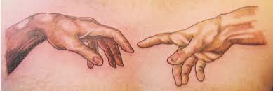Characterisation: Using this detail from Michelangelo’s painting, look again at the text and find a quote which could relate to this idea of contact/communication. What happens next? Who is in control? Who desires what?
4. Chronology: Where in the book does this event take place? How do the preceding events/points of view lead up to this? How do they affect the reader?
5. Moral: What ideas do you think Shelley is considering here? How and why?

[](http://www.google.co.uk/url?sa=i&rct=j&q=&esrc=s&frm=1&source=images&cd=&cad=rja&uact=8&ved=0CAcQjRxqFQoTCL70taDhicYCFeWy2wodhoEAlQ&url=http://www.ecosprinter.eu/migration-culture-and-identity/&ei=Spt6Vb6nHuXl7gaGg4KoCQ&bvm=bv.95515949,d.ZGU&psig=AFQjCNGGK2i-wp6Jy7Qt55-Lq0veb_JAiw&ust=1434184902931350)is the ‘Creature’ a person?

What does it mean to be a person? Is this different from being a human?

Which of these characteristics do you think are necessary for ‘Personhood’?

|  |  |
| --- | --- |
| A network of beliefs |  |
| Social being / relationships |  |
| Language / communication |  |
| Automony /capacity to make choices /beliefs |  |
| Rationality |  |
| Self-awareness / individuality |  |
| Reflective |  |
| Responsibility /accountable |  |

You will find these podcasts from BBC Radio 4’s ‘A History of Ideas’ interesting and informative.

Paul Broks on **John Locke and Personal Identity** <http://www.bbc.co.uk/programmes/b05qgcgx>

Neuropsychologist Paul Broks asks how we can be sure we're the same person as we were yesterday. The philosopher John Locke thought it depended on what we could remember: if we could remember something happening to us, then we were the same person as the person it happened to. But is that true? (11 mins)

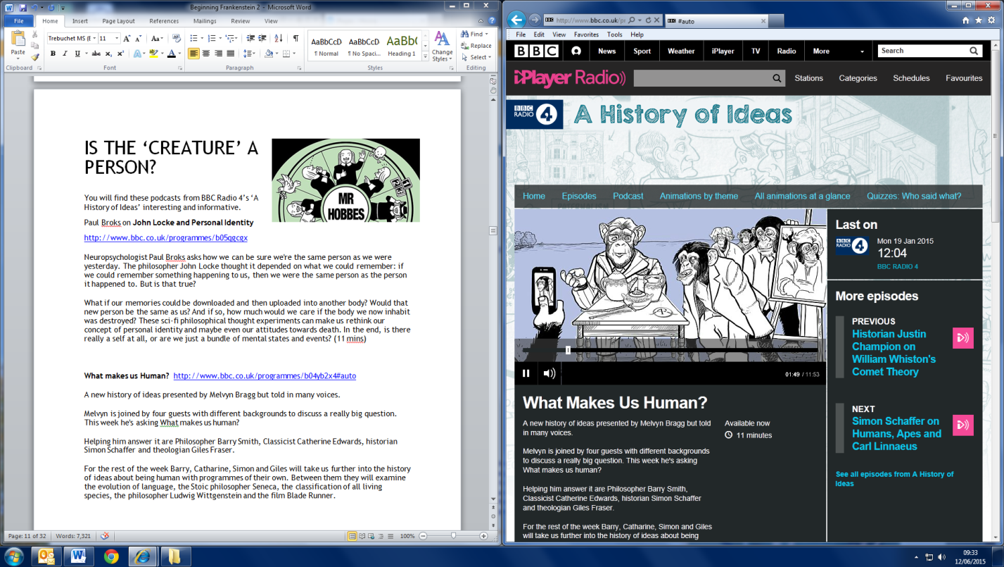**What makes us Human?** <http://www.bbc.co.uk/programmes/b04yb2x4#auto>

A new history of ideas presented by Melvyn Bragg but told in many voices.

Melvyn is joined by four guests with different backgrounds to discuss a really big question. This week he's asking ‘What makes us human’?

So, is the Creature a person? Where does he fit in the ‘Society’ depicted in the novel? (see next page for ideas)

SOCIETY IN FRANKENSTEIN

**What is a society?**

A group of people ruled by the same government, sharing common needs forms a society. Mary Shelley is English, but chooses to set her novel in Europe. Why do you think she might have chosen to do this?

**What is a Social System?**

A social system is the way in which members of a society organise themselves into groups and specialise in different jobs. The Hierarchy is the system by which people are ranged according to their wealth and power. It takes the form of a pyramid. People who share similar occupations within this pyramid are known as a social class.

What jobs or occupations do the different characters in ‘Frankenstein’ do?

|  |  |
| --- | --- |
| Mr Frankenstein (Victor’s father) |  |
| Victor |  |
| Clerval |  |
| Caroline |  |
| Elizabeth |  |
| Mr de Lacey |  |
| Safie’s father |  |

What does this tell you about the hierarchy of the society in Shelley’s novel?

THE WOMEN IN FRANKENSTEIN

An important question is: are women always represented in this novel as passive and powerless, or is the picture more complex? What strengths and resources do they show?

|  |  |  |  |  |
| --- | --- | --- | --- | --- |
| *Character* | *Role* | *Key actions* | *Quotes* | *Method* |
| Mrs Saville |  |  |  |  |
| Caroline Beaufort |  |  |  |  |
| Elizabeth |  |  |  |  |
| Justine |  |  |  |  |
| Agatha |  |  |  |  |
| Safie |  |  |  |  |
| The female creature |  |  |  |  |

[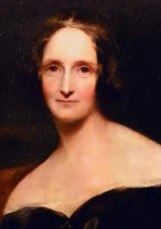](http://fwsablog.org.uk/wp-content/uploads/2013/08/mary-shelley1.jpg)MARY SHELLEY

Shared Experience recently produced a brilliant theatrical recreation of Shelley’s life and times: explore their information pack here: <http://www.sharedexperience.org.uk/media/education/mary-shelley_edpack.pdf>

|  |  |
| --- | --- |
| When and where was she born? |  |
| Who were her parents? |  |
| What did her father write? |  |
| And her mother write? |  |
| Who was Mary living with when she wrote this book? |  |
| Where were they? |  |
| When was the book written? |  |
| What had Mary experienced by this stage in her life? |  |
| How might these experiences have affected her (in relation to the story of ‘Frankenstein’)? |  |
| Research her attitude to her own mother and motherhood? |  |

Understanding ideas and their origins in ‘Frankenstein’

*Please watch this documentary and make notes on the questions below. We will discuss your thoughts and ideas in our next lesson – so please make sure you have your notes with you.*

**The Romantics – Liberty’ BBC Documentary presented by Peter Ackroyd**

Youtube link: <http://www.youtube.com/watch?v=5CAMEK3GLOQ>

1. Complete this short quote from Diderot “man is born to…..”

2. JJ Rousseau’s ideas were quite different, although both believed in a new freedom for the individual. Complete this quote “to feel is to ……….”

3. In Diderot’s ‘Encyclopedia’, he laid out a map of human understanding and claimed that “civilisation has usurped…..(what)?”

4. In 1749, Rousseau claimed “Man was born free and…… (complete)”? Think about who is ‘free’ in ‘Frankenstein’?

5. He wrote “man is essentially…… and science is…….” (Complete?) Consider this in the light of Shelley’s presentation of human nature and scientific ambition in ‘Frankenstein’.

6. Which British artist and writer agreed with this radical philosophy?

7. Why was the Bastille such a significant symbol?

8. On a visit to Paris, William Wordsworth said “I stared and listened with a stranger’s ears.” Which character in ‘Frankenstein’ does this make you think of?

9. What started the ‘Great Terror’? How could this idea link with the Gothic idea of ‘terror’?

10. The significance of the epistolary (letter) form is explored. How might this link with Shelley’s choices in ‘Frankenstein’?

11. Writing the Prelude on his return from Paris, Wordsworth writes “My dreams were miserable. I had scarcely one night of quiet sleep such ghastly visions had I of despair and tyranny.” Which character in Frankenstein does this make you think of? And at which stage in the novel?

12. What was the purpose/achievement of Samuel Taylor Coleridge & Wordsworth’s ‘Lyrical Ballads’?

13. What links do you notice between Shelley’s novel and Coleridge’s ‘The Rime of the Ancient Mariner’?

14. Would you say that ‘Frankenstein’ is a cautionary tale too? If so, about what?

Further exploration of ideas in ‘Frankenstein’

*This documentary explores Shelley’s contribution and position as well as giving a broader picture of the ideas and concerns of the time. (You might also find the first half of this relevant to your exploration of Marxist Literary theories on the other side of the course.)*

**The Romantics –Nature BBC Documentary presented by Peter Ackroyd**

<http://www.youtube.com/watch?v=zfGugapN0hs>

1. Why did the rapid pace of industrial and technological change shift human perception?

2. Both Blake and Shelley talk of a vision in the creation of their texts. Why might this be significant?

3. Blake talks about the evils of modern ‘creations’ of industry. In ‘Jerusalem’ he writes “and did the countenance divine shine forth upon our clouded hills?” How might this link with Shelley’s exploration of Victor’s creation in ‘Frankenstein’?

4. Ackroyd suggests that Blake’s ideas are still relevant to anyone who dreams of “a simple life free from the constraints of modern society”. Which character in ‘Frankenstein’ dreams of such an escape?

5. The Romantics believed that “childhood was inseparable from …… that our earliest lives are……” (complete?) How do their ideas of parenting and locations link with Shelley’s choices of setting and ideas in ‘Frankenstein’? How does Shelley ‘gothicise’ these Romantic ideas?

6. In the Prelude (1805), Blake writes of the power of nature and “huge and mighty forms that do not live ……… and were the trouble ………” (complete?). Can you see similarities with Shelley’s ideas?

7. Shelley echoes Wordsworth’s search for “the sublime”. How does Ackroyd define it? And where does it appear in ‘Frankenstein’?

8. Why did John Clare want to go to the ‘end of the earth’?

9. Who were Mary Shelley’s parents and what did they do?

10. What power(s) and struggle(s) do you think Shelley is exploring in ‘Frankenstein’?

12. What does Ackroyd say is the central ‘prophecy’ and ‘frightful horror’ of the novel? Do you agree?

*If you have enjoyed these documentaries and find this a good way to learn, you might like to watch the 3rd and final episode ‘The Romantics – Eternity’. This is the youtube link:* <http://www.youtube.com/watch?v=9UF4_WACOTw>

Feminism in ‘Frankenstein’: some ideas

Mellor (critic writing in the 1980s) argues Shelley is pointing out the dangerous consequences of attempting to dismiss the ‘female’.

She sees the De Lacey group as “a vision of a social group based on justice, equality and mutual affection.”

Mellor sees Shelley as celebrating Nature as “a sacred force in which human beings ought to participate in conscious harmony.” Nature is female: “I pursued Nature to her hiding places”. At first Nature is passive, beautiful and serene, but once Victor manipulates/ attempts to penetrate/control her, (by creating the monster), thunder, lightning, harsh winds and rain rage. Nature takes revenge by denying Victor his physical and mental health.

This could be seen as characteristic of Romanticist writing, and/or as a symbol of the repercussions of males ignoring the rights/contribution of the female.

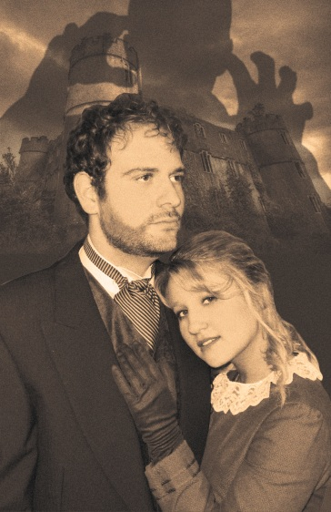Shelley sees the role of the writer as a moral educator. She defines moral virtue as based on self-sacrifice, moderation, domestic affection and aesthetic beauty. (Interesting not aggressive feminism then…) The women serve this purpose in the novel: events and actions happen to them, for the sake of teaching a male character a lesson or sparking an emotion within him. Margaret is the most passive of all, arguably the most necessary to the novel as a whole (without her, Walton would have no reason to relay his story) and ultimately the only one who survives..

Victor’s inability to love (Elizabeth) leads to his related inability to empathise with the monster. This leads to his own and the monster’s ruin. Elizabeth’s too – so the consequences of ignoring the female are dangerous/terminal…

The violence of his destruction of the female creature can be seen as a symbol of his fear of female sexuality. He fears his own lack of control if the monster has a partner and they go on to create a race. His speech hear reveals that he fears a woman who can make her own choices – but Shelley’s creation of the direction of the novel at this point, makes clear that she sees this as an error.

[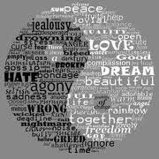](http://www.google.co.uk/url?sa=i&rct=j&q=&esrc=s&frm=1&source=images&cd=&cad=rja&uact=8&docid=zDKOtZ5rnepABM&tbnid=RFQ49sWbo-ob0M:&ved=0CAUQjRw&url=http://integral-options.blogspot.com/2013/11/everywhere-and-nowhere-are-binary.html&ei=dAykU7yyLpLo7AbRs4EQ&bvm=bv.69411363,d.ZGU&psig=AFQjCNGKgm8DO7xcodGobATe96Bhr-ugMQ&ust=1403346402033836)Can you see a typically Gothic series of binary opposites?

* Male Female
* Science Nature
* Control Subjugation
* Active Passive

Certainly all the females in the novel are passive and respect the distinction between the public, male domain and the female, domestic one. All die before the end of the novel: shocking, but also constructive – forces the reader to see the chaos created by men without the natural restraining/caring influence of women.

Traditional patriarchal values show the men as intellectuals and innovators and the women as emotional. Not so in Frankenstein…., where Victor’s troubles occur as a result of being both too emotional) obsessive in his work/ambition and insufficiently emotional (failure to take responsibility, exercise caution or love his fiancée/family/friends. By taking women’s role of giving life, he disrupts the natural order and causes chaos and tragedy.

Perhaps only positive feminist theme in Frankenstein is Nature. Subtle themes of Romanticism mixed with dark gothic themes. Nature offers solace, is strong and vibrant, protects and provides for the monster when he runs off to the forest. But also refuses to bow to male ambition (Victor’s work makes him sick and Walton’s gets him locked in the ice).

1815, huge volcano erupts, creates the ‘sunless summer’ for the Northern Hemisphere. Mary Shelley gives birth prematurely and the baby dies. Could also contextualise the ‘birth’ of the creature scenes... some have seen this as post-natal grief or guilt?

Victor ‘loves’ (or desires?) Elizabeth most when he sees her dead body after she has been killed by the monster, he “embraced her with ardour”. Suggestion that one only realises the value of things after they are gone. Also remember dream of Elizabeth turning into his dead mother. Could be seen as a fear of female sexuality again – so he can mourn her when she is gone, because she no longer has any potential power over him.

Do you think this text illustrates the dangers of not allowing women a voice or power? Or do you think the female question is irrelevant because so much of the novel focuses on men and their actions? Or perhaps you think differently at different points in the novel?

*Pin your ideas down to specific moments and support them with quotes:*

|  |  |  |
| --- | --- | --- |
|  | When? | Quote? |
| Woman as a guide/moral educator? |  |  |
| Woman as irrelevant? |  |  |
| Nature (female) as important? |  |  |
| Woman as victim? |  |  |
| Woman as heroine? |  |  |

[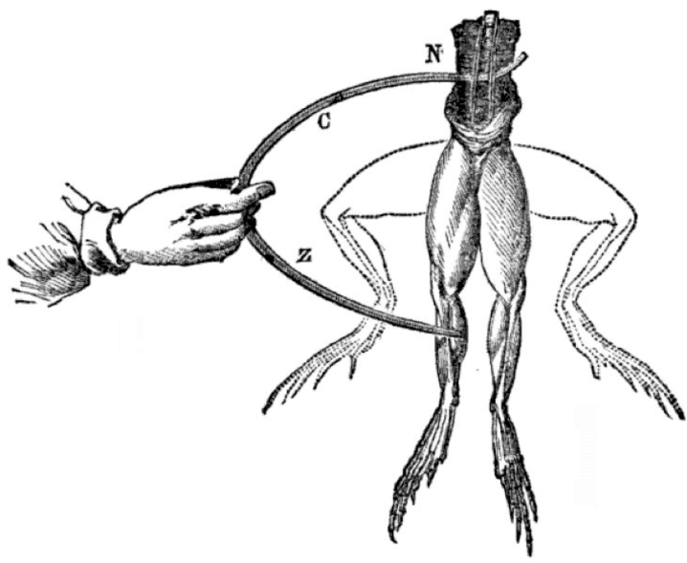](https://www.google.co.uk/url?sa=i&rct=j&q=&esrc=s&frm=1&source=images&cd=&docid=D16JpKwIYC1L3M&tbnid=0sKgWxPwaRIJeM:&ved=0CAUQjRw&url=https://wiki.engr.illinois.edu/display/BIOE414/History%2Bof%2BElectroencephalography&ei=VQ6kU_O8H8GN7QaW44DADQ&bvm=bv.69411363,d.ZGU&psig=AFQjCNF1uMtziO2nIT8MUH3RPka-AEeq1w&ust=1403346895833733)Science in ‘Frankenstein’: some ideas

The novel criticises science in so far as it is a tool of the patriarchy: it invents a scenario where the aggressive, male, virile scientist captures and enslaves a passive, fertile, female nature.

[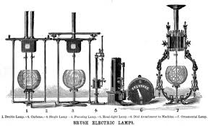](https://www.google.co.uk/imgres?imgurl&imgrefurl=http://en.wikipedia.org/wiki/Arc_lamp&h=0&w=0&tbnid=NBpA8xLHt6bQiM&zoom=1&tbnh=175&tbnw=288&docid=nDmdwsQqja1JfM&tbm=isch&ei=rw2kU9GcLYyV7AbW64H4Bw&ved=0CAIQsCUoAA)Shelley distinguishes between ‘good’ science: the detailed and reverent description of the workings of nature and ‘bad’ science as the hubristic manipulation of forces of nature to serve man’s private ends (ambition). So there is a difference between investigating the functioning of the physical universe and seeking to control or change it. (This is a transgression = Gothic)

3 important scientists in her time: Humphrey Davy; Erasmus Darwin and Luigi Galvani.

Davy’s ‘Elements of Chemical Philosophy’ published London 1812, owned by Percy Shelley and referred to in Mary’s own Journals. This informs Waldman’s lecture to Victor in which he claims that “these modern masters…have indeed performed miracles.” “They penetrate into the recesses of nature and shew how she works in her hiding places.” “They have acquired new and almost unlimited powers: they can command the thunders of heaven, mimic the earthquake and even mock the invisible world with its own shadows.”

Davy, in his celebration of the powers of chemistry asserts that “the phenomena of combustion… the conversion of dead matter into living matter.. all belong to chemistry.” Davy sketches a picture of the scientist of the future as one who “would become acquainted with the most profound secrets of nature; of ascertaining her hidden operations and of exhibiting to men that system of knowledge that relates so intimately to their own physical and moral constitution.” Davy argues that this will result in a more harmonious, cooperative and healthy [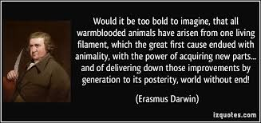](http://www.google.co.uk/url?sa=i&rct=j&q=&esrc=s&frm=1&source=images&cd=&cad=rja&uact=8&docid=5XmW_4cgYQ2UqM&tbnid=L3SlyXz474QYwM:&ved=0CAUQjRw&url=http://izquotes.com/quote/304873&ei=GA6kU-6hDfOV7Aaz04HADw&bvm=bv.69411363,d.ZGU&psig=AFQjCNEvotzG2-GS__Ltrkvack0AuS-yZg&ust=1403346832137573)society….

Shelley presents Victor as the embodiment of hubris – of that Satanic or Faustian presumption which blasphemously attempts to penetrate the sacred mysteries of the universe. She also questions whether this science produces only good – and makes the reader consider this by creating Victor as an alienated scientist working in feverish isolation, cut off from family and friends. So detached from a respect for nature and strong sense of personal responsibility, the products of one’s research can and will produce monsters. (At the time of writing, one of the most notable achievements of chemistry was the discovery of gunpowder…)

But Erasmus Darwin is an example of Shelley’s ‘good’ scientist. His ‘The Temple of Nature’ (book owned by the Shelleys) in which he discusses the superiority of sexual reproduction over solitary paternal propagation (flowers/animals). His ideas change during this period. In 1794, he argued that males produce the seed while females only provide nourishment. Monstrous births result from female deficiencies – when there is excessive or insufficient nourishment in the egg or uterus. But by 1801, he had changed his mind over the latter part, but still argued that the male imagination was more definitive because it was more intense, whereas the female contribution was less intense because it lasts for longer and so it more diffuse. Shelley uses these ideas, by Victor wanting to originate new life quickly (which will go reverse evolution leading to worse outcomes) and by chemical means (solitary propagation rather than the preferred sexual reproduction.)

This is how Victor is the modern Prometheus – he steals the spark of life (here electricity/the life of Nature) from the God(s) to give it to mankind (the monster) and so overthrows the established, sacred order of both heaven and earth – and the consequences are disastrous for everyone – Victor (he dies finally in torment) the monster (disappears “ lost in darkness and distance” – the final words of the novel - and society (Justine, William, Elizabeth etc).

[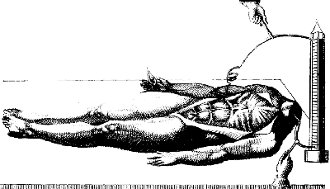](http://i1090.photobucket.com/albums/i376/simper_roma/Aldini1_zps016fa586.gif)In Jan 1803, galvanism was used in London by Aldini. He took a recently hanged criminal, Thomas Forster from the prison at Newgate and applied electric shocks to make him convulse. Polidori (whose house Shelley, Byron etc were staying in in Geneva) was a medical student in Edinburgh and so would have known of this experiment.

So not a fear of science, but of ‘crossing a line’, failing to take responsibility. Victor is an example of the Romantic over-reacher who transgresses the boundary between the human and the divine. The creature’s rejection by Victor can be seen as the second Fall of Man. Refs to Paradise Lost.

Shelley was writing just 10 years after the abolition of the slave trade in the British Empire – many refs to this too: Victor is enslaved by his work; the monster escapes like a refugee slave and is pursued by his master. But in power shift (Gothic fear?) the slave becomes the master and the master is a slave to his work and to his obsession/ambition.

**The novel takes a scientist as its central character, and explores the unforeseen consequences for him and for others of his scientific activities – his ardent desire for the acquisition of knowledge** (page 46).

Find quotes for each of these ideas:

Mary Shelley emphasises **the dangers of scientific research when the scientist does not** **think through the possible consequences of his work**. She also examines what happens when an experiment takes a different direction from the one he expected, and the scientist does not take responsibility for it (Marilyn Butler points out that Frankenstein abandons his Creature when it “goes wrong” rather than trying to understand and remedy the problem: “[The Creature] tracks his own maturation, from a solitary to a social animal. It is he, not Frankenstein, who follows through Frankenstein’s technological achievement in a scientific spirit.” (Introduction to the Oxford World’s Classics edition of the 1818 text). Frankenstein, by contrast, becomes unscientific, highly emotional and irrational.

|  |  |
| --- | --- |
|  |  |
|  |  |

There are many references in the novel to **the history of science, and to what the study of** **science involves**. Frankenstein is first interested in the medieval scientists who wanted to explain everything, and this fills his mind with what he later calls “chimaeras [fantasies] of boundless grandeur”(page 48). There is an emphasis on **scientific knowledge as a source of reputation and power**, with Frankenstein’s desire for the **glory** (page 42) that would be the result of banishing disease and so becoming a benefactor of the human race. It has often been pointed out that his **“fervent longing to penetrate the secrets of nature”** (page 41) uses a revealingly sexual metaphor, as if his scientific researches were an assault (compare the phrase **“entering the citadel of nature”** further down the page). In the same passage his reference to **“picking up shells beside the great ocean of truth”** links him to the ardent explorer, Robert Walton.

|  |  |
| --- | --- |
|  |  |
|  |  |

Science (Natural Philosophy) is also explored in the novel in terms of **research that was being done in Mary Shelley’s own time (and in the previous generation)**: electricity and galvanism (page 43), chemistry, astronomy, physics and physiology (page 49). Like Galvani, Priestley, Humphry Davy, Erasmus Darwin and many others, Frankenstein is engaged in **a great enterprise to “unfold to the world the deepest mysteries of creation”**(page 49). The contemporary “vitalist controversy” about the nature and origins of the life-force is a major influence on the novel.

|  |  |
| --- | --- |
|  |  |
|  |  |

[](http://www.google.co.uk/url?sa=i&rct=j&q=&esrc=s&frm=1&source=images&cd=&cad=rja&uact=8&docid=cukjvglw8N2p-M&tbnid=GtBK2Nc6Gl6cbM:&ved=0CAUQjRw&url=http://rapgenius.com/1569908/Ztb-look-up/Playing-games-of-poker-with-my-inner-devil&ei=khWkU9vrKtTe7AbLs4HgDQ&bvm=bv.69411363,d.ZGU&psig=AFQjCNHxQxkx6TSukucULAw-ZNEePdL1Fg&ust=1403348730295200)THE DARK SIDE OF HUMAN NATURE

**Shadow (psychology)** (From Wikipedia)

[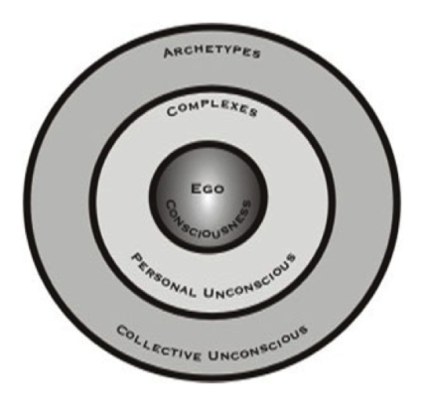](http://www.google.co.uk/url?sa=i&rct=j&q=&esrc=s&frm=1&source=images&cd=&cad=rja&uact=8&docid=IFuX7E0N6xgQoM&tbnid=vcqk7DKETRhnuM:&ved=0CAUQjRw&url=http://ampretty.wordpress.com/tag/archetypes/&ei=wRSkU6bhG-ye7AbuiICoDw&bvm=bv.69411363,d.ZGU&psig=AFQjCNFX_aSaSAW6c_aWVirVs6w86-05CA&ust=1403348525419453)In [Jungian psychology](http://en.wikipedia.org/wiki/Jungian_psychology), the **shadow** or "**shadow aspect**" may refer to (1) an unconscious aspect of the personality which the conscious ego does not identify in itself. Because one tends to reject or remain ignorant of the least desirable aspects of one's personality, the shadow is largely negative, or (2) the entirety of the unconscious, i.e., everything of which a person is not fully conscious. There are, however, positive aspects which may also remain hidden in one's shadow (especially in people with low [self-esteem](http://en.wikipedia.org/wiki/Self-esteem)).[[1]](http://en.wikipedia.org/wiki/Shadow_(psychology)#cite_note-1) Contrary to a [Freudian](http://en.wikipedia.org/wiki/Freudian) definition of shadow, therefore, the Jungian shadow can include everything outside the light of consciousness, and may be positive or negative. "Everyone carries a shadow," Jung wrote, "and the less it is embodied in the individual's conscious life, the blacker and denser it is."[[2]](http://en.wikipedia.org/wiki/Shadow_(psychology)#cite_note-2) It may be (in part) one's link to more primitive animal instincts,[[3]](http://en.wikipedia.org/wiki/Shadow_(psychology)#cite_note-3) which are superseded during early childhood by the conscious mind.

According to Jung, the shadow, in being instinctive and [irrational](http://en.wikipedia.org/wiki/Irrationality), is prone to [psychological projection](http://en.wikipedia.org/wiki/Psychological_projection), in which a perceived personal inferiority is recognised as a perceived moral deficiency in someone else. Jung writes that if these projections remain hidden, "The projection-making factor (the Shadow archetype) then has a free hand and can realize its object--if it has one--or bring about some other situation characteristic of its power." [[4]](http://en.wikipedia.org/wiki/Shadow_(psychology)#cite_note-4) These projections insulate and harm individuals by acting as a constantly thickening veil of illusion between the [ego](http://en.wikipedia.org/wiki/Id,_ego_and_super-ego) and the real world.

[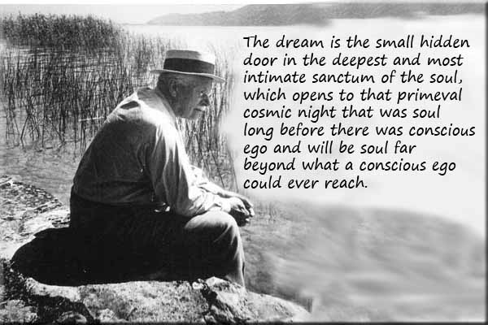](http://www.google.co.uk/url?sa=i&rct=j&q=&esrc=s&frm=1&source=images&cd=&cad=rja&uact=8&docid=1fvqOAZn4hzauM&tbnid=_0RzUbc4PeoHxM:&ved=0CAUQjRw&url=http://jungcurrents.com/the-dream-is-a-small-hidden-door/&ei=ChWkU9TZMMPX7AbTnIGoBA&bvm=bv.69411363,d.ZGU&psig=AFQjCNHybF8w3UsQvgY4CedaWOnd9PqlhA&ust=1403348612506415)From one perspective, 'the shadow...is roughly equivalent to the whole of the Freudian unconscious';[[5]](http://en.wikipedia.org/wiki/Shadow_(psychology)#cite_note-5) and Jung himself asserted that 'the result of the Freudian method of elucidation is a minute elaboration of man's shadow-side unexampled in any previous age'.[[6]](http://en.wikipedia.org/wiki/Shadow_(psychology)#cite_note-6)

Jung also believed that "in spite of its function as a reservoir for human darkness—or perhaps because of this—the shadow is the seat of [creativity](http://en.wikipedia.org/wiki/Creativity).";[[7]](http://en.wikipedia.org/wiki/Shadow_(psychology)#cite_note-7) so that for some, it may be, 'the dark side of his being, his sinister shadow...represents the true spirit of life as against the arid scholar'.[[8]](http://en.wikipedia.org/wiki/Shadow_(psychology)#cite_note-8)

**Appearance**

The shadow may appear in [dreams](http://en.wikipedia.org/wiki/Dream) and [visions](http://en.wikipedia.org/wiki/Vision_(religion)) in various forms, and typically 'appears as a person of the same sex as that of the dreamer'.[[9]](http://en.wikipedia.org/wiki/Shadow_(psychology)#cite_note-9) The shadow's appearance and role depend greatly on the living experience of the individual, because much of the shadow develops in the individual's mind rather than simply being inherited in the [collective unconscious](http://en.wikipedia.org/wiki/Collective_unconscious). Nevertheless some Jungians maintain that '*The shadow* contains, besides the personal shadow, the shadow of society ... fed by the neglected and repressed collective values'.[[10]](http://en.wikipedia.org/wiki/Shadow_(psychology)#cite_note-10)

Interactions with the shadow in [dreams](http://en.wikipedia.org/wiki/Dream) may shed light on one's state of mind. A conversation with the shadow may indicate that one is concerned with conflicting desires or intentions. Identification with a despised figure may mean that one has an unacknowledged difference from the character; a difference which could point to a rejection of the illuminating qualities of ego-consciousness. These examples refer to just two of many possible roles that the shadow may adopt, and are not general guides to interpretation. Also, it can be difficult to identify characters in dreams — "all the contents are blurred and merge into one another ... 'contamination' of unconscious contents"[[11]](http://en.wikipedia.org/wiki/Shadow_(psychology)#cite_note-11) — so that a character who seems at first to be a shadow might represent some other [complex](http://en.wikipedia.org/wiki/Complex_(psychology)) instead..

**Encounter with the shadow**

The encounter with the shadow plays a central part in the process of [individuation](http://en.wikipedia.org/wiki/Individuation). Jung considered as a perennial danger in life that 'the more consciousness gains in clarity, the more monarchic becomes its content...the king constantly needs the renewal that begins with a descent into his own darkness'[[15]](http://en.wikipedia.org/wiki/Shadow_(psychology)#cite_note-15) — his shadow - which the 'dissolution of the persona'[[16]](http://en.wikipedia.org/wiki/Shadow_(psychology)#cite_note-16) sets in motion.

"The shadow personifies everything that the subject refuses to acknowledge about himself" and represents "a tight passage, a narrow door, whose painful constriction no one is spared who goes down to the deep well".[[17]](http://en.wikipedia.org/wiki/Shadow_(psychology)#cite_note-17) If and when 'an individual makes an attempt to see his shadow, he becomes aware of (and often ashamed of) those qualities and impulses he denies in himself but can plainly see in others — such things as egotism, mental laziness, and sloppiness; unreal [fantasies](http://en.wikipedia.org/wiki/Fantasies), schemes, and plots; carelessness and cowardice; inordinate love of money and possessions — ...[a] painful and lengthy work of self-education".[[18]](http://en.wikipedia.org/wiki/Shadow_(psychology)#cite_note-18)

The dissolution of the persona and the launch of the individuation process also brings with it 'the danger of falling victim to the shadow ... the black shadow which everybody carries with him, the inferior and therefore hidden aspect of the personality'[[19]](http://en.wikipedia.org/wiki/Shadow_(psychology)#cite_note-19) — of a merger with the shadow.

|  |  |
| --- | --- |
| Dreams in the novel | Quotes/Method/Effect? |
|  |  |

DIFFERENT READINGS OF THE NOVEL

**You must consider and write about different interpretations of the novel. These ideas are trawled from the internet and give you lots of informal starting points, but make sure you can argue for yourself and support your opinions with accurate evidence from the book…..**

“However, more fundamentally, the book (in my opinion) is about how Man's unchecked quest for, and abuse of, Knowledge and Perfection (Science) along with a self-centred world view leads to the corruption of Nature that causes his own downfall. (Theme of Abuse of Science.)”  
  
“I understand how the creature becomes a monster. He starts out with naive instincts (a blank slate of sorts), but the way he is treated by Victor and society leads him to despair at his situation and fury at his creator. He can never be part of the society he was brought into nor accepted as a "child" by his creator. From the creature's point of view, his struggle is with his creator and his own abandonment to a miserable and lonely loveless life by his "father." His evil deeds, to him, are revenge on his father.”

“From Victor's POV, he has created a monstrosity out of his scientific curiosity without regard for the consequences. Clearly, he never considered what would happen once his experiment succeeded; perhaps deep down he wasn't sure he would ever succeed. After the creature comes to life, Victor refuses his responsibility and maintains his selfish pursuit of fame. He was hoping to discover something that would benefit humanity, but his experiment spiralled out of his control right away and he couldn't undo what he'd done. The creature had a mind of its own. (Theme of Free Will.)

“Revulsion to the creature may be due to his grotesqueness, his "otherness", or it can also be allusions to our fear of the unknown, the un-natural, and our misunderstanding of it.”

Loading

OpinO

“Adam, made by man and not by God was the ultimate expression of the fear and anxiety that the Enlightenment and scientific zietgist of that era. While based on a nightmare the author had (which would have unwittingly given more of herself to the writing and her own pysche than she intended). It is an examination on what makes us human.”

“If there is no God only the black and white of science, without the structured morality, without limits, without heaven or hell, then what does it mean to live and what does it mean to die? We live in an age when science is the hero, we forget that it was not always seen that way. We live in an age where in the west it is rare for children to die. Disease was everywhere, death was everywhere and science was shaking the foundations of the very things that gave comfort and meaning to most people’s lives. I think that Victor acts out of fear, the mob act out of fear. Adam as the monster is the only innocent party. He is an metaphor, a fear made manifest, a weapon against death, a weapon against God. Death is not your enemy if you believe in heaven but if you don't then it is something to battle against with ever greater vigour. Interestingly these themes and it's anxieties were far ahead of its time and still remain today.”

“I think if we try and put morality on to this work from the 21st century we are hard pressed because we don't inderstand what it is like to live through such changes as the author did.”

“I think Mary Shelley was exploring the destructive aspects of Romanticism sublime ego.”

“How dangerous is the acquirement of knowledge and how much happier that man is who believes his native town to be the world, than he who aspires to be greater than his nature will allow.”   
  
"Seek happiness in tranquility and avoid ambition even if it be only the apparently innocent one of distinguishing yourself in science and discoveries."  
  
“Also, on a random and probably unrelated note. I thought that the monster perfectly demonstrated Maslow's hierarchy of needs - physiological, safety and security, love and belongingness, esteem, self-actualization...”

*“Everyone thinks of changing the world, but no one thinks of changing himself.”* — Leo Tolstoy

*“The ego has learned to be very clever in order to survive. It is capable of resorting to any lengths or ruse of self-deception and camouflage. The world we witness is merely the drama of collective egos acting out on the perceptual stage of form and time. The satisfactions of the ego are more pleasurable and addictive than the preservation of human life, much less dignity.”* — David R. Hawkins

Our modern world is reflection of our collective “Ego” (our false, illusionary self/identity) and this reflection is frightening. What we are doing to each other and to our children is the reality hard to believe and to accept.

Although no person wants to suffer, people continually gravitate to the things that cause suffering because of their ignorance. The origin of suffering is attachment to transient things and the ignorance thereof.

War and violence are fueled by human greed and envy rooted in deep ignorance. Genocide has never resolved any problems – in fact it made problems and conflicts much worse.

**Your ideas:**

|  |  |
| --- | --- |
| Morals? |  |
| Society? |  |
| Science? |  |
| Ambition? |  |

Frankenstein: chapters & quotes

|  |  |  |
| --- | --- | --- |
|  | *Story* | *Gothic quotes* |
| Letter 1 | Walton to Margaret. St Petersburgh. December. Explains the dream of the voyage. | “an enterprise….with evil forebodings”  “I may discover the wondrous power which attracts the needle”  “do I not deserve to accomplish some great purpose?” |
| Letter 2 | Walton to Margaret. Archangel. March. The ship and crew. | “I desire the company of a man who could sympathise with me” |
| Letter 3 | Walton to Margaret. At sea. July. Calm. Determination. | “I will not rashly encounter danger. I will be cool, persevering and prudent.”  “But success shall crown my endevaours”  “the very stars themselves being witnesses and testimonies of my triumph” |
| Letter 4 | Walton to Margaret. At sea. August. Sighting of the creature. Rescues Frankenstein. Writes in instalments. Friendship, dreams, determination to succeed. | “a being which had the shape of man, but apparently of gigantic structure.”  “his eyes have an expression of wildness and even madness”  “so noble a creature destroyed by misery”  “the burning ardour of my soul”  “one man’s life or death were but a small price to pay for the acquirement of the knowledge which I sought; for the dominion I should acquire and transmit over the elemental foes of our race.” |
| Chapter 1 | Frankenstein’s story. Birth & ancestry. Arrival of Elizabeth. | “respected by all who knew him” “a protective spirit” (his father)  “benevolent disposition” (his mother)  “guardian angel” (Elizabeth)  “fairer than a garden rose among dark-leaved brambles” (Elizabeth)  “to shed radiance” (Elizabeth) |
| Chapter 2 | Shared childhood & education. Henry Clerval. Natural philosophy & dreams. Destiny. | “Natural philosophy is the genius that has regulated my fate.”  “Destiny was too potent, and her immutable lawas had decreed my utter and terrible destruction”.  “deeply smitten with the thirst for knowledge.”  “the raising of ghosts or devils….I most eagerly sought”  “that passion like a mountain river…. Became a torrent…. Swept away all my hopes and joys.” |
| Chapter 3 | Aged 17. Death of his mother. Ingolstadt. Professor Waldman. | “She died calmly and her countenance expressed affection even in death” (his mother)  “the misfortune of my life occurred”  “he was an uncouth man, but deeply imbued in the secrets of his science.” (Krempe)  “I was now alone”  “it decided my future destiny.” |
| Chapter 4 | Natural philosophy. The principle of life… recourse to death. Discovery of power to create animation. Focus & isolation on task for 2 years. | “When I found so astonishing a power placed within my hands, I hesitated a long time….”  “Forced to spend days and nights in vaults and charnel houses”  “no father could claim the gratitude of his child so completely as I should deserve theirs” (of the creature)  “a new species would bless me as its creator and source.” |
| Chapter 5 | November. The Creature stirs. Runs. Dreams of Elizabeth & his mother. Clerval arrives. Nervous fever. | “the beauty of the dream vanished and breathless horror and disgust filled my heart.” “I was lifeless.”  “infused the spark of being into this thing that lay at my feet.”  “I could not have asked for a more kind and attentive nurse” (than Clerval.) |
| Chapter 6 |  |  |
| Chapter 7 |  |  |
| Chapter 8 |  |  |
|  | End of Volume 1 |  |
| Vol 2, Chap 1 |  |  |
| Vol 2  Chap 2 |  |  |
| Vol 2  Chap 3 |  |  |
| Vol 2  Chap 4 |  |  |
| Vol 2  Chap 5 |  |  |

KEY EVENTS: STORY BOARD

Compile a storyboard of the key events in the first third of the novel. Illustrate each section and write a brief caption.

|  |  |  |
| --- | --- | --- |
|  |  |  |
|  |  |  |
|  |  |  |
|  |  |  |
|  |  |  |
|  |  |  |

Test yourself! -10 quick questions

(and to really impress yourself: quote from the novel wherever you can….)

1. What is the alternative title of the novel?

1. Who are the letters written to?

1. Where did Victor and Elizabeth grow up?

1. What delayed Victor’s departure for Ingolstadt?

1. What was Victor’s reaction to the creature’s first movement?
2. Who comes to Ingolstadt and cares for Victor?
3. Whose sad tale does Elizabeth recount in her letter?
4. What does his father’s letter inform him of?

1. What drew the creature to the cottage?

1. What was the name of the dark lady on horseback?

TESTING YOURSELF: ADD QUOTES TO DESCRIBE EACH CHARACTER

Justine

Victor

[](http://www.google.co.uk/url?sa=i&rct=j&q=silhouette+of+people&source=images&cd=&cad=rja&docid=BJ0usKe8A4SPFM&tbnid=EhJRbFFyxqzVoM:&ved=0CAUQjRw&url=http://ru.clipdealer.com/video/media/50115&ei=iStDUf3VDeKN0wWi64HIDQ&bvm=bv.43828540,d.ZWU&psig=AFQjCNGJAgpfhaT0C7yhu0F0iuPI8t7V_Q&ust=1363442902373451)

Elizabeth

The Creature

Walton

complete the other half and identify the speaker…

|  |  |  |
| --- | --- | --- |
| I ardently hope the gratification of your wishes | May not be a serpent to sting you | F |
| You are pursuing the same course |  |  |
| It was the secrets of heaven and earth |  |  |
| The saintly soul of Elizabeth |  |  |
| Made the doing good |  |  |
| The birth of that passion that afterwards |  |  |
| I pursued nature |  |  |
| The horrors of my secret toil as I dabbled |  |  |
| A dreary night in November |  |  |
| With an anxiety |  |  |
| I collected the instruments |  |  |
| That I might infuse a spark of being |  |  |
| It was already one in the morning |  |  |
| I saw the dull, yellow |  |  |
| His shrivelled complexion and |  |  |
| I had desired it with an ardour |  |  |
| The beauty of the dream had vanished, and |  |  |
| Hear features appeared to change and I |  |  |
| I beheld the miserable |  |  |
| A grin |  |  |
| I took refuge |  |  |
| I felt the bitterness of disappointment |  |  |
| Devil |  |  |
| Begone |  |  |
| If you refuse |  |  |
| Abhorred monster |  |  |
| The tortures of hell are |  |  |
| I am thy creature |  |  |
| But I am rather the |  |  |
| I was benevolent and good |  |  |
| I was benevolent |  |  |
| The desert mountains and dreary glaciers |  |  |
| These bleak skies I hail for they are |  |  |
| I am miserable, and they |  |  |
| I saw, felt and heard |  |  |
| A radiant form [rose] from among the trees |  |  |
| Happy to have found a shelter |  |  |
| The gentle manners of the girl |  |  |
| If I cannot inspire love |  |  |
| I will work at your destruction, nor finish |  |  |