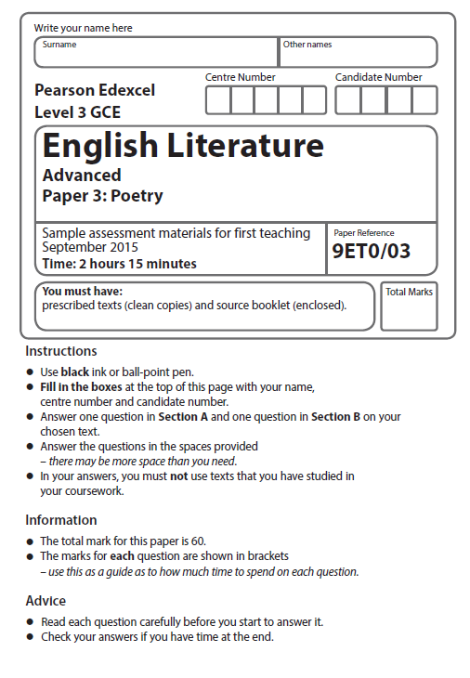

Mock Exam 2017

**SECTION A: Post-2000 Specified Poetry**

**Read the poem on the next page before answering ONE question.**

**Write your answer in the space provided below.**

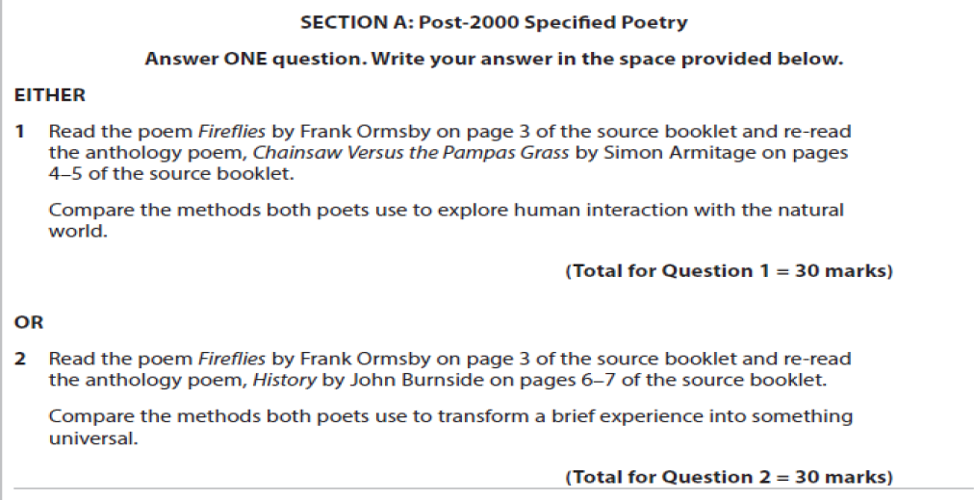

**SECTION A: Post-2000 Specified Poetry**

***Fireflies***

The lights come on and stay on under the trees.

Visibly a whole neighborhood inhabits the dusk,

so punctual and in place it seems to deny

dark its dominion. Nothing will go astray,

the porch lamps promise. Sudden, as though a match 5

failed to ignite at the foot of the garden, the first squibs

trouble the eye. Impossible not to share

that sportive, abortive, clumsy, where-are-we-now

dalliance with night, such soothing relentlessness.

What should we make of fireflies, their quick flare 10

of promise and disappointment, their throwaway style?

Our heads turn this way and that. We are loath to miss

such jauntiness in nature. Those fugitive selves,

winged and at random! Our flickery might-have-beens

come up form the woods to haunt us! Our yet-to-be 15

as tentative frolic! What do fireflies say?

That loneliness made of light becomes at last

convivial singleness? That any antic spark

cruising the void might titillate creation?

And whether they spend themselves, or go to ground, 20

or drift with their lights out, they have left the gloom,

for as long as our eyes take to absorb such absence,

less than it seemed, as childless and deprived

as Chaos and Old Night. But ruffled, too,

as though it unearthed some memory of light 25

from its long blackout, a hospitable core

fit home for fireflies, brushed by fireflies' wings.

**Frank Ormsby**

**SECTION B: Specified Poetry Pre- or Post-1900**

**Answer ONE question on your chosen text. Write your answer in the space provided.**

**You must select a poem from the prescribed list for your studied collection.**

**The poems are listed in Section B of the source booklet on pages 4 to 14.**

**Medieval Poet: Geoffrey Chaucer**

Prescribed text

*The Wife of Bath’s Prologue and Tale*, editor James Winny

**3** Explore how attitudes towards masculine roles are presented in *The Wife of Bath’s*

*Prologue and Tale,* by referring to lines 882–898 and **one** other passage of similar

length.

*You must discuss relevant contextual factors.*

**(Total for Question 3 = 30 marks)**

**OR**

**4** Explore the ways in which ageing is presented in *The Wife of Bath’s Prologue and Tale,*

by referring to lines 455–459 and lines 469–479 and **one** other passage of similar length.

*You must discuss relevant contextual factors.*

**(Total for Question 4 = 30 marks)**

**The Romantics**

Prescribed text

*English Romantic Verse*, editor David Wright

**5** Explore the ways in which nature is presented in *Lines Composed a Few Miles Above Tintern Abbey* and **one** other poem.

*You must discuss relevant contextual factors.*

**(Total for Question 5 = 30 marks)**

**OR**

**6** Explore the ways in which religion is presented in *Holy Thursday (Innocence)* by

William Blake and **one** other poem.

*You must discuss relevant contextual factors.*

**(Total for Question 6 = 30 marks)**

**Metaphysical Poet: John Donne**

Prescribed text

*John Donne Selected Poems*

**7** Explore the ways in which John Donne's poetry makes use of unusual comparisons, by referring to *A Valediction: Forbidding Mourning* and one other poem.

*You must discuss relevant contextual factors.*

**(Total for Question 7 = 30 marks)**

**OR**

**8** Explore the dramatic nature of Donne’s poetry, by referring to *Holy Sonnet X* (‘*Death*

*be not proud’)* and **one** other poem.

*You must discuss relevant contextual factors.*

**(Total for Question 8 = 30 marks)**