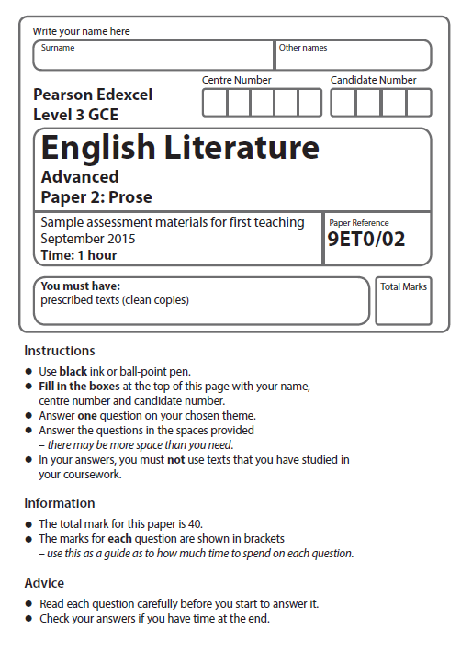

Mock Exam 2017

**Answer ONE question from your chosen theme. Write your answer in the space provided.**

**Science and Society**

**Texts**

Pre-1900: *Frankenstein*, Mary Shelley; *The War of the Worlds*, H G Wells

Post-1900: *Never Let Me Go*, Kazuo Ishiguro; *The Handmaid’s Tale*, Margaret Atwood

**1** Compare the ways in which the writers of your **two** chosen texts use different voices in their works. You must relate your discussion to relevant contextual factors.

**(Total for Question 1 = 40 marks)**

**OR**

**2** Compare the ways in which the writers of your **two** chosen texts present the effects of scientific progress on the individual in their works. You must relate your discussion to relevant contextual factors.

**(Total for Question 2 = 40 marks)**