**Research: B1 Students’ Findings**

**The Life of Geoffrey Chaucer**

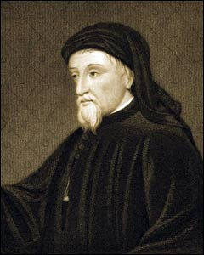

* His date of birth is uncertain, but 1340-3 most likely
* Died in 1400 and buried in Westminster Abbey
* Born in a prosperous London family and worked his way up the royal household, so was familiar with life at court
* In 1359 he went on a military campaign to Brittany, was captured but had his ransom paid by the King.
* Around 1336 married his wife Philippa, the sister-in-law of John of Gaunt (Edward III’s third son). Had several children.
* Spoke French and probably Italian fluently and wrote his first works in French.
* Is often called ‘the father of English poetry’ as people felt English was an inferior literary language to French before he wrote his works.

**The Canterbury Tales (1387-1400)**

Like all literature, the Tales were handwritten, as the printing press had not yet been brought to Britain, so there were very few copies and they were extremely precious. They would have been read aloud, by Chaucer himself, at court. His audience would have been educated and sophisticated – royals, nobles, civil servants like himself, etc. Women would also have been present.

The Canterbury Tales are a frame narrative: Chaucer presents himself as a pilgrim going to Canterbury Cathedral (to the shrine of St Thomas à Becket) who meets other pilgrims at an inn in London. They decide to tell each other stories on the way there and back to make the journey more enjoyable.

**Women**

* There was a large variety in the level of wealth, status and power for women in medieval times.
* Society in the 14th century was heavily influenced by religion, which validated a patriarchal society: it was claimed that because Eve was tempted and caused the fall of man, therefore all women were evil and rightly considered inferior to men.
* However Mary, the mother of Jesus, who at the time was considered the most important saint, influenced a positive view on women, as she was a symbol of chastity. Belief in the virgin birth led to virgins being seen as superior to married women.
* Women usually had their husbands selected for them by their male relatives (lthough many men also had no real choice of marriage partner).
* In both rural and urban communities, women often worked alongside their husbands as well as caring for their children.
* A woman’s basic choice was to become a wife or a nun. Since many women died in childbirth, several chose the convent, where they would be materially secure and have a good education.

**Gender roles**

* Strict roles for men and women, especially for the lower classes
* Women submissive, based upon bible.
* Men head of the household, were the decision makers.
* Women were expected to have children and look after the house
* Women were considered their fathers’ then their husbands’ property
* Only women of royal blood had any political power
* The Church (in the form of convents) did offer possibilities for women to rise socially. An abbess (head of a convent) had greater authority than a monk.
* In Britain, women were rarely educated to more than a basic standard and were not admitted into the universities.
* According to the rules of courtly love, however, the woman was the ‘mistress’ and the man the ‘servant’ who obeyed all her commands. This was more often found in the pages of literature than in real life, though.

**Marriage**

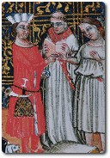

* A marriage was validated simply by the consent of the couple, not necessarily in front of a priest. A marriage based on words like ‘I plight thee my troth' could not be dissolved, despite, for example, parental objections.
* Girls could be legally married at age 12
* Consent must have been freely given, though love was not a requirement!
* As in other periods, it was difficult to marry without enough money to establish a viable household. Considerations of property and the alliance of families might be very important in the families of the nobility and the wealthy gentry. This sometimes led to early betrothals to secure an alliance.
* Today the term bigamy refers to someone who unlawfully marries a second spouse whilst still being legally married to his/her first spouse. However, in medieval times, bigamy was the word used to refer to a man's second marriage after the death of his first wife.
* The ‘bigamist’ could be affected in some ways. For example, if a man had been widowed twice, or his deceased wife had been a widow, he could not become a priest.
* Wealthy widows, unlike married women, were both legally and financially independent
* Widows were sometimes regarded with suspicion because they were sexually experienced yet unmarried.
* The Church regarded chaste widowhood as preferable to remarriage, but remarriage was seen as preferable to fornication (sex outside marriage).

**Education in the Middle Ages**

* In 1330, 95% of the population was illiterate. 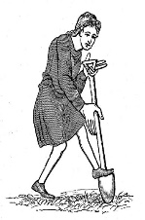
* Many serfs were banned from education.
* Sons from rich families went to either ‘elementary song schools’, monastic or grammar schools.

Elementary song schools

* Attached to a large church in the town
* Boys were taught to sing Latin hymns and songs
* If there was an educated priest, he would teach the boys to read and write.

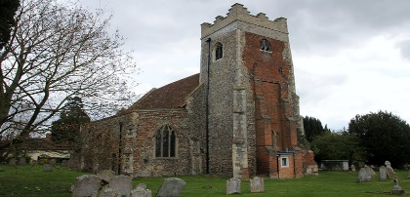

Monastic schools

* Where boys were trained for the Church
* The boys were taught by monks, in lessons all concerning religious education.
* Some students were local boys from poorer families.
* The boys paid for their lessons by working in the monastery.

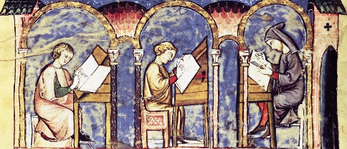 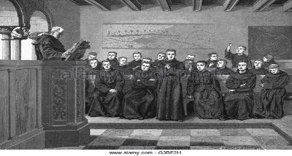

Grammar schools

* Usually part of a Cathedral or large Church
* Main purpose was to teach boys Latin grammar.
* These schools were very similar to those established by the Romans.
* Boys were also taught logic (the art of arguing), and rhetoric (the art of public speaking.)
* Not much time was spent on the subjects of mathematics and science

Oxford and Cambridge

* These were the two main centres of learning in England, founded in the 12thcentury, and the only universities.
* Boys were taken to Oxford or Cambridge when they were considered ‘ready’ for advanced studies, which could be as young as thirteen.
* Admission depended on parents’ wallets, not on ability!

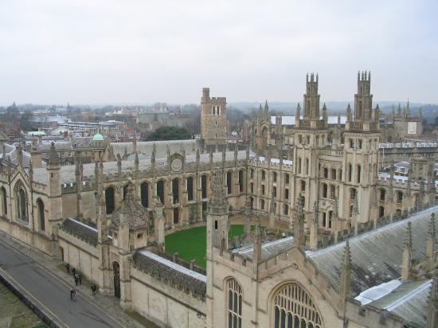 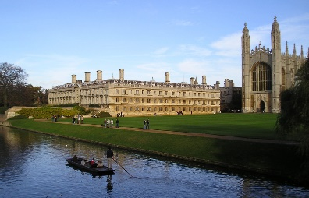

**Religion**

* The headquarters of the Western Church was Rome. Almost everyone in Britain and Europe was Roman Catholic (a few were Jews)
* The Vatican in Rome was (and still is) the chief residence of the Pope
* The Church was symbolised by a woman, Ecclesia
* For most medieval Christians, religious experience was focused on a parish church which they attended, at least in theory, on Sundays and religious festivals.
* The regular church, by contrast, consisted of men and women who had sworn vows of obedience, celibacy and poverty.
* Monks and nuns tried to remove themselves as much as possible from the secular world, ideally living in communities with minimal contact with the outside world.
* Anyone who disagreed with the Church’s teachings was considered a heretic and could be punished or even killed.
* It was considered noble to fight in the Crusades against ‘unbelievers’ (i.e. anyone not a Catholic, especially Muslims) in an attempt to regain Jerusalem. The Crusades were over by Chaucer’s day, however.

Pilgrimages

* Another aspect of the religious life was pilgrimages to holy places, usually the shrines of saints.
* These were undertaken to show devotion, thank the saint for a supposed miracle, ask for help or absolve sins. Some people simply enjoyed the travelling and change of scene, though, as no-one went on other holidays.
* They could be difficult and dangerous, in the case of shrines at Constantinople or Compostella, or shorter, like the one to Canterbury that Chaucer’s pilgrims are on.