**English Romantic Verse** One-Page Guides

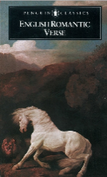**Poet**

Poet

|  |  |
| --- | --- |
| Context (biographical, Romantic attitudes, social/historical etc) |  |
| A poem about… (Interpretations, key Romantic themes, nature, mortality) |  |
| Speaker (who? talking to whom? attitude to subject- ironic, reverent etc) |  |
| Form (sonnet, ballad, verse form, rhyme and rhythm) |  |
| Overall structure (shifts, changes, climax of narrative etc) |  |
| Language (vocabulary - heightened or demotic; rhetorical features etc) |  |
| Sound effects (harsh and soft, onomatopoeia etc) |  |
| Imagery (metaphor, simile, images etc) |  |
| Patterns of language (semantic fields, repetitions, oppositions) |  |
| Punctuation and grammar (sentence length, end-stopping, caesura, verb mood - imperative, declarative, interrogative, exclamatory) |  |
| Links to other poems |  |