**JERUSALEM**

[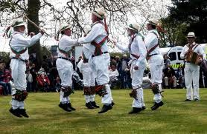](http://www.google.com/imgres?q=morris+men+dancing&start=286&hl=en&gbv=2&biw=1366&bih=587&tbm=isch&tbnid=05zTrBHwcBJg0M:&imgrefurl=http://www.winchester-morris-men.org.uk/&docid=7s9FXXkkYqWxEM&imgurl=http://www.winchester-morris-men.org.uk/CranburyPark2010_SO212HL_2.jpg&w=448&h=292&ei=zTfWT9fFBNL-8QPiw8iBAw&zoom=1&iact=hc&vpx=87&vpy=78&dur=1043&hovh=181&hovw=278&tx=133&ty=96&sig=105511694509115003484&page=12&tbnh=124&tbnw=176&ndsp=26&ved=1t:429,r:13,s:286,i:46)[](http://www.northdevongazette.co.uk/polopoly_fs/ndg_torr_mayfair_ak19105_1_888798!image/2193930783.jpg_gen/derivatives/landscape_490/2193930783.jpg)[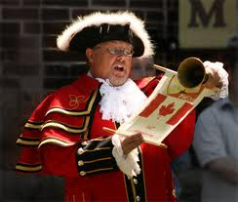](http://www.google.com/imgres?q=town+crier&hl=en&gbv=2&biw=1366&bih=587&tbm=isch&tbnid=AoJVOiA4zIC6AM:&imgrefurl=http://kingstonherald.com/news/kingston-town-crier-best-in-world-201031078&docid=ow3nj7gHlIVpAM&imgurl=http://kingstonherald.com/graphics/201006/town-crier.jpg&w=326&h=276&ei=qznWT8G1GYTT8QOfz_msAw&zoom=1&iact=hc&vpx=475&vpy=40&dur=2503&hovh=207&hovw=244&tx=129&ty=85&sig=105511694509115003484&page=1&tbnh=104&tbnw=123&start=0&ndsp=34&ved=1t:429,r:27,s:0,i:221)

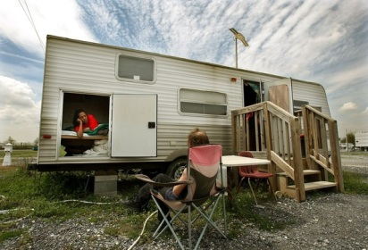

[](http://www.google.com/imgres?q=countryside+litter&hl=en&gbv=2&biw=1366&bih=587&tbm=isch&tbnid=VYIRrguM4fCvUM:&imgrefurl=http://litterheroes.co.uk/horror.htm&docid=3zKn3tEosOEYJM&imgurl=http://litterheroes.co.uk/images/carlsberg.jpg&w=400&h=300&ei=Nj7WT-n4ItP78QP4y9mXAw&zoom=1&iact=hc&vpx=752&vpy=119&dur=3889&hovh=194&hovw=259&tx=144&ty=86&sig=105511694509115003484&page=1&tbnh=120&tbnw=168&start=0&ndsp=23&ved=1t:429,r:4,s:0,i:84)[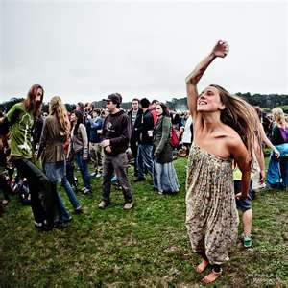](http://images.search.yahoo.com/images/view;_ylt=A0PDoS39RtZPXVYAAXCJzbkF;_ylu=X3oDMTBlMTQ4cGxyBHNlYwNzcgRzbGsDaW1n?back=http://images.search.yahoo.com/search/images?p=dancing+outside+at+night&n=30&ei=utf-8&y=Search&fr=sfp&tab=organic&ri=6&w=640&h=640&imgurl=farm5.staticflickr.com/4137/4939926235_daf92a9633_z.jpg&rurl=http://www.flickr.com/photos/paigekparsons/4939926235/&size=413.5+KB&name=Hippies+Dancing+at+Outside+Lands+during+Further's+headlining+show+Saturday+night.&p=dancing+outside+at+night&oid=cf9e30ac498caa852776f1921ff4f349&fr2=&fr=sfp&tt=Hippies+Dancing+at+Outside+Lands+during+Further's+headlining+show+Saturday+night.&b=0&ni=84&no=6&ts=&tab=organic&sigr=11mipdcqf&sigb=13mu1h9fc&sigi=11nbg8uvk&.crumb=LRKFAZiin0.)

**Study Guide**

**Title and Prologue**

Make sure you are clear about the different connotations of the play’s title:

* Jerusalem is ‘the promised land’ in the Bible, often seen as a metaphor for Heaven.
* The stanzas sung by Phaedra are taken from a longer poem by William Blake (1757-1827), revolutionary poet and artist, who deplored the effects of the Industrial Revolution on the English countryside; he was also opposed to any sort of authority or institution and believed we should follow our hearts in everything.
* These stanzas, with the following two (see Q3 below), form the song ‘Jerusalem’, which has been adopted as a patriotic anthem by respectable Middle England (probably the last thing Blake would have wanted).

1. Bearing these points in mind, suggest some of the ways in which the play’s title is significant. (e.g. if Jerusalem stands for England, how are these different viewpoints illustrated?).
2. Looking at the Prologue, why do you think Butterworth chose to begin the play in this somewhat surreal way? What might this strange theatre represent? What might Phaedra represent?
3. The third and fourth verses of ‘Jerusalem’ are:

*Bring me my bow of burning gold!*

*Bring me my arrows of desire!*

*Bring me my spear! O, clouds, unfold!*

*Bring me my chariot of fire!*

*I will not cease from mental fight,*

*Nor shall my sword sleep in my hand,*

*Till we have built Jerusalem*

*In England’s green and pleasant land.*

Why do you think Phaedra is interrupted before she can sing these verses?

1. Phaedra is an unusual name. Look up her legendary Greek namesake. Can you see any connection between the two?

[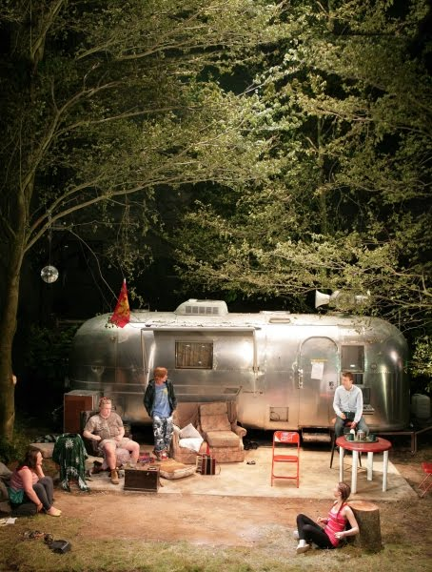](http://therecognitionscenedotcom.files.wordpress.com/2012/01/jerusalem1.jpg?w=454&h=600)

**Act One**

***Section1: from beginning to ‘Enter the PROFESSOR’ (page 15)***

1. Comment on the overall setting and on some of the details Butterworth describes (e.g. the Wessex flag, the smashed television). How might they represent aspects of England or of Johnny himself?
2. How sympathetically are the council officials represented? Consider their names, the way they speak, their response to Johnny’s barking.
3. Consider an audience’s likely response to Johnny’s first speech and actions. In what ways might they be shocked, amused, disgusted, intrigued? What is your own initial response to him?
4. Ginger’s rap song about the Flintock fair ends with the line ‘It’s shit. But you love it.’ How far would you say this accurately sums up the main characters’ feelings about the fair? To what extent do you think Butterworth wants us to mock it?
5. Johnny now proceeds to tell outrageous lies. Can he be seen as anything more than a compulsive liar?
6. What is your reaction to Ginger’s more reliable account of Johnny’s behaviour at The Cooper’s and the other pubs that have banned him?

***Section 2: down to the appearance of Pea and Tanya (page 26)***

1. Basing your answer only on the Professor’s first appearance, suggest some of the ways in which Butterworth uses him. (Think, for a start, about the clash between his obvious erudition and his mental state, the different ways in which Ginger and Johnny react to him, his con-fusion over Ginger’s identity.)
2. What parallels, if any, can you find between the Professor and Johnny?
3. Ginger is very ready to mock Lee’s ambitions, but are there any parallels between them?
4. Look at the first description of Davey in the SD. What two sides to him are suggested and how is each illustrated as the dialogue goes on?
5. Both Ginger and Davey enter singing snatches of ‘The Merry Morning of May’, a traditional May Day song that is part of the Flintock St George’s Day celebrations, which are going on off-stage. What effect does this have on our perception of the central characters in relation to mainstream Flintock society?

[](http://www.google.com/imgres?q=man+with+accordion&hl=en&biw=1366&bih=587&gbv=2&tbm=isch&tbnid=_ujGeEyTpcDQwM:&imgrefurl=http://www.dreamstime.com/royalty-free-stock-images-royalty-free-stock-images-man-plays-accordion-image16018669&docid=dq1yu54igrMZhM&imgurl=http://www.dreamstime.com/a-man-plays-the-accordion-thumb16018669.jpg&w=400&h=267&ei=RRnaT9CELZGN0wX3xq2rBA&zoom=1&iact=hc&vpx=602&vpy=172&dur=4200&hovh=183&hovw=275&tx=147&ty=111&sig=105511694509115003484&page=3&tbnh=129&tbnw=171&start=63&ndsp=31&ved=1t:429,r:4,s:63,i:288)

***Section 3: down to Wesley’s entrance (page 34)***

1. What seems to be Johnny’s attitude to the girls? Is there any evidence, here or later in the play, that he doesn’t entirely mean what he says?
2. Apart from generating humour, what do you think is the significance of the mess Tanya has rolled in?
3. At what point do we realise that the missing girl is the one who sang at the beginning of the play?
4. How does Ginger change the young people’s rather scornful view of Johnny?
5. ‘Council stepped in. Made daredevilling illegal.’ How might this comment be seen to have a wider significance?
6. How does Johnny’s account of the village meeting (if we believe him) begin to show the hypocrisy of the ‘respectable’ townspeople?

[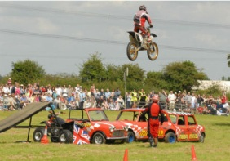](http://images.search.yahoo.com/r/_ylt=A0PDoX4pINtPbn4Av7mjzbkF;_ylu=X3oDMTBpcGszamw0BHNlYwNmcC1pbWcEc2xrA2ltZw--/SIG=13nblsu25/EXP=1339789481/**http:/www.thisislincolnshire.co.uk/10-things-Lincolnshire-weekend/story-16002880-detail/story.html) [](http://images.search.yahoo.com/images/view;_ylt=A0PDoKsoJttPiUMAfomJzbkF;_ylu=X3oDMTBlMTQ4cGxyBHNlYwNzcgRzbGsDaW1n?back=http://images.search.yahoo.com/search/images?p=country+fair&n=30&ei=utf-8&y=Search+Images&tab=organic&ri=14&w=327&h=218&imgurl=blog.visitwales.co.uk/wp-content/uploads/2011/04/Country-Fair.jpg&rurl=http://blog.visitwales.co.uk/6353/win-tickets-to-glanusk-international-horse-trials/&size=34.1+KB&name=Enjoy+a+family+day+out+at+the+Glanusk+Country+Fair&p=country+fair&oid=1280397372b9ccec81addea2664f0d27&fr2=&fr=&tt=Enjoy+a+family+day+out+at+the+Glanusk+Country+Fair&b=0&ni=96&no=14&ts=&tab=organic&sigr=12kbqrg7d&sigb=13bh1t2ej&sigi=1219j3hr0&.crumb=4g1AITFkv6k)

***Section 4: down to end of Act One (page 48)***

1. What seems to be Wesley’s attitude to being co-opted as a Morris man?
2. Outline Johnny’s and Wesley’s argument about the young people. Which of them would you say wins this argument?
3. Why do you think Wesley decides to warn Johnny about the extent of his imminent eviction?
4. Bearing in mind events so far, is there now anything ironic about the words of the May Song (page 45)?
5. How would you say the programme Ginger reads out (page 46) demonstrates the two sides of the Flintock Fair (i.e. a long-established, colourful, riotous celebration with its roots in pagan ritual and a more formal, organised, sedate occasion)?

**Prologue II**

1. Find a recording of Barry Dransfield‘s song ‘The Werewolf’ on youtube – the lyrics are very clear. Note all the links you can think of between the song and the play as a whole. Which characters could be seen as ‘the werewolf’?

**Act Two**

***Section 1: down to’JOHNNY turns’ (page 62)***

1. What sort of atmosphere would you say is set by the description of the setting and the actions of the characters at the beginning of this act, before the dialogue starts?
2. What elements of traditional myths do Johnny’s accounts of his birth and his meeting with the giant contain?
3. What is the other characters’ response to Wesley’s arrival, and why?
4. Wesley could be seen as a bit of a myth-maker as well as Johnny. What sort of myths does he create about himself and his life?
5. Think about Lee’s comment on what has been happening to the local BBC news towards the bottom of page 60, ending, ‘And that, in a nutshell, is what’s wrong with this country.’ What truths does his verdict hold about contemporary society?
6. What evidence is there that, on some level, the characters do believe Johnny’s story about the giant? Why might they?
7. The appearance of Marky, when the characters may be half-expecting a giant, may seem a comic anti-climax. Could it be taken in any other way? What effect does it have on Johnny’s followers?

[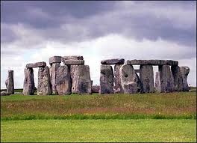](http://images.google.com/imgres?q=stonehenge&num=10&hl=en&biw=1366&bih=587&tbm=isch&tbnid=cbu7ZPHGpX2fZM:&imgrefurl=http://agonist.org/20090619/big_police_operation_planned_for_stonehenge_summer_solstice&docid=ynf_z40KEhirqM&imgurl=http://news.bbc.co.uk/media/images/42209000/jpg/_42209114_stonehenge416bbc.jpg&w=416&h=300&ei=QFvrT8S-DMGXhQfq4IS_BQ&zoom=1&iact=hc&vpx=1018&vpy=161&dur=6533&hovh=191&hovw=264&tx=106&ty=102&sig=105511694509115003484&page=4&tbnh=126&tbnw=179&start=72&ndsp=24&ved=1t:429,r:5,s:72,i:401) [](http://images.google.com/imgres?q=green+man&hl=en&biw=1366&bih=587&tbm=isch&tbnid=nL4rc8UMf8kMCM:&imgrefurl=http://www.begreenman.com/Purchase.html&docid=pfuF7kIbetsZ1M&imgurl=http://www.begreenman.com/New/BGM_VIC/images/Manufacturer.jpg&w=855&h=1140&ei=MlzrT8m7EYiBhQeajb3TBQ&zoom=1&iact=hc&vpx=448&vpy=23&dur=1077&hovh=259&hovw=194&tx=96&ty=126&sig=105511694509115003484&page=2&tbnh=123&tbnw=83&start=29&ndsp=36&ved=1t:429,r:12,s:29,i:267)

***Section 2: down to bottom of page 71.***

1. Why does Marky not want to kiss his father?
2. Find the speech in this section you feel shows us Johnny most clearly through Dawn’s eyes. Are you able to have any sympathy with him at this point?
3. What signs are there that Dawn still has some feelings for Johnny?
4. What makes Wesley’s appearance (bottom of page 63/top of page 64) comic?
5. On page 66, Dawn accuses Johnny of failing to move on. Which of the other characters fall into this category?
6. Why do you think it is important to Johnny to know the name of Dawn’s new boyfriend?
7. Throughout this section, Johnny repeatedly assures Dawn that things will be all right. Is he simply failing to face the truth?
8. What is your interpretation of Dawn’s strange reaction when she looks deep into Johnny’s eyes?

***Section 3: down to end of Act Two (page 84)***

1. What explanations can you think of for Johnny’s amazing ability with the Trivial Pursuit cards?
2. What is the significance of his inability to remember who wrote the words to ‘Jerusalem’?
3. What is Johnny insinuating about Troy Whitworth’s concern for his step-daughter (page 81)?
4. Comment on the reaction Troy allegedly had in the wood a generation ago when he looked in the mirror during the magic rituals (page 81).
5. Just after this, Troy scoffs at Ginger: ‘Got lost? Can’t find your way home?’ Where else in the play has the idea of loss and being lost been seen?
6. If the council workers represent respectable but unimaginative law and order, what would you say Troy represents?
7. What is important about the other characters’ reaction to Troy’s parting revelation? Does it mark some sort of crux or turning-point in the play?
8. What do you make of the Professor’s recital of the tale of St George and the dragon? How would you link it with anything else in the play?

[](https://www.google.co.uk/imgres?imgurl=https://i.ytimg.com/vi/12WYv4oIWpw/maxresdefault.jpg&imgrefurl=https://www.youtube.com/watch?v%3D12WYv4oIWpw&docid=cm9cexALLIgTlM&tbnid=w_cj8YQcO3teYM:&vet=1&w=1280&h=720&bih=743&biw=1371&ved=0ahUKEwi_6uamjqvQAhXGCsAKHVHOBNIQMwhAKBgwGA&iact=mrc&uact=8) [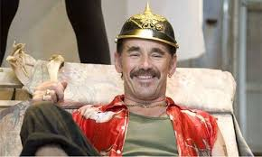](https://www.google.co.uk/imgres?imgurl=https://i.guim.co.uk/img/static/sys-images/Guardian/Pix/pictures/2011/10/25/1319536094061/Mark-Rylance-as-Rooster-i-007.jpg?w%3D620%26q%3D55%26auto%3Dformat%26usm%3D12%26fit%3Dmax%26s%3D587f3f6d1ebf9f6ce3834b0325100a53&imgrefurl=https://www.theguardian.com/stage/theatreblog/2011/oct/25/why-i-love-butterworths-jerusalem&docid=YMz9nvbXa4MBBM&tbnid=tTk2O7WtGDwvkM:&vet=1&w=460&h=276&bih=743&biw=1371&ved=0ahUKEwi_6uamjqvQAhXGCsAKHVHOBNIQMwhlKD0wPQ&iact=mrc&uact=8)

**Act Three**

***Section 1: down to “They leave, ‘singing’ (page 91)***

1. Which central ideas might Ginger’s helmet, and the business with it, reflect?
2. Why does Ginger respond as he does to Davey’s news about the Trevs’ split?
3. Explain why you do or don’t believe Davey actually received this text.
4. On page 88, Davey advises Lee, ‘I wouldn’t worry too much, boy. Rooster Byron’s got a heart of stone.’ Do you feel Johnny has been hurt by his friends’ behaviour?
5. Davey’s speech at the bottom of page 89 could be seen as displaying either an attitude of philosophical acceptance of his lot in life or as a (perhaps half-disguised) bitter comment on the injustice of a society that has given him no opportunities. How do you read it?
6. When Lee exits with Davey on page 91, it is the last we see of him. Do you think he goes to Australia? Why, or why not?
7. The spitfires that fly over during this part of the act are obviously part of the fair, but do you think Butterworth is using them for a symbolic purpose as well?

***Section 2: down to ‘Exit THE PROFESSOR’ (page 100)***

1. Wesley’s drunken state is obviously making him maudlin, but there is an old Latin saying, ‘in vino veritas’, meaning that drink brings out the truth. Where does his usual mask drop during his brief appearance here?
2. Having confided in Johnny and reminisced about the past, Wesley suddenly turns brisk and even antagonistic as he leaves. What explains this change?

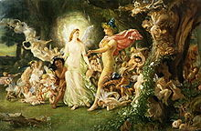 [](http://images.google.co.uk/imgres?q=bulldozers+in+wood&hl=en&biw=1366&bih=587&tbm=isch&tbnid=yFffveq2odpdhM:&imgrefurl=http://toolmonger.com/category/85/heavy-equipment/page/3/&docid=AMWG2xACY3v0ZM&imgurl=http://toolmonger.com/wp-content/uploads/2008/05/Bulldozer450.jpg&w=450&h=301&ei=TZ78T4G0MoWmhAe-lJzJBg&zoom=1&iact=hc&vpx=531&vpy=127&dur=2157&hovh=184&hovw=275&tx=127&ty=84&sig=117583907891949037990&page=1&tbnh=118&tbnw=148&start=0&ndsp=21&ved=1t:429,r:10,s:0,i:101) [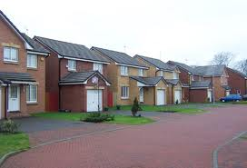](http://images.google.co.uk/imgres?q=housing+estate&hl=en&biw=1366&bih=587&tbm=isch&tbnid=4O6c5omcTNG4RM:&imgrefurl=http://paisleyjoinery.co.uk/&docid=cFDCq4MOEoAidM&imgurl=http://paisleyjoinery.co.uk/lightbox-pics/elder-housing-estate-1G.jpg&w=450&h=306&ei=15_8T9eXJYiKhQfciJjGBg&zoom=1&iact=hc&vpx=101&vpy=220&dur=1207&hovh=185&hovw=272&tx=125&ty=118&sig=117583907891949037990&page=2&tbnh=129&tbnw=197&start=21&ndsp=24&ved=1t:429,r:0,s:21,i:144)

1. How does the language used by Fawcett and Parsons on the one hand and Johnny on the other help illustrate the clash between the official and the personal here? In what ways could this confrontation illustrate the conflict between the ‘two societies’ which is at the centre of the play?
2. The council officers appear to have decency, common sense and the popular vote on their side as well as the law. What flaws does Johnny point out in their approach?
3. What effect does the reading aloud of the petition have, especially following close on Wesley’s listing of past May Queens?
4. The Professor’s final appearance reinforces the idea that Rooster’s Wood looks different to everyone in it, depending on their perspective on life. Comment on his speeches in the light of this idea.
5. It now seems that Mary is not a dog but the professor’s dead wife. Go back to the first few pages of the play and find earlier links between people and animals. Why has Butterworth included them?

***Section 3: down to end of play***

1. Phaedra’s comment, ‘Everything needs a name’ (page 101) reminds us of various earlier remarks about names (look at the bottom of page 22 and page 89, for example). What is the significance of Phaedra’s remark?
2. How far does Johnny’s speech at the bottom of page 102 convince you that he is the rightful owner of the wood?
3. Why do you think Johnny tells Ginger ‘I’m nobody’s friend’? Does this confirm Davey’s claim that he has ‘a heart of stone’?
4. What do you make of Johnny’s advice to Marky (apparently much the same as Butterworth’s grandfather’s advice to him at a young age)?
5. Why do you think Johnny pours petrol all over his caravan?
6. To what extent could you see the ending as both a tragic and a comic one?

