**Critical approaches to *Othello***

* Article by: [Virginia Mason Vaughan](https://www.bl.uk/shakespeare/articles/critical-approaches-to-othello#authorBlock1)
* Themes: [Tragedies](https://www.bl.uk/shakespeare/themes/tragedies), [Ethnicity and identity](https://www.bl.uk/shakespeare/themes/ethnicity-and-identity)
* Published: 15 Mar 2016

There have been numerous interpretations of *Othello* over the last 400 years. Virginia Mason Vaughan discusses four recent critical approaches: feminist, new historicist, marxist and post-colonial.

[*Othello*](https://www.bl.uk/works/othello) was crafted at the dawn of the 17th century, shaped by complex social and geopolitical issues that new historicist critics, who seek to place literary works within a historical framework, have recently sought to unravel. Yet from its first staging to the present, *Othello* has also been among the few Shakespearean plays to be repeatedly staged to enthusiastic audiences, not only in England, but across the globe. This continuing appeal suggests that the tragedy transcends the time and location in which it was written, provoking new interpretations from generation to generation, place to place. In order to fully appreciate *Othello*, we need to see it in its multifaceted historical context – then – and consider the myriad ways it speaks to audiences now.

**Cinthio's *Gli Hecatommithi*, an Italian source for *Othello* and *Measure for Measure***

[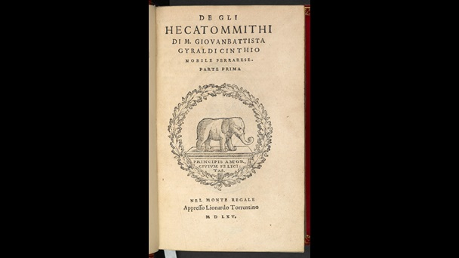](https://www.bl.uk/collection-items/cinthios-gli-hecatommithi-an-italian-source-for-othello-and-measure-for-measure?shelfitemviewer=1&fromother=1&imgSelectedId=%7b69C3C89B-5009-420B-B1D8-53F2E8FFA062%7d)

Shakespeare took the idea for Othello from a tale of doomed mixed-race marriage in Cinthio’s *De Gli Hecatommithi*, 1565.

**Postcolonial reading: ‘something from Cyprus’**

Postcolonial readings focus on the play’s representation of Ottoman Turks. Shakespeare derived *Othello*’s plot from a short narrative in Giraldi Cinthio’s *Gli Hecatommithi* (1565), but set his play within the context of Venice’s struggle during the 1570s with the Ottoman Empire for control of Cyprus, the eastern Mediterranean island that overlooked the shipping lanes between Europe and trading centres in the East. Venice owned Cyprus from 1470 to 1569, but in 1571 Turkish forces seized the island. Later that year an alliance of Christian powers defeated the Turk in the famous naval battle of Lepanto. As a young man, James VI of Scotland (James I of England in 1603) celebrated that battle, fought ‘Betwixt the baptiz’d race, / And circumcised Turband Turkes’.[[1]](https://www.bl.uk/shakespeare/articles/critical-approaches-to-othello#footnote1) References throughout *Othello* to ‘the Turk’ or ‘turning Turk’ evoke the intermittent conflict between Europe’s Christian powers and the Islamic Ottoman Empire, which was as much an economic competition as a clash of religions. In sermons and treatises, English writers like Richard Knolles, who published *The General Historie of the Turks* (1603), demonised the Ottoman Empire as barbaric and cruel, even as they admired its military success and bureaucratic structure.

**Description of the Battle of Lepanto in Knolles's *History of the Turks***

[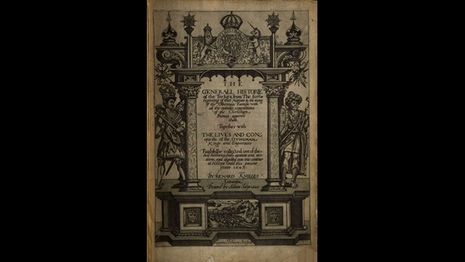](https://www.bl.uk/collection-items/description-of-the-battle-of-lepanto-in-knolless-history-of-the-turks?shelfitemviewer=1&fromother=1&imgSelectedId=%7bB9764DD3-1FBF-4FAE-B0D9-62DDC60C4B40%7d)

Richard Knolles’ *General Historie of the Turks* (1603) demonizes the lion-like Turks but admires their military power.

Shakespeare draws upon the Christian-Turkish binary but also undercuts it by making the play’s most villainous character a Venetian and its hero an outsider. Fearful of vesting military power in one of its own citizens, Venice’s republican government contracted with foreign mercenaries who could easily be dismissed once the crisis was over (as Othello is in Act 5). Although Othello has been chosen by the Venetian government to lead its army, ‘the Moor’ (a term that originally referred to practitioners of Islam) remains an alien in Venice. Like the liminal island of Cyprus, he is caught in the middle, neither European nor Turk yet embodying both, and in his suicide he highlights his service as a Christian hero by killing the ‘turbaned Turk’ within, who ‘beat a Venetian and traduced the state’ (5.2.352–53).

*Othello*’s geopolitical impact is not limited, however, to conflicts between Venice and the Ottoman Empire. Othello’s blackness and his background as a foreign mercenary prefigures the hybridity postcolonial theorists have identified in colonial subjects. Brabantio and Desdemona are fascinated by his strange stories of cannibals and anthropophagi; Othello’s first gift to her is a handkerchief given to him by an Egyptian charmer, ‘dyed in mummy [a black liquid distilled from corpses] and steeped in the ancient lore of charmers, sibyls and magic’.[[2]](https://www.bl.uk/shakespeare/articles/EditorPage.aspx?da=core&id=%7B4BA49ADA-AAD5-4180-8BF4-1323AEF62AEE%7D&ed=FIELD2728129641&vs&la=en&fld=%7BA03AE84A-59C0-4905-BE50-B6AE9CE96875%7D&so&di=0&hdl=H2728129863&us=sitecore%5Cythorsdottir&mo&pe=0#footnote2) The Moor’s stories allow Desdemona to experience the exotic/erotic delight found by many early modern readers in travel narratives that described the ‘antres vast’ of unexplored territories in Africa, the East and the New World.

**Manuscript of *The Travels of John Mandeville* showing headless men, 1430**

[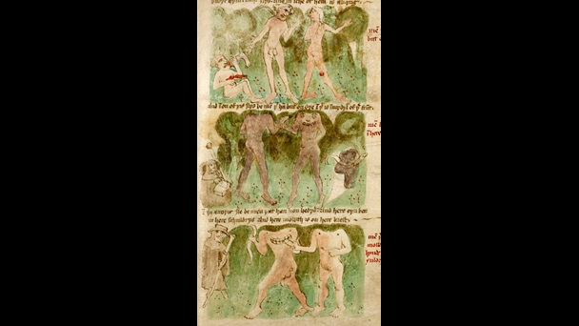](https://www.bl.uk/collection-items/manuscript-of-mandevilles-travels-showing-headless-men-1430?shelfitemviewer=1&fromother=1&imgSelectedId=%7b1044E3F6-7924-4139-AA59-58B1610C462F%7d)

Headless men and men with mouths behind their shoulders: these are some of the wondrous creatures depicted in *The Travels of John Mandeville*, a book still hugely popular in Shakespeare’s day.

**New historicist reading: ‘far more fair than black’**

New historicist critics often debate whether or not race was a factor in early modern representations of non-English peoples. Although Othello’s racial identity is clearly a factor in Shakespeare’s text, when the play was first performed the audience would not have seen it as squarely focussed on race as we do. As editor Michael Neill observes, ‘to talk about race in *Othello* is inevitably to fall into some degree of anachronism, while to ignore it is to efface something fundamental to the tragedy.’[[3]](https://www.bl.uk/shakespeare/articles/critical-approaches-to-othello#footnote3) As a result, Shakespeare’s *Othello* has been appropriated worldwide as a vehicle for the exploration of racial and ethnic tensions.

In the opening scene Iago refers to Othello as ‘the thick-lips’ (1.1.66) and later he raises a toast to ‘the health of black Othello’ (2.2.29). Through these and other comments we learn that Othello is a black African of sub-Saharan origin. In 1604 England was not yet formally immersed in the slave trade, but as early as 1565 English privateers had bought captured Africans, and Shakespeare may well have known some of them or other people of African heritage. Contemporary conceptions of race and racism, influenced by the history of racial slavery and 18th-century pseudo-science, are often based on hard and fast racial categories that were only incipient in Shakespeare’s England. While Iago’s and Brabantio’s remarks in Act 1 exude what is today accepted as racism, the Duke’s pronouncement that Othello is ‘far more fair than black’ and Montano’s claim that ‘the man commands / Like a full soldier’ (2.1.36–37) indicate the high esteem others have for him. Nevertheless, references to Othello as black and a Moor, as well as his lack of understanding of Venetian customs, establish his liminal position in Venetian society.

**16th-century costume guide**

[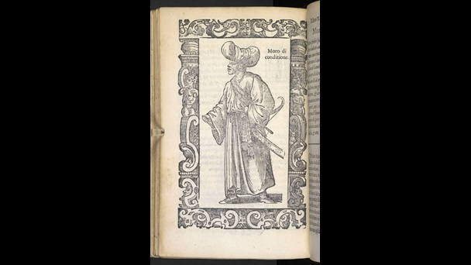](https://www.bl.uk/collection-items/16th-century-costume-guide?shelfitemviewer=1&fromother=1&imgSelectedId=%7bF763D894-10BF-4057-ADFB-4D298547D78C%7d)

A wealthy Moor, 1598: In his guide to global fashions, Cesare Vecellio shows the fluid meaning of the word ‘Moor’ at the time Shakespeare was writing.

In Shakespeare’s time Othello was performed by Richard Burbage, a white actor who wore black make-up and a wig of black lamb’s wool. (Burbage’s powerful cross-racial performance should not be confused with the caricatured blackface used in 19th-century minstrel shows.) Still, by the early 19th century, a truly black Othello was no longer tenable in England and America. The English actor Edmund Kean chose instead to appear as a North African in light brown make-up, suggesting an African from the Mediterranean rim rather than a sub-Saharan. With the exception of Ira Aldridge, a black actor who portrayed Othello throughout northern Europe in the 19th century, the role was taken by white actors in various shades of make-up until the African-American actor Paul Robeson undertook the role in London (1930) and New York (1943). Since then, black actors have usually impersonated Shakespeare’s Moor.

**Portrait of Richard Burbage**

[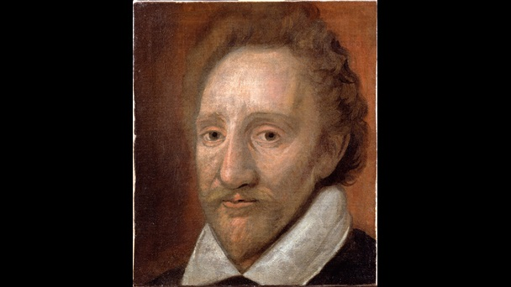](https://www.bl.uk/collection-items/portrait-of-richard-burbage?shelfitemviewer=1&fromother=1&imgSelectedId=%7b55BC81FC-6353-4C48-BDF5-950D6A58974C%7d)

17th-century portrait of the actor, Richard Burbage, probably the first man to play Othello. He played the part wearing black make-up and a wig made of black lamb’s wool.

**Paul Robeson as Othello and Uta Hagen as Desdemona in New York, 1943–44**

[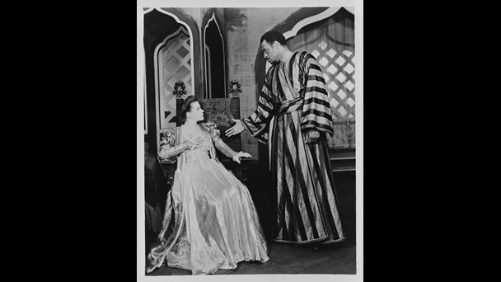](https://www.bl.uk/collection-items/paul-robeson-as-othello-and-uta-hagen-as-desdemona-in-new-york-1943-44?shelfitemviewer=1&fromother=1&imgSelectedId=%7bDD22E229-09C8-4D7E-B276-DA2D0A3BFB3C%7d)

When Paul Robeson played Othello in New York in 1943, it ran for 296 performances – still the longest Shakespearean run in Broadway history.

**Feminist reading: ‘a maiden never bold’**

Feminist critics highlight the ways Shakespeare portrays gender roles. In Act 1, Scene 3, Brabantio describes his daughter Desdemona as ‘a maiden never bold’, yet in choosing a foreigner she has violated the Venetian norm of arranged endogamous marriages (the practice of marrying within a local community or ethnic group) and rejected her father’s authority. Still, she honours the patriarchal dictum that, once married, the wife owes her husband the same respect and duty she had shown her father. Emilia, too, defers to her husband Iago’s wishes. Even after she realises the full extent of his villainy, she admits, ‘’Tis proper I obey him, but not now’ (5.2.194). At the same time, romances, poems and plays often countered patriarchal authority in favour of romantic love. Just as the Duke overrules Brabantio’s demands in Act 1, Scene 3, in fictional narratives the blocking father figure cannot prevail and young lovers marry. If *Othello* ended after Act 1, it would be, as many commentators have observed, a romantic comedy.

Alas, Desdemona and Othello’s love is no match for Iago’s plots and the green-eyed monster jealousy. Infidelity was the ultimate marital crime in early modern England. The prospect of illegitimate children subverted the bedrock of the era’s social and economic system, the inheritance of property from father to son. In a speech that is often described as ‘proto-feminist’, Emilia argues that a wife’s infidelity is a response to the husband’s behaviour:

Say they slack their duties,  
And pour our treasures into foreign laps,  
Or else break out in peevish jealousies,  
Throwing restraint upon us; or say they strike us,  
Or scant of former having in despite –  
. . .   
Yet have we some revenge. (4.4.82–88)

Desdemona rejects this reasoning, promising ‘Not to pick bad from bad, but by bad mend’ (4.4.100). As she nears death in the play’s final moments, she exonerates Othello by claiming no one has murdered her except herself.

From the play’s earliest performances, audiences responded sympathetically to Desdemona’s plight. After a 1610 production at Oxford, Henry Jackson recalled that Desdemona ‘entreated the pity of the spectators by her very countenance’.[[4]](https://www.bl.uk/shakespeare/articles/critical-approaches-to-othello#footnote4) That changed in the late 20th century, however, when feminist critics underscored Desdemona’s initial independence and Emilia’s eventual strength, and outlined the ways both women – as well as the courtesan Bianca – were constrained by the male characters’ patriarchal suppositions. From a feminist perspective, early modern England’s preoccupation with cuckoldry demonstrates a basic male insecurity about women’s sexuality.

**Broadside ballad on cuckolds**

[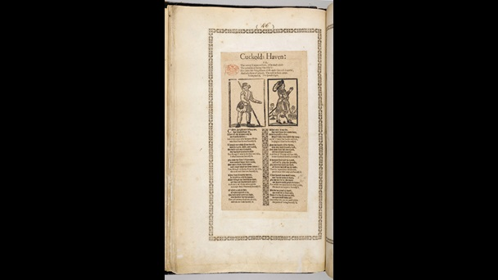](https://www.bl.uk/collection-items/broadside-ballad-on-cuckolds?shelfitemviewer=1&fromother=1&imgSelectedId=%7b1DC14A1A-91F7-4E0C-B717-2BCF4FEEBE41%7d)

This 17th-century ballad, ‘Cuckolds Haven’, shows the early modern obsession with cuckolds – men who were depicted with animal horns as a sign that their wives had been unfaithful.

**Marxist reading: ‘’Tis the curse of service’**

Marxist critics are concerned with the economic and psychological impact of early modern England’s hierarchical social system. In 1604 James I took Shakespeare’s acting company under his patronage, making Shakespeare a ‘servant’ of the king. Indeed, service to someone in a higher position was expected from the lowest kitchen maid to the lords and ladies of the king’s court.[[5]](https://www.bl.uk/shakespeare/articles/critical-approaches-to-othello#footnote5) The pecking order in *Othello* is clear. The Duke and aristocratic members of the Venetian Senate give orders to Othello, who in turn commands his Lieutenant Cassio. Ensign Iago is subordinate to both. All three ostensibly serve out of loyalty to the state and for the status their military position brings, but they can be dismissed at the pleasure of their superiors. Iago resents Cassio, a man with ‘a daily beauty in his life’ (5.1.19), hates being tied to Othello’s service and yearns for preferment.

The different gradations of status embedded in the text are often represented in military terms, with Iago presented as a rough-speaking non-commissioned officer, resentful of Cassio’s rank and courtly manners. But the play’s exploration of rank and class go beyond the military. Iago’s repeated advice, ‘Put money in thy purse’, suggests that a new economic model has replaced the feudal obligations of service, which had been based on a bond of loyalty and duty between servant and master. As a ‘servant’ of the king, Shakespeare – who applied for a coat of arms to be named a ‘gentleman’ but was also an entrepreneur who loaned money and invested in land and rents – was implicated in both models.

**Photograph of Hugh Quarshie and Lucian Msamati in *Othello*, 2015**

[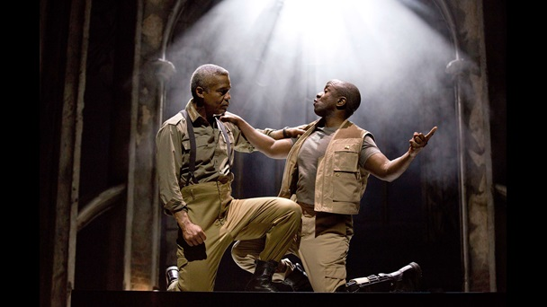](https://www.bl.uk/collection-items/photograph-of-hugh-quarshie-and-lucian-msamati-in-othello-2015?shelfitemviewer=1&fromother=1&imgSelectedId=%7b869D3118-DEF7-4477-BF68-897B4F0F0FA2%7d)

In the RSC’s 2015 production of *Othello*, the lead role was played by Hugh Quarshie and Iago was played by Lucian Msamati.

**‘O bloody period!’**

Shakespeare wove the contradictory discourses of his age into *Othello*’s tangled web, whether it be the conflict between women’s self-rule and patriarchal marriage, western society’s fascination with and fear of the Islamic or African other, or the resentment caused by shifting economic parameters. 400 years later the discourses have changed, but as contemporary appropriations of *Othello* remind us, the issues have only intensified.

**Footnotes**

[1] James VI of Scotland, ‘Lepanto’, in *The Poems of James VI of Scotland*, ed. by James Craigie (Edinburgh: William Blackwood for the Scottish Text Society, 3rd series, no. XXII, 1955), p. 202.

[2] Ian Smith, ‘Othello’s Black Handkerchief’, in *Othello: The State of Play*, ed. by Lena Cowan Orlin (London: Bloomsbury, 2014), pp. 95–120 (p. 103).

[3] Michael Neill, ‘Introduction’, *Othello* (Oxford: Oxford University Press, 2006), p. 125.

[4] See Neill, p. 9.

[5] See Neill, p. 161.

* Written by Virginia Mason Vaughan
* Virginia Mason Vaughan is Research Professor and Professor Emerita of English at Clark University in Worcester, Massachusetts where she taught for thirty-eight years. She is the author of *Othello: A Contextual History* (Cambridge University Press, 1994), *Performing Blackness on English Stages, 1500-1800* (Cambridge University Press, 2005), and *The Tempest* for Manchester University Press’s ‘Shakespeare in Performance’ series (2011). With Alden T. Vaughan she also co-authored *Shakespeare’s Caliban: A Cultural History* (Cambridge University Press, 1991) and *Shakespeare in America* (Oxford Shakespeare Topics, 2012) and co-edited The Tempest for the Third Arden Series (1999; rev. ed. 2011). She is also a co-editor of *Women Making Shakespeare* (with Gordon McMullan and Lena Cowen Orlin [Arden Shakespeare, 2014]). Her textual edition of *Antony and Cleopatra* for the *Norton Shakespeare 3* was published this year, as was the monograph, *Antony and Cleopatra: Language and Writing*, for Arden Shakespeare.

The text in this article is available under the [Creative Commons License.](https://uk.sitestat.com/bl/shelvesandspaces/s?creativecommons.org.licenses.by-nc.4.0&ns_type=clickout&ns_url=http://creativecommons.org/licenses/by-nc/4.0/)