OTHELLO EXAM QUESTIONS/2

**Explore Shakespeare’s presentation of betrayal in Othello. You must relate your discussion to relevant contextual factors and ideas from your critical reading.**

1. Highlight the key words in the question.
2. Define/explain ‘betrayal’.
3. List the people who are betrayed in the play.
4. List how each person is betrayed (one example for each character in your list). (This should include both details of by whom and reference to Shakespeare’s dramatic techniques.)
5. Betrayal can be of an idea or concept as well as of a person. List the ideas or ideals that are betrayed in this play?
6. Treason is defined as: “(the [crime](https://dictionary.cambridge.org/dictionary/english/crime) of) [showing](https://dictionary.cambridge.org/dictionary/english/showing) no [loyalty](https://dictionary.cambridge.org/dictionary/english/loyalty) to [your](https://dictionary.cambridge.org/dictionary/english/your) [country](https://dictionary.cambridge.org/dictionary/english/country), [especially](https://dictionary.cambridge.org/dictionary/english/especially) by [helping](https://dictionary.cambridge.org/dictionary/english/helping) [its](https://dictionary.cambridge.org/dictionary/english/its) [enemies](https://dictionary.cambridge.org/dictionary/english/enemy) or [trying](https://dictionary.cambridge.org/dictionary/english/trying) to [defeat](https://dictionary.cambridge.org/dictionary/english/defeat) [its](https://dictionary.cambridge.org/dictionary/english/its) [government](https://dictionary.cambridge.org/dictionary/english/government)” (Cambridge Dictionary)

Which characters, concepts and/or episodes within the play could be deemed as treasonous?

1. Queen Elizabeth I died in March 1603, the same year in which Othello is believed to have been written. (The play was first performed in 1604.) How might the concept of betrayal in ‘Othello’ have been relevant (and alarming) for the English audience of the time?
2. 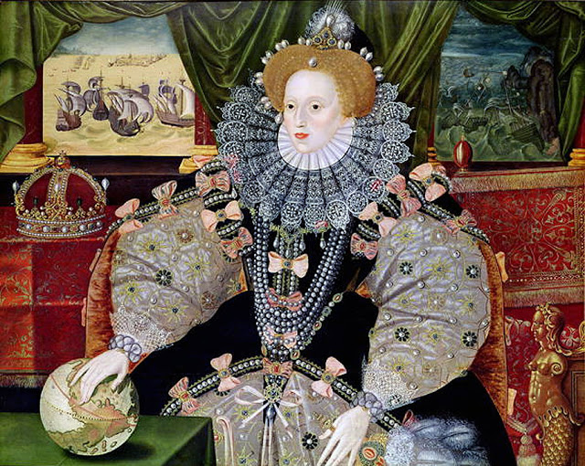Look at the Armada Portrait (1588) What ideas can you find in this work which are also referenced in ‘Othello’?
3. The Fourth Venetian-Ottoman War was fought between 1570-73. The island of Cyprus had been under Venetian rule since 1489 and was one of the Republic’s most important possessions, both as a trading post and for the profits of the cotton and sugar trade. The conflict was fought both at sea (the Christians was victorious in the Battle of Lepanto) and on land, with thousands dying on both sides, before the island was eventually given up to the Ottomans.

Consider the implication of this context for the play and its audiences? The consequences of Iago’s betrayal of Othello undermines Venetian military strength and reputations so that the private battle between Othello and Desdemona is seen to have public and political consequences…. Explain the potential damage and its relevance to an English audience?

Now think about how you would structure a response to the question? Here it is again:

**Explore Shakespeare’s presentation of betrayal in Othello. You must relate your discussion to relevant contextual factors and ideas from your critical reading.**

1. Make a plan. Cite 5 different points you want to cover.
2. Write an introduction for this question, using your earlier definition of key terms and exploring the presentation options.
3. Find suitable quotes (1 main and at least 1 supporting) for each of the 5 points you have listed above.

|  |  |  |
| --- | --- | --- |
|  | Act/Scene ref | Quote |
| 1 |  |  |
| 2 |  |  |
| 3 |  |  |
| 4 |  |  |
| 5 |  |  |

1. Now write up one point. Use the following checklist to ensure you have developed your answer effectively:
   1. Clear initial topic sentence?
   2. Clear reference to question and development of your argument in response?
   3. Main and supporting quote?
   4. Discussion of presentation (how/when/who/what LINKED to meaning/impact/effect on audience)?
   5. Integrated discussion of relevant context (as a way of strengthening evaluation of impact)?
   6. Reference to genre of tragedy and conventions?
   7. Evaluation of at least one critical response/alternative reading?
2. Peer feedback

You will learn much from reading other responses. Other students may have made different points or evaluation which can give you different insights. **Teacher marking cannot achieve this – it can only assess the ideas you have put down.** So share your work: it does not matter if other responses are better or worse than your own, they will all give you food for thought. Put some constructive comment here on the work you are reading above.