**Christina Rossetti: Painting in words**

By Sarah Phillips

A discussion based on the following poems: *Goblin Market; Jessie Cameron; A Royal Princess; Maude Clare* and *Cousin Kate*

*Christina Rossetti’s artistic circle discussed new ideas and experimental methods that are often overlooked in the literary analysis of her work. As the new A levels seek to boost assessment of the contextual readings of texts, Sarah Phillips looks at Rossetti’s interaction with the Pre-Raphaelite Brotherhood in Victorian London.*

The Pre-Raphaelite Brotherhood (formed 1848) aimed to provoke artistic renewal and moral reform through works which explored a keen observation of the natural world with minute detail and a luminous palette of strong colours. Emerging in a time of huge social change, the artists (Christina’s brother: Dante Gabriel Rossetti; William Holman Hunt; John Millais; James Collinson; Frederick George Stephens and later joined by Edward Burne-Jones and William Morris) sought to challenge the concept of industrial ‘progress’ and the comfortable conventions of academic practice.

Like the group, Christina Rossetti’s subject matter demonstrates a fascination with a past world of myth and mystery. In an era of huge population growth (at her birth in 1830, the population of Britain was 12 million, but by her death in 1894, it had passed 30 million), her poems are lonely and uncrowded. In an era of industrial change and technological invention, her motifs derive from rural and biblical symbols, and in the modern world of the city – and she lived in the biggest – her characters occupy fantastical realms of “brookside rushes” and “mossy glen” (*Goblin Market*) far from busy streets and pavements. Yet these choices focus our attention on the modern, moral questions of her day, just as in Holman Hunt’s *Mariana*. In these works (whether in painting or poetry) we find a creative exploration of sincere contemporary dilemmas: religion, science and morals in the Victorian era. In fact, it is interesting to see that unlike her male painting peers, she arguably goes further in resiting the woman’s experience outside the domestic environment. In *Goblin Market, Maude Clare, Cousin Kate* and *Jessie Cameron*, the setting is outside in the natural world. This allows her female protagonists to think the unthinkable: to share their honest ideas free from patriarchal restrictions and to articulate a voice which often runs contrary to the norms of her contemporary society. Thus she takes up the Pre-Raphaelite challenge of fresh innovation but perhaps pushes it further than the ‘Brothers’ themselves.

Christina Rossetti’s female voice gives a different viewpoint from that of the Brotherhood. Her sensitivity to those who must endure “music of a lulling sort” urges us to look again at “the pause between” (*The Royal Princess*). In this way, gaps in her poetry are used to reveal the impossible struggle of female piety against corruption in a Victorian patriarchal world in a voice which is brilliantly detailed yet never obvious. Rossetti’s female protagonists are freed from the daily grind of Realism (the rituals of Victorian sewing and visiting or hard labour and workhouses) by the vision of her Pre-Raphaelite brothers. They (and we) are transported to the “darkening beach” where the “sea-waves swell” (*Jessie Cameron*) to look at fixed assumptions with new eyes.

Her innovations in rhyme and rhythm can also be seen to have their roots in the Pre- Raphaelite interest in earlier forms. Millais, Hunt and DG Rossetti experimented with painting in thin glazes to build up vivid colour on a white ground in rebellion against the traditional use of dark backgrounds. Similarly, Christina Rossetti turns away from the formal clarity of classical verse to the earlier oral, ballad form. Thus she goes back to an earlier world but in order to make us think about the problems of our own world. Glimpses of dialogue are never far from the surface of her poems, but the snatches of conversations are often only revealed in part. Such informality lessens our defences and encourages independent thought. In this way, she adds Pre-Raphaelite layers of thin glazes to her work, but again, insists that the viewer must reflect on her difficult moral questioning for themselves rather than be given a conventional answer as “the troubled sea for all its stir/Finds no voice to tell” (*Jessie Cameron*). Rhyme is frequent but again inconsistent throughout these works. Her loved triplet might become a didactic emphasis of The Holy Trinity if used consistently, but, even in *A Royal Princess,* the variety of punctuation lightens her touch and effect. This seems appropriate for one who, herself, went in the “name of God” *(Royal Princess)* but is never dogmatic in her writing. Again, inspiration can be seen in the shared artistic determination “to sympathise with that which is direct and heartfelt… to the exclusion of what is conventional.” (Pre-Raphaelite manifesto)

Similarly, the paintings of the Pre-Raphaelite Brotherhood share a bold evocation of colour in fine brushstrokes. The opening stanza of *Goblin Market* is just such a vivid evocation. In an era of Victorian expansionism, markets were growing vigorously, but even London ship merchants could not have dreamt of the luxuries of the goblins’ provocative haul. Rossetti paints in words as she lists “Plump, unpecked cherries/…Bloom-down-cheeked peaches,/….wild free-born cranberries” to the irresistible chorus of ‘Come, buy, come buy’. Behind the enticing allure of the market, it is possible to read a strident warning. The cherry will lose its innocent attraction once it has been “pecked”; the youthful appeal of blooming cheeks will be lost with age and the reminder of free-birth to women now condemned to a prison of labour or marriage is powerfully nostalgic. Christina Rossetti is surely subtly challenging the Victorian love of commercial progress. In the same way, the symbols of Holman Hunt’s *The Awakening Conscience* (1853) add a sombre undertone to a work which on first looking seems to be bright and clean. The discarded glove in the foreground of this work hints at the ominous future for the young girl in the same way as Rossetti’s narrator in *Cousin Kate* laments her “shameless shameful life” that has seen her “changed…like a glove.”

Christina Rossetti’s choice of props again reveals her belief in the agenda of the Pre-Raphaelite Brotherhood. Early Christian artistic motifs adorn both her poetry and their paintings. In *Ecce Ancilla Domine (The Annunciation*), 1850, now in the Tate, Dante Gabriel paints his sister as Mary, with their brother, William, as the angel handing her a long stemmed lily. The multiple connotations of the lily must have appealed to the Pre-Raphaelites in their determination to be simultaneously archaic and modern: it is both a symbol of life to come and of death as a funeral flower. Rossetti uses this same simultaneous shift in *Goblin Market* to powerful effect. When Laura’s temptation is too great to bear, she is “like a lily from the beck” (line 83) but when Lizzie stands firm against the combined force of the goblins, she is “like a lily in a flood” (line 409). Rossetti’s religious symbolism is everywhere here in this brilliant evocation of female power: Lizzie, (like the Virgin Mary) is “like a rock of blue-veined stone… sending up a golden fire”: references to the Medieval conventions that the Virgin Mother should be shown in colours made from rare and expensive lapis lazuli and with a tooled golden halo. Perhaps this reading of the poem suggests that rescue may be inspired by different sources simultaneously: sisterly love, religion and personal belief. This would indeed be a contemporary reading that sits well amongst our own difficulties of finding British values in a changing, more secular and divided world. Similar ideas in *Maude Clare* convince me that this Pre-Raphaelite convergence is not just coincidence. Rossetti’s protagonist gives a gift to the newly married groom, reminding him of “That day we waded ankle-deep/For lilies in the beck” to a real time shift in “With feet amongst the lily leaves, -/The lilies are budding now.” Simultaneously loving and left out, the “bloom were gone” and Rossetti’s Victorian hatchet falls.

Christina Rossetti contributed much to the agenda of the Pre-Raphaelite movement. She wrote a series of poems (under the pen name Ellen Alleyne) for their periodical, *The Germ* (1850) which aimed to set out their combined thoughts “towards nature in art and literature.” It was a mutual exchange: both *Goblin Market* (1862) and *The Prince’s Progress and Other Poems* (1866) were published with frontispieces and decorations by her brother Gabriel and his own poem *The Sea Limits* shows some striking similarities with Christina’s imagery and mood. The importance of *A Royal Princess* (published in 1863) in support of the Lancashire cotton mill crises is surely recognised by Millais’ painting of *Queen Esther* (1865) which captures the final line of the poem and sums up their common spirit and determination to fly in the face of convention: “The lesson I have learned, which is death, is life, to know/I, if I perish, perish: in the name of God I go.”

In conclusion then, the ‘art historical’ analysis of Christina Rossetti’s poetry reveals much of her cultural context and redefines her extraordinary achievement as a female artist.

Paintings cited:

* Homan Hunt *Marianna 1851*
* Holman Hunt *The Awakening Conscience 1853*
* Dante Gabriel Rossetti *Ecce Ancilla Domine 1850*
* Millais *Queen Esther1865*

Sarah Phillips teaches both English Literature and History of Art at A Level. She works at St Catherine’s School, Bramley.

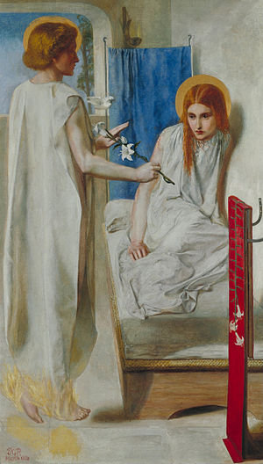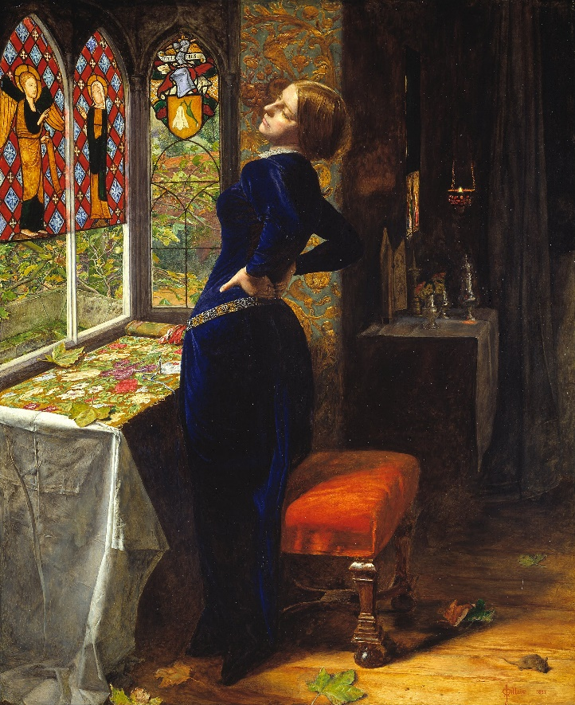

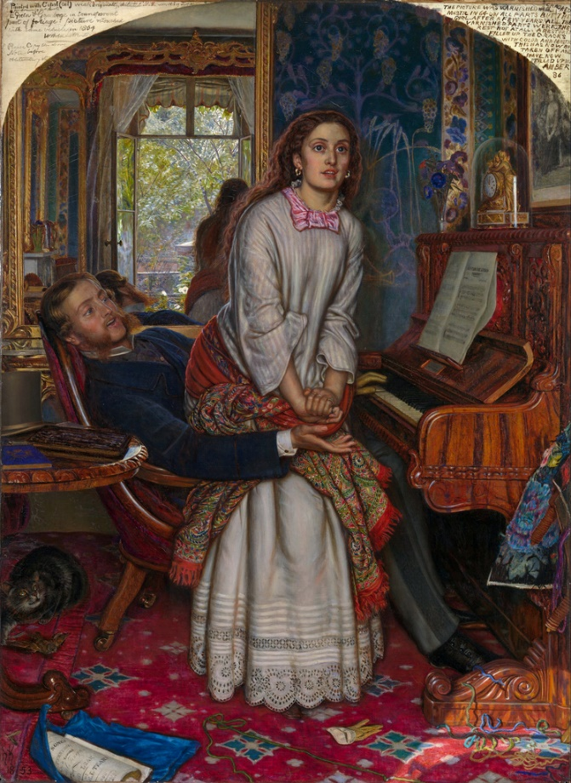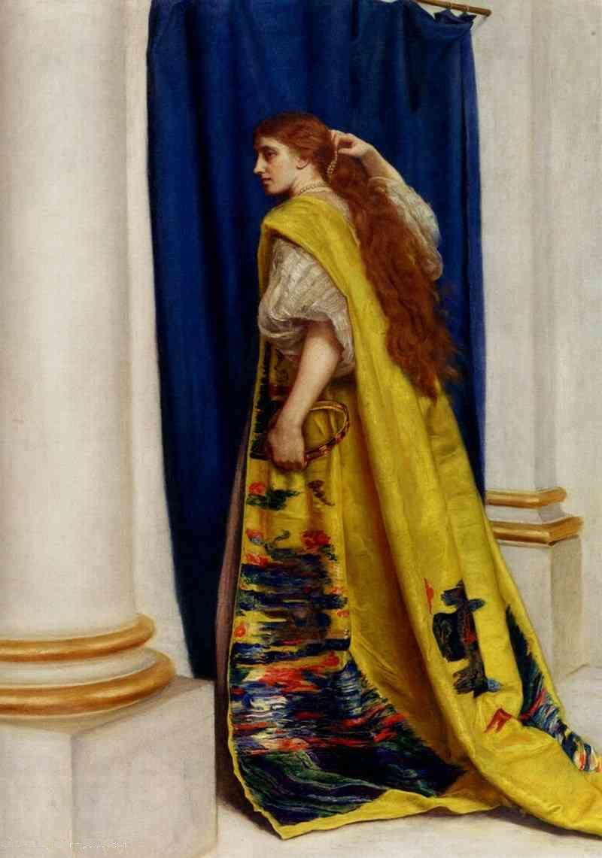

Clockwise from top right: Homan Hunt *Marianna 1851* Holman Hunt *The Awakening Conscience 1853* Dante Gabriel Rossetti *Ecce Ancilla Domine 1850* Millais *Queen Esther1865*