[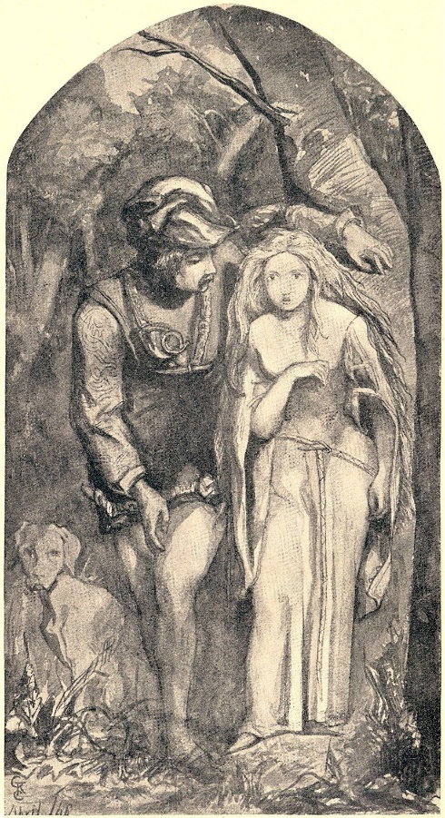](https://www.google.co.uk/url?sa=i&rct=j&q=&esrc=s&source=images&cd=&cad=rja&uact=8&ved=0ahUKEwib46OD3r_WAhUCyRQKHfsdDoYQjRwIBw&url=https%3A%2F%2Fcommons.wikimedia.org%2Fwiki%2FFile%3ADante_Gabriel_Rossetti_-_La_Belle_Dame_sans_Merci%2C_1848.jpg&psig=AFQjCNE2hCBGL3KO_b2Vdaip7rOepEV0uA&ust=1506408205106804)

**By** [**John Keats**](https://www.poetryfoundation.org/poets/john-keats)**, 1820**

Enable annotations

O what can ail thee, knight-at-arms,

       Alone and palely loitering?

The sedge**sedge** Grasslike or rushlike plant that grows in wet areas. has withered from the lake,

       And no birds sing.

O what can ail thee, knight-at-arms,

       So haggard**haggard** Wild looking and so woe-begone**begone** To happen, occur, transpire ?

The squirrel’s granary is full,

       And the harvest’s done.

I see a lily on thy brow,

       With anguish moist and fever-dew,

And on thy cheeks a fading rose

       Fast withereth too.

I met a lady in the meads**meads** Meadow ,

       Full beautiful—a faery’s child,

Her hair was long, her foot was light,

       And her eyes were wild.

I made a garland for her head,

       And bracelets too, and fragrant zone;

She looked at me as she did love,

       And made sweet moan**made sweet moan** Compare "virgin-choir to make delicious moan" from *Ode to Psyche* (30), written between April 21 and 30, 1819. Noted by John Barnard in *John Keats: The Complete Poems* (Penguin, 2003).

I set her on my pacing steed,

       And nothing else saw all day long,

For sidelong would she bend, and sing

       A faery’s song.

She found me roots of relish sweet,

       And honey wild, and manna-dew**honey wild, and manna-dew** Echoes manna in the Bible, first described in Exodus, 16:14-21, 31. The Israelites eat the manna, a food miraculously supplied in the wilderness after the dew has lifted, in the morning: “The house of Israel called it manna; it was like coriander seed, white, and the taste of it was like wafers made with honey” (Exodus 16:31, NRSV).,

And sure in language strange she said—

       ‘I love thee true’.

She took me to her Elfin grot**Elfin grot** An elf’s grotto ,

       And there she wept and sighed full sore,

And there I shut her wild wild eyes

       With kisses four.

And there she lullèd me asleep,

       And there I dreamed—Ah! woe betide!—

The latest dream I ever dreamt

       On the cold hill side.

I saw pale kings and princes too,

       Pale warriors, death-pale were they all;

They cried—‘La Belle Dame sans Merci**La Belle Dame sans Merci** This phrase—and the poem’s title—is from Alain Chartier’s courtly French ballad, “La Belle Dame sans Merci” (1424). Keats wrote the poem in a letter to George and Georgiana Keats, April 21, 1819.

       Thee hath**Thee hath** The version of this poem has “Thee hath” (see *The Letters of John Keats, 1814-1821*, ed. H. E. Rollins, 1958); though other versions of this poem reads “Hath thee” in thrall!’

I saw their starved lips in the gloam**gloam** Twilight; Keats coined the word from “gloaming”,

       With horrid warning gapèd wide,

And I awoke and found me here,

       On the cold hill’s side.

And this is why I sojourn**sojourn** To stay or visit temporarily here,

       Alone and palely loitering,

Though the sedge is withered from the lake,

       And no birds sing.