Political and Social Climate of England 1860s

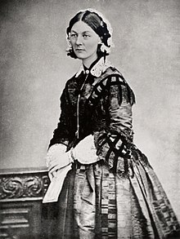Crimean War

* October 1853 – March 1856
* Russian Empire lost to alliance of the Ottoman Empire, France, Britain and Sardinia.
* British Crimean War Casualties: 21,097 dead
* Rossetti – when she was 24 she applied to be a nurse in the Crimean war but was turned down due to youth and inexperience
* (Florence Nightingale – organised team of nurses and travelled to Turkey in 1854 – lots of men were ill with cholera and malaria – female role model)
* Showed power of Britain and importance of sea power in global conflict

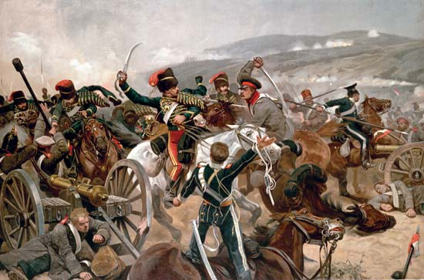

Political:

* 50s/60s workers formed moderate trade unions called New Model Unions
* Second Reform Act passed in 1867 widened the electorate to include any man who either owned a house or paid rent of more than 10 pounds a year
* 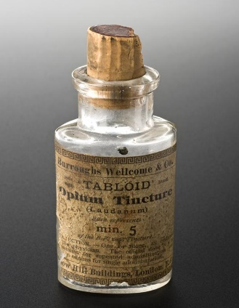No vote for women
* Discovery of diamonds and gold in south Africa – colonialism

Social:

* Karl Marx published Das Kapital – Communist
* Impressionism art movement – Claude Monet
* Victorian era/culture thrived from 1860-1901
* Alice’s Adventures in Wonderland published, Les Mis, War and Peace, Great Expectations, all deal with duality and binary opposites, society
* 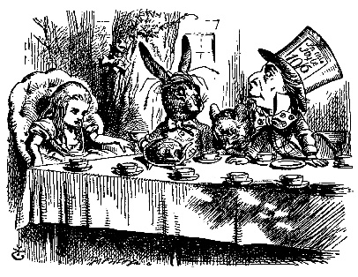Catholics against Liberal Movements in Europe
* Start of bicycle craze
* Laudanum – many writers took the drug – Charles Dickens, Dante Rossetti, Percy Shelley – Dante’s girlfriend died of it