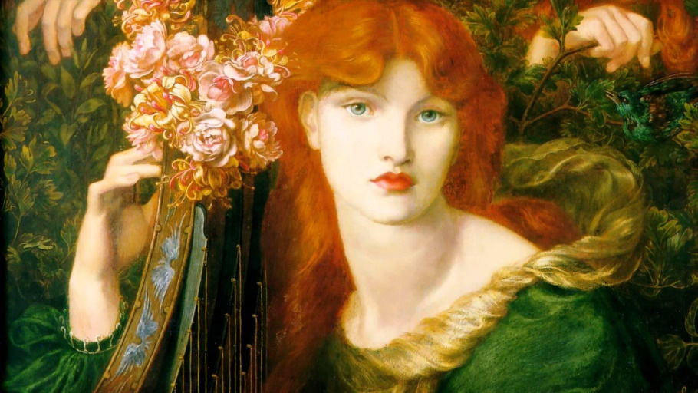**Pre-Raphelite Brotherhood**

* English painters, poets, critics founded in 1848, in Gower Street, London, with the intention of rejecting the mechanistic approach, in particular, Sir Joshua Reynolds (founder of the English Royal Academy of Arts). Accepted imitation painting and the influence of nature, favouring intense colours and complex compositions of Quattrocento Italian art.
* Founders: William Holman Hunt, John Everett Millais and Dante Gabriel Rossetti.
* United creative minds wanting to reform English art.
* 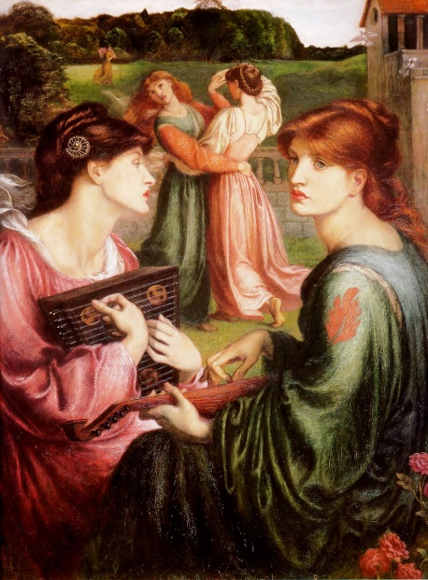Declared that pre Raphaelite artist must have genuine ideas to express, study nature attentively (so they knew how to express it), sympathise with what was direct, serious and heartfelt in previous art and produce good pictures and statues.
* Dante illustrated some of Rossetti’s poems such as “Goblin Market“.
* Rich in detail with clarity and meaning but adhering to the ideals of movement, with the influence of Rossetti’s brother’s leadership. Rossetti’s poems have been directly influenced by the brotherhood.