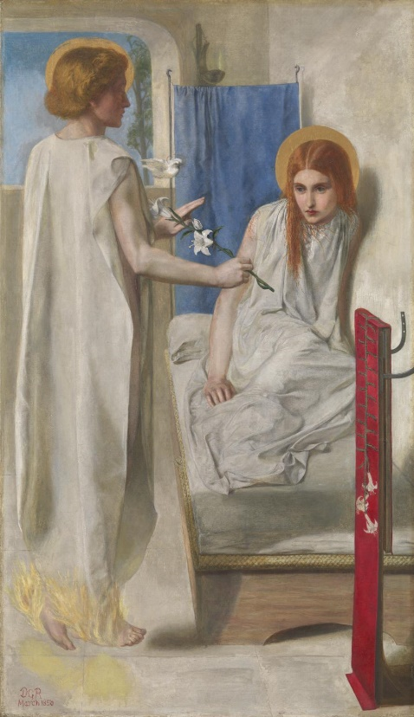The life of Christina Rossetti

* Born 5th December 1830
* Father was the poet Gabriel Rossetti
* Attempted to run a day school with mother to support family as father was ill with bronchitis
* Had a nervous breakdown at the age of 14
* Modelled for her brother Dante rosette in 1848 for his painting of the virgin Mary
* Engaged to James Collinson (minor pre-Raphaelite brethren) but this ended after he converted to Roman Catholicism
* 1849 she was diagnosed with tuberculosis
* Her sister became deeply interested in Anglo-Catholic movements
* All family devout Anglicans (Protestant)
* Loved Charles Cayley but refused to marry, as she “inquired into his creed” and found he wasn’t Christian
* By the 1880s she had recovered bouts of graves’ disease and tuberculosis which ended her attempt to work as a governess but she continued to write
* Her brother Dante was diagnosed with paranoid mania
* In 1891 Rossetti developed cancer which she dies from in London on the 29th of December 1894