**Shakespearean theatre**

Elizabethan theatre itself was notoriously raucous. People, most of which stood throughout the play, talked back to the actors as if they were real people.

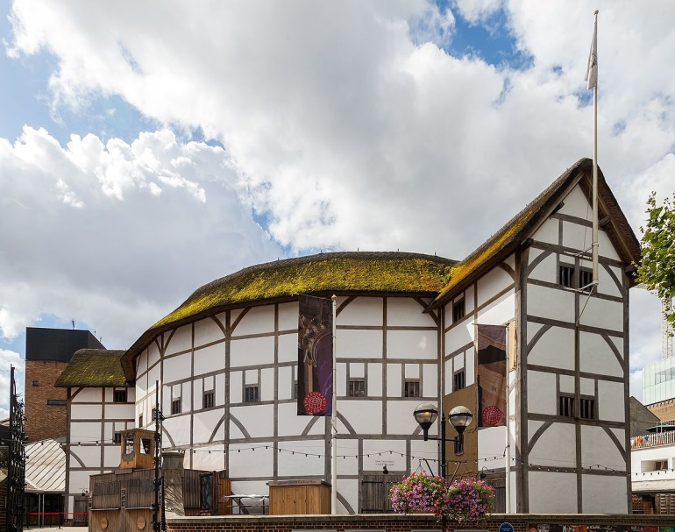There was also no scenery to speak of, and the costumes let the audience know the social status of the characters. Because sumptuary laws restricted what a person could wear according to their class, actors were licensed to wear clothing above their station.

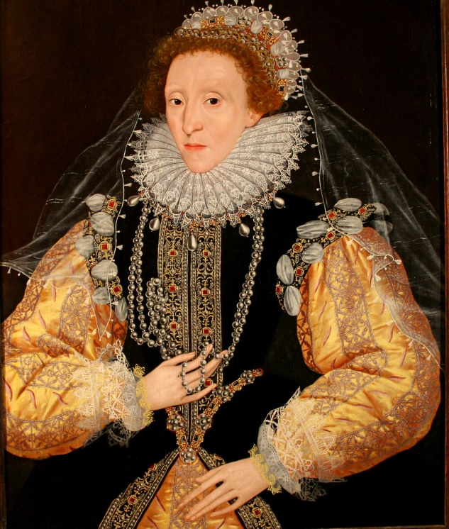Queen Elizabeth I was one of Shakespeare's chief patrons and served as a defender of his plays when critics attempted to have them banned from the stage. Her insistence that women were emotionally and intellectually equal to men influenced his portrayal of women characters as three-dimensional human beings, a first in literature and theatre at that time.

Adolescent men often played female roles as women were not allowed to act. This became very complicated in Shakespeare’s play ‘Twelfth night’!

Plague outbreaks in the 16th century and the early 17th century and then the really big outbreak in 1665 -1666. In each case, the public theatres were closed to protect the public from infection.